FTP Server Setup

# Objective

The objective of this project is to configure an FTP server on a Windows laptop and access it from a Linux Mint PC. The purpose is to enable file sharing, create files, and manage directories over the network using the FTP protocol.

# Requirements

• Windows Laptop with IIS (Internet Information Services) installed.  
• Linux Mint PC with FTP client access.  
• Network connection to allow communication between both devices.  
• Proper configuration of Windows Firewall to allow FTP connections.

# Implementation Details

FTP (File Transfer Protocol) is a standard network protocol used for transferring files between computers on a TCP/IP network such as the Internet or a local area network (LAN). It allows users to upload, download, delete, rename, move, and copy files on a server.  
  
Key Features of FTP:  
- Client-Server Architecture: The FTP server hosts the files, while the client initiates the connection and file transfer.  
- Authentication: Basic username and password authentication are supported.  
- Separate Control and Data Channels: Commands and data are transmitted over different channels to enhance efficiency.  
- Compatibility: FTP is supported across multiple operating systems including Windows, Linux, and macOS.  
  
**FTP Modes:**1. Active Mode: The client opens a port and waits for the server to connect.  
2. Passive Mode: The server opens a port and waits for the client to connect, improving connectivity across firewalls.  
  
**Security Considerations:**- FTP transfers are not encrypted by default.  
- FTP over SSL/TLS (FTPS) provides secure file transfers.  
- It is recommended to use FTP within trusted networks or alongside VPNs for secure operations.

# Step 1: Assign IP Address

The IP address assigned to the Windows laptop is **192.168.4.1** This is configured through the network settings to ensure both systems are on the same network segment.  
  
Description: The IP address is essential for identifying the device within the local network. The Linux Mint PC uses this IP to access the FTP server hosted on the Windows machine.

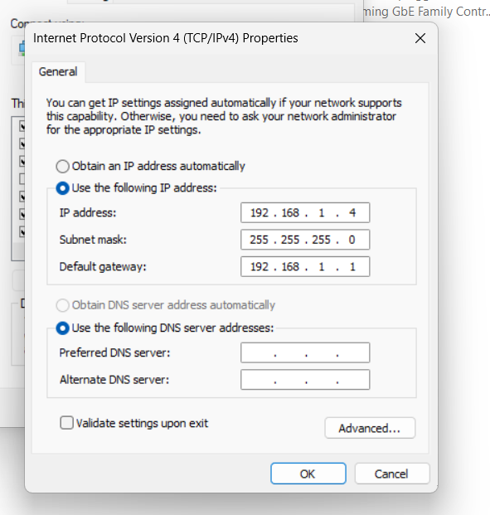

# Step 2: Access IIS Dashboard

Displays the IIS (Internet Information Services) dashboard on Windows.  
  
Description: IIS is used to manage web and FTP services. The FTP server is set up through this interface, which provides configuration tools and options for hosting FTP sites.

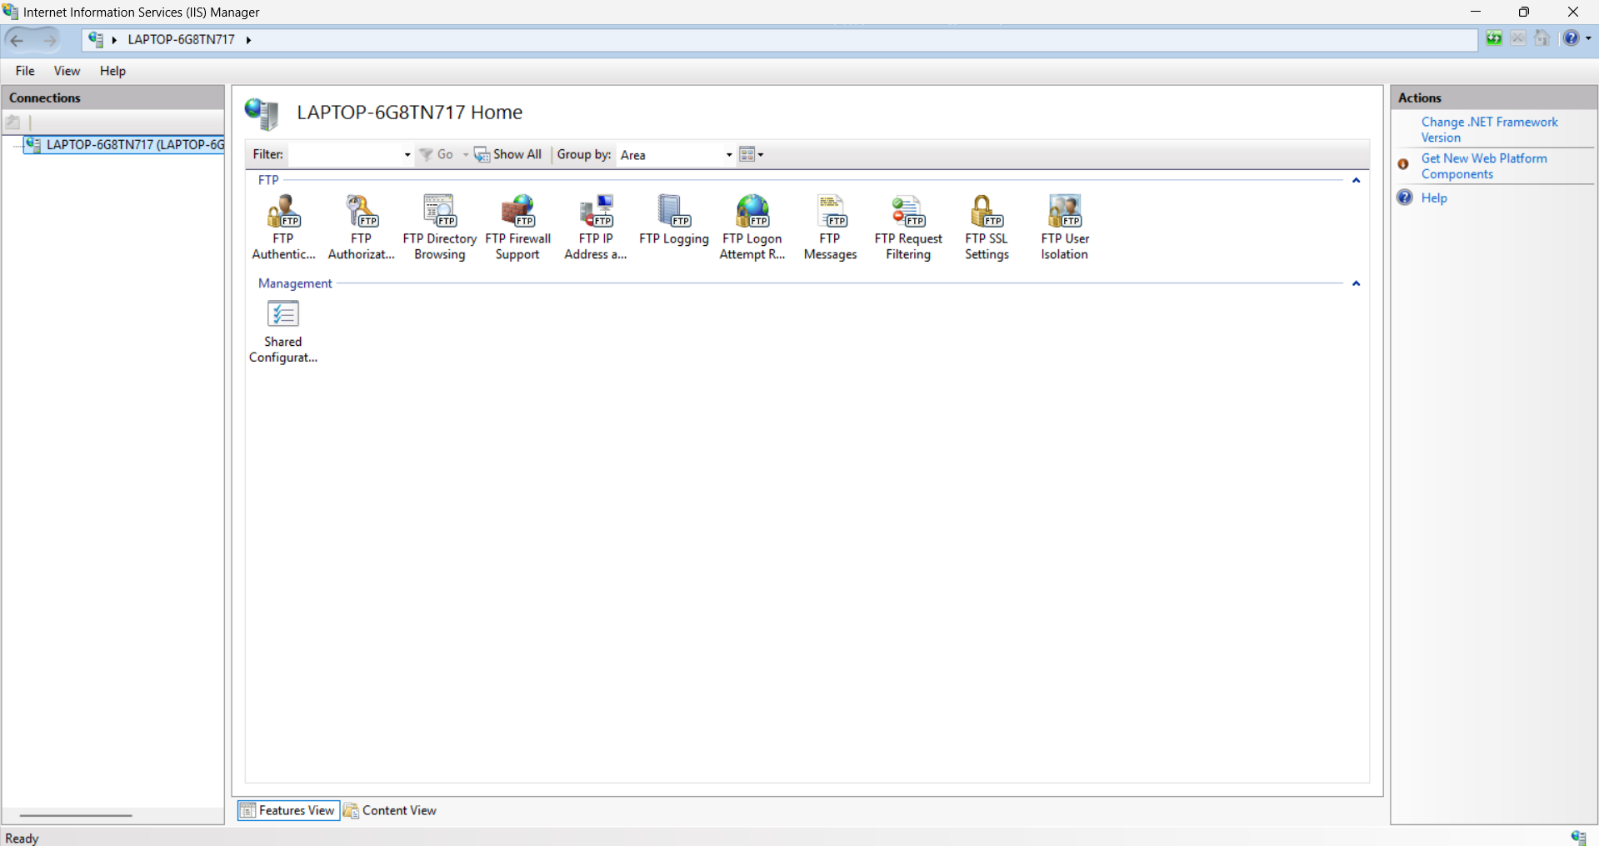

# Step 3: Add FTP Site in IIS

Steps:  
1. Click 'Add FTP Site.'  
2. Enter the site name.  
3. Select the physical folder for storing FTP files.  
4. Skip SSL configuration (No SSL).  
5. Add user permissions with read/write access.  
  
Description: A dedicated folder is selected for FTP operations, and a new site is created under IIS for clients to access it. Users are given permissions required for file management.

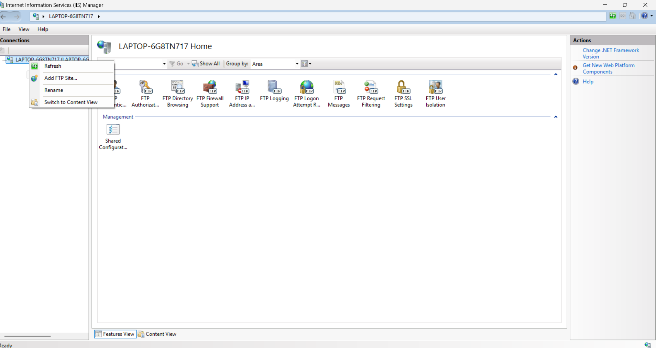

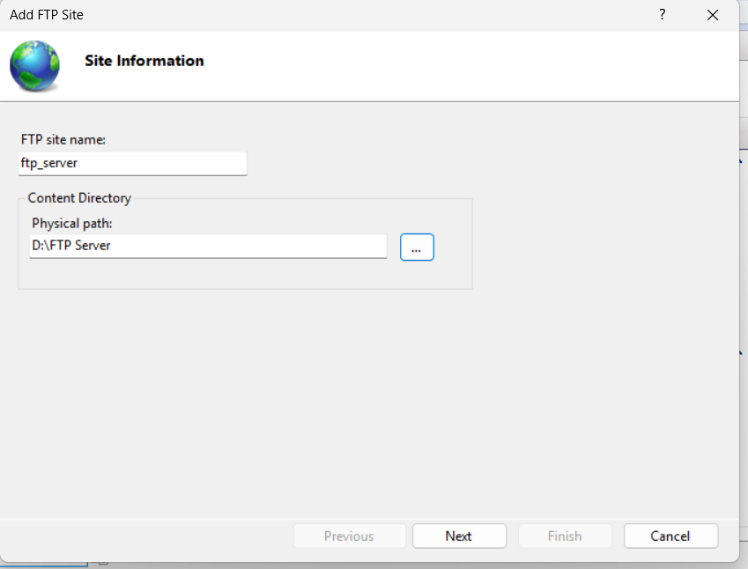

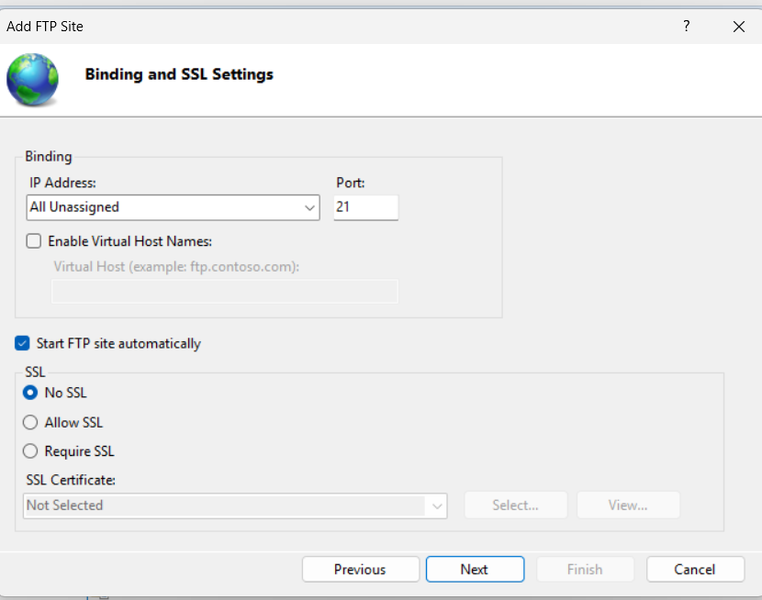

# Step 4: Configure Authentication and Authorization

Description: Authentication is configured to allow basic credentials. Authorization rules are applied to permit specified users to read and write to the FTP directory.

# 

# 

# Step 5: Configure Windows Firewall for FTP Access

Shows the configuration of Windows Firewall to allow FTP traffic.  
  
Description:The firewall is adjusted to ensure that incoming FTP requests are not blocked, which is necessary for external devices like the Linux Mint PC to connect successfully.

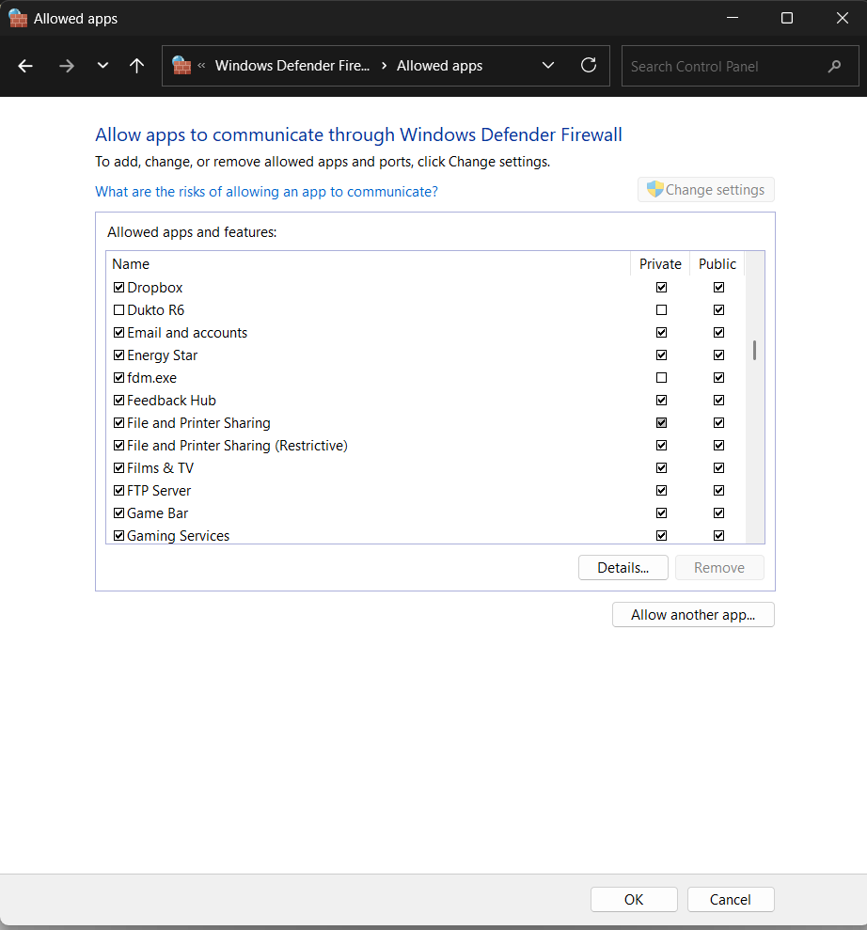

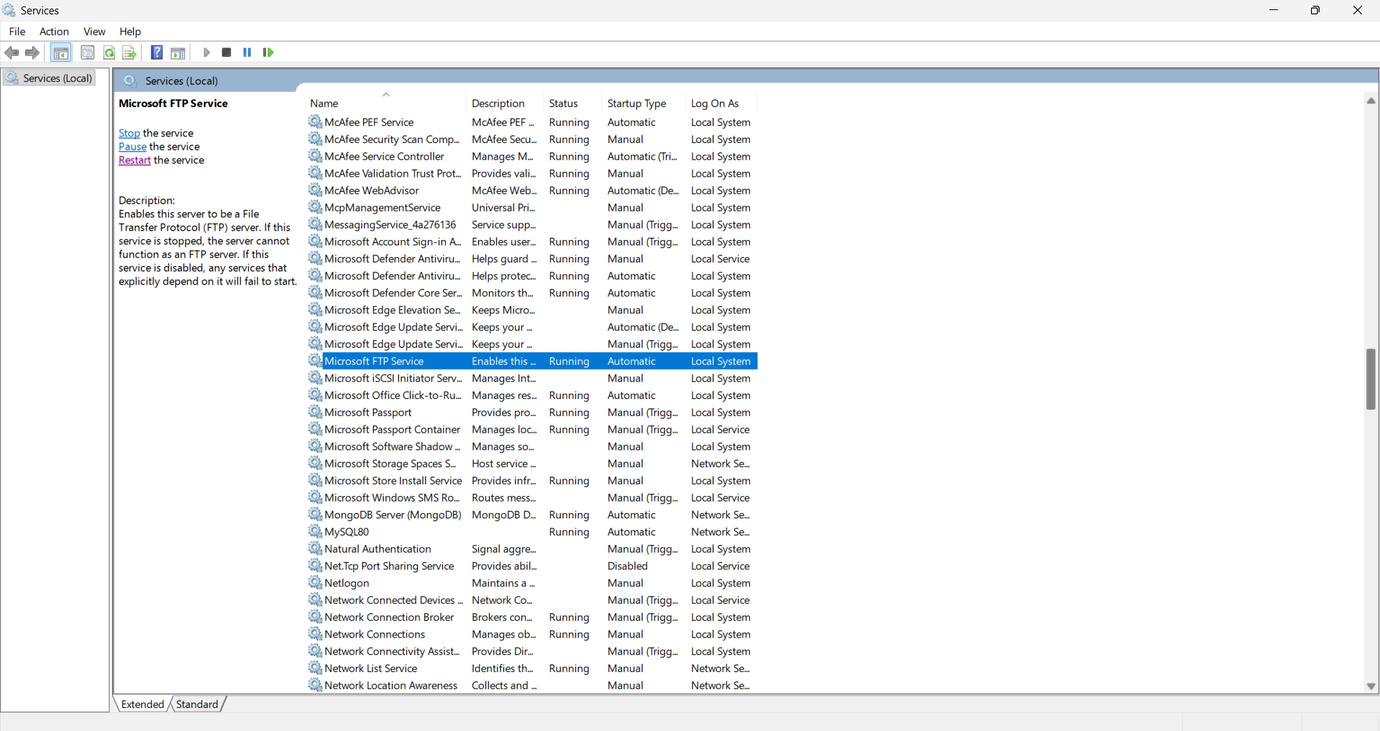

# Step 6: File and Directory Operations from Linux Mint

Demonstrates the creation of a new file and folder from the Linux Mint PC using FTP client commands.  
  
Description:These screenshots confirm that the Linux Mint PC is able to connect to the FTP server, create files, and organize directories. The changes are reflected in real-time on the Windows host

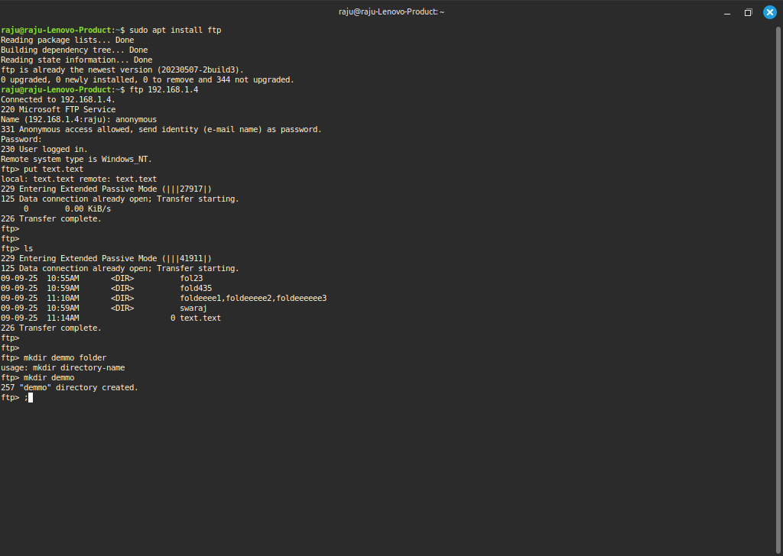

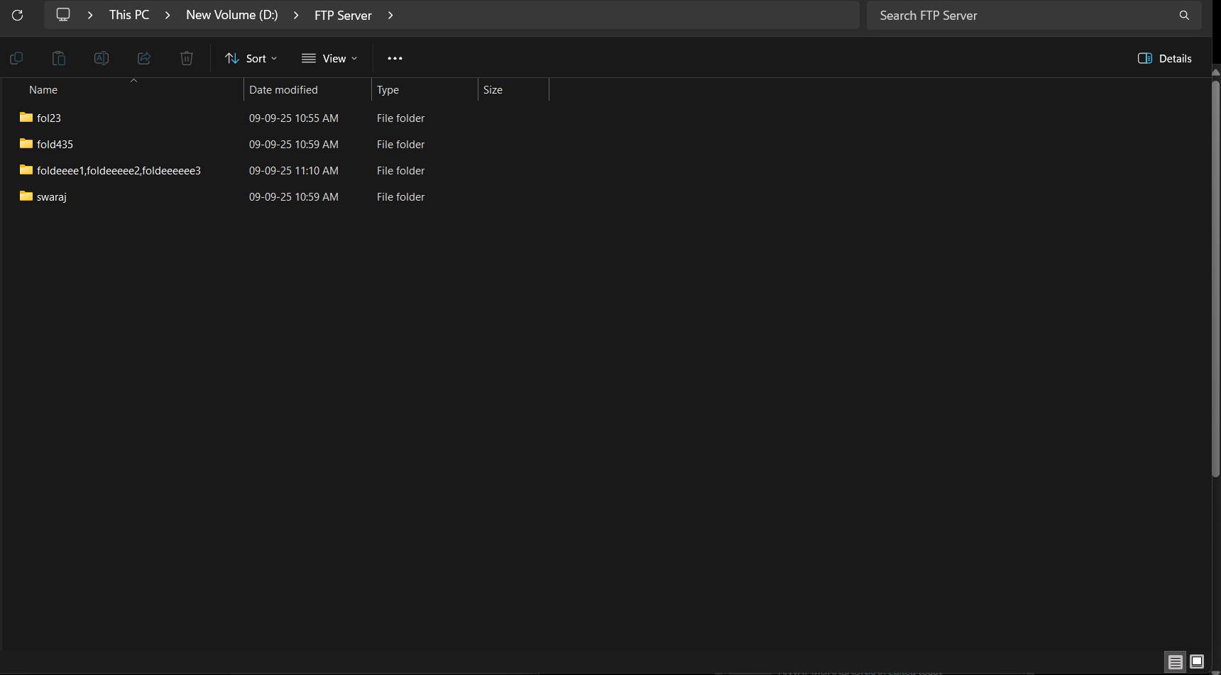

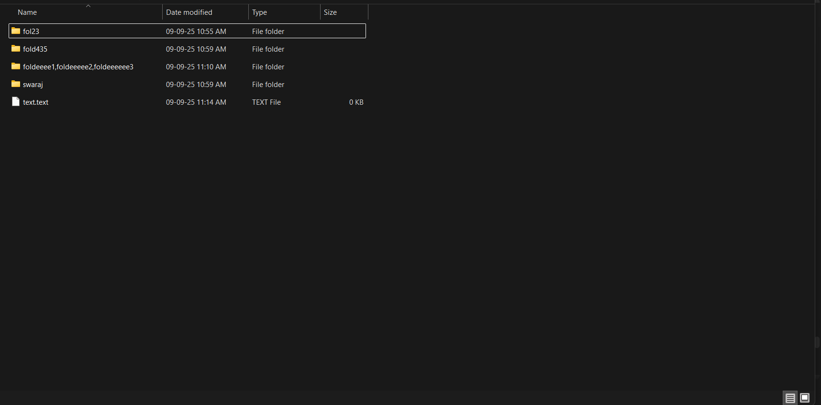

# Conclusion

This project successfully sets up an FTP server on a Windows laptop using IIS, assigns a static IP address, configures authentication, and opens firewall ports for external access. A Linux Mint PC accesses the server, creates files and directories, and confirms data exchange across the network.