# 14. Implementation of HTTP Server on AWS EC2 (Amazon Linux)

Name : Swaraj Pawar

Roll No : 382069

Div : B

## 1. Introduction

The purpose of this report is to explain the implementation of an HTTP server on an AWS EC2 instance running Amazon Linux. Hosting an HTTP server on EC2 allows users to serve web content, host applications, or test deployments in a cloud environment.

## 2. Objectives

- Deploy a reliable and lightweight HTTP server on an EC2 instance.  
- Understand the commands required for installation and configuration.  
- Enable HTTP traffic by configuring AWS Security Groups.  
- Ensure the server is persistent and secure.

## 3. Step-by-Step Implementation

### 3.1 Launch an EC2 Instance

1. Log in to the AWS Management Console.  
2. Navigate to EC2 and click 'Launch Instance'.  
3. Choose 'Amazon Linux 2 AMI'.  
4. Select instance type (e.g., t2.micro for free tier).  
5. Configure security group to allow inbound rules for HTTP (port 80) and SSH (port 22).  
6. Launch instance with a key pair (.pem file).

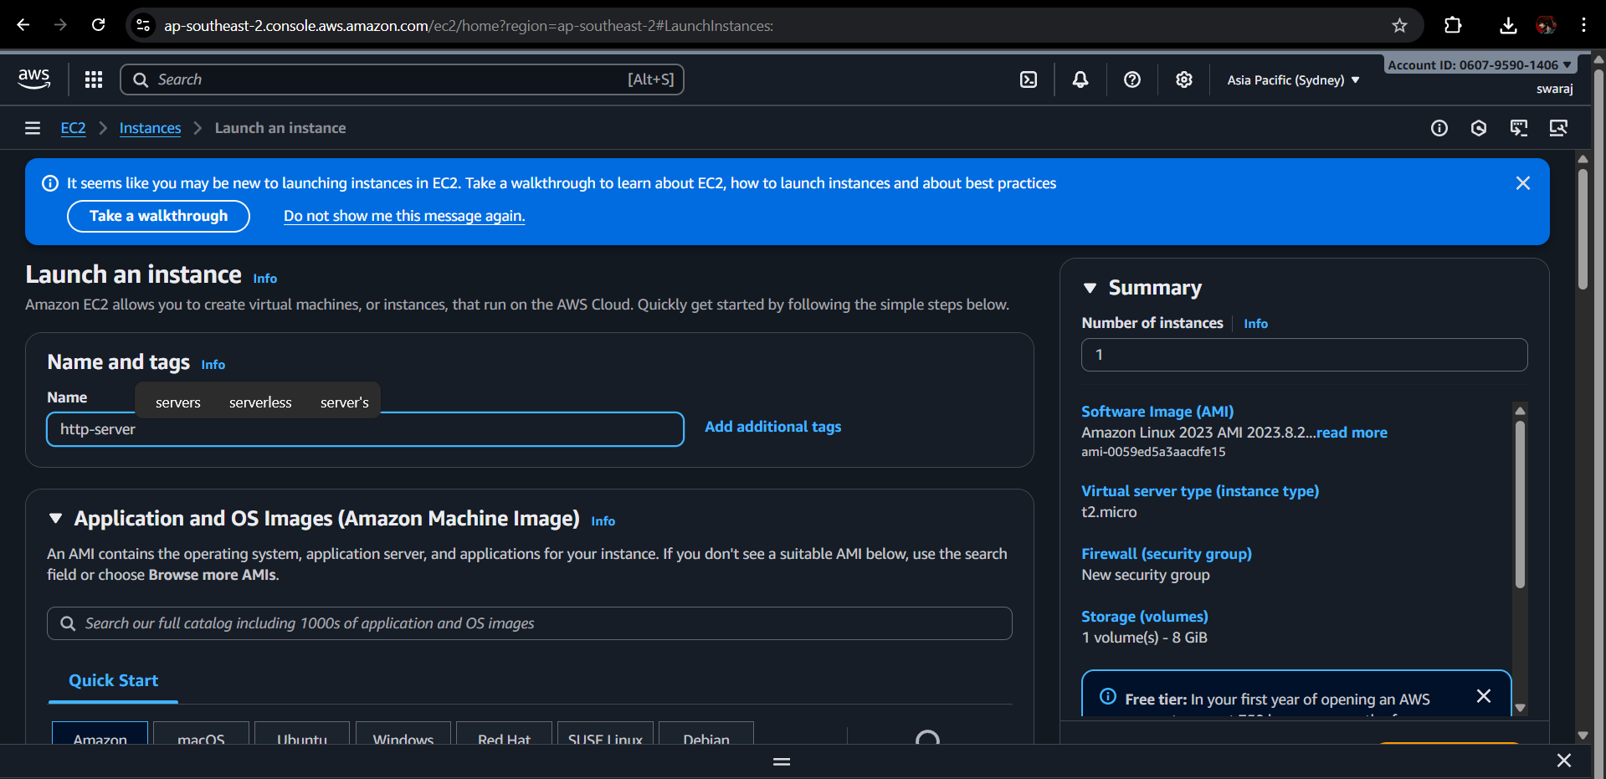

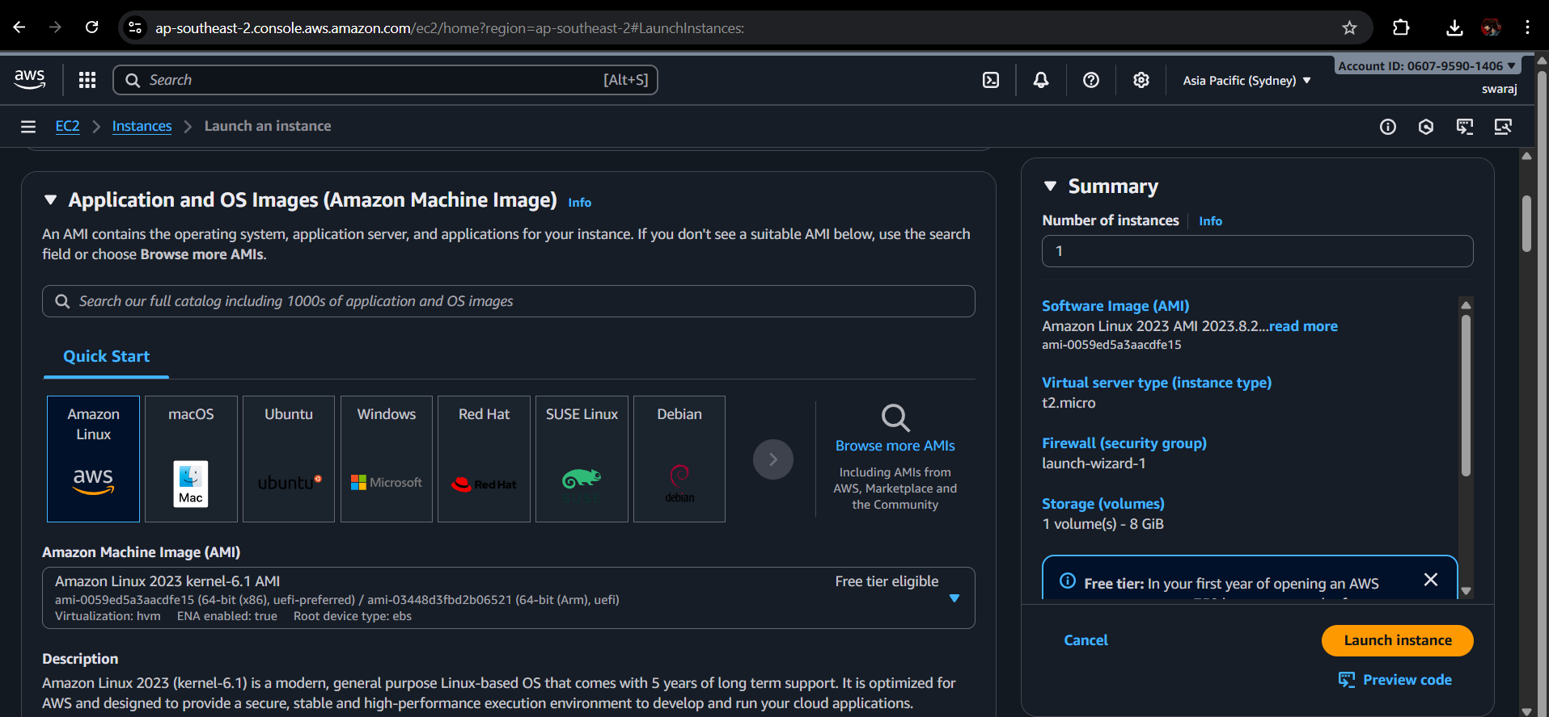

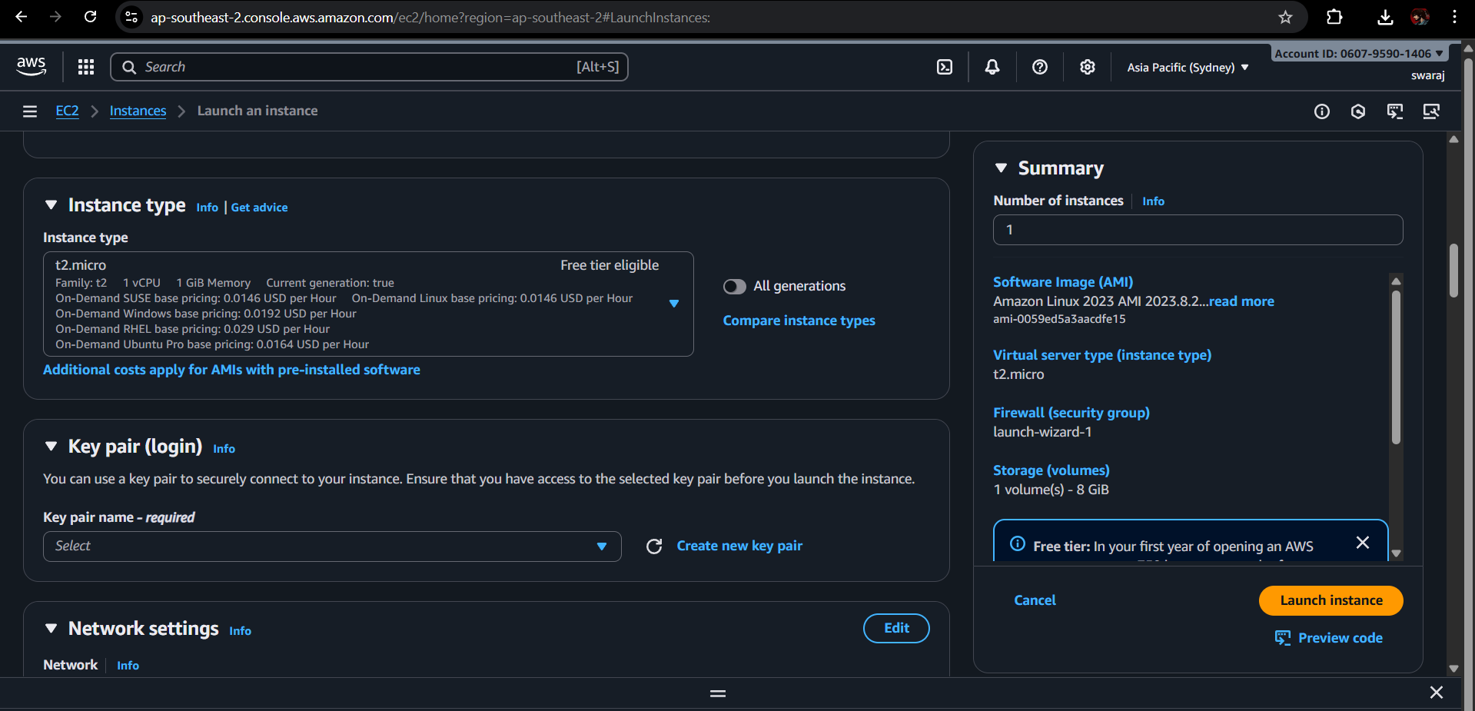

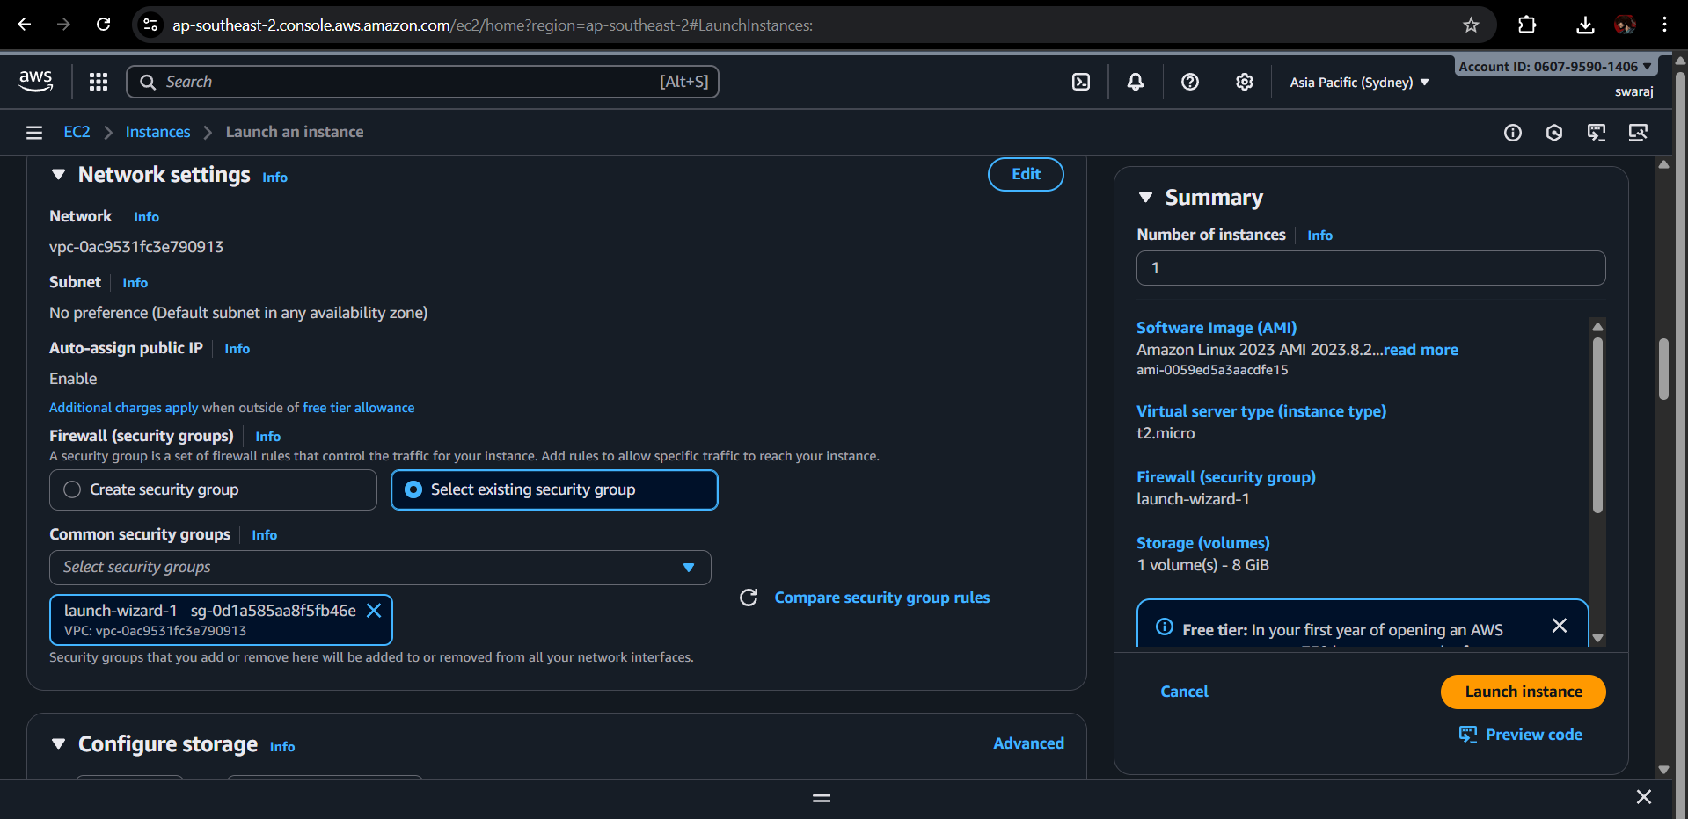

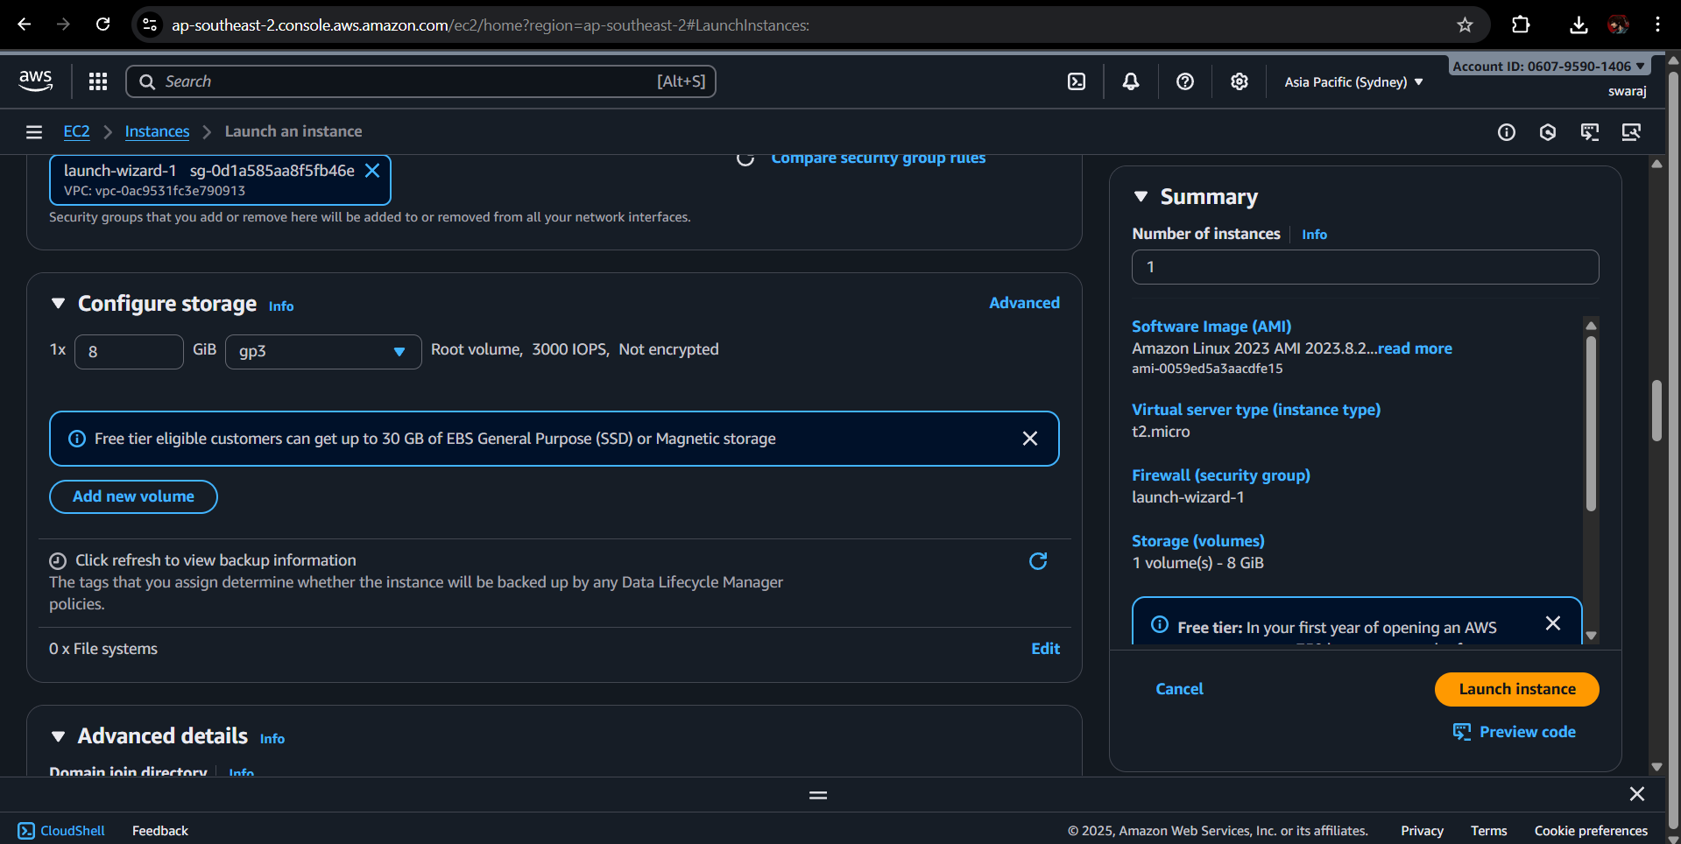

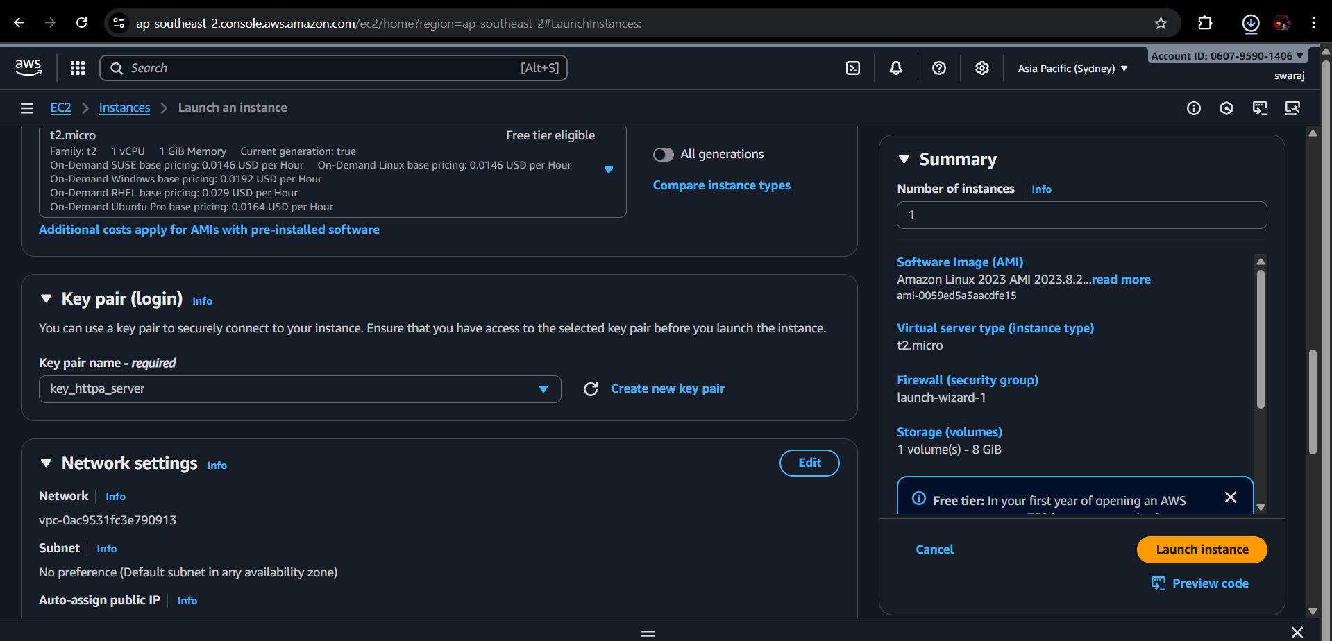

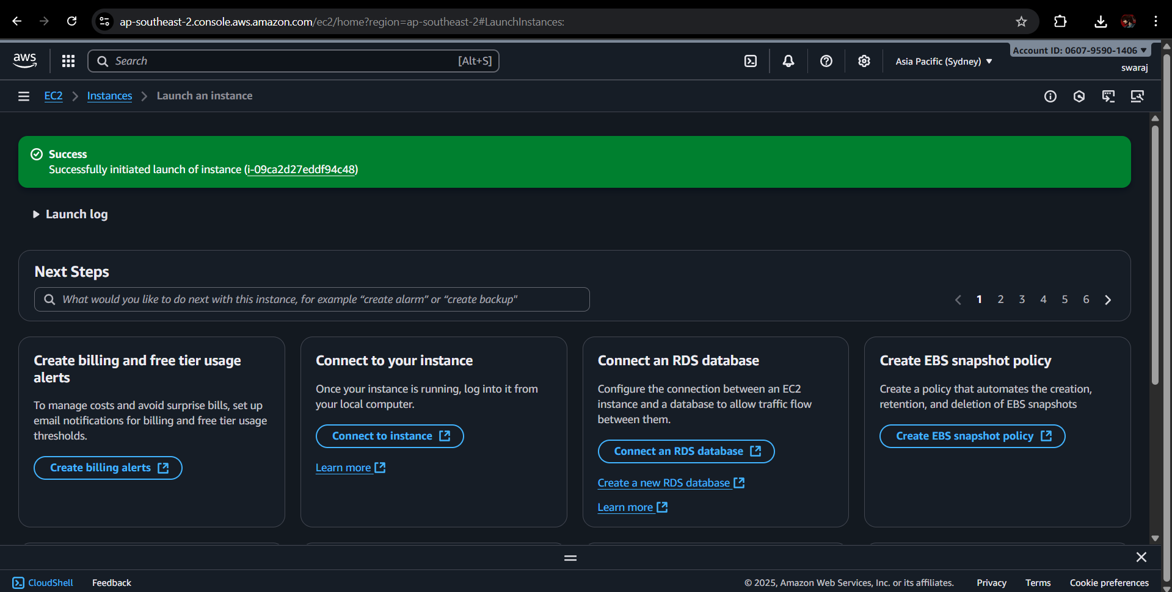

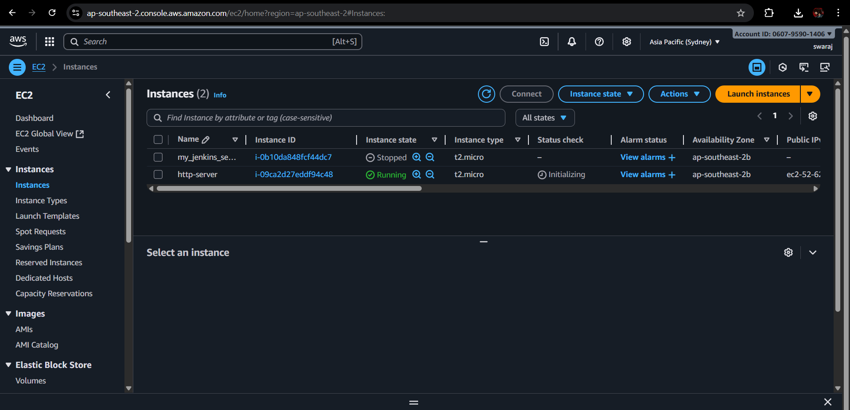

### 3.2 Connect to EC2 Instance

Use SSH to connect:  
  
ssh -i your-key.pem ec2-user@<EC2-Public-IP>

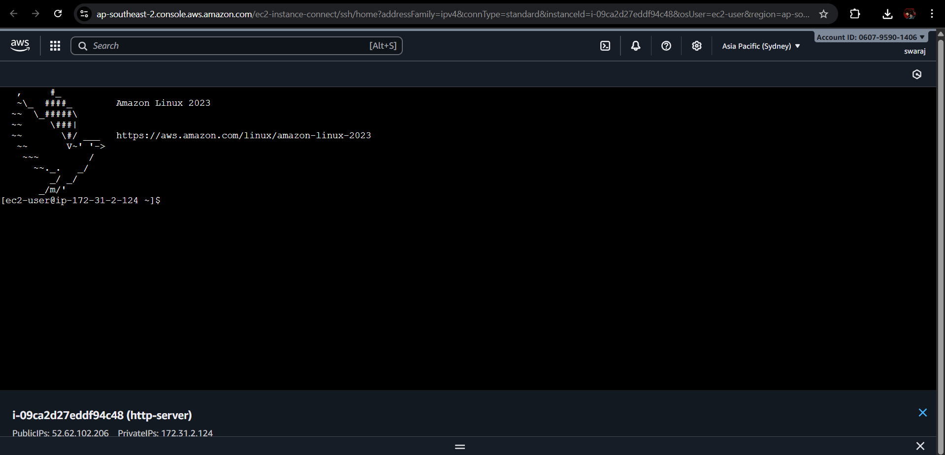

### 3.3 Update System Packages

Keeping the system updated ensures security patches and latest features:  
  
sudo yum update -y

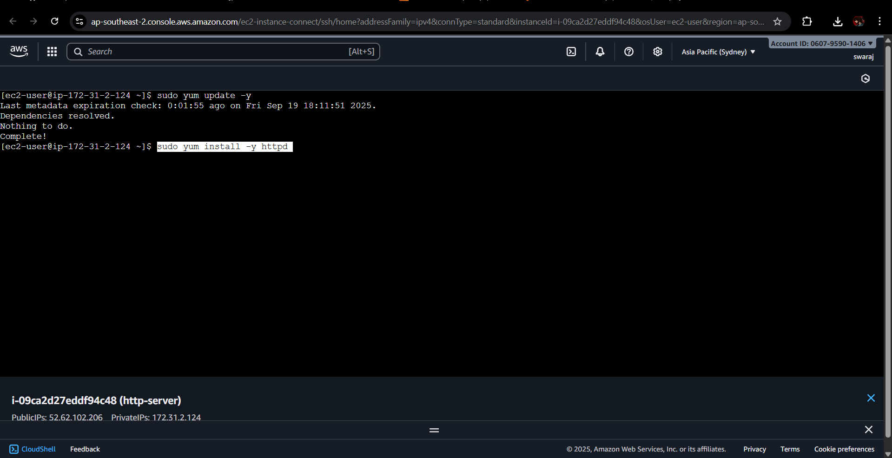

### 3.4 Install and Configure Apache HTTP Server

Apache is one of the most popular web servers. Installation and setup:  
  
sudo yum install -y httpd  
sudo systemctl start httpd  
sudo systemctl enable httpd  
systemctl status httpd

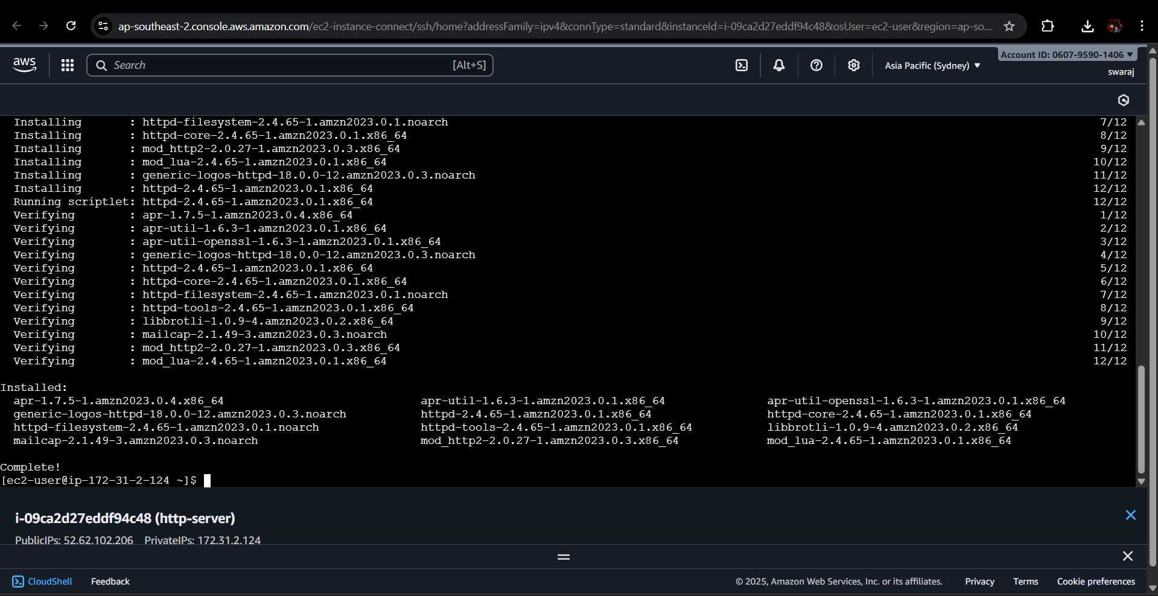

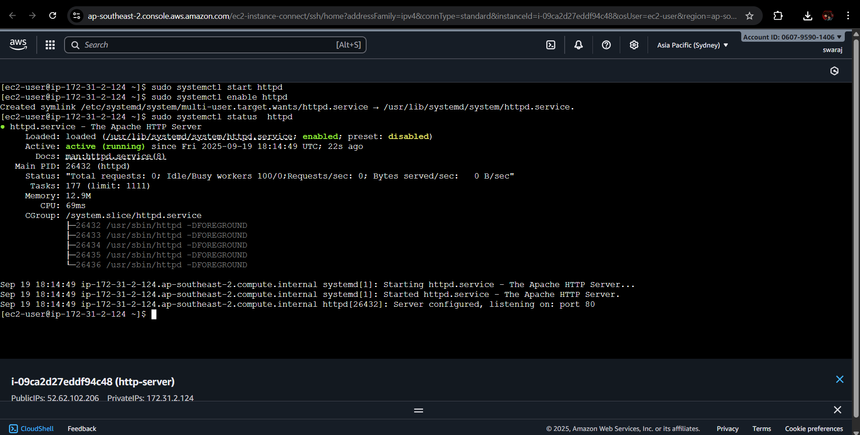

### 3.5 Install and Configure Nginx (Alternative)

If preferred, Nginx can be used as a lightweight alternative:  
  
sudo amazon-linux-extras enable nginx1  
sudo yum install -y nginx  
sudo systemctl start nginx  
sudo systemctl enable nginx  
systemctl status nginx

### 3.6 Configure Security Groups

Security Groups act as virtual firewalls for EC2. Ensure the following inbound rules:  
- Port 22 (SSH): For connecting to instance.  
- Port 80 (HTTP): For serving web content.  
- Port 443 (HTTPS): If SSL/TLS is required.  
  
This step is crucial, as without allowing port 80 traffic, the server will not be accessible.

### 3.7 Testing the HTTP Server

After installation and configuration, verify by opening in a browser:  
  
http://<EC2-Public-IP>  
  
You should see the default Apache or Nginx welcome page.



### 3.8 Hosting Custom Content

For Apache:  
cd /var/www/html  
echo 'Hello from Amazon Linux Apache Server!' | sudo tee index.html  
  
For Nginx:  
cd /usr/share/nginx/html  
echo 'Hello from Amazon Linux Nginx Server!' | sudo tee index.html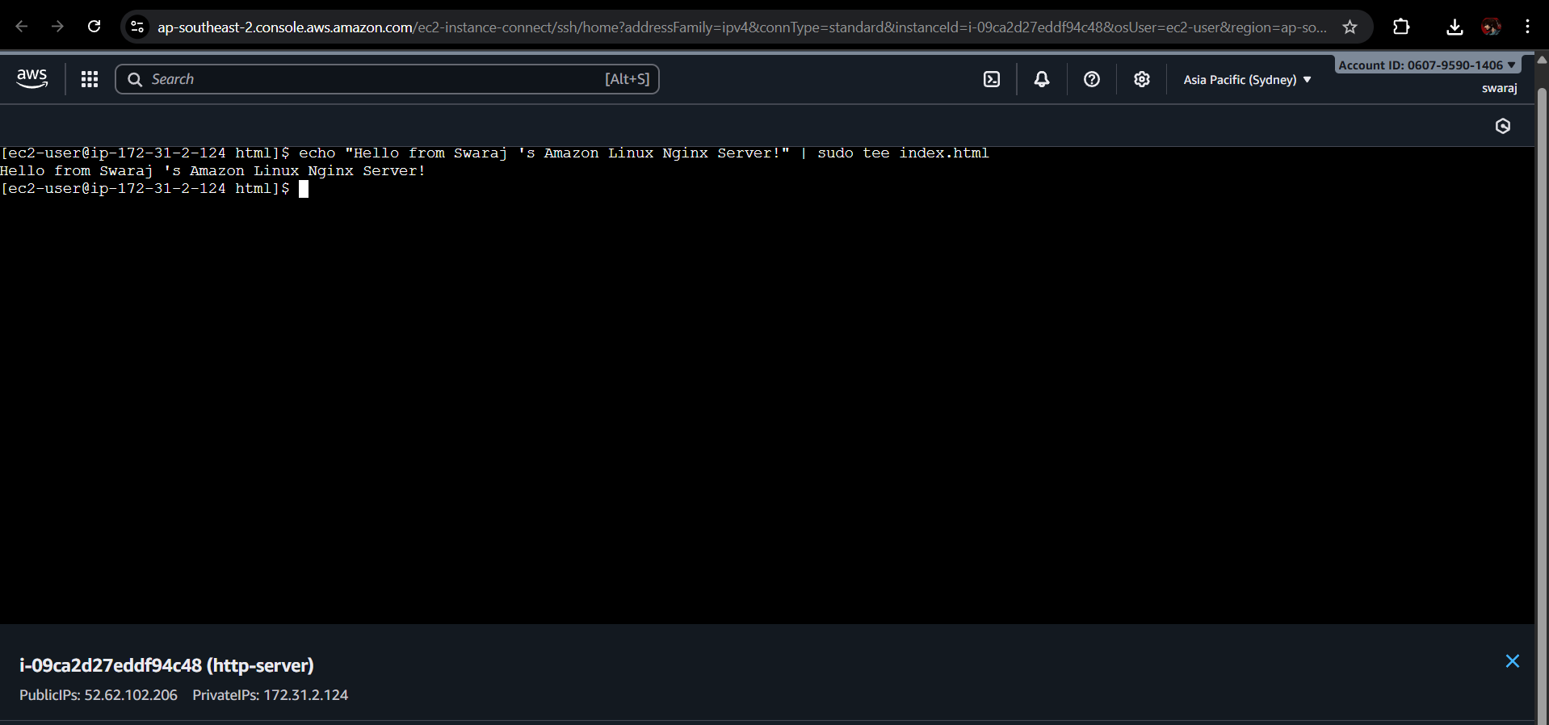

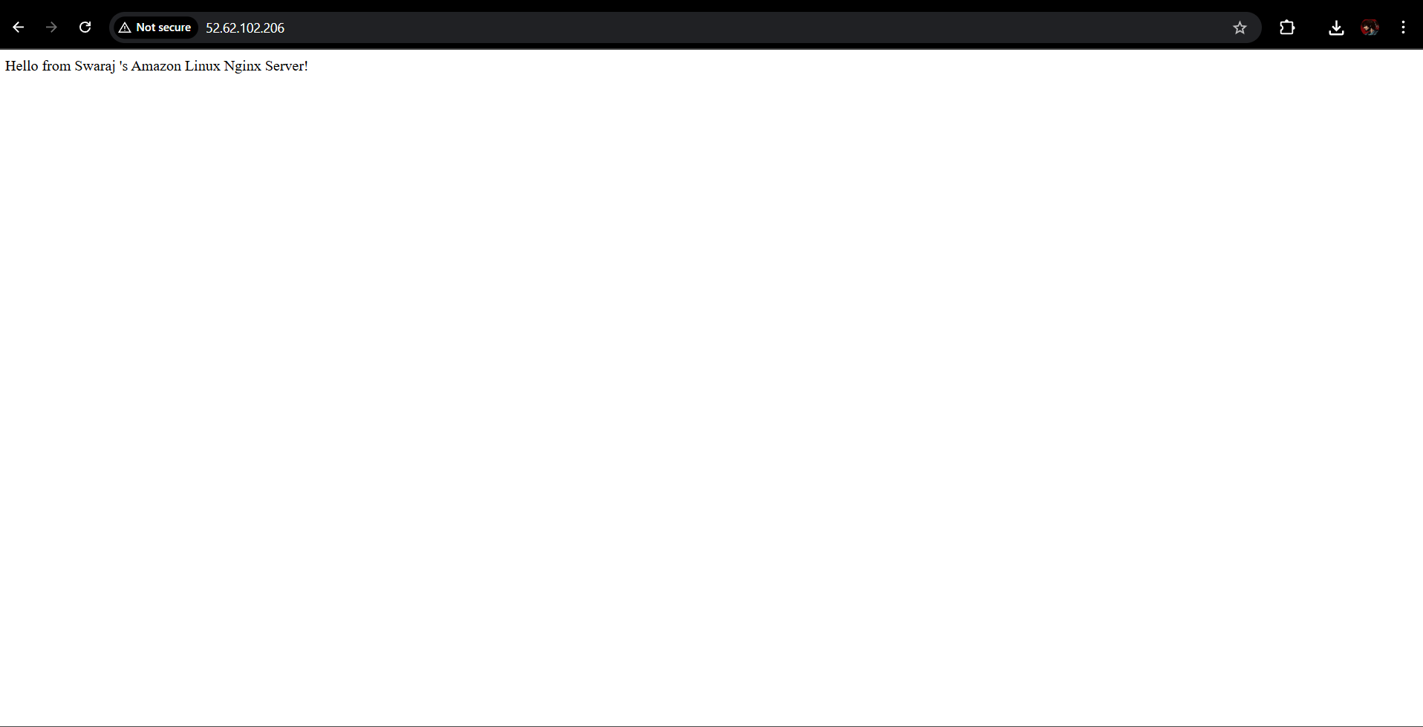

## 4. Key Considerations

- Always restrict SSH access (Port 22) to trusted IPs for security.  
- Enable HTTPS (port 443) if hosting a production website.  
- Regularly update the system for patches.  
- Use IAM roles and least privilege principles when managing EC2.  
- Monitor logs for unusual activity using CloudWatch.

## 5. Conclusion

Deploying an HTTP server on Amazon Linux EC2 is straightforward using Apache or Nginx. By carefully configuring system packages, services, and security groups, users can reliably host web applications on AWS infrastructure.