**Configuring a DHCP Server**

**1. Introduction**

The Dynamic Host Configuration Protocol (DHCP) is a network management protocol used to automate the process of configuring devices on IP networks. By assigning IP addresses and other network configuration parameters, DHCP enables devices to communicate on an IP network without manual configuration. This report outlines the steps to configure a DHCP server, as demonstrated in the provided video.

**2. Prerequisites**

Before proceeding with the DHCP server configuration, ensure the following:

* **Operating System**: The steps are demonstrated on a Windows Server environment.
* **Administrator Access**: Ensure you have administrative privileges on the server.
* **Network Configuration**: Verify that the server's network interfaces are correctly configured.
* **Server Role**: The DHCP Server role must be installed.

**3. Step-by-Step Configuration**

**3.1. Install the DHCP Server Role**

1. Open the **Server Manager**.
2. Navigate to **Manage** > **Add Roles and Features**.
3. In the **Add Roles and Features Wizard**, click **Next** until you reach the **Select Features** page.
4. Check **DHCP Server**, then click **Next** and complete the wizard.

**3.2. Authorize the DHCP Server**

1. Open the **DHCP Management Console**.
2. Right-click the server node and select **Authorize**.
3. Wait for the server to be authorized; this may take a few minutes.

**3.3. Configure DHCP Scopes**

1. In the DHCP Management Console, right-click **IPv4** and select **New Scope**.
2. Follow the wizard to define the scope:
   * **Scope Name**: Enter a descriptive name.
   * **IP Address Range**: Specify the start and end IP addresses.
   * **Subnet Mask**: Automatically populated based on the IP range.
   * **Exclusions**: Define any IP addresses to exclude from the DHCP range.
   * **Lease Duration**: Set the duration for which IP addresses are leased.
   * **Configure DHCP Options**: Set options like router (default gateway), DNS servers, and domain name.
3. Activate the scope to begin leasing IP addresses.

**3.4. Configure DHCP Reservations (Optional)**

1. In the DHCP Management Console, expand the server node and select **Reservations**.
2. Right-click **Reservations** and select **New Reservation**.
3. Enter the reservation details:
   * **Reservation Name**: Enter a descriptive name.
   * **IP Address**: Specify the IP address to reserve.
   * **MAC Address**: Enter the MAC address of the device.
   * **Description**: Optional field for additional information.
4. Click **Add** to create the reservation.

**3.5. Monitor and Manage DHCP Leases**

1. In the DHCP Management Console, select **Address Leases** under the appropriate scope.
2. Review the list of leased IP addresses, including client information and lease expiration times.
3. Right-click entries to **Delete** or **Renew** leases as necessary.

**4. Best Practices**

* **Regular Backups**: Periodically back up the DHCP database to prevent data loss.
* **Scope Planning**: Plan IP address ranges to avoid conflicts with static IP addresses.
* **Security**: Implement DHCP snooping on network switches to prevent unauthorized DHCP servers.
* **Monitoring**: Regularly monitor DHCP logs for unusual activity or errors.

**5. Conclusion**

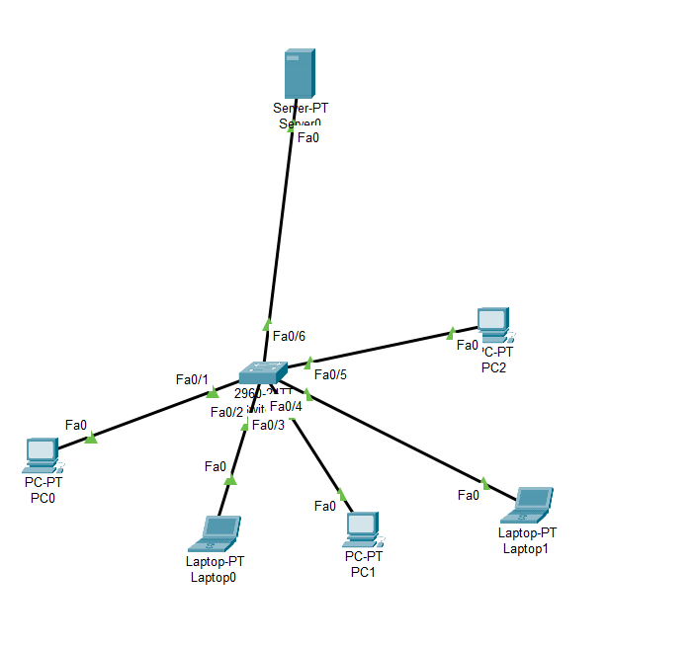Configuring a DHCP server automates IP address management, reducing administrative overhead and minimizing configuration errors. By following the steps outlined in this report, you can successfully set up and manage a DHCP server in a Windows Server environment.

**DHCP Server**