~~Aditya Kamble~~

~~Lab 9~~

~~Q 1. Perform the following tasks:~~

~~a. Create Student table with following attributes (STUDENT_ID , FIRST_NAME, LAST_NAME, PHONE_NUMBER, MARKS, COURSE_ID).~~

**~~CODE~~**

~~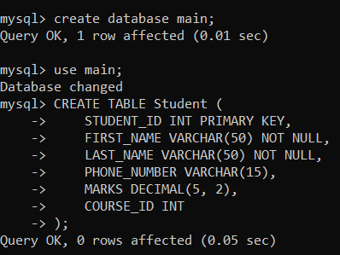~~

~~b. Create Course table with following attributes (COURSE_ID, COURSE_NAME).~~

**~~CODE~~**

~~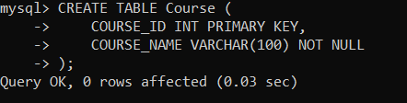~~

~~c. Write a SQL statement to insert 8 records with your own value into the tables.~~

**~~CODE~~**

~~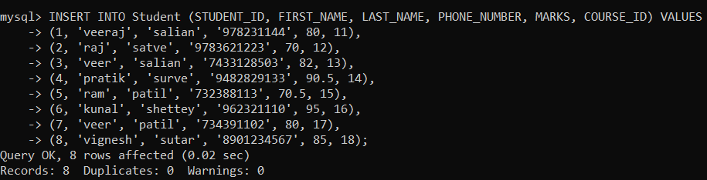~~

**~~OUTPUT~~**

~~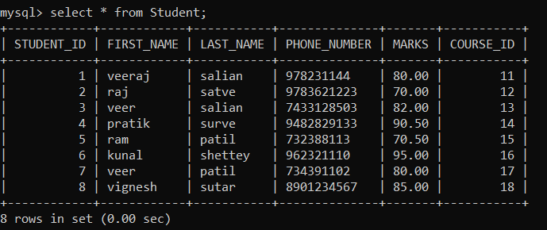~~

**~~CODE~~**

~~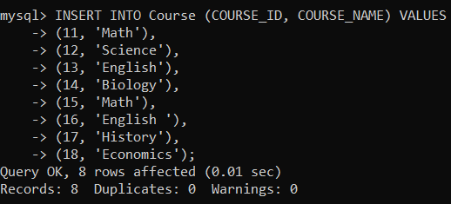~~

**~~OUTPUT~~**

~~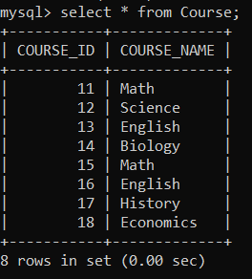~~

~~d. Write a query to get the number of students with the same course.~~

**~~CODE~~**

~~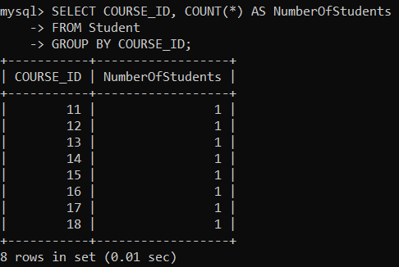~~

~~f. Write a query to get the student name, course name and marks of the students.~~

**~~CODE~~**

~~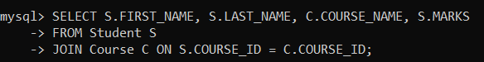~~

**~~OUTPUT~~**

~~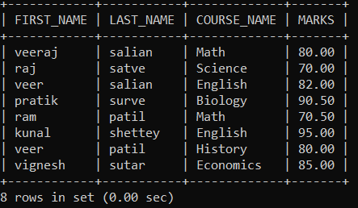~~

~~g. Write a query to get the Average marks of students course wise.~~

**~~CODE~~**

~~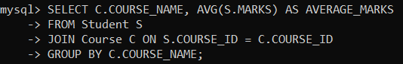~~

**~~OUTPUT~~**

~~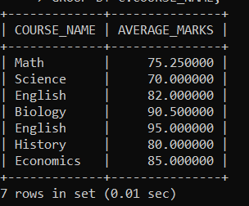~~

~~Q 2.  Create database for hospital management system & Perform the following tasks:~~

~~a. Create HEALTH CARE WORKERS table with following attributes (EMPLOYEE_ID , FIRST_NAME, LAST_NAME,EMAIL, PHONE_NUMBER, HIRE_DATE, SALARY, DESIGNATION).~~

**~~CODE~~**

~~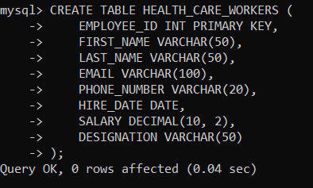~~

~~b. Create PATIENT table with following attributes (PATIENT_ID,NAME, PHONE_NUMBER).~~

**~~CODE~~**

~~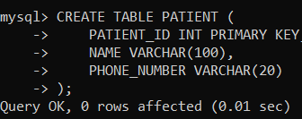~~

~~c. Write a SQL statement to insert 10 records with your own value into the tables.~~

**~~CODE~~**

~~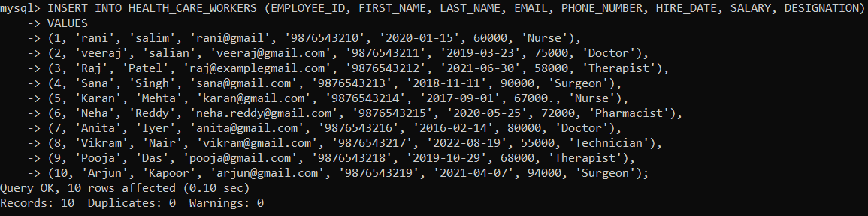~~

**~~OUTPUT~~**

~~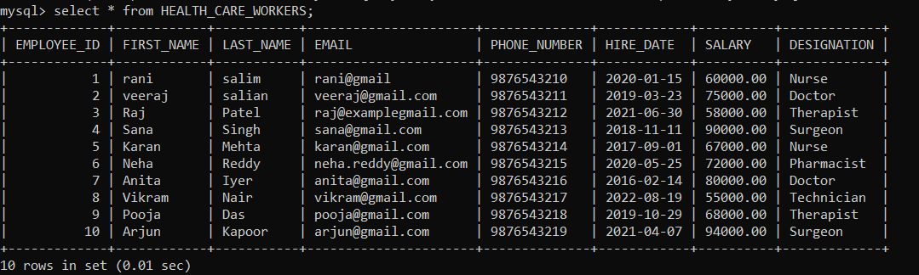~~

**~~CODE~~**

~~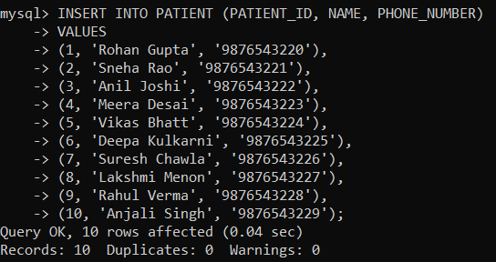~~

**~~OUTPUT~~**

~~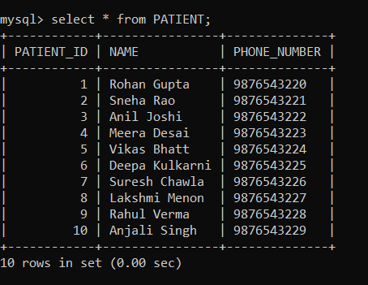~~

~~d.Write a query to get the names (first_name, last_name),Designation, salary.~~

**~~CODE~~**

~~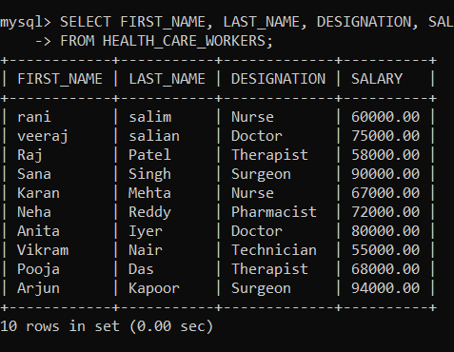~~

~~e. Write a query to get the number of employees with the same Designation~~

**~~CODE~~**

~~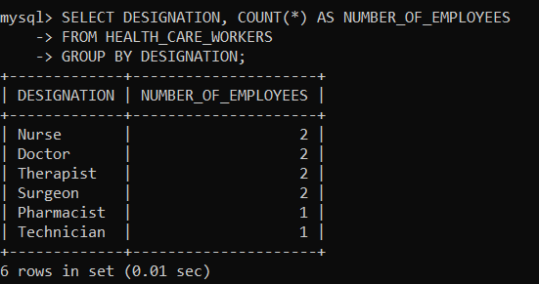~~

~~f.Write a query to get employee name who are getting salary more than 25000.~~

**~~CODE~~**

~~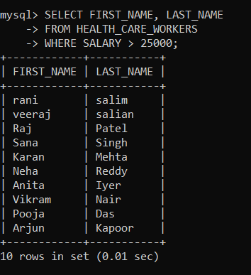~~

~~g. Fetch HEALTH CARE WORKERS name using their employee id.~~

**~~CODE~~**

~~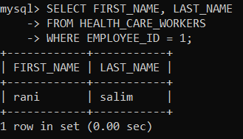~~

~~3.Consider two tables, customers and orders, with the following structures:~~

~~Customers Table: customer_id (Primary Key) first_name Last_name~~

~~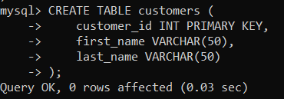~~

~~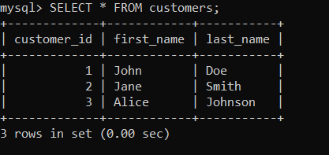~~

~~Orders Table: order_id (Primary Key) customer_id (Foreign Key) order_date Total_amount~~

**~~CODE~~**

~~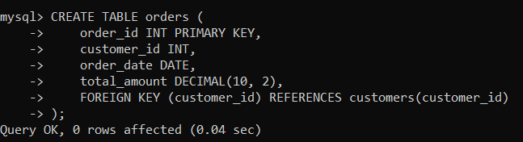~~

~~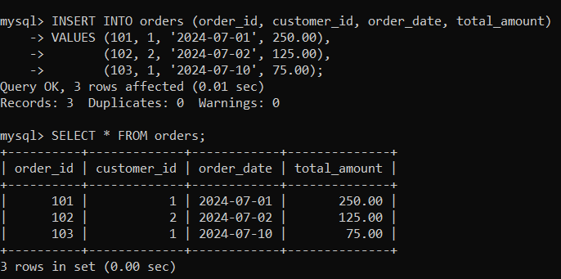~~

~~Write an SQL query to retrieve the first and last names of customers along with the order date and total amount of their orders.~~

~~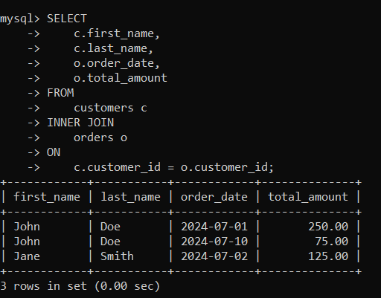~~

~~4.Consider two tables, departments and employees, with the following structures:~~

~~Departments Table: department_id (Primary Key) department_name~~

**~~CODE~~**

~~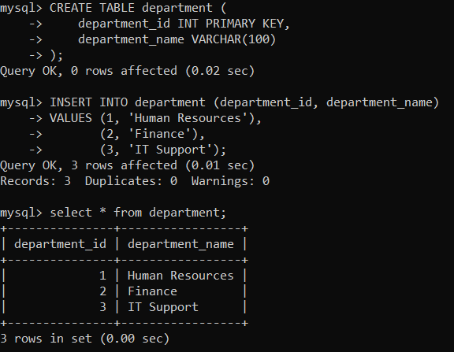~~

~~Employees Table: employee_id (Primary Key) first_name last_name department_id (Foreign Key)~~

**~~CODE~~**

~~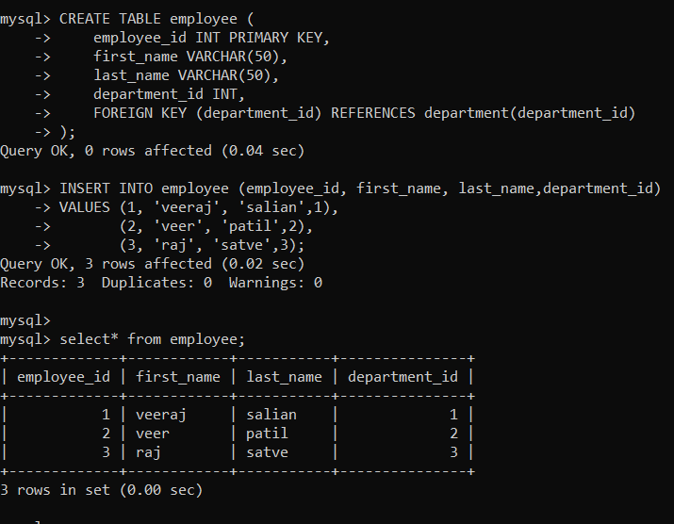~~

~~Write an SQL query to retrieve a list of all departments and the names of employees who belong to each department. Use a LEFT JOIN to include departments that have no employees.~~

**~~CODE~~**

~~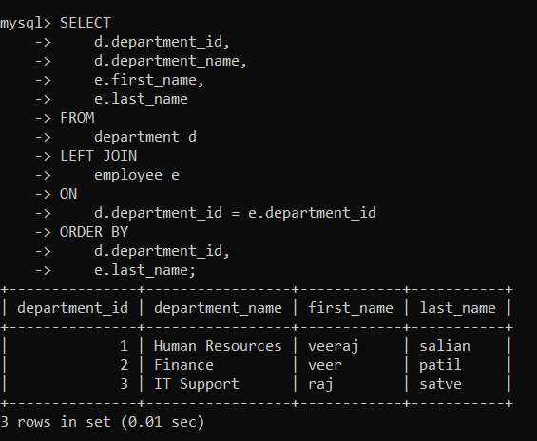~~

~~4. Write a program to show  JDBC connection with MYSQL and perform the following operations:~~

~~Create table Customer with following fields:~~

~~Custno, Custame,Custaddress,Phoneno, City, Pincode, Country~~

~~Insert 5 records in Customer table.~~

~~a.     Insert values~~

~~b.    Delete values~~

~~c.     update city name Shimla to Shilong.~~

~~d.    Show table in the console~~

**~~Insert values~~**

**~~CODE~~**

**~~package~~** ~~demo;~~

**~~import~~** ~~java.sql.*;~~

**~~public~~****~~class~~** ~~data {~~

**~~public~~****~~static~~****~~void~~** ~~main(String[] args)~~ **~~throws~~** ~~ClassNotFoundException,SQLException {~~

**~~try~~** ~~{~~

~~Class.~~*~~forName~~*~~("com.mysql.cj.jdbc.Driver");~~

~~Connection con = DriverManager.~~*~~getConnection~~*~~("jdbc:mysql://localhost:3306/student","root","1234");~~

~~Statement st = con.createStatement();~~

~~String createTableSQL = "CREATE TABLE Customers ("~~

~~+"Custno INT PRIMARY KEY, "~~

~~+"Custname VARCHAR(100), "~~

~~+ "Custaddress VARCHAR(255), "~~

~~+ "Phoneno VARCHAR(20), "~~

~~+ "City VARCHAR(50), "~~

~~+ "Pincode VARCHAR(10), "~~

~~+ "Country VARCHAR(50)"~~

~~+ ")";~~

~~st.executeUpdate(createTableSQL);~~

~~System.~~***~~out~~***~~.println("Table 'Customer' created successfully.");~~

~~String insertSQL = "INSERT INTO Customers (Custno, Custname, Custaddress, Phoneno, City, Pincode, Country) "~~

~~+ "VALUES (1, 'veeraj', '313 gharkul blg', '933929121', 'Shimla', '123456', 'India'), "~~

~~+ "(2, 'raj', '113 mahda blg', '922838272', 'Delhi', '654321', 'India'), "~~

~~+ "(3, 'veer', '789 jagasmuthi blg', '92210321232', 'Mumbai', '112233', 'India'), "~~

~~+ "(4, 'ram', '101 Maple blg', '7023451188', 'Shimla', '445566', 'India'), "~~

~~+ "(5, 'abhi', '202 hendre blg', '932321102', 'Bangalore', '778899', 'India')";~~

~~st.executeUpdate(insertSQL);~~

~~System.~~***~~out~~***~~.println("5 records inserted into 'Customer' table.");~~

~~}~~**~~catch~~** ~~(Exception e) {~~

~~System.~~***~~out~~***~~.println(e);~~

~~}~~

~~}~~

~~}~~

**~~OUTPUT~~**

~~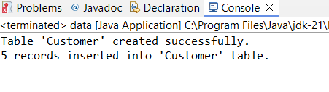~~

~~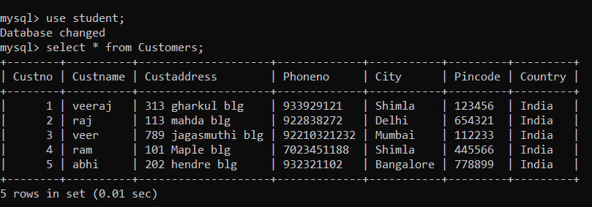~~

**~~update city name Shimla to Shilong~~**

**~~CODE~~**

**~~package~~** ~~demo;~~

**~~import~~** ~~java.sql.*;~~

**~~public~~****~~class~~** ~~update {~~

**~~public~~****~~static~~****~~void~~** ~~main(String[] args) {~~

**~~try~~** ~~{~~

~~String city1 = "shilong";~~

~~Class.~~*~~forName~~*~~("com.mysql.cj.jdbc.Driver");~~

~~Connection con = DriverManager.~~*~~getConnection~~*~~("jdbc:mysql://localhost:3306/student","root","1234");~~

~~PreparedStatement ps = con.prepareStatement("update Customers set City =?");~~

~~ps.setString(1, city1);~~

**~~int~~** ~~count = ps.executeUpdate();~~

**~~if~~**~~(count > 0)~~

~~{~~

~~System.~~***~~out~~***~~.println("updated");~~

~~}~~

**~~else~~**

~~{~~

~~System.~~***~~out~~***~~.println("failed");~~

~~}~~

~~}~~**~~catch~~** ~~(Exception e) {~~

~~System.~~***~~out~~***~~.println(e);~~

~~}~~

~~}~~

~~}~~

**~~OUTPUT~~**

~~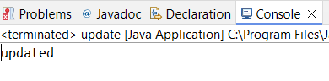~~

~~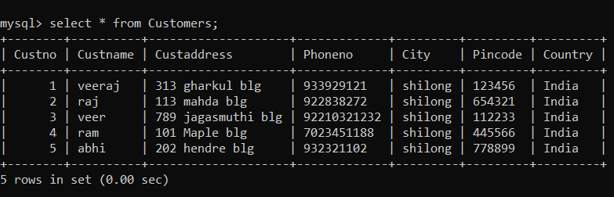~~

**~~Delete values~~**

**~~CODE~~**

**~~package~~** ~~demo;~~

**~~import~~** ~~java.sql.Connection;~~

**~~import~~** ~~java.sql.DriverManager;~~

**~~import~~** ~~java.sql.PreparedStatement;~~

**~~public~~****~~class~~** ~~delete {~~

**~~public~~****~~static~~****~~void~~** ~~main(String[] args)~~ **~~throws~~** ~~Exception {~~

~~String custname1 = "abhi";~~

~~Class.~~*~~forName~~*~~("com.mysql.cj.jdbc.Driver");~~

~~Connection con = DriverManager.~~*~~getConnection~~*~~("jdbc:mysql://localhost:3306/student","root","1234");~~

~~PreparedStatement ps = con.prepareStatement("delete from Customers where Custname =?");~~

~~ps.setString(1, custname1);~~

**~~int~~** ~~count = ps.executeUpdate();~~

**~~if~~**~~(count > 0)~~

~~{~~

~~System.~~***~~out~~***~~.println("deleted");~~

~~}~~

**~~else~~**

~~{~~

~~System.~~***~~out~~***~~.println("failed");~~

~~}~~

~~}}~~

**~~OUTPUT~~**

~~