Lab 8

Aditya kamble

(1)Write a program that tries to access an element outside the bounds of an array and handles the ArrayIndexOutOfBoundsException by printing a user-friendly message.

**-**

**package** raju;

**public** **class** TrycatchFinallyExample {

**public** **static** **void** main(String[] args) {

// **TODO** Auto-generated method stub

**try** {

**int**[] numbers= {1,2,3};

System.***out***.println("Trying to access element at index 3:"+ numbers[3]);

}**catch**(ArrayIndexOutOfBoundsException e) {

System.***out***.println("Error:Index is out of Bounds!");

}**finally** {

System.***out***.println("Execution completed.");

}

}

}

Output-

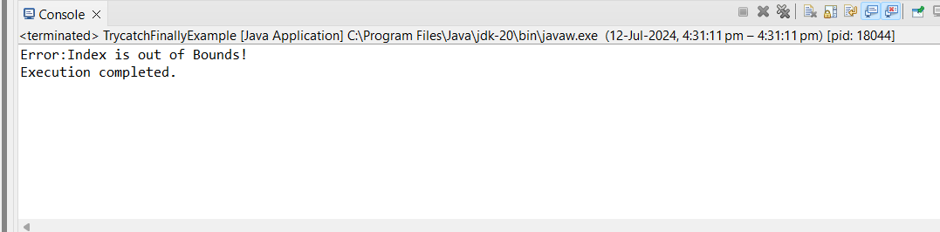

(2) Write a program that attempts to divide a number by zero and handles the ArithmeticException by printing a message that division by zero is not allowed.

-

**Package** raju;

**public** **class** DivideByZero {

**public** **static** **void** main(String[] args) {

**int** numerator=5;

**int** denominator=0;

**try** {

**int** result=numerator/denominator;

}**catch**(ArithmeticException e) {

System.***out***.println("Error:Division by zero is not allowed.");

}

System.***out***.println("Program continues to execute after handlind the exception.");

}

}

-

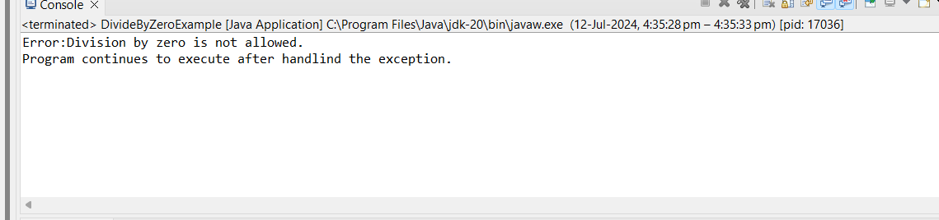

(3). Write a Java program that reads an integer input from the user and throws an IllegalArgumentException if the input is negative. Display an appropriate message when the exception is caught.

**-**

**package** raju;

**import** java.util.Scanner;

**import** java.util.Scanner.*;

**public** **class** IllegalArrguementdemo {

**public** **static** **void** main(String[] args) {

// **TODO** Auto-generated method stub

Scanner scanner=**new** Scanner(System.***in***);

System.***out***.println("Enter an integer");

**int** number=scanner.nextInt();

**try** {

*checkIfNegative*(number);

System.***out***.println("no exception thrown.number is positive or zero.");

}**catch**(IllegalAccessException e) {

System.***out***.println("illegalarguementException caught:"+e.getMessage());

}

}

**private** **static** **void** checkIfNegative(**int** number) **throws** IllegalAccessException {

**if**(number<0) {

**throw** **new** IllegalAccessException("Input cannot be negative.");

}

}

}

Output:

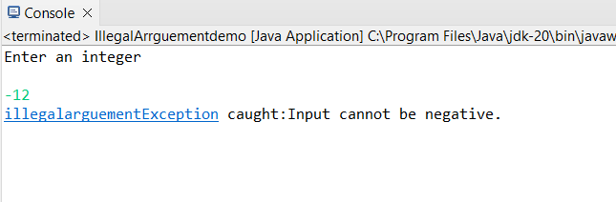

4. Define a custom exception called InvalidAgeException. Write a Java program that throws this exception if the age provided is less than 18. Handle the exception and display an appropriate message.

-

**package** raju;

**import** java.lang.Exception;

**public** **class** UserAgeValidationException **extends** Exception {

**public** UserAgeValidationException(String s) {

// **TODO** Auto-generated constructor stub

**super**(s);//constructor parent class

}

}

---------------------------------------------------------------------------------

**package** raju;

**import** java.lang.Exception;

**public** **class** UserAgeDemo {

**static** **void** checkage(**int** n) **throws** UserAgeValidationException{

**if**(n>18) {

**throw** **new** UserAgeValidationException("Allow the User...");

}

**else**

{

**throw** **new** UserAgeValidationException("User not allowed ..");

}

}

**public** **static** **void** main(String[] args) {

**try** {

*checkage*(17);

}

**catch**( UserAgeValidationException ab) {

System.***out***.println(ab.getMessage());

}

}

}

-

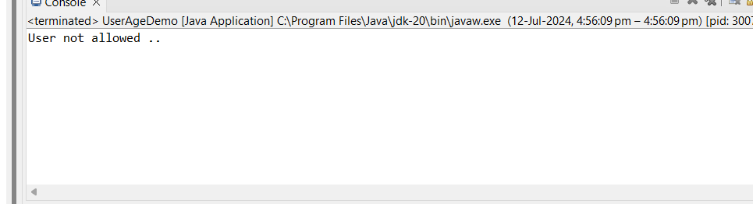

5 Write a Java program that has a method to validate a user's email address. The method should throw a custom exception InvalidEmailException if the email does not contain @ and .. Handle the exception in the main method.

Code:

**package** raju;

**class** InvalidEmailException **extends** Exception{

**public** InvalidEmailException(String message) {

**super**(message);

}

}

**public** **class** EmailValidation {

**public** **static** **void** main(String[] args) {

String email1="john.doe@example.com";

String email2="invalid.email.example.com";

**try**{

*validateEmail*(email1);

System.***out***.println("is avalid email address."+email1);

}**catch**(InvalidEmailException e) {

System.***out***.println("InvalidEmailException caught:"+e.getMessage());

}

**try** {

*validateEmail*(email2);

System.***out***.println(email2 + " is a valid email address.");

} **catch** (InvalidEmailException e) {

System.***out***.println("InvalidEmailException caught: " + e.getMessage());

}

}

**private** **static** **void** validateEmail(String email1) **throws** InvalidEmailException {

**if** (!email1.contains("@") || !email1.contains(".")) {

// **TODO** Auto-generated method stub

**throw** **new** InvalidEmailException("email must contain '@'and '.'characters.");

}

}}

Output:

