**9th Feb 2022**

**ExternalStorageApp**

**Aim: Demonstrate use of SD Card**

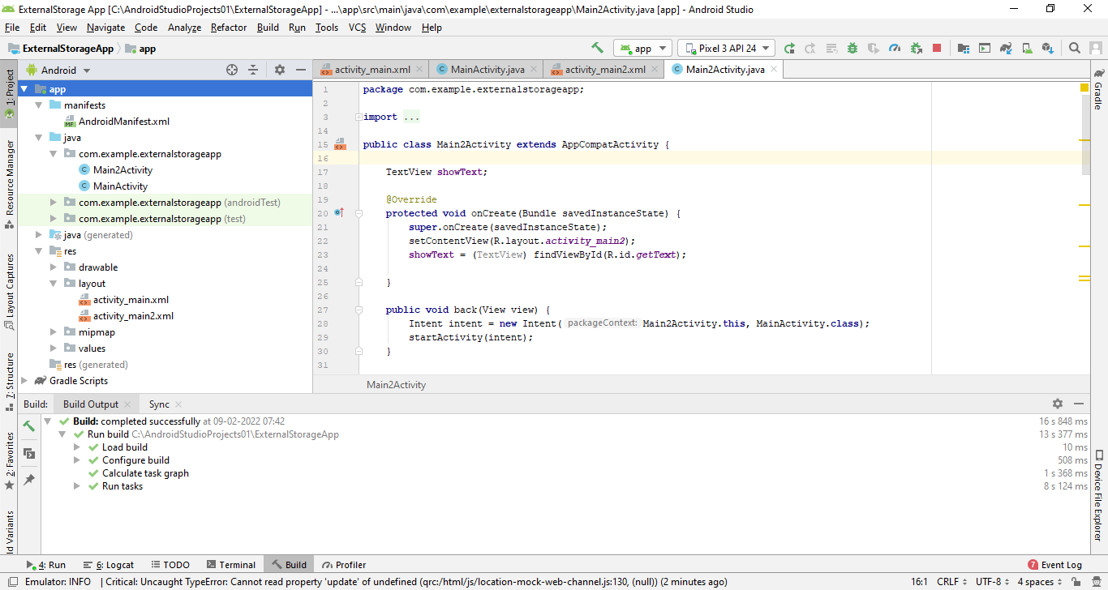

*<?***xml version="1.0" encoding="utf-8"***?>*<**manifest xmlns:android="http://schemas.android.com/apk/res/android"  
 package="com.example.externalstorageapp"**>  
  
 <**uses-permission android:name="android.permission.WRITE_EXTERNAL_STORAGE"** />  
 <**uses-permission android:name="android.permission.READ_EXTERNAL_STORAGE"** />  
  
 <**application  
 android:allowBackup="true"  
 android:icon="@mipmap/ic_launcher"  
 android:label="@string/app_name"  
 android:roundIcon="@mipmap/ic_launcher_round"  
 android:supportsRtl="true"  
 android:theme="@style/AppTheme"**>  
 <**activity android:name=".Main2Activity"**></**activity**>  
 <**activity android:name=".MainActivity"**>  
 <**intent-filter**>  
 <**action android:name="android.intent.action.MAIN"** />  
  
 <**category android:name="android.intent.category.LAUNCHER"** />  
 </**intent-filter**>  
 </**activity**>  
 </**application**>  
  
</**manifest**>

**activity_main.xml**

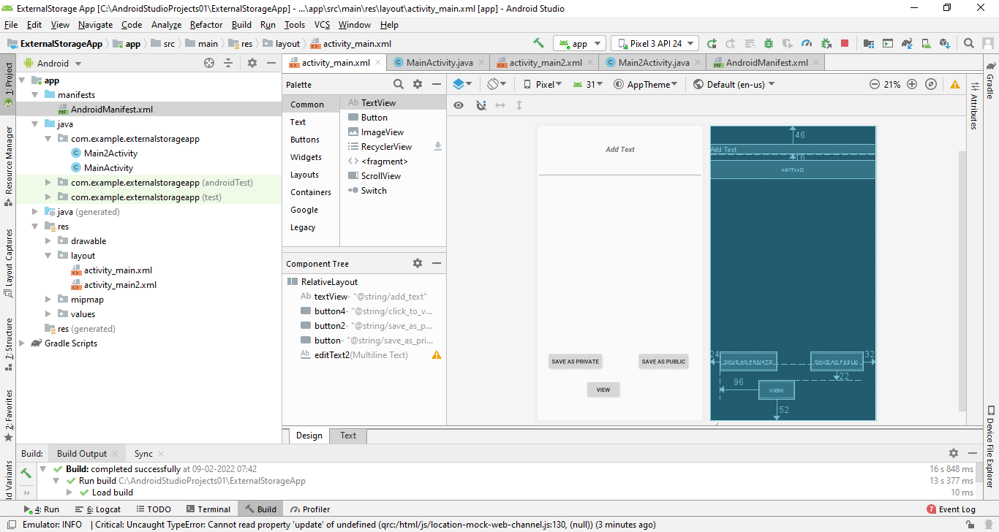

*<?***xml version="1.0" encoding="utf-8"***?>*<**RelativeLayout xmlns:android="http://schemas.android.com/apk/res/android"  
 xmlns:app="http://schemas.android.com/apk/res-auto"  
 xmlns:tools="http://schemas.android.com/tools"  
 android:layout_width="match_parent"  
 android:layout_height="match_parent"  
 tools:context=".MainActivity"**>  
  
 <**TextView  
 android:id="@+id/textView"  
 android:layout_width="match_parent"  
 android:layout_height="wrap_content"  
 android:layout_alignParentTop="true"  
 android:layout_marginTop="46dp"  
 android:gravity="center"  
 android:text="@string/add_text"  
 android:textSize="18sp"  
 android:textStyle="bold|italic"** />  
  
  
 <**Button  
 android:id="@+id/button4"  
 android:layout_width="wrap_content"  
 android:layout_height="wrap_content"  
 android:layout_alignLeft="@+id/button"  
 android:layout_alignParentBottom="true"  
 android:layout_alignStart="@+id/button"  
 android:layout_marginBottom="52dp"  
 android:layout_marginLeft="96dp"  
 android:layout_marginStart="96dp"  
 android:onClick="next"  
 android:text="@string/click_to_view"** />  
  
 <**Button  
 android:id="@+id/button2"  
 android:layout_width="wrap_content"  
 android:layout_height="wrap_content"  
 android:layout_above="@+id/button4"  
 android:layout_alignParentEnd="true"  
 android:layout_alignParentRight="true"  
 android:layout_marginBottom="22dp"  
 android:layout_marginEnd="32dp"  
 android:layout_marginRight="32dp"  
 android:onClick="savePublic"  
 android:text="@string/save_as_public"** />  
  
 <**Button  
 android:id="@+id/button"  
 android:layout_width="wrap_content"  
 android:layout_height="wrap_content"  
 android:layout_alignBaseline="@+id/button2"  
 android:layout_alignBottom="@+id/button2"  
 android:layout_alignParentLeft="true"  
 android:layout_alignParentStart="true"  
 android:layout_marginLeft="24dp"  
 android:layout_marginStart="24dp"  
 android:onClick="savePrivate"  
 android:text="@string/save_as_private"** />  
  
 <**EditText  
 android:id="@+id/editText2"  
 android:layout_width="match_parent"  
 android:layout_height="wrap_content"  
 android:layout_alignParentLeft="true"  
 android:layout_alignParentStart="true"  
 android:layout_below="@+id/textView"  
 android:layout_marginTop="16dp"  
 android:ems="10"  
 android:gravity="center_vertical|center"  
 android:inputType="textMultiLine"** />  
  
</**RelativeLayout**>

**activity2_main.xml**

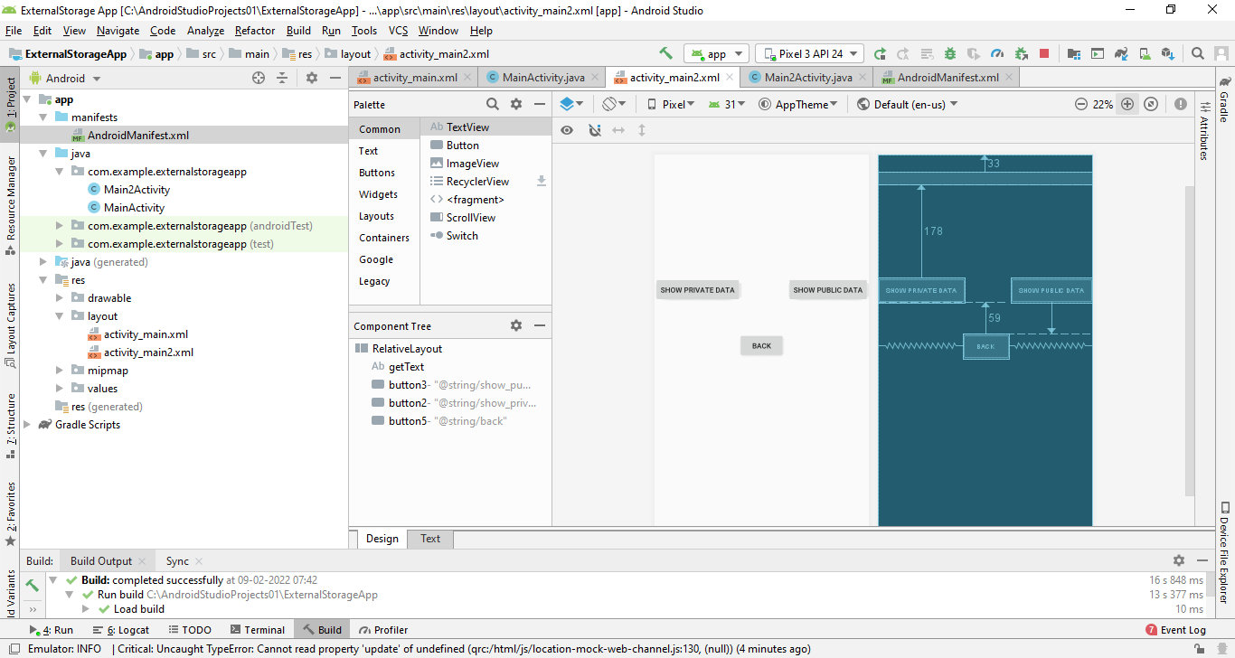

*<?***xml version="1.0" encoding="utf-8"***?>*<**RelativeLayout xmlns:android="http://schemas.android.com/apk/res/android"  
 xmlns:app="http://schemas.android.com/apk/res-auto"  
 xmlns:tools="http://schemas.android.com/tools"  
 android:layout_width="match_parent"  
 android:layout_height="match_parent"  
 tools:context=".Main2Activity"**>  
  
 <**TextView  
 android:id="@+id/getText"  
 android:layout_width="match_parent"  
 android:layout_height="wrap_content"  
 android:layout_alignParentLeft="true"  
 android:layout_alignParentStart="true"  
 android:layout_alignParentTop="true"  
 android:layout_marginTop="33dp"  
 android:gravity="center"  
 android:text=""  
 android:textSize="18sp"  
 android:textStyle="bold|italic"** />  
  
 <**Button  
 android:id="@+id/button3"  
 android:layout_width="wrap_content"  
 android:layout_height="wrap_content"  
 android:layout_above="@+id/button5"  
 android:layout_alignParentEnd="true"  
 android:layout_alignParentRight="true"  
 android:onClick="getPublic"  
 android:text="@string/show_public_data"** />  
  
 <**Button  
 android:id="@+id/button2"  
 android:layout_width="wrap_content"  
 android:layout_height="wrap_content"  
 android:layout_alignParentLeft="true"  
 android:layout_alignParentStart="true"  
 android:layout_below="@+id/getText"  
 android:layout_marginTop="178dp"  
 android:onClick="getPrivate"  
 android:text="@string/show_private_data"  
 tools:ignore="UnknownId"** />  
  
 <**Button  
 android:id="@+id/button5"  
 android:layout_width="wrap_content"  
 android:layout_height="wrap_content"  
 android:layout_below="@+id/button2"  
 android:layout_centerHorizontal="true"  
 android:layout_marginTop="59dp"  
 android:onClick="back"  
 android:text="@string/back"** />  
  
</**RelativeLayout**>

**MainActivity.java**

**package** com.example.externalstorageapp;  
  
**import** androidx.appcompat.app.AppCompatActivity;  
**import** androidx.core.app.ActivityCompat;  
  
**import** android.Manifest;  
**import** android.content.Intent;  
**import** android.os.Bundle;  
**import** android.os.Environment;  
**import** android.view.View;  
**import** android.widget.EditText;  
**import** android.widget.Toast;  
  
**import** java.io.File;  
**import** java.io.FileOutputStream;  
**import** java.io.IOException;  
  
**public class** MainActivity **extends** AppCompatActivity {  
 EditText **editText**;  
 **private int STORAGE_PERMISSION_CODE** = 23;  
  
 @Override  
 **protected void** onCreate(Bundle savedInstanceState) {  
 **super**.onCreate(savedInstanceState);  
 setContentView(R.layout.***activity_main***);  
 **editText** = (EditText) findViewById(R.id.***editText2***);  
 }  
  
 **public void** next(View view) {  
 Intent intent = **new** Intent(MainActivity.**this**, Main2Activity.**class**);  
 startActivity(intent);  
 }  
  
 @SuppressWarnings(**"deprecation"**)  
 **public void** savePublic(View view) {  
 *//Permission to access external storage* ActivityCompat.*requestPermissions*(**this**, **new** String[]{Manifest.permission.***READ_EXTERNAL_STORAGE***}, **STORAGE_PERMISSION_CODE**);  
 String info = **editText**.getText().toString();  
 File folder = Environment.*getExternalStoragePublicDirectory*(Environment.*DIRECTORY_ALARMS*);*// Folder Name* File myFile = **new** File(folder, **"pubmyData1.txt"**);*// Filename* writeData(myFile, info);  
 **editText**.setText(**""**);  
 }  
  
 **public void** savePrivate(View view) {  
 String info = **editText**.getText().toString();  
 File folder = getExternalFilesDir(**"AbhiAndroid"**);*// Folder Name* File myFile = **new** File(folder, **"myData2.txt"**);*// Filename* writeData(myFile, info);  
 **editText**.setText(**""**);  
 }  
  
 **private void** writeData(File myFile, String data) {  
 FileOutputStream fileOutputStream = **null**;  
 **try** {  
 fileOutputStream = **new** FileOutputStream(myFile);  
 fileOutputStream.write(data.getBytes());  
 Toast.*makeText*(**this**, **"Done"** + myFile.getAbsolutePath(), Toast.***LENGTH_SHORT***).show();  
 } **catch** (Exception e) {  
 e.printStackTrace();  
 } **finally** {  
 **if** (fileOutputStream != **null**) {  
 **try** {  
 fileOutputStream.close();  
 } **catch** (IOException e) {  
 e.printStackTrace();  
 }  
 }  
 }  
 }  
}

**Main2Activity.java**

**package** com.example.externalstorageapp;  
  
**import** androidx.appcompat.app.AppCompatActivity;  
  
**import** android.content.Intent;  
**import** android.os.Bundle;  
**import** android.os.Environment;  
**import** android.view.View;  
**import** android.widget.TextView;  
  
**import** java.io.File;  
**import** java.io.FileInputStream;  
**import** java.io.IOException;  
  
**public class** Main2Activity **extends** AppCompatActivity {  
  
 TextView **showText**;  
  
 @Override  
 **protected void** onCreate(Bundle savedInstanceState) {  
 **super**.onCreate(savedInstanceState);  
 setContentView(R.layout.***activity_main2***);  
 **showText** = (TextView) findViewById(R.id.***getText***);  
  
 }  
  
 **public void** back(View view) {  
 Intent intent = **new** Intent(Main2Activity.**this**, MainActivity.**class**);  
 startActivity(intent);  
 }  
  
 @SuppressWarnings(**"deprecation"**)  
 **public void** getPublic(View view) {  
 File folder = Environment.*getExternalStoragePublicDirectory*(Environment.*DIRECTORY_ALARMS*); *// Folder Name* File myFile = **new** File(folder, **"pubmyData1.txt"**); *// Filename* String text = getdata(myFile);  
 **if** (text != **null**) {  
 **showText**.setText(text);  
 } **else** {  
 **showText**.setText(**"No Data"**);  
 }  
 }  
  
 **public void** getPrivate(View view) {  
 File folder = getExternalFilesDir(**"AbhiAndroid"**); *// Folder Name* File myFile = **new** File(folder, **"myData2.txt"**); *// Filename* String text = getdata(myFile);  
 **if** (text != **null**) {  
 **showText**.setText(text);  
 } **else** {  
 **showText**.setText(**"No Data"**);  
 }  
 }  
  
 **private** String getdata(File myfile) {  
 FileInputStream fileInputStream = **null**;  
 **try** {  
 fileInputStream = **new** FileInputStream(myfile);  
 **int** i = -1;  
 StringBuffer buffer = **new** StringBuffer();  
 **while** ((i = fileInputStream.read()) != -1) {  
 buffer.append((**char**) i);  
 }  
 **return** buffer.toString();  
 } **catch** (Exception e) {  
 e.printStackTrace();  
 } **finally** {  
 **if** (fileInputStream != **null**) {  
 **try** {  
 fileInputStream.close();  
 } **catch** (IOException e) {  
 e.printStackTrace();  
 }  
 }  
 }  
 **return null**;  
 }  
  
}

**Saving data in public files**

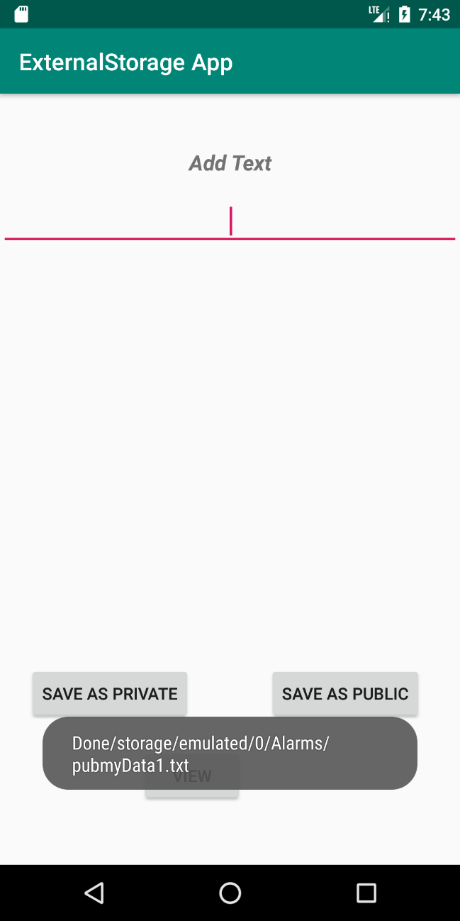 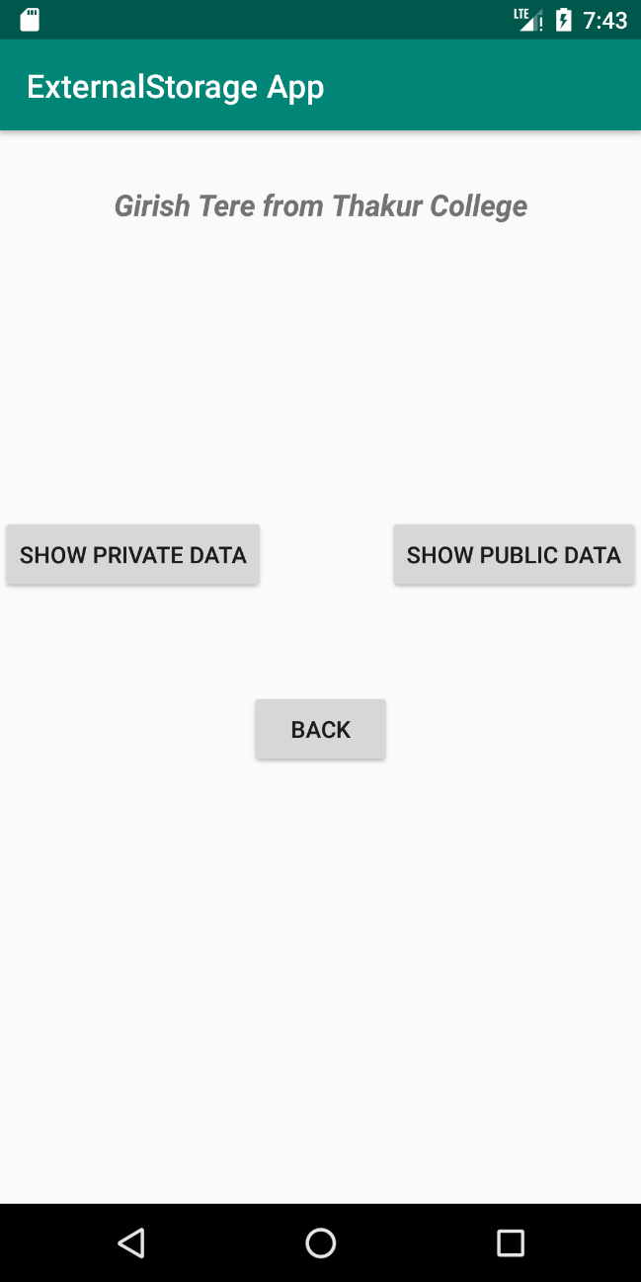

**Saving data in private files**

