[LeetCode](https://leetcode.com/problems/remove-nth-node-from-end-of-list/description/?envType=daily-question&envId=2024-03-03)

<https://github.com/AdityaKonda6/-50DaysOfCoding>

<https://leetcode.com/problems/remove-nth-node-from-end-of-list/description/?envType=daily-question&envId=2024-03-03>

<https://www.linkedin.com/in/aditya-adi-konda/>

 Day 13 of [#50dayscodingchallenge](https://www.linkedin.com/feed/hashtag/?keywords=50dayscodingchallenge&highlightedUpdateUrns=urn:li:activity:7166316239483461633):  
[#leetcode](https://www.linkedin.com/feed/hashtag/?keywords=leetcode&highlightedUpdateUrns=urn:li:activity:7166316239483461633) [#leetcodechallenge](https://www.linkedin.com/feed/hashtag/?keywords=leetcodechallenge&highlightedUpdateUrns=urn:li:activity:7166316239483461633) [#leetcodestreak](https://www.linkedin.com/feed/hashtag/?keywords=leetcodestreak&highlightedUpdateUrns=urn:li:activity:7166316239483461633) [#leetcode2024](https://www.linkedin.com/feed/hashtag/?keywords=leetcode2024&highlightedUpdateUrns=urn:li:activity:7166316239483461633) [#leetcode50day](https://www.linkedin.com/feed/hashtag/?keywords=leetcode50day&highlightedUpdateUrns=urn:li:activity:7166316239483461633)  
   
Just kicked off my coding journey with a fascinating problem - "Successfully solved LeetCode Problem “19. Remove Nth Node From End Of List” !”  
   
✨ Task: Given the head of a linked list, remove the nth node from the end of the list and return its head.

Examples:

Example 1:

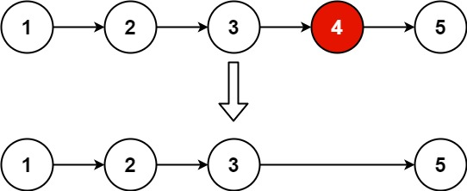

Input: head = [1,2,3,4,5], n = 2Output: [1,2,3,5]

Example 2:

Input: head = [1], n = 1Output: []

Example 3:

Input: head = [1,2], n = 1Output: [1]

Let's Connect:

If you find this problem intriguing or have insights to share, let's connect! I'm passionate about problem-solving, algorithmic thinking, and collaborative learning. Feel free to comment or reach out for engaging discussions and knowledge exchange.Unravel the mystery using your coding skills!

[#CodingChallenge](https://www.linkedin.com/feed/hashtag/?keywords=codingchallenge&highlightedUpdateUrns=urn:li:activity:7166316239483461633) [#Algorithm](https://www.linkedin.com/feed/hashtag/?keywords=algorithm&highlightedUpdateUrns=urn:li:activity:7166316239483461633) [#LinkedInPost](https://www.linkedin.com/feed/hashtag/?keywords=linkedinpost&highlightedUpdateUrns=urn:li:activity:7166316239483461633) #Algorithm #Optimization #DataStructures #CodingChallenge  
  
Excited about the progress and challenges ahead!  
   
Make Sure You Follow My GitHub For Solutions: <https://github.com/AdityaKonda6/-50DaysOfCoding>  
  
  
Happy coding!

**Solution:-**

class Solution {

  public ListNode removeNthFromEnd(ListNode head, int n) {

    ListNode slow = head;

    ListNode fast = head;

    while (n-- > 0)

      fast = fast.next;

    if (fast == null)

      return head.next;

    while (fast.next != null) {

      slow = slow.next;

      fast = fast.next;

    }

    slow.next = slow.next.next;

    return head;

  }

}

