[LeetCode](https://leetcode.com/problems/reverse-linked-list/?envType=daily-question&envId=2024-03-21)

<https://github.com/AdityaKonda6/-50DaysOfCoding>

<https://leetcode.com/problems/reverse-linked-list/?envType=daily-question&envId=2024-03-21>

<https://www.linkedin.com/in/aditya-adi-konda/>

Day 31 of [#50dayscodingchallenge](https://www.linkedin.com/feed/hashtag/?keywords=50dayscodingchallenge&highlightedUpdateUrns=urn:li:activity:7166316239483461633):  
[#leetcode](https://www.linkedin.com/feed/hashtag/?keywords=leetcode&highlightedUpdateUrns=urn:li:activity:7166316239483461633) [#leetcodechallenge](https://www.linkedin.com/feed/hashtag/?keywords=leetcodechallenge&highlightedUpdateUrns=urn:li:activity:7166316239483461633) [#leetcodestreak](https://www.linkedin.com/feed/hashtag/?keywords=leetcodestreak&highlightedUpdateUrns=urn:li:activity:7166316239483461633) [#leetcode2024](https://www.linkedin.com/feed/hashtag/?keywords=leetcode2024&highlightedUpdateUrns=urn:li:activity:7166316239483461633) [#leetcode50day](https://www.linkedin.com/feed/hashtag/?keywords=leetcode50day&highlightedUpdateUrns=urn:li:activity:7166316239483461633)  
   
Ventured further into my coding journey today, tackling the engaging LeetCode Problem "Successfully solved LeetCode Problem 🎈💻“206. Reverse Linked List.”  
   
✨ Task: Given the head of a singly linked list, reverse the list, and return the reversed list.

Examples:

Example 1:

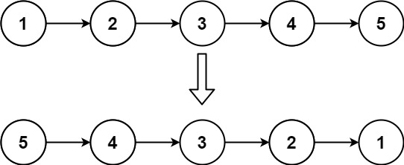

Input: head = [1,2,3,4,5]

Output: [5,4,3,2,1]

Example 2:

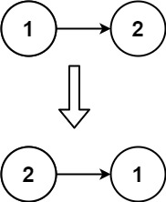

Input: head = [1,2]

Output: [2,1]

Example 3:

Input: head = []

Output: []

Let's Connect:

If you find this problem intriguing or have insights to share, let's connect! I'm passionate about problem-solving, algorithmic thinking, and collaborative learning. Feel free to comment or reach out for engaging discussions and knowledge exchange.Unravel the mystery using your coding skills!

[#CodingChallenge](https://www.linkedin.com/feed/hashtag/?keywords=codingchallenge&highlightedUpdateUrns=urn:li:activity:7166316239483461633) [#Algorithm](https://www.linkedin.com/feed/hashtag/?keywords=algorithm&highlightedUpdateUrns=urn:li:activity:7166316239483461633) [#LinkedInPost](https://www.linkedin.com/feed/hashtag/?keywords=linkedinpost&highlightedUpdateUrns=urn:li:activity:7166316239483461633) #Algorithm #Optimization #DataStructures #CodingChallenge  
  
Excited about the progress and challenges ahead!  
   
Make Sure You Follow My GitHub For Solutions: <https://github.com/AdityaKonda6/-50DaysOfCoding>  
  
  
Happy coding!

**Solution:-**

class Solution {

  public ListNode reverseList(ListNode head) {

    if (head == null || head.next == null)

      return head;

    ListNode newHead = reverseList(head.next);

    head.next.next = head;

    head.next = null;

    return newHead;

  }

}

