[LeetCode](https://leetcode.com/problems/reorder-list/?envType=daily-question&envId=2024-03-23)

<https://github.com/AdityaKonda6/-50DaysOfCoding>

<https://leetcode.com/problems/reorder-list/?envType=daily-question&envId=2024-03-23>

<https://www.linkedin.com/in/aditya-adi-konda/>

Day 33 of [#50dayscodingchallenge](https://www.linkedin.com/feed/hashtag/?keywords=50dayscodingchallenge&highlightedUpdateUrns=urn:li:activity:7166316239483461633):  
[#leetcode](https://www.linkedin.com/feed/hashtag/?keywords=leetcode&highlightedUpdateUrns=urn:li:activity:7166316239483461633) [#leetcodechallenge](https://www.linkedin.com/feed/hashtag/?keywords=leetcodechallenge&highlightedUpdateUrns=urn:li:activity:7166316239483461633) [#leetcodestreak](https://www.linkedin.com/feed/hashtag/?keywords=leetcodestreak&highlightedUpdateUrns=urn:li:activity:7166316239483461633) [#leetcode2024](https://www.linkedin.com/feed/hashtag/?keywords=leetcode2024&highlightedUpdateUrns=urn:li:activity:7166316239483461633) [#leetcode50day](https://www.linkedin.com/feed/hashtag/?keywords=leetcode50day&highlightedUpdateUrns=urn:li:activity:7166316239483461633)  
   
Ventured further into my coding journey today, tackling the engaging LeetCode Problem "Successfully solved LeetCode Problem 🎈💻“143. Reorder List.”  
   
✨ Task:

You are given the head of a singly linked-list. The list can be represented as:

L0 → L1 → … → Ln - 1 → Ln

Reorder the list to be on the following form:

L0 → Ln → L1 → Ln - 1 → L2 → Ln - 2 → …

You may not modify the values in the list's nodes. Only nodes themselves may be changed.

Examples:

Example 1:

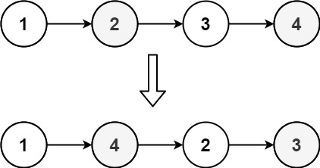

Input: head = [1,2,3,4]

Output: [1,4,2,3]

Example 2:

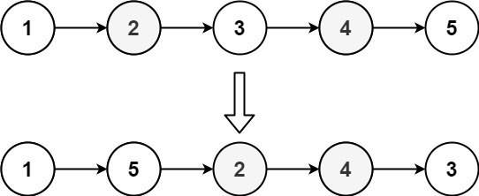

Input: head = [1,2,3,4,5]

Output: [1,5,2,4,3]

Let's Connect:

If you find this problem intriguing or have insights to share, let's connect! I'm passionate about problem-solving, algorithmic thinking, and collaborative learning. Feel free to comment or reach out for engaging discussions and knowledge exchange.Unravel the mystery using your coding skills!

[#CodingChallenge](https://www.linkedin.com/feed/hashtag/?keywords=codingchallenge&highlightedUpdateUrns=urn:li:activity:7166316239483461633) [#Algorithm](https://www.linkedin.com/feed/hashtag/?keywords=algorithm&highlightedUpdateUrns=urn:li:activity:7166316239483461633) [#LinkedInPost](https://www.linkedin.com/feed/hashtag/?keywords=linkedinpost&highlightedUpdateUrns=urn:li:activity:7166316239483461633) #Algorithm #Optimization #DataStructures #CodingChallenge  
  
Excited about the progress and challenges ahead!  
   
Make Sure You Follow My GitHub For Solutions: <https://github.com/AdityaKonda6/-50DaysOfCoding>  
  
  
Happy coding!

**Solution:-**

class Solution {

  public void reorderList(ListNode head) {

    if (head == null || head.next == null)

      return;

    ListNode mid = findMid(head);

    ListNode reversed = reverse(mid);

    merge(head, reversed);

  }

  private ListNode findMid(ListNode head) {

    ListNode prev = null;

    ListNode slow = head;

    ListNode fast = head;

    while (fast != null && fast.next != null) {

      prev = slow;

      slow = slow.next;

      fast = fast.next.next;

    }

    prev.next = null;

    return slow;

  }

  private ListNode reverse(ListNode head) {

    ListNode prev = null;

    ListNode curr = head;

    while (curr != null) {

      ListNode next = curr.next;

      curr.next = prev;

      prev = curr;

      curr = next;

    }

    return prev;

  }

  private void merge(ListNode l1, ListNode l2) {

    while (l2 != null) {

      ListNode next = l1.next;

      l1.next = l2;

      l1 = l2;

      l2 = next;

    }

  }

}

