**EXPERIMENT NO. 3**

**NAME: ADITYA B. KULKARNI  
REGISTRATION NO : 241070908  
SUBJECT : DAA (LAB)  
SY BTECH COMPUTER ENGINEERING  
  
AIM :** Write an algorithm to find gross and net salary of employees.  
ABC co. ltd. has 2000 employees. calculate each employees salary and find employee with minimum salary and maximum salary.

**THEORY :**Divide and Conquer Algorithm is a problem-solving technique used to solve problems by dividing the main problem into subproblems, solving them individually and then merging them to find solution to the original problem

**Key Steps in the Divide and Conquer Approach**

1. **Divide:** Break the problem into smaller subproblems that are similar to the original problem but smaller in size.
2. **Conquer:** Solve the subproblems recursively. If the subproblems are small enough, solve them directly (base case).
3. **Combine:** Combine the solutions of the subproblems to form the solution to the original problem.

**Algorithm /** **Pseudocode :**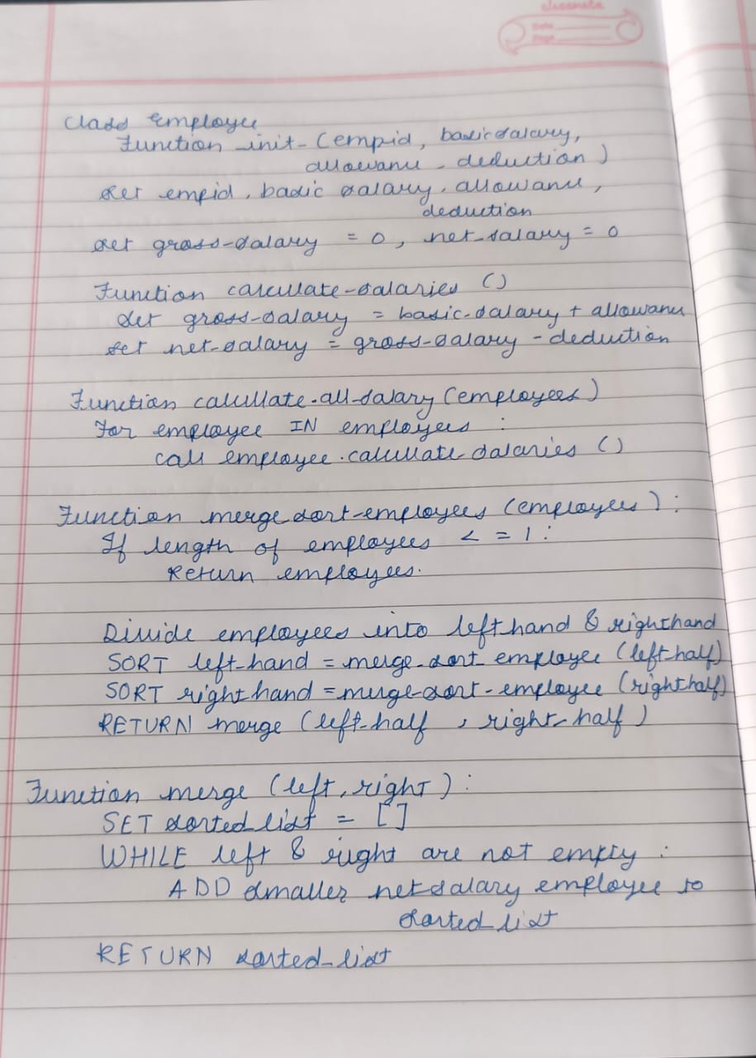

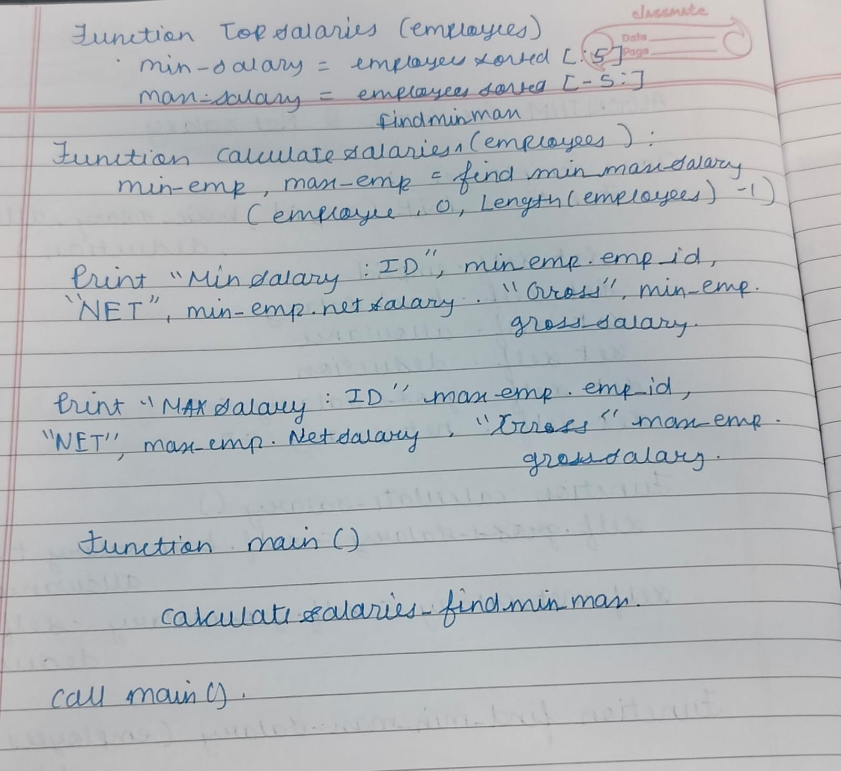

**TIME COMPLEXITY :**

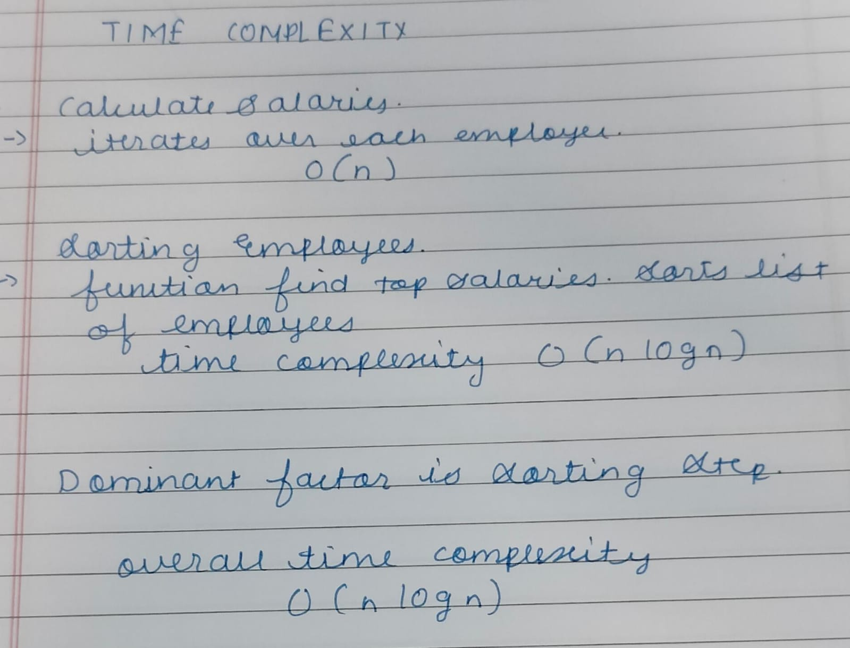

**CODE :**

import csv

# Employee Class to represent basic details

class Employee:

    def __init__(self, emp_id, basic_salary, allowances, deductions):

        self.emp_id = emp_id

        self.basic_salary = basic_salary

        self.allowances = allowances

        self.deductions = deductions

        self.gross_salary = 0

        self.net_salary = 0

    # Method to calculate gross and net salary

    def calculate_salaries(self):

        self.gross_salary = self.basic_salary + self.allowances

        self.net_salary = self.gross_salary - self.deductions

# Function to calculate salaries for all employees

def calculate_all_salaries(employees):

    for emp in employees:

        emp.calculate_salaries()

# Divide and Conquer: Merge Sort Algorithm

def merge_sort_employees(employees):

    if len(employees) <= 1:

        return employees

    mid = len(employees) // 2

    # Divide the list into two halves

    left_half = merge_sort_employees(employees[:mid])

    right_half = merge_sort_employees(employees[mid:])

    # Conquer: Merge the two halves

    return merge_employees(left_half, right_half)

# Function to merge two sorted lists of employees based on net salary

def merge_employees(left, right):

    sorted_list = []

    i = j = 0

    # Merging two sorted halves

    while i < len(left) and j < len(right):

        if left[i].net_salary < right[j].net_salary:

            sorted_list.append(left[i])

            i += 1

        else:

            sorted_list.append(right[j])

            j += 1

    # Append remaining items in both halves

    sorted_list.extend(left[i:])

    sorted_list.extend(right[j:])

    return sorted_list

# Function to find top 5 min and max salaries using merge sort

def find_top_salaries(employees):

    # Use divide-and-conquer merge sort to sort employees by net salary

    employees_sorted = merge_sort_employees(employees)

    # Get top 5 min and max salaries

    min_salaries = employees_sorted[:5]

    max_salaries = employees_sorted[-5:]

    return min_salaries, max_salaries

# Function to output the results

def print_salaries(salaries, title):

    print(f"{title}:")

    for emp in salaries:

        print(f"ID {emp.emp_id}, Gross Salary: {emp.gross_salary}, Net Salary: {emp.net_salary}")

    print()

# Reading the CSV file and creating employee objects

employees = []

csv_file_path = 'emp.csv'  # Ensure the CSV file is in the same directory

with open(csv_file_path, mode='r') as file:

    reader = csv.DictReader(file)

    for row in reader:

        emp_id = int(row["Emp_ID"])

        basic_salary = int(row["Basic_Salary"])

        allowances = int(row["Allowances"])

        deductions = int(row["Deductions"])

        employees.append(Employee(emp_id, basic_salary, allowances, deductions))

# Calculate salaries for all employees

calculate_all_salaries(employees)

# Find top 5 min and max salaries using divide and conquer approach (merge sort)

min_salaries, max_salaries = find_top_salaries(employees)

# Print results

print_salaries(min_salaries, "Top 5 Employees with Minimum Salaries")

print_salaries(max_salaries, "Top 5 Employees with Maximum Salaries")

**OUTPUT (POSITIVE AND NEGATIVE TEST CASES ) :**

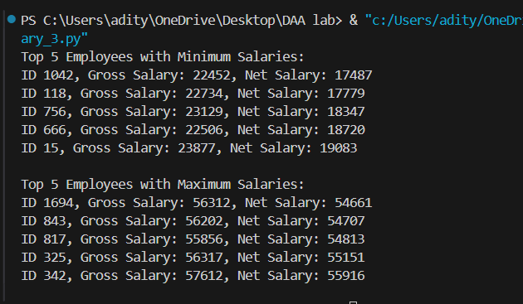

**CONCLUSION :** Hence we have calculated the Gross and Net salary of the employees using  Divide and Conquer algorithm.