

**Admission 2024**

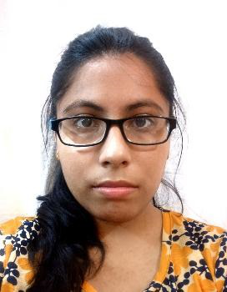

**Application Form Number - 73581**

|  |  |  |
| --- | --- | --- |
| **Program Details** |  |  |
| Program Catagory | Name of Program | Exam Center |
| **PG** | **M.SC. DIGITAL FORENSICS** | **Delhi** |

**AND INFORMATION**

**SECURITY**

|  |  |  |  |
| --- | --- | --- | --- |
| **Personal Details** |  |  |  |
| First Name | Middle Name | Last Name | Email ID (Primary) |
| **Disha** | **--** | **Saini** | **officialdisha028@gmail.co** |

**m**

|  |  |  |  |
| --- | --- | --- | --- |
| Alternate Email ID | Mobile Number | Date of Birth | Gender |
| Blood Group | **8920539467** | **28-04-2003** | **Female** |
| Nationality | Religion | Caste Category |
| **A+Ve** | **INDIAN** | **Hindu** | **GENERAL** |
| Mother Tongue | Aadhar Card Number | Differently Abled? | Are you J&K Migrant |
| **Hindi** | **241372007537** | **NO** | **NO** |
| Army Quota | Enrollment Preference | School Name |
| **NO** | **NA** | **--** |

Do you need scribe as per the criteria given in the information Bulletin for PWD

**NA**

|  |  |  |  |
| --- | --- | --- | --- |
| **Father/Mother/Guardian Details** | |  |  |
| Guardian Name | Mobile Number | Email ID | Aadhar Number |
| **Rajesh Saini** | **9971701630** |

Occupation

**Government Sector**

|  |  |
| --- | --- |
| **Address** |  |
| Correspondence Address | Permanent Address |

**RZE-65 Gali no. 4, Raj Nagar part 2, Dada Dev road,New Delhi City/Taluka : District : SOUTH WEST**   
**State : NEW DELHI PIN Code : 110077 Country : INDIA**

**RZE-65 Gali no. 4, Raj Nagar part 2, Dada Dev road,New Delhi**

**City/Taluka : District : SOUTH WEST**   
**State : NEW DELHI PIN Code : 110077 Country : INDIA**

|  |
| --- |
| **Base Exam Details** |

|  |  |  |  |  |  |
| --- | --- | --- | --- | --- | --- |
| **Base Exam** | **Seat/Roll No** | **Result** | **Percentile** | **Composite Score** | **Year of Exam** |

|  |
| --- |
| **Educational Qualification Details** |

|  |  |  |  |  |
| --- | --- | --- | --- | --- |
| **Exam** | **Board/University** | **CGPA** | **Total**  **Percentage** | **Passing Year** |
| Bachelors Degree | Bachelor's Of Computer Applications - Guru  Gobind Singh  Indraprastha University | 8.99 | 84.09 | 2024 |
| Standard 10 | CBSE - NA | 0.00 | 77.80 | 2019 |
| Standard 12 / 10+2 / Diploma | CBSE - NA | 0.00 | 79.66 | 2021 |

|  |
| --- |
| **Upload Documents** |

|  |
| --- |
| **List of Documents Uploaded** |
| S.S.C MARKSHEET |
| H.S.C MARKSHEET |
| Your Signature |
| Passport Size Photograph |
| GRADUATION MARKSHEET |
| BIRTH DATE CERTIFICATE (OR ANY OTHER PROOF OF BIRTH DATE) |
| Identity Proof |

|  |  |  |  |  |
| --- | --- | --- | --- | --- |
| **Payment Detail** |  |  |  |  |
| *Transaction No .* | *Payment Reference No .* | *Transa* | *Order ID .* | *Paid Amount* |

*ction*   
*Date*

|  |
| --- |
| **Declaration** |

1.I understand that category selected by me in the application form is the final one and non-production of requisite category certificate at any time of admission results into ineligibility of my candidature for admission.

2.I have read the admission policy thoroughly and checked the eligibility criteria, fee structure and other relevant details of my program before filing / submitting my application form.

3.I certify that the information submitted by me in support of this application is true to the best of knowledge and belief. I understand that in the event of any information being found false or incorrect, my admission is liable to be rejected / cancelled at any stage of admission. I undertake to abide by the disciplinary rules and regulations of the University.

**Place : Date :** 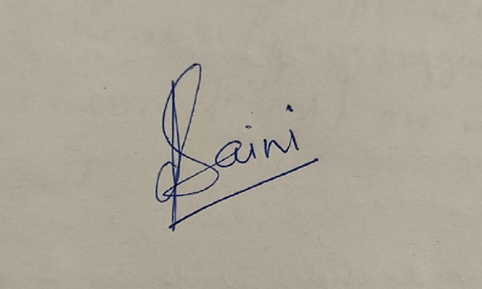

***signature***