Project title
A short and simple responsive javascript registration form which contains
- First name,Last name
- Email
- Phone number
- Date of birth
- Password
- Confirm Password
- Register button

Screenshots
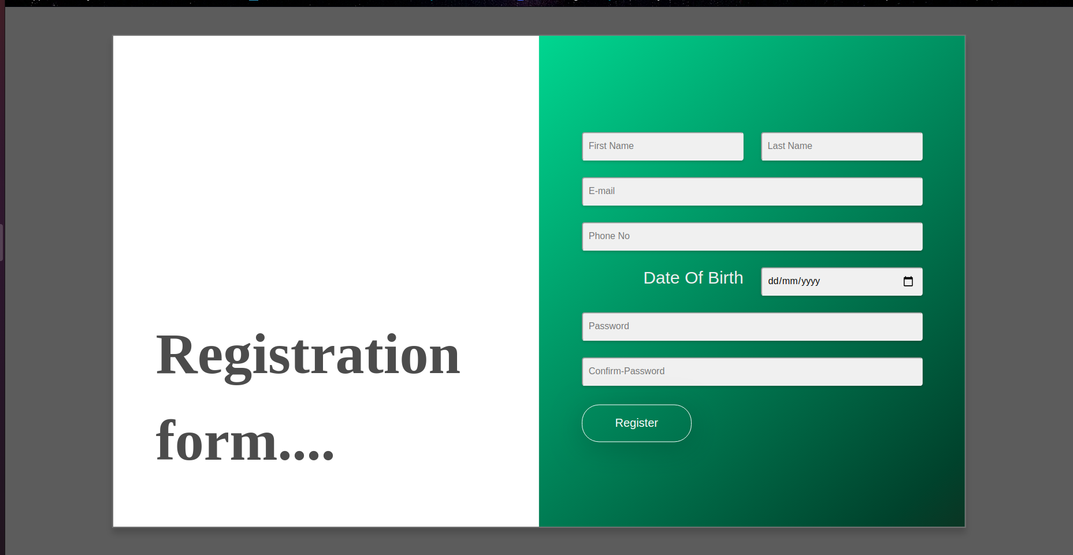

Technology Used
- Html
- CSS
- Bootstrap
- JavaScript

Features
This project contains real time validation like:
- it will suggest your email id with some random numbers once the user had entered the first and last name.
- It will check whether the phone number entered by user is valid or not by counting the length of number.
- It would tell whether the password entered is week, medium or strong.
- The register button will not be able to click untill the user:
  - had entered the first name.(as first name can never be blank)
  - the password enterd fulfill all the requirements(i.e, it contains at least one uppercase, one lowercase and one number)
  - the password and confirm password field value is same.

Credits
w3school

