Name-Aditya Kundu

Div-D15A

Roll No-31

**EXPERIMENT NO.3**

**AIM:- To include icons, images, and fonts in the Flutter app.**

**THEORY:-**

**Including icons, images, and fonts in a Flutter app involves integrating visual elements to enhance the user interface. Here's a theoretical approach on how to include these assets:**

**Icons:**

**1. Material Icons:**

**- Flutter comes with a set of Material Design icons. You can use them directly by referencing their names from the `Icons` class (e.g., `Icons. home`, `Icons. camera`).**

**2. Custom Icons:**

**- To use custom icons, you can create an `Icon` widget and specify the icon's image using the `Image. asset` widget.**

**```dart**

**Icon(**

**Icons. add,**

**size: 30.0,**

**color: Colors. blue,**

**)**

**```**

**Images:**

**1. Asset Images:**

**- Place your image files in the `assets` folder in your Flutter project.**

**- Use the `Image. asset` widget to display these images.**

**```dart**

**Image. asset(**

**'assets/my_image.png',**

**width: 100.0,**

**height: 100.0,**

**)**

**```**

**2. Network Images:**

**- Load images from the network using the `Image. network` widget.**

**```dart**

**Image. network(**

**'https://example.com/my_image.jpg',**

**width: 100.0,**

**height: 100.0,**

**)**

**```**

**Fonts:**

**1. Adding Fonts:**

**- Place your font files (e.g., `.ttf` or `.otf`) in a folder (e.g., `fonts`) in your Flutter project.**

**- Specify the font files in the `pubspec.yaml` file.**

**```yaml**

**flutter:**

**fonts:**

**- family: YourFontFamily**

**fonts:**

**- asset: fonts/your_font.ttf**

**```**

**2. Using Custom Fonts:**

**- Apply the custom font to your text by specifying the `font-family` property in the `TextStyle` widget.**

**```dart**

**Text(**

**'Custom Font Text',**

**style: TextStyle(**

**fontFamily: 'YourFontFamily',**

**font size: 16.0,**

**fontWeight: FontWeight.bold,**

**),**

**)**

**```**

**Best Practices:**

**1. Asset Structure:**

**- Organize assets in a structured manner, such as placing images in an `images` folder and fonts in a `fonts` folder.**

**2. Pubspec.yaml:**

**- Keep your `pubspec.yaml` file up-to-date with the correct paths to your assets.**

**3. Package:**

**- If you're using custom icons or images from packages, follow the package's documentation for correct usage.**

**4. Size and Resolution:**

**- Consider different screen sizes and resolutions when including images. Provide images at multiple resolutions for better quality on various devices.**

**5. Lazy Loading:**

**- Use `Image.network` with caching libraries like `cached_network_image` for better performance and lazy loading.**

**By following these theoretical guidelines, you can effectively include icons, images, and fonts in your Flutter app, making it visually appealing and user-friendly.**

**CODE:-**

**import 'package:flutter/material.dart';**

**void main() {**

**runApp(MyApp());**

**}**

**class MyApp extends StatelessWidget {**

**@override**

**Widget build(BuildContext context) {**

**return MaterialApp(**

**home: VideoCallScreen(),**

**);**

**}**

**}**

**class VideoCallScreen extends StatelessWidget {**

**@override**

**Widget build(BuildContext context) {**

**return Scaffold(**

**appBar: AppBar(**

**title: Text('Microsoft Teams'),**

**),**

**body: Center(**

**child: Column(**

**mainAxisAlignment: MainAxisAlignment.center,**

**children: [**

**Placeholder(**

**// Video stream or preview placeholder**

**fallbackHeight: 200.0,**

**),**

**SizedBox(height: 20.0),**

**Row(**

**mainAxisAlignment: MainAxisAlignment.center,**

**children: [**

**IconButton(**

**icon: Icon(**

**Icons.videocam,**

**size: 30.0,**

**color: Colors.blue,**

**),**

**onPressed: () {**

**// Toggle video on/off**

**},**

**),**

**SizedBox(width: 20.0),**

**IconButton(**

**icon: Icon(**

**Icons.mic,**

**size: 30.0,**

**color: Colors.green,**

**),**

**onPressed: () {**

**// Toggle microphone on/off**

**},**

**),**

**],**

**),**

**SizedBox(height: 20.0),**

**// Using Image.network for loading an image from the internet**

**Image.network(**

**'https://i.postimg.cc/W3xf1w5k/close-up-young-businessman-having-work-video-call-while-staying-home-new-normal-lifestyle-business-c.jpg',**

**width: 100.0,**

**height: 100.0,**

**),**

**SizedBox(height: 20.0),**

**// Using custom font**

**Text(**

**'Hello, Aditya Kundu!',**

**style: TextStyle(**

**fontSize: 20.0,**

**fontFamily: 'CustomFont', // Replace 'CustomFont' with your font**

**),**

**),**

**],**

**),**

**),**

**floatingActionButton: FloatingActionButton(**

**onPressed: () {**

**// End the call**

**},**

**child: Icon(**

**Icons.call_end,**

**size: 30.0,**

**),**

**),**

**);**

**}**

**}**

**OUTPUT:-**

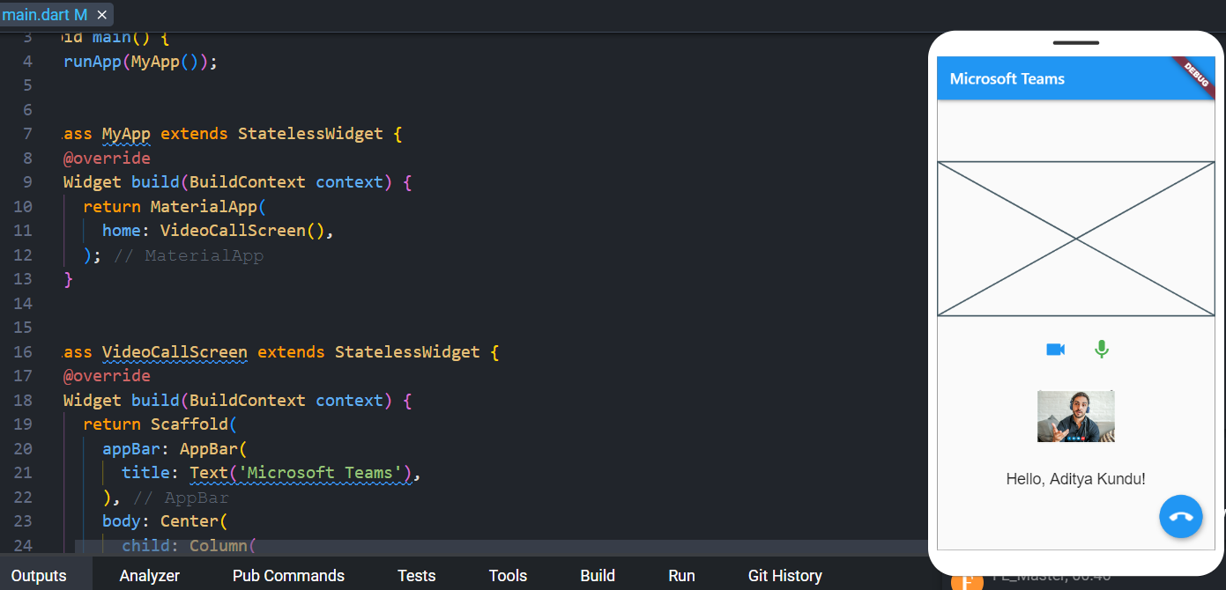

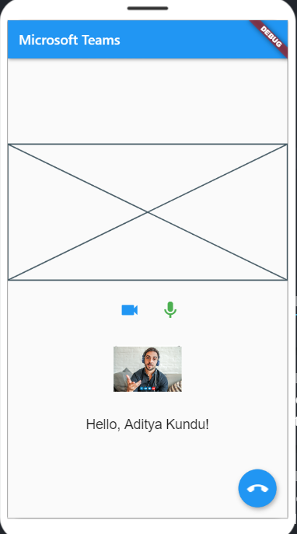

**CONCLUSION:-**

**Here learned about images, fonts and icons in flutter app.**