Name- Aditya Kundu

Div-D15A

Roll No-31

**EXPERIMENT NO.4**

**AIM:- To create an interactive form using the Form widget.**

**THEORY:-**

**Creating an interactive form using the `Form` widget in Flutter involves using various form-related widgets and handling user input. Here's a theoretical guide on how to create an interactive form:**

**1. Import Necessary Packages:**

**- Ensure that you've imported the required Flutter packages. Commonly used packages include `flutter/material.dart` for the core material design components.**

**```dart**

**import 'package:flutter/material.dart';**

**```**

**2. Create a StatefulWidget:**

**- Use a `StatefulWidget` to manage the state of the form. This is necessary because the form will likely change based on user input.**

**```dart**

**class MyForm extends StatefulWidget {**

**@override**

**_MyFormState createState() => _MyFormState();**

**}**

**```**

**3. Define Form Fields:**

**- Inside the state class, define variables to store the values of the form fields.**

**```dart**

**class _MyFormState extends State<MyForm> {**

**// Define variables for form fields**

**TextEditingController _nameController = TextEditingController();**

**TextEditingController _emailController = TextEditingController();**

**// ... add more as needed**

**}**

**```**

**4. Build the Form Widget:**

**- Use the `Form` widget to create the form and include various form fields.**

**```dart**

**class _MyFormState extends State<MyForm> {**

**// ... (previous code)**

**@override**

**Widget build(BuildContext context) {**

**return Scaffold(**

**appBar: AppBar(**

**title: Text('Interactive Form'),**

**),**

**body: Form(**

**child: Padding(**

**padding: EdgeInsets.all(16.0),**

**child: Column(**

**children: [**

**TextFormField(**

**controller: _nameController,**

**decoration: InputDecoration(labelText: 'Name'),**

**),**

**TextFormField(**

**controller: _emailController,**

**decoration: InputDecoration(labelText: 'Email'),**

**),**

**// ... add more form fields as needed**

**],**

**),**

**),**

**),**

**);**

**}**

**}**

**```**

**5. Handle Form Submission:**

**- Implement a method to handle the form submission, typically triggered by a button press.**

**```dart**

**class _MyFormState extends State<MyForm> {**

**// ... (previous code)**

**void _submitForm() {**

**// Access form field values and perform actions**

**String name = _nameController.text;**

**String email = _emailController.text;**

**// Perform further actions, e.g., validation or submission to a server**

**}**

**@override**

**Widget build(BuildContext context) {**

**return Scaffold(**

**appBar: AppBar(**

**title: Text('Interactive Form'),**

**),**

**body: Form(**

**child: Padding(**

**padding: EdgeInsets.all(16.0),**

**child: Column(**

**children: [**

**TextFormField(**

**controller: _nameController,**

**decoration: InputDecoration(labelText: 'Name'),**

**),**

**TextFormField(**

**controller: _emailController,**

**decoration: InputDecoration(labelText: 'Email'),**

**),**

**// ... add more form fields as needed**

**],**

**),**

**),**

**),**

**floatingActionButton: FloatingActionButton(**

**onPressed: _submitForm,**

**child: Icon(Icons.send),**

**),**

**);**

**}**

**}**

**```**

**6. Validate User Input:**

**- Implement validation logic to ensure that user input meets specific criteria.**

**```dart**

**class _MyFormState extends State<MyForm> {**

**final _formKey = GlobalKey<FormState>();**

**// ... (previous code)**

**void _submitForm() {**

**if (_formKey.currentState!.validate()) {**

**// Form is valid, perform actions**

**String name = _nameController.text;**

**String email = _emailController.text;**

**// Perform further actions, e.g., submission to a server**

**}**

**}**

**@override**

**Widget build(BuildContext context) {**

**return Scaffold(**

**appBar: AppBar(**

**title: Text('Interactive Form'),**

**),**

**body: Form(**

**key: _formKey,**

**child: Padding(**

**padding: EdgeInsets.all(16.0),**

**child: Column(**

**children: [**

**TextFormField(**

**controller: _nameController,**

**decoration: InputDecoration(labelText: 'Name'),**

**validator: (value) {**

**if (value!.isEmpty) {**

**return 'Please enter your name';**

**}**

**return null;**

**},**

**),**

**TextFormField(**

**controller: _emailController,**

**decoration: InputDecoration(labelText: 'Email'),**

**validator: (value) {**

**if (value!.isEmpty || !value.contains('@')) {**

**return 'Please enter a valid email address';**

**}**

**return null;**

**},**

**),**

**// ... add more form fields as needed**

**],**

**),**

**),**

**),**

**floatingActionButton: FloatingActionButton(**

**onPressed: _submitForm,**

**child: Icon(Icons.send),**

**),**

**);**

**}**

**}**

**```**

**7. Display Error Messages:**

**- Display error messages if form validation fails.**

**```dart**

**class _MyFormState extends State<MyForm> {**

**final _formKey = GlobalKey<FormState>();**

**// ... (previous code)**

**void _submitForm() {**

**if (_formKey.currentState!.validate()) {**

**// Form is valid, perform actions**

**String name = _nameController.text;**

**String email = _emailController.text;**

**// Perform further actions, e.g., submission to a server**

**}**

**}**

**@override**

**Widget build(BuildContext context) {**

**return Scaffold(**

**appBar: AppBar(**

**title: Text('Interactive Form'),**

**),**

**body: Form(**

**key: _formKey,**

**child: Padding(**

**padding: EdgeInsets.all(16.0),**

**child: Column(**

**children: [**

**TextFormField(**

**controller: _nameController,**

**decoration: InputDecoration(labelText: 'Name'),**

**validator: (value) {**

**if (value!.isEmpty) {**

**return 'Please enter your name';**

**}**

**return null;**

**},**

**),**

**TextFormField(**

**controller: _emailController,**

**decoration: InputDecoration(labelText: 'Email'),**

**validator: (value) {**

**if (value!.isEmpty || !value.contains('@')) {**

**return 'Please enter a valid email address';**

**}**

**return null;**

**},**

**),**

**// ... add more form fields as needed**

**],**

**),**

**),**

**),**

**floatingActionButton: FloatingActionButton(**

**onPressed: _submitForm,**

**child: Icon(Icons.send),**

**),**

**);**

**}**

**}**

**```**

**8. Handle Form State Changes:**

**- Use the `onChanged` property of form fields to react to changes in user input.**

**```dart**

**class _MyFormState extends State<MyForm> {**

**final _formKey = GlobalKey<FormState>();**

**String _name = '';**

**String _email = '';**

**// ... (previous code)**

**void _submitForm() {**

**if (_formKey.currentState!.validate()) {**

**// Form is valid, perform actions**

**// ...**

**}**

**}**

**@override**

**Widget build(BuildContext context) {**

**return Scaffold(**

**appBar: AppBar(**

**title: Text('Interactive Form'),**

**),**

**body: Form(**

**key: _formKey,**

**child: Padding(**

**padding: EdgeInsets.all(16.0),**

**child: Column(**

**children: [**

**TextFormField(**

**CODE:-**

**import 'package:flutter/material.dart';**

**void main() {**

**runApp(MyApp());**

**}**

**class MyApp extends StatelessWidget {**

**@override**

**Widget build(BuildContext context) {**

**return MaterialApp(**

**home: MyForm(),**

**);**

**}**

**}**

**class MyForm extends StatefulWidget {**

**@override**

**_MyFormState createState() => _MyFormState();**

**}**

**class _MyFormState extends State<MyForm> {**

**final _formKey = GlobalKey<FormState>();**

**TextEditingController _nameController = TextEditingController();**

**TextEditingController _emailController = TextEditingController();**

**void _submitForm() {**

**if (_formKey.currentState!.validate()) {**

**// Form is valid, perform actions**

**String name = _nameController.text;**

**String email = _emailController.text;**

**// Perform further actions, e.g., submission to a server**

**print('Submitted: Name - $name, Email - $email');**

**}**

**}**

**void _resetForm() {**

**_formKey.currentState!.reset();**

**_nameController.clear();**

**_emailController.clear();**

**}**

**@override**

**Widget build(BuildContext context) {**

**return Scaffold(**

**appBar: AppBar(**

**title: Text('MAD LAB Demo Form By Aditya Kundu'),**

**),**

**body: Form(**

**key: _formKey,**

**child: Padding(**

**padding: EdgeInsets.all(16.0),**

**child: Column(**

**children: [**

**TextFormField(**

**controller: _nameController,**

**decoration: InputDecoration(labelText: 'Name'),**

**validator: (value) {**

**if (value!.isEmpty) {**

**return 'Please enter your name';**

**}**

**return null;**

**},**

**),**

**TextFormField(**

**controller: _emailController,**

**decoration: InputDecoration(labelText: 'Email'),**

**validator: (value) {**

**if (value!.isEmpty || !value.contains('@')) {**

**return 'Please enter a valid email address';**

**}**

**return null;**

**},**

**),**

**SizedBox(height: 20.0),**

**Row(**

**mainAxisAlignment: MainAxisAlignment.spaceEvenly,**

**children: [**

**ElevatedButton(**

**onPressed: _submitForm,**

**child: Text('Submit'),**

**),**

**ElevatedButton(**

**onPressed: _resetForm,**

**child: Text('Reset'),**

**),**

**],**

**),**

**],**

**),**

**),**

**),**

**);**

**}**

**}**

**OUTPUT:-**

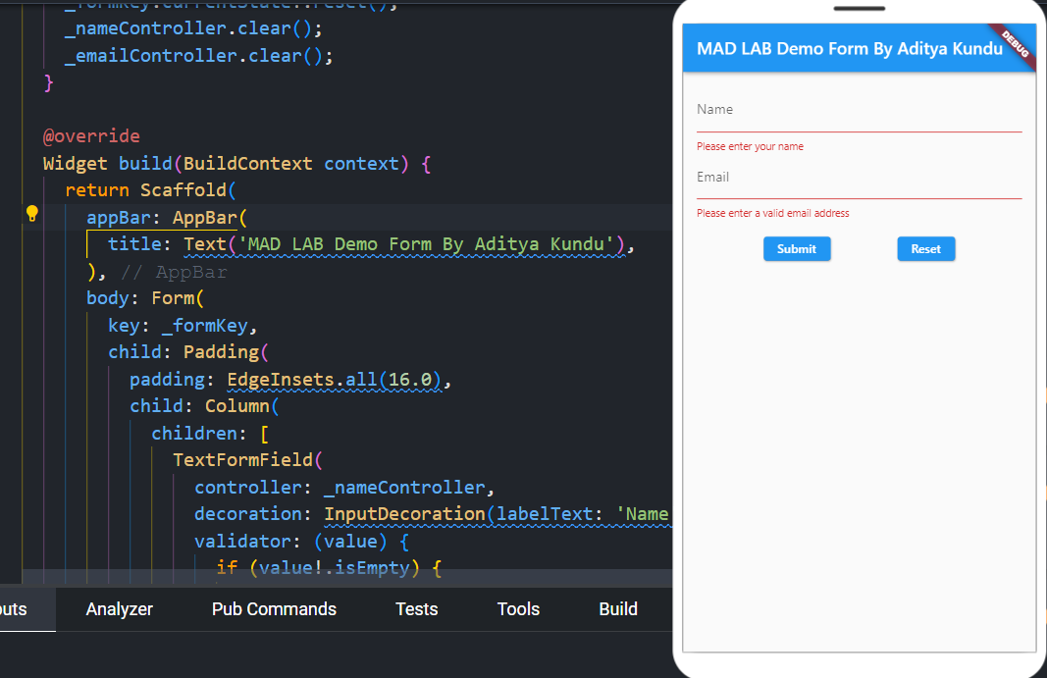

**Conclusion:-**

**Learned about to create an interactive form using the Form widget.**