**DN 4.0 Dotnet FSE**

**Name: Aditya Mohanty**

**Superset ID:6361043**

**Week 7**

**React**

**Handson No. 9**

**ListofPlayers.js:**

const ListofPlayers = () => {

const players = [

{ name: 'Jack', score: 50 },

{ name: 'Michael', score: 70 },

{ name: 'John', score: 40 },

{ name: 'Ann', score: 61 },

{ name: 'Elisabeth', score: 61 },

{ name: 'Sachin', score: 95 },

{ name: 'Dhoni', score: 100 },

{ name: 'Virat', score: 84 },

{ name: 'Jadeja', score: 64 },

{ name: 'Raina', score: 75 },

{ name: 'Rohit', score: 80 },

];

const players70 = players.filter(player => player.score <= 70);

return (

<div className="p-4 md:p-6">

<h1 className="text-2xl font-bold mb-4 text-gray-800">List of All Players</h1>

<ul className="list-disc list-inside bg-gray-50 p-4 rounded-lg shadow-sm mb-6">

{}

{players.map((player, index) => (

<li key={index} className="text-gray-700 mb-2">

Mr. {player.name} <span className="font-semibold ml-2 bg-blue-100 text-blue-800 px-2 py-1 rounded-full">{player.score}</span>

</li>

))}

</ul>

<hr className="my-6" />

<h1 className="text-2xl font-bold mb-4 text-gray-800">List of Players with Scores 70 or Less</h1>

<ul className="list-disc list-inside bg-gray-50 p-4 rounded-lg shadow-sm">

{}

{players70.map((player, index) => (

<li key={index} className="text-gray-700 mb-2">

Mr. {player.name} <span className="font-semibold ml-2 bg-red-100 text-red-800 px-2 py-1 rounded-full">{player.score}</span>

</li>

))}

</ul>

</div>

);

};

export default ListofPlayers;

**IndianPlayers.js:**

const IndianPlayers = () => {

const allPlayers = ['Sachin1', 'Dhoni2', 'Virat3', 'Rohit4', 'Yuvraj5', 'Raina6'];

const [first, second, third, fourth, fifth, sixth] = allPlayers;

const T20Players = ['First Player', 'Second Player', 'Third Player'];

const RanjiTrophyPlayers = ['Fourth Player', 'Fifth Player', 'Sixth Player'];

const mergedIndianPlayers = [...T20Players, ...RanjiTrophyPlayers];

return (

<div className="p-4 md:p-6">

<h1 className="text-2xl font-bold mb-4 text-gray-800">Odd Players</h1>

<div className="bg-gray-50 p-4 rounded-lg shadow-sm mb-6">

<ul className="list-disc list-inside">

<li className="text-gray-700">First: {first}</li>

<li className="text-gray-700">Third: {third}</li>

<li className="text-gray-700">Fifth: {fifth}</li>

</ul>

</div>

<hr className="my-6" />

<h1 className="text-2xl font-bold mb-4 text-gray-800">Even Players</h1>

<div className="bg-gray-50 p-4 rounded-lg shadow-sm mb-6">

<ul className="list-disc list-inside">

<li className="text-gray-700">Second: {second}</li>

<li className="text-gray-700">Fourth: {fourth}</li>

<li className="text-gray-700">Sixth: {sixth}</li>

</ul>

</div>

<hr className="my-6" />

<h1 className="text-2xl font-bold mb-4 text-gray-800">List of Indian Players Merged</h1>

<div className="bg-gray-50 p-4 rounded-lg shadow-sm">

<ul className="list-disc list-inside">

{}

{mergedIndianPlayers.map((player, index) => (

<li key={index} className="text-gray-700">Mr. {player}</li>

))}

</ul>

</div>

</div>

);

}

export default IndianPlayers;

**App.js:**

import React, { useState } from 'react';

import ListofPlayers from './ListofPlayers';

import IndianPlayers from './IndianPlayers';

function App() {

const [showList, setShowList] = useState(true);

return (

<div className="min-h-screen bg-gray-100 font-sans">

<div className="container mx-auto p-4">

<div className="bg-white rounded-xl shadow-lg overflow-hidden">

<div className="p-6 bg-blue-600 text-white flex justify-between items-center">

<h1 className="text-3xl font-bold">Cricket App</h1>

{}

<button

onClick={() => setShowList(!showList)}

className="bg-white text-blue-600 font-semibold py-2 px-4 rounded-lg shadow-md hover:bg-blue-50 transition duration-300"

>

Toggle View

</button>

</div>

{}

{showList ? <ListofPlayers /> : <IndianPlayers />}

</div>

</div>

</div>

);

}

export default App;

**OUPUT:**

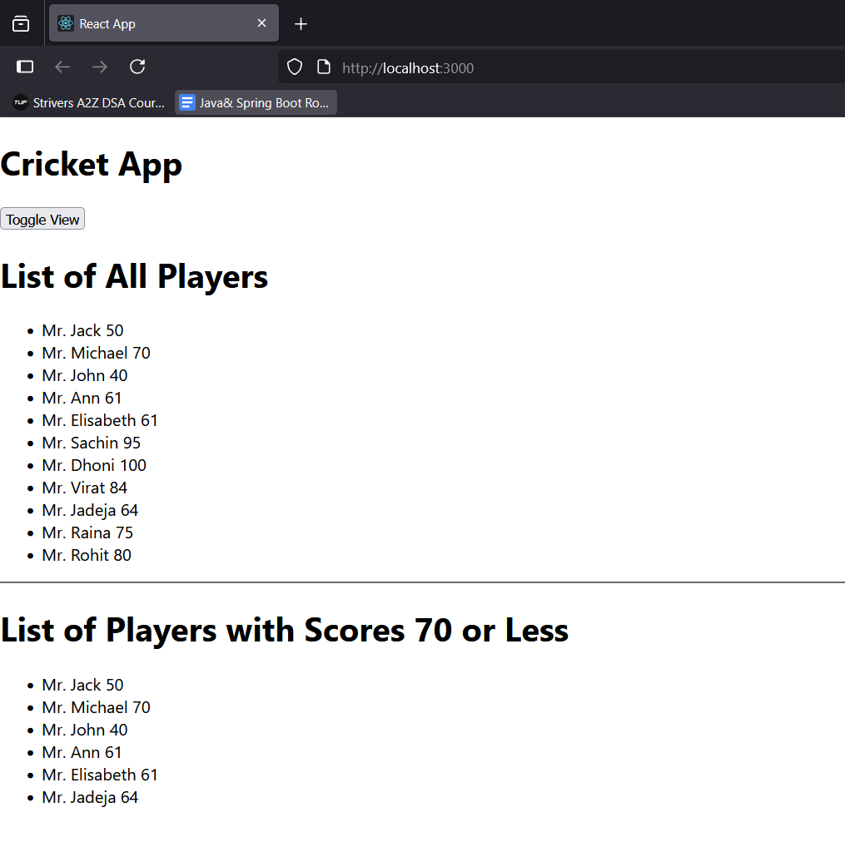

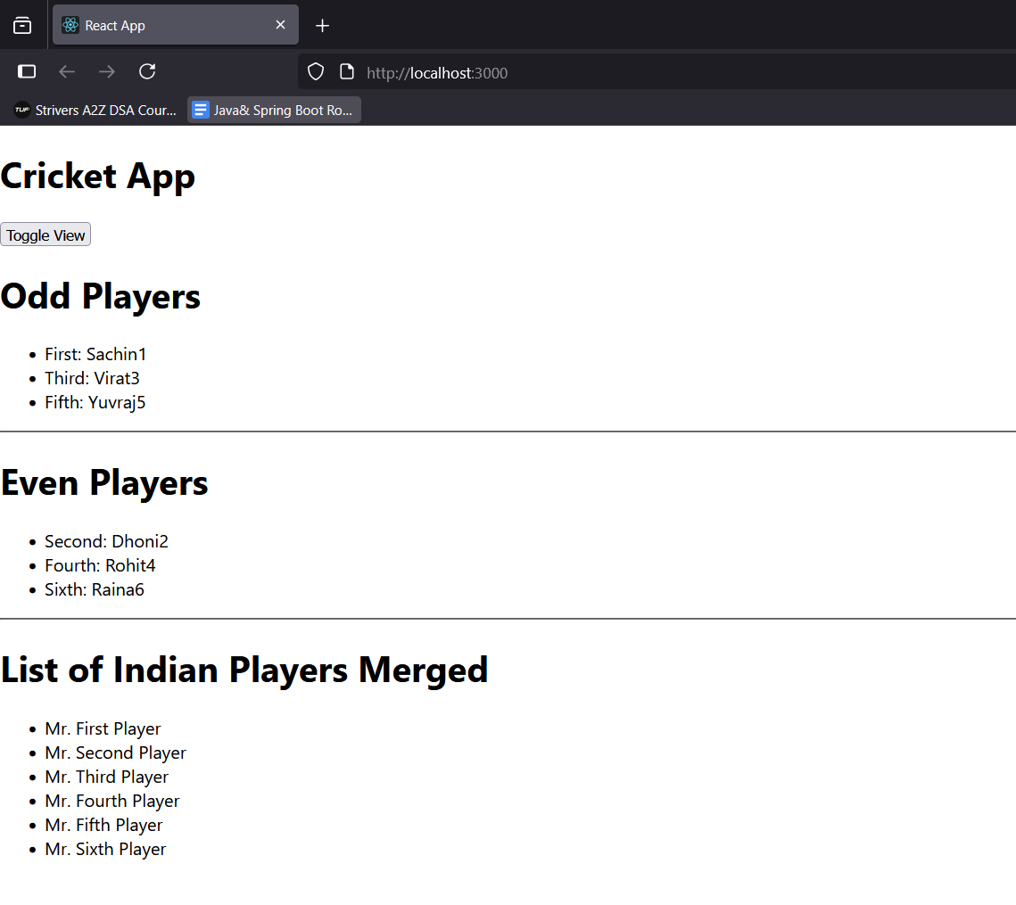

**Handson No. 10**

**App.js:**

const OfficeSpaceCard = ({ office }) => {

const rentStyle = {

color: office.rent > 60000 ? 'green' : 'red',

fontWeight: 'bold',

};

return (

<div className="bg-white rounded-xl shadow-lg overflow-hidden mb-8 p-6 border border-gray-200">

<img

className="w-full h-56 object-cover rounded-lg mb-4"

src={office.image}

alt={`Office space at ${office.name}`}

onError={(e) => { e.target.onerror = null; e.target.src='https://placehold.co/600x400/e2e8f0/4a5568?text=Image+Not+Found'; }}

/>

<h2 className="text-2xl font-bold text-gray-800 mb-2">Name: {office.name}</h2>

<p className="text-lg mb-2">

Rent: <span style={rentStyle}>Rs. {office.rent.toLocaleString()}</span>

</p>

<p className="text-lg text-gray-600">Address: {office.address}</p>

</div>

);

};

function App() {

const pageTitle = "Office Space, at Affordable Range";

const officeSpaces = [

{

name: 'DBS',

rent: 50000,

address: 'Chennai',

},

{

name: 'WeWork',

rent: 75000,

address: 'Bangalore',

},

{

name: 'Regus',

rent: 60000,

address: 'Mumbai',

},

{

name: 'Innov8',

rent: 90000,

address: 'Delhi',

}

];

return (

<div className="min-h-screen bg-gray-100 font-sans p-4 md:p-8">

<div className="container mx-auto max-w-4xl">

<h1 className="text-4xl font-bold text-center text-gray-800 mb-8">{pageTitle}</h1>

<div>

{officeSpaces.map((space, index) => (

<OfficeSpaceCard key={index} office={space} />

))}

</div>

</div>

</div>

);

}

export default App;

**OUPUT:(Next Page)**

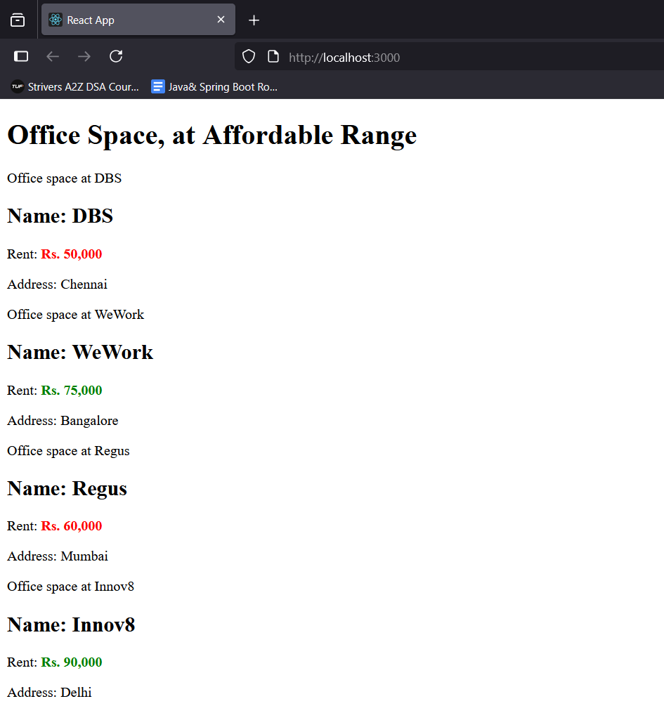

**Handson No. 11**

**App.css:**

body {

margin: 0;

font-family: -apple-system, BlinkMacSystemFont, 'Segoe UI', 'Roboto', 'Oxygen',

'Ubuntu', 'Cantarell', 'Fira Sans', 'Droid Sans', 'Helvetica Neue',

sans-serif;

background-color: #ffffff;

}

.app-wrapper {

display: flex;

height: 100vh;

}

/* Sidebar styles */

.sidebar {

width: 200px;

background-color: #f0f0f0;

padding: 20px;

border-right: 1px solid #ccc;

display: flex;

flex-direction: column;

}

.sidebar button {

background-color: #e7e7e7;

border: 1px solid #ccc;

padding: 10px;

margin-bottom: 10px;

text-align: left;

cursor: pointer;

border-radius: 4px;

}

.sidebar button:hover {

background-color: #ddd;

}

/* Main content styles */

.main-content {

flex-grow: 1;

padding: 40px;

}

.main-title {

color: #2e8b57; /* A shade of green */

font-size: 2.5rem;

margin-top: 0;

margin-bottom: 30px;

}

/* Form styles */

.currency-form {

width: 100%;

max-width: 300px;

}

.form-group {

margin-bottom: 15px;

display: flex;

align-items: center;

}

.form-group label {

width: 80px; /* Fixed width for labels */

margin-right: 10px;

font-weight: bold;

}

.form-group input {

flex-grow: 1;

padding: 8px;

border: 1px solid #ccc;

border-radius: 4px;

}

.submit-button {

background-color: #e7e7e7;

border: 1px solid #ccc;

padding: 10px 20px;

cursor: pointer;

border-radius: 4px;

display: block;

margin-left: 90px; /* Aligns with input fields */

}

.submit-button:hover {

background-color: #ddd;

}

/* Custom Alert styles */

.alert-overlay {

position: fixed;

top: 0;

left: 0;

right: 0;

bottom: 0;

background-color: rgba(0, 0, 0, 0.2);

display: flex;

justify-content: center;

align-items: flex-start;

padding-top: 20px;

}

.alert-box {

background-color: #f0f0f0;

border: 1px solid #ccc;

padding: 15px 20px;

border-radius: 5px;

box-shadow: 0 2px 10px rgba(0, 0, 0, 0.1);

display: flex;

align-items: center;

}

.alert-box p {

margin: 0;

margin-right: 20px;

}

.alert-box button {

background-color: #007bff;

color: white;

border: none;

padding: 8px 16px;

border-radius: 4px;

cursor: pointer;

}

**App.js:**

import React, { useState } from 'react';

import './App.css';

const CustomAlert = ({ message, onClose }) => {

if (!message) return null;

return (

<div className="alert-overlay">

<div className="alert-box">

<p>{message}</p>

<button onClick={onClose}>OK</button>

</div>

</div>

);

};

function App() {

const [amount, setAmount] = useState('80');

const [currency, setCurrency] = useState('Euro');

const [alertMessage, setAlertMessage] = useState('');

const handleFormSubmit = (event) => {

event.preventDefault();

setAlertMessage(`Converting ${amount} ${currency}!`);

};

return (

<div className="app-wrapper">

<CustomAlert message={alertMessage} onClose={() => setAlertMessage('')} />

<div className="sidebar">

<button onClick={() => setAlertMessage('Increment clicked!')}>Increment</button>

<button onClick={() => setAlertMessage('Decrement clicked!')}>Decrement</button>

<button onClick={() => setAlertMessage('Welcome!')}>Say welcome</button>

<button onClick={() => setAlertMessage('You clicked me!')}>Click on me</button>

</div>

<div className="main-content">

<h1 className="main-title">Currency Convertor!!!</h1>

<form onSubmit={handleFormSubmit} className="currency-form">

<div className="form-group">

<label htmlFor="amount">Amount</label>

<input

type="text"

id="amount"

value={amount}

onChange={(e) => setAmount(e.target.value)}

/>

</div>

<div className="form-group">

<label htmlFor="currency">Currency</label>

<input

type="text"

id="currency"

value={currency}

onChange={(e) => setCurrency(e.target.value)}

/>

</div>

<button type="submit" className="submit-button">Submit</button>

</form>

</div>

</div>

);

}

export default App;

**OUPUT:**

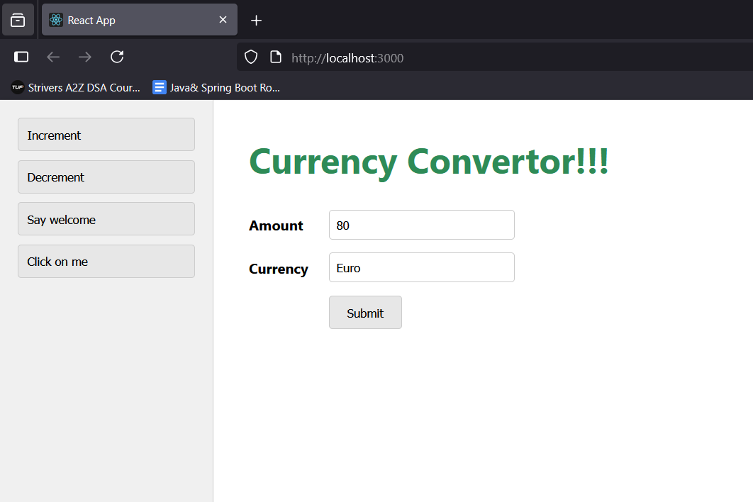

**Handson No. 12**

**App.js:**

import React, { useState } from 'react';

import './App.css';

function UserGreeting() {

return <h1>Welcome back</h1>;

}

function GuestGreeting() {

return <h1>Please sign up.</h1>;

}

function Greeting(props) {

const isLoggedIn = props.isLoggedIn;

if (isLoggedIn) {

return <UserGreeting />;

}

return <GuestGreeting />;

}

function LoginButton(props) {

return (

<button onClick={props.onClick}>

Login

</button>

);

}

function LogoutButton(props) {

return (

<button onClick={props.onClick}>

Logout

</button>

);

}

function App() {

const [isLoggedIn, setIsLoggedIn] = useState(false);

const handleLoginClick = () => {

setIsLoggedIn(true);

};

const handleLogoutClick = () => {

setIsLoggedIn(false);

};

let button;

if (isLoggedIn) {

button = <LogoutButton onClick={handleLogoutClick} />;

} else {

button = <LoginButton onClick={handleLoginClick} />;

}

return (

<div className="container">

<Greeting isLoggedIn={isLoggedIn} />

{button}

</div>

);

}

export default App;

**OUPUT:**

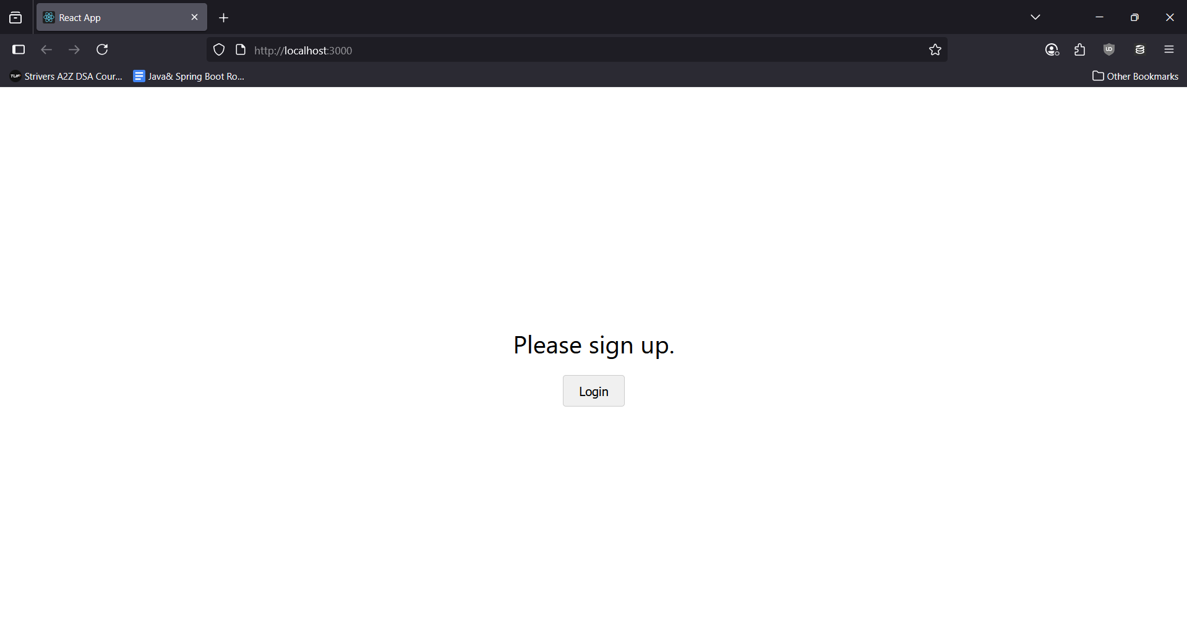

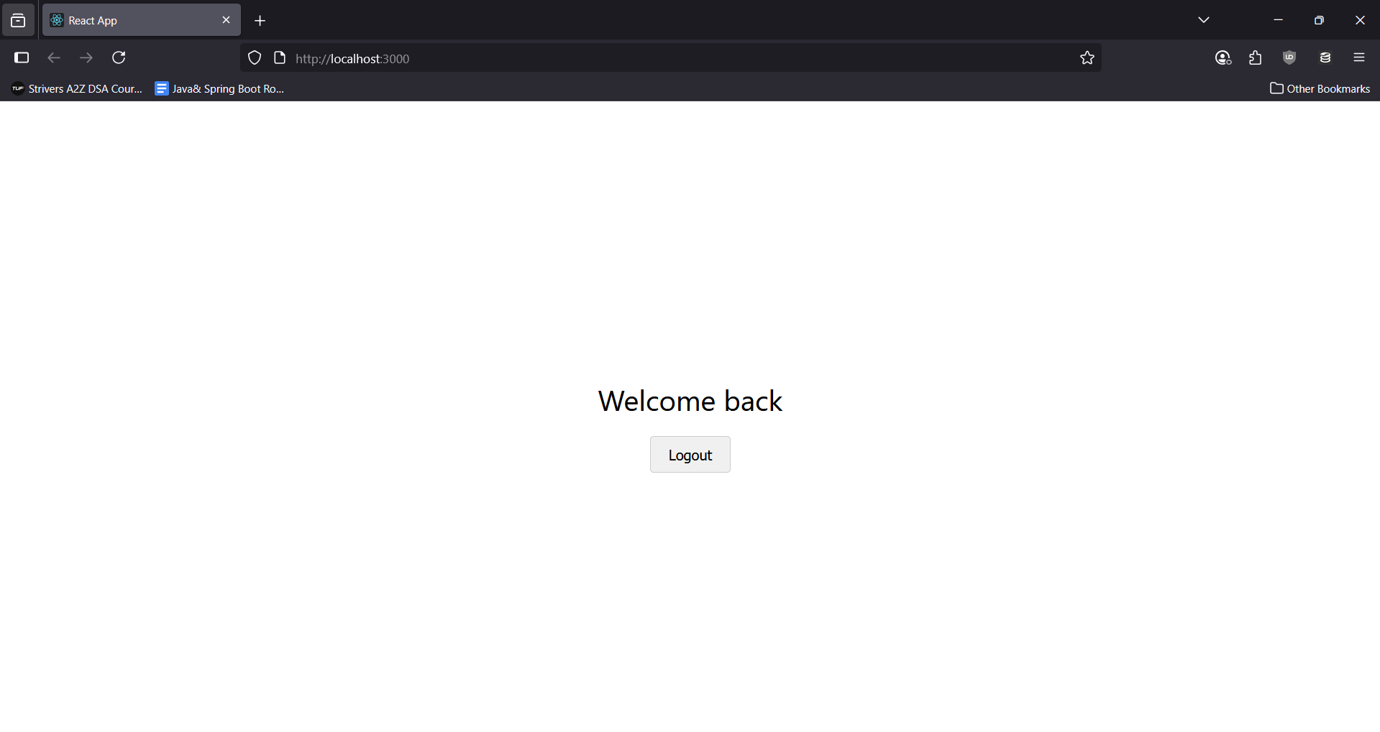

**Handson No. 13**

**App.js:**

import React from 'react';

import './App.css';

const courses = [

{ id: 1, name: 'Angular', date: '4/5/2021' },

{ id: 2, name: 'React', date: '6/3/2021' },

];

const books = [

{ id: 101, bname: 'Master React', price: 670 },

{ id: 102, bname: 'Deep Dive into Angular 11', price: 800 },

{ id: 103, bname: 'Mongo Essentials', price: 450 },

];

const blogs = [

{

id: 1,

title: 'React Learning',

author: 'Stephen Biz',

content: 'Welcome to learning React!'

},

{

id: 2,

title: 'Installation',

author: 'Schewzdenier',

content: 'You can install React from npm.'

}

];

function CourseDetails() {

return (

<div className="section">

<h2 className="section-title">Course Details</h2>

{courses.map(course => (

<div key={course.id} className="item">

<h3>{course.name}</h3>

<p>{course.date}</p>

</div>

))}

</div>

);

}

function BookDetails() {

return (

<div className="section">

<h2 className="section-title">Book Details</h2>

{books.map(book => (

<div key={book.id} className="item">

<h3>{book.bname}</h3>

<p>{book.price}</p>

</div>

))}

</div>

);

}

function BlogDetails() {

return (

<div className="section">

<h2 className="section-title">Blog Details</h2>

{blogs.map(blog => (

<div key={blog.id} className="item">

<h3>{blog.title}</h3>

<p><strong>{blog.author}</strong></p>

<p>{blog.content}</p>

</div>

))}

</div>

);

}

function App() {

return (

<div className="app-container">

<CourseDetails />

<div className="vertical-divider"></div>

<BookDetails />

<div className="vertical-divider"></div>

<BlogDetails />

</div>

);

}

export default App;

**OUPUT:**

