DN 4.0 Dotnet FSE
Name: Aditya Mohanty
Superset ID:6361043
Week 8
Git
HOL-1
Step 1
Git Version
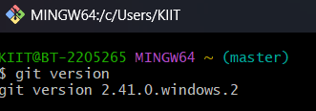
User level configuration
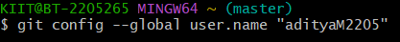
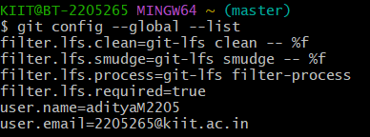
Step 2
Notepad with bash
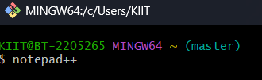
Alias
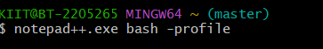
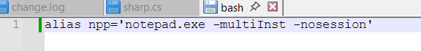
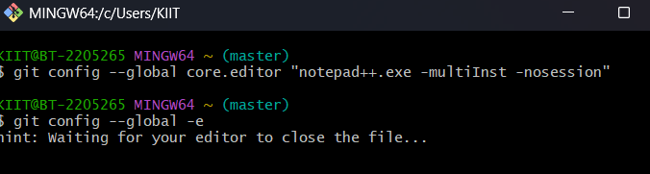
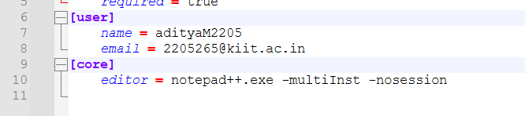
Step 3
Add file to source code repository
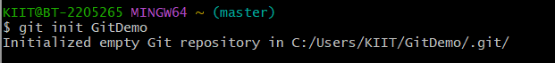
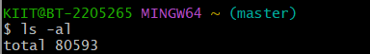
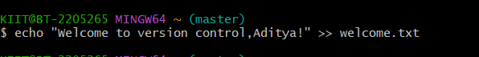
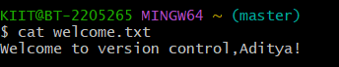
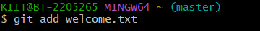
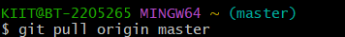

HOL-2
Git ignore
Creating a sample example.log and log folder in an already existing repository(last week’s react app).
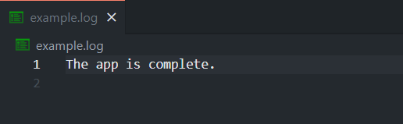
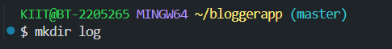
Adding files in .gitignore
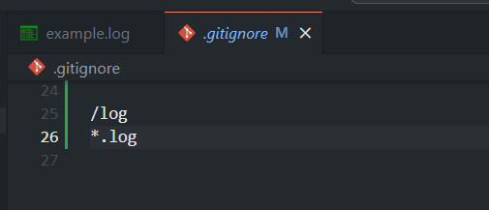

Adding and Comitting files
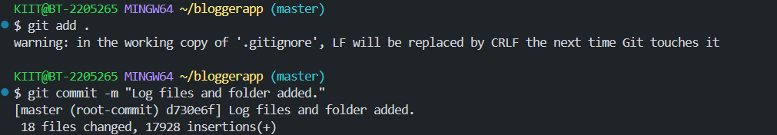
Checking
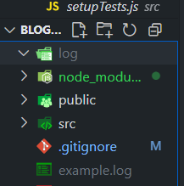
We see locally the example.log and log folder have been ignored(greyed out/dull).Even on gitlab the files are not visible.
HOL-3
Creating and switching to a new branch
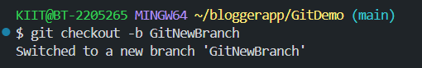
Listing all the branches(*is on the new one)
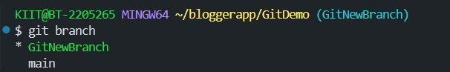
Adding a new file in the new branch
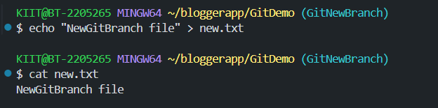
Git status
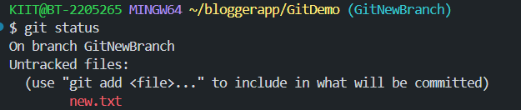
Configuring p4merge
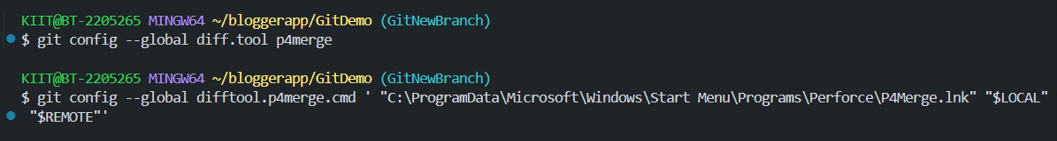
HOL-4
Checking if master is clean
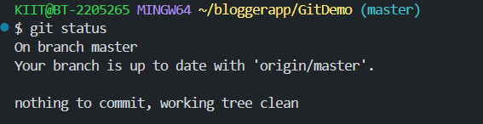
Creating new branch and file
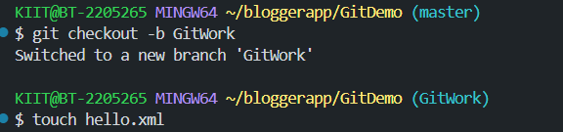
Updating contents
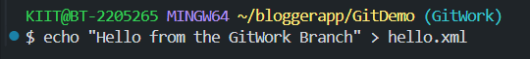
Comitting
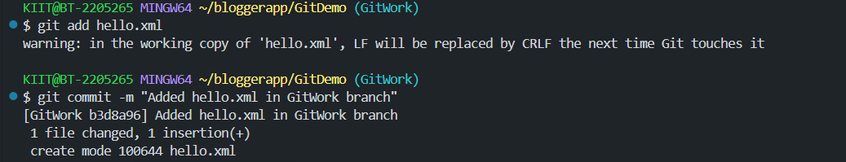
Switching to master and adding the same file with different contents
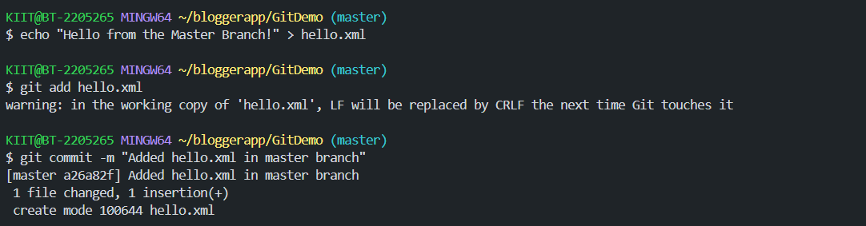
Log
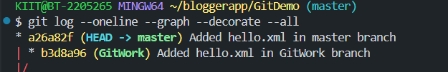
Checking differences:
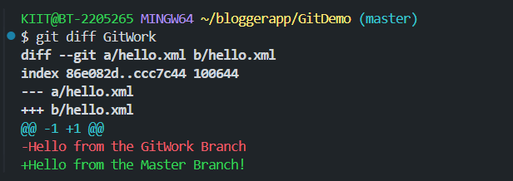
Trying to merge but conflict arises
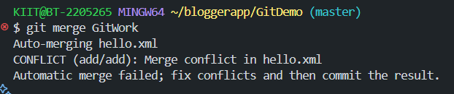
Observing conflict markers
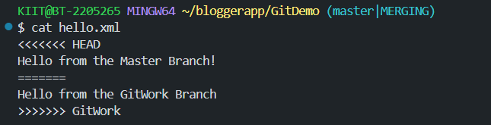
Merged and resolved conflicts:
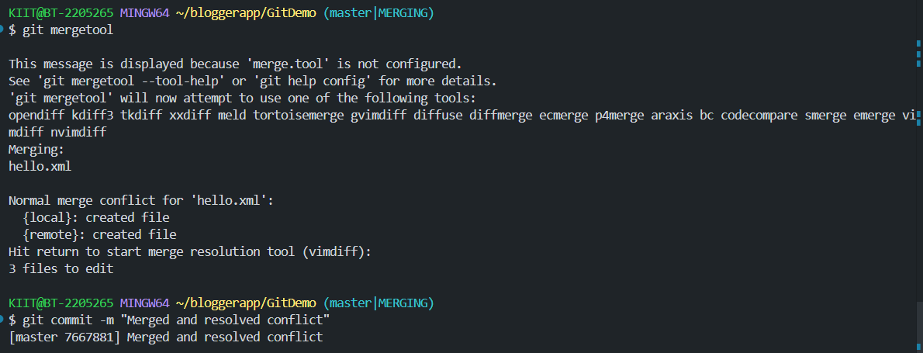
Updating git ignore
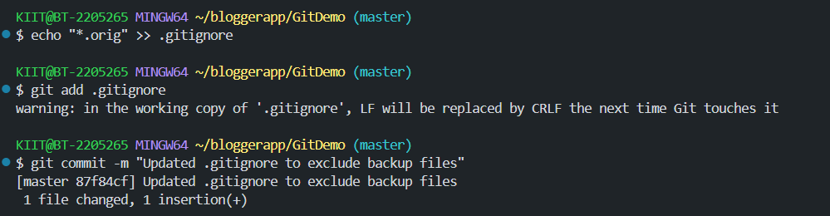
Checking if merge was successful
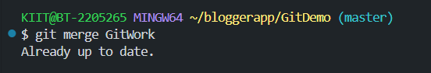
Available branches
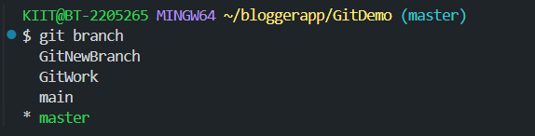
Deleting GitWork
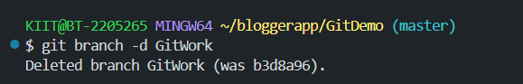
Checking Logs
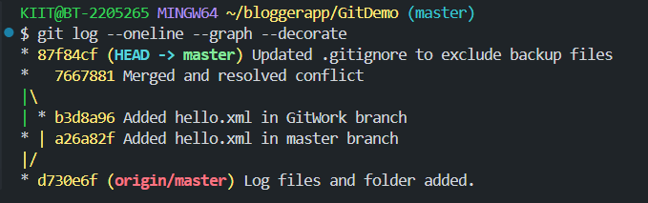
HOL-5
Checking if master is clean
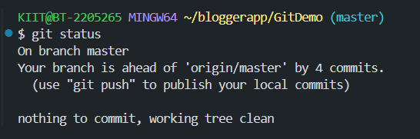
Available branches(GitWork deleted)
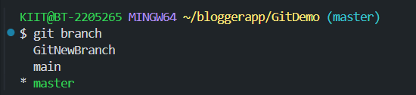
Pulling from Remote repository

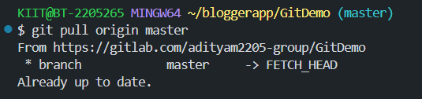
Pushing changes
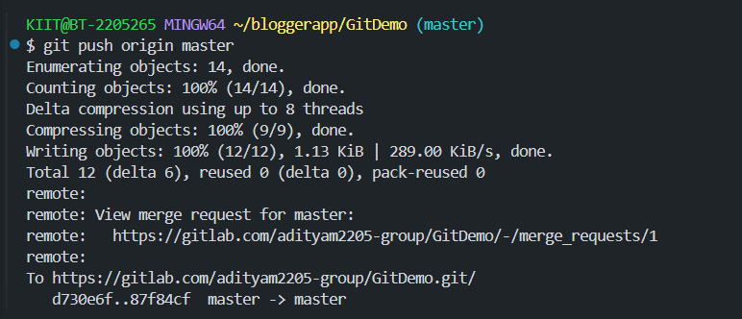
Checking if changes are reflected in remote repository
