**LAB1:**

1. **Describe Operating System**
2. **Types of Operating System**
3. **Features of Operating System**
4. **Linux Architecture with Diagram**
5. **Shell and kernel with example.**
6. **Command done in class.**
7. **Operating system:**

An Operating System (OS) is an interface between a computer user and computer hardware. An operating system is a software which performs all the basic tasks like file management, memory management, process management, handling input and output, and controlling peripheral devices such as disk drives and printers.

1. **Types of Operating system:**

* Batch Operating System
* Multitasking/Time Sharing OS
* Multiprocessing OS
* Real Time OS
* Distributed OS
* Network OS
* Mobile OS

### **Batch Operating System**

Some computer processes are very lengthy and time-consuming. To speed the same process, a job with a similar type of needs are batched together and run as a group.

The user of a batch operating system never directly interacts with the computer. In this type of OS, every user prepares his or her job on an offline device like a punch card and submit it to the computer operator.

### **Multitasking/Time-sharing Operating systems**

Time-sharing operating system enables people located at a different terminal(shell) to use a single computer system at the same time. The processor time (CPU) which is shared among multiple users is termed as time sharing.

### **Real time OS**

A real time operating system time interval to process and respond to inputs is very small. Examples: Military Software Systems, Space Software Systems.

### **Distributed Operating System**

Distributed systems use many processors located in different machines to provide very fast computation to its users.

### **Network Operating System**

Network Operating System runs on a server. It provides the capability to serve to manage data, user, groups, security, application, and other networking functions.

### **Mobile OS**

Mobile operating systems are those OS which is especially that are designed to power smartphones, tablets, and wearable devices.

Some most famous mobile operating systems are Android and iOS, but others include BlackBerry,etc.

1. **Features of an operating system:**

* Protected and supervisor mode
* Allows disk access and file systems Device drivers Networking Security
* Program Execution
* Memory management Virtual Memory Multitasking
* Handling I/O operations
* Manipulation of the file system
* Error Detection and handling
* Resource allocation
* Information and Resource Protection

1. **Linux architecture with diagram:**

The Linux system works basically on 4 layers. First view the diagram below, which is showing the architecture of a Linux System.

[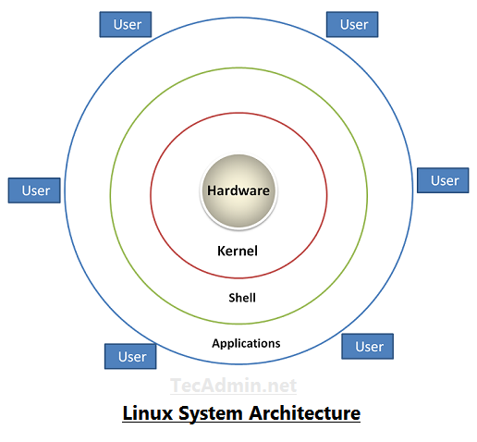](https://tecadmin.net/tutorial/wp-content/uploads/2017/10/linux-architecture-image.png)

1. **Shell and Kernel:**
2. **Shell:** A shell is an interface between a user and the operating system. It lets us give commands to the system and start other programs. Your task is to program a simple [shell](https://en.wikipedia.org/wiki/Shell_(computing)" \t "http://www.it.uu.se/education/course/homepage/os/vt18/module-2/shell/_blank) similar to for example [Bash](https://en.wikipedia.org/wiki/Bash_(Unix_shell)" \t "http://www.it.uu.se/education/course/homepage/os/vt18/module-2/shell/_blank), which probably is the command shell you normally use when you use a Unix/Linux system.
3. **Kernel:** The kernel is the central component of a computer operating systems. The only job performed by the kernel is to the manage the communication between the software and the hardware. A Kernel is at the nucleus of a computer. It makes the communication between the hardware and software possible. While the Kernel is the innermost part of an operating system, a shell is the outermost one.