UNIT III: LINKED LIST
DEVELOP A MATCHSTICKS GAME USING SINGLY LINKED LIST

1.Problem Statement
The Matchsticks Game is a classic two-player game in which a fixed number of matchsticks are placed on the table and the players take turns removing a limited number of sticks. To implement this game as a program, the matchsticks must be stored in a structure that shrinks as sticks are removed, and the program must always know how many sticks are left. Using a fixed-size array for this purpose wastes memory and does not model the removal of items naturally.
The aim of this project is to develop a two-player Matchsticks Game in C++ using a Singly Linked List. Each matchstick is represented as a node containing its number and a pointer to the next matchstick. The game starts with 21 matchsticks. The two players alternately pick 1 to 4 matchsticks, and the player who picks the last matchstick loses. This project demonstrates the practical application of pointers, dynamic memory allocation, structures, functions, and singly linked lists in C++.
2. Objective
The main objectives of this project are:
- To understand the concept and implementation of a singly linked list.
- To create matchstick nodes dynamically using pointers and the new operator.
- To traverse a linked list in order to count and display the remaining matchsticks.
- To delete nodes from the beginning of the list whenever a player picks matchsticks.
- To validate the player's input, such as non-numeric values, values outside the range 1 to 4, and values greater than the number of remaining matchsticks.
- To alternate turns between two players and to decide the winner of the game.
- To release the dynamically allocated memory using the delete operator.
- To develop a console-based game using structures, functions, loops, and conditional statements.
3. Introduction
3.1 Introduction to Singly Linked List
A Singly Linked List is a linear data structure in which each node contains two parts:
Data: Stores the information associated with the node.
Next pointer (next): Stores the address of the next node in the list.
Unlike a doubly linked list, a singly linked list can be traversed in the forward direction only. The first node is pointed to by a pointer called head, and the last node has its next pointer set to NULL (nullptr in C++), which marks the end of the list. Nodes are created dynamically at run time, so no fixed amount of memory is required in advance.
The general structure of a node is:
[ data | next ]
In this project, the data part stores the number of the matchstick. A list of 21 matchsticks can be represented as:
head → Stick 1 → Stick 2 → Stick 3 → … → Stick 21 → NULL
3.2 Rules of the Game
- The game starts with 21 matchsticks.
- Two players take turns.
- Each player can pick 1 to 4 matchsticks per turn.
- The player who picks the last matchstick loses.
- The program displays the remaining matchsticks after every turn.
3.3 Working of the Matchsticks Game
The program uses a structure named Node to represent each matchstick. It contains an integer field matchstick and a pointer next that points to the next node. The following functions work on the list through the head pointer:
- createMatchsticks(n): Creates n nodes dynamically, numbers them from 1 to n, links each new node to the end of the list, and returns the head of the list. The game uses n = 21.
- countMatchsticks(head): Traverses the list from the first node to the last node and returns the number of nodes, that is, the number of matchsticks remaining.
- displayMatchsticks(head): Traverses the list and prints one vertical bar (|) for every remaining matchstick.
- removeMatchsticks(head, n): Removes n nodes from the beginning of the list. For each node, the program stores the head in a temporary pointer, moves head to the next node, and releases the removed node using the delete operator. The head is passed by reference so that the change is visible in the calling function.
- deleteList(head): Deletes all the nodes that are still present in the list, so that no memory is leaked when the program ends.
The main function creates the list of 21 matchsticks, sets the current player to Player 1, and displays the rules. It then repeats the following loop while matchsticks remain. The remaining matchsticks are displayed and the current player is asked to pick 1 to 4 matchsticks. A non-numeric input, a number outside the range 1 to 4, or a number greater than the remaining matchsticks is rejected with an error message, and the same player is asked again. For a valid choice, the selected number of nodes is removed from the beginning of the list. If the list becomes empty, the current player has picked the last matchstick, so that player loses and the other player wins. Otherwise, the turn passes to the other player.
3.4 Advantages of Using a Singly Linked List
1.The list grows and shrinks dynamically, so it matches the changing number of matchsticks.
2.Removing nodes from the beginning only requires moving the head pointer.
3.No fixed amount of memory is required in advance.
4.Memory of each removed matchstick is returned to the system immediately using delete.
5.It provides a practical example of pointer manipulation and dynamic memory management.
3.5 Applications
Singly linked lists are used wherever data has to be inserted or removed dynamically and traversed in one direction, such as stacks and queues, task and job lists, polynomial representation, and the chaining of items in hash tables.

4. Algorithm
Step 1: Start
Begin the program.
Step 2: Create the List
Create a singly linked list of 21 nodes (matchsticks numbered 1 to 21) using createMatchsticks(), and set player = 1.
Step 3: Display Rules
Display the game title and the rules of the game.
Step 4: Check the List
If the number of nodes in the list is greater than 0, go to Step 5. Otherwise, go to Step 11.
Step 5: Display Matchsticks
Display one | for every remaining node, and ask the current player to pick 1 to 4 matchsticks.
Step 6: Read the Choice
Read the choice entered by the player. If the input is not a number, clear the input error, discard the invalid input, display "Invalid input! Enter a number.", and go back to Step 4. The same player plays again.
Step 7: Validate the Choice
If the choice is less than 1 or greater than 4, display "Invalid choice! Pick between 1 and 4." and go back to Step 4. If the choice is greater than the remaining matchsticks, display "Not enough matchsticks remaining!" and go back to Step 4.
Step 8: Remove Matchsticks
Remove the chosen number of nodes from the beginning of the list. For each node, store head in a temporary pointer, move head to the next node, and delete the temporary node.
Step 9: Check for the Last Matchstick
If head is NULL, the current player has picked the last matchstick. Display that the current player loses and the other player wins, and go to Step 11.
Step 10: Switch Player
Change the player (Player 1 to Player 2, or Player 2 to Player 1) and go back to Step 4.
Step 11: Free Memory
Delete all the nodes remaining in the list using deleteList().
Step 12: Stop
Terminate the program.

5. Flowchart:

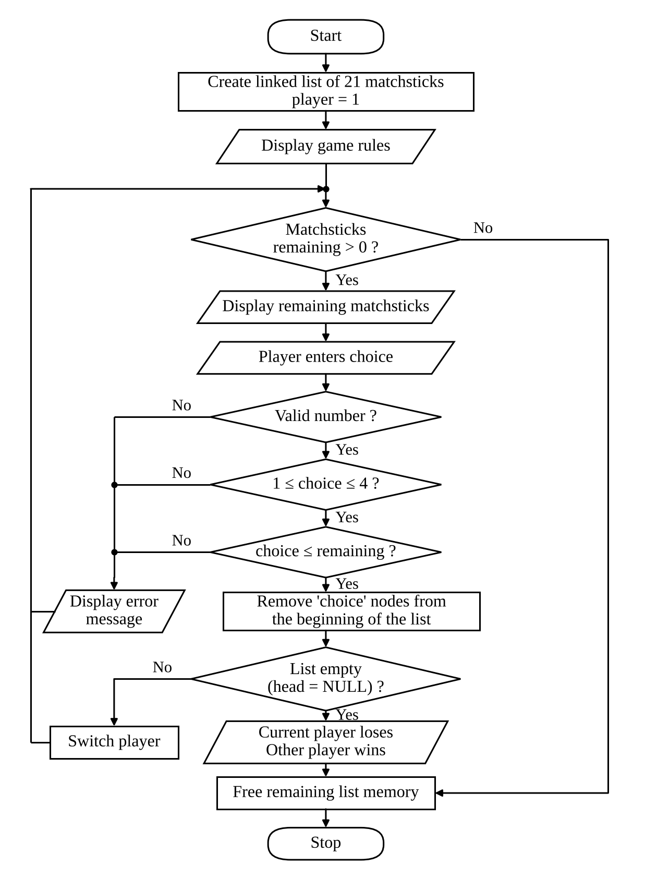

6. Program:
#include <iostream>

using namespace std;

struct Node {
int matchstick;
Node* next;
};

// Create a linked list of matchsticks
Node* createMatchsticks(int n) {
Node* head = nullptr;
Node* temp = nullptr;

for (int i = 1; i <= n; i++) {
Node* newNode = new Node;
newNode->matchstick = i;
newNode->next = nullptr;

if (head == nullptr) {
head = newNode;
temp = newNode;
} else {
temp->next = newNode;
temp = newNode;
}
}

return head;
}

// Count the remaining matchsticks
int countMatchsticks(Node* head) {
int count = 0;

while (head != nullptr) {
count++;
head = head->next;
}

return count;
}

// Display the remaining matchsticks
void displayMatchsticks(Node* head) {
cout << "\nRemaining matchsticks: ";

while (head != nullptr) {
cout << "| ";
head = head->next;
}

cout << '\n';
}

// Remove matchsticks from the beginning
void removeMatchsticks(Node*& head, int n) {
for (int i = 0; i < n && head != nullptr; i++) {
Node* temp = head;
head = head->next;
delete temp;
}
}

// Free the remaining linked list memory
void deleteList(Node*& head) {
while (head != nullptr) {
Node* temp = head;
head = head->next;
delete temp;
}
}

int main() {
Node* head = createMatchsticks(21);
int player = 1;
int choice;

cout << "===== MATCHSTICKS GAME =====\n";
cout << "Rules:\n";
cout << "1. Total matchsticks = 21\n";
cout << "2. Pick 1 to 4 matchsticks per turn\n";
cout << "3. The player who picks the last matchstick loses\n";

while (countMatchsticks(head) > 0) {
displayMatchsticks(head);

cout << "\nPlayer " << player
<< ", pick matchsticks (1-4): ";
cin >> choice;

if (cin.fail()) {
cin.clear();
cin.ignore(10000, '\n');
cout << "Invalid input! Enter a number.\n";
continue;
}

int remaining = countMatchsticks(head);

if (choice < 1 || choice > 4) {
cout << "Invalid choice! Pick between 1 and 4.\n";
continue;
}

if (choice > remaining) {
cout << "Not enough matchsticks remaining!\n";
continue;
}

removeMatchsticks(head, choice);

if (head == nullptr) {
cout << "\nPlayer " << player
<< " picked the last matchstick(s).\n";
cout << "Player " << player << " loses!\n";
cout << "Player " << (player == 1 ? 2 : 1)
<< " wins!\n";
break;
}

player = (player == 1) ? 2 : 1;
}

deleteList(head);
return 0;
}

7. Output:
===== MATCHSTICKS GAME =====
Rules:
1. Total matchsticks = 21
2. Pick 1 to 4 matchsticks per turn
3. The player who picks the last matchstick loses

Remaining matchsticks: | | | | | | | | | | | | | | | | | | | | |

Player 1, pick matchsticks (1-4): 4

Remaining matchsticks: | | | | | | | | | | | | | | | | |

Player 2, pick matchsticks (1-4): 4

Remaining matchsticks: | | | | | | | | | | | | |

Player 1, pick matchsticks (1-4): abc
Invalid input! Enter a number.

Remaining matchsticks: | | | | | | | | | | | | |

Player 1, pick matchsticks (1-4): 7
Invalid choice! Pick between 1 and 4.

Remaining matchsticks: | | | | | | | | | | | | |

Player 1, pick matchsticks (1-4): 4

Remaining matchsticks: | | | | | | | | |

Player 2, pick matchsticks (1-4): 4

Remaining matchsticks: | | | | |

Player 1, pick matchsticks (1-4): 3

Remaining matchsticks: | |

Player 2, pick matchsticks (1-4): 3
Not enough matchsticks remaining!

Remaining matchsticks: | |

Player 2, pick matchsticks (1-4): 2

Player 2 picked the last matchstick(s).
Player 2 loses!
Player 1 wins!

8. Result
The Matchsticks Game was successfully implemented in C++ using a singly linked list, and the program compiled and ran without errors. The sample run shown in the output section confirms the following:
- A linked list of 21 matchsticks was created and the remaining matchsticks were displayed correctly after every turn.
- The players were switched correctly after every valid move: Player 1 and Player 2 picked matchsticks alternately.
- Invalid entries were rejected without losing the turn. The text "abc" produced the message "Invalid input! Enter a number.", the number 7 produced "Invalid choice! Pick between 1 and 4.", and picking 3 when only 2 matchsticks were left produced "Not enough matchsticks remaining!".
- The chosen number of nodes was removed from the beginning of the list each time, and the count of the remaining matchsticks reduced accordingly (21, 17, 13, 9, 5, 2).
- Player 2 picked the last matchstick, so the program declared that Player 2 loses and Player 1 wins, as per the rules of the game.
- All remaining nodes were released using deleteList() before the program ended.

9. Conclusion
The Matchsticks Game was designed and implemented successfully in C++ using a singly linked list. The program creates the matchsticks dynamically, displays the remaining matchsticks, validates the input of the players, removes matchsticks from the list, alternates the turns, and declares the winner when the last matchstick is picked.
This project demonstrates how a singly linked list can be used to manage dynamically changing data efficiently. It also provides practical experience with structures, pointers, dynamic memory allocation and deallocation, functions, and loop-based programming. The project helped develop an understanding of linked list operations such as creation, traversal, and deletion, along with their real-world applications. In the future, the game could be extended to allow the players to choose the starting number of matchsticks, to play against the computer, to keep a score across several rounds, or to use a graphical interface.

