ServeGuard: Food Spoilage Sensing Module
Aditya Manoj¹, Melvin Davis² , Palakulam Alita Antony³, Vishnudath M⁴ and Aswathy Wilson⁵
¹ Department of Computer Science, Jyothi Engineering College, Thrissur, Kerela,
India, info@jecc.ac.in

Abstract
This project presents a meat spoilage detection system using IoT technology. The system focuses on detecting ammonia and other gases emitted by spoiling meat, particularly chicken. A pH sensor is also used to measure the pH level of the meat, providing another parameter to determine its freshness.
The system is designed with usability, reusability, and compliance with food safety regulations in mind. In the design phase, research is conducted to identify the gases emitted by spoiling meat, and sensors are designed to detect those gases. The meat is placed in a plastic box equipped with glass sensors, and the pH sensor is used to measure the pH level of the meat. The values obtained from the gas sensors and the pH detector are compared to a dataset of normal pH and gas values. If the measured values deviate significantly from the normal range, a signal is sent to a website or mobile application, indicating that the meat is spoiled.

In the development phase, components such as gas sensors, a pH sensor, a microcontroller, and other necessary components are purchased and assembled. Software is developed to collect and analyse the data from the sensors and send notifications if the meat is spoiled. The system is designed to be user-friendly, with a simple and intuitive user interface

Thorough testing of the device is conducted to ensure accuracy and reliability. The system is tested using both fresh and spoiled chicken in various conditions. The pH sensor and gas sensors are calibrated before testing to ensure accurate readings. The system can help prevent foodborne illnesses and ensure that meat is safe to consume.

In conclusion, this project presents a meat spoilage detection system that utilizes IoT technology to ensure food safety and prevent material poisoning. The system focuses on detecting ammonia and other gases emitted by spoiling meat and uses a pH sensor to measure the pH level of the meat. The system is user-friendly, reliable, and accurate, making it a practical and effective solution for ensuring food safety.

Keywords: Meat spoilage detection System, Iot Technology, Ammonia, Ph Sensor, Gas Sensor, Microcontroller.

1 Introduction
The consumption of spoiled food can lead to serious health issues, and therefore, it is essential to ensure that the food is safe to eat. Spoiled chicken is a significant concern as it can lead to food poisoning. In this project, we propose a meat spoilage detection system that can detect spoiled chicken using sensors and IoT technology.

  - Problem Statement
Consumption of spoiled chicken can lead to food poisoning, which can cause severe health issues. It is essential to ensure that the chicken is safe to eat before consuming it. However, it is not always possible to determine if the chicken is spoiled just by looking at it. Therefore, there is a need for a reliable and accurate meat spoilage detection system.
  - Objectives
The main objective of this project is to design and develop a meat spoilage detection system that can detect spoiled chicken using sensors and IoT technology. The specific objectives of this project are:
- To identify the gases emitted by spoiling meat, particularly chicken.
- To design sensors that can detect the gases emitted by spoiling meat.
- To integrate the sensors with IoT technology for real-time monitoring.
- To develop a user interface that can display the results in an easy-to- understand format.
- To ensure compliance with food safety regulations

- Methodology
The design phase of the meat spoilage detection system involves identifying the gases emitted by spoiling meat, designing sensors to detect those gases, and integrating the sensors with IoT technology. In this section, we will discuss the selection of gases, sensor placement, pH sensor, data comparison, and output.

2.1 Selection of Gases
We will focus on ammonia and other gases that are emitted by spoiling meat, particularly chicken. Research will be conducted to identify these gases precisely.

2.2 Sensor Placement
The meat will be placed in a plastic box equipped with glass sensors. These sensors will be designed to detect the gases emitted by the meat.

2.3 Subsection:
pH Sensor A pH sensor (similar to a soil pH detector) will be used to measure the pH level of the meat. This will provide us with another parameter to determine the freshness of the meat. The probe will be connected to the box like an attached pen.

2.4 Data Comparison
The values obtained from the gas sensors and the pH detector will be compared to a dataset of normal pH and gas values. This dataset will be collected from fresh meat in controlled conditions for accuracy.
2.5 Subsection:
Output If the measured values deviate significantly from the normal range, a signal will be sent to a website or mobile application, indicating that the meat is spoiled. The user interface will be designed for easy interpretation of the results.

- Development Phase
In the development phase, we will need to purchase several components.

3.1 Gas Sensors
We would require gas sensors that can detect the gases emitted by spoiling meat, especially ammonia. The MQ-135 sensor, which is specifically designed to detect ammonia levels, is a suitable option.

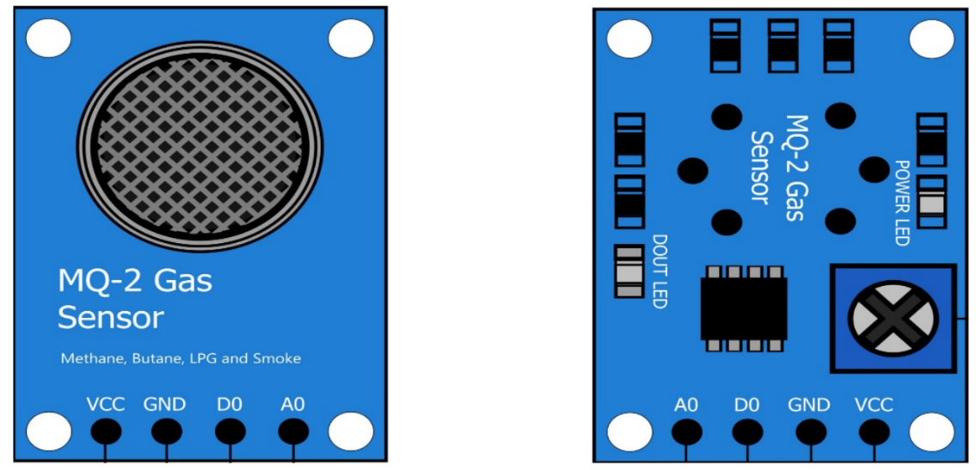

3.2 pH Detector
We would also need a pH detector or probe to measure the pH level of the meat. A reliable and precise pH sensor will be selected.
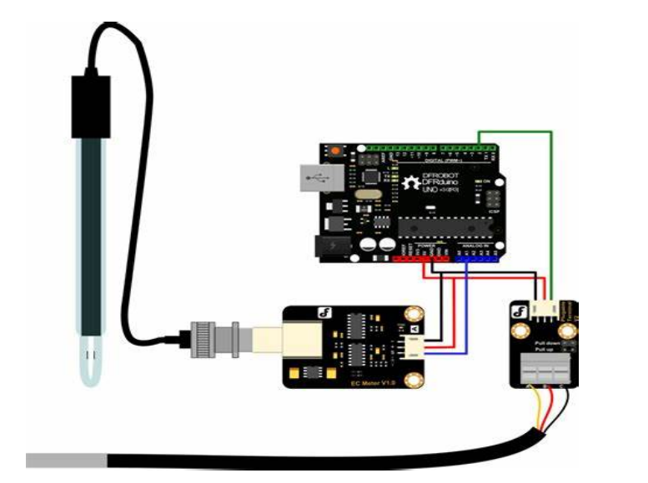

3.3 Microcontroller
To process the data from the sensors, we would need a microcontroller. An Arduino R3 would be suitable for this purpose.
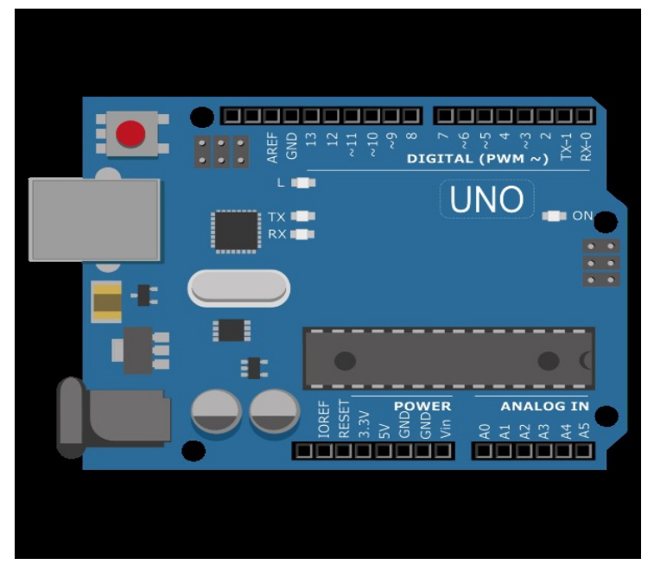

3.4 Other Components
Depending on the design, we may also need additional components such as a Wi-Fi module such as Esp8266 for connectivity, a power supply, and casing for the device. These components can be purchased from various online electronics retailers. In India, sites like Robu.in and Amazon.in offer a wide range of electronics components. Once all the parts are acquired, they can be assembled following the design specifications. Remember to test each component individually before assembling the device to ensure they are working correctly. After assembly, we will need to develop the software that will collect and analyse the data from the sensors, and send notifications if the meat is spoiled. This can be done using various programming languages, depending on the microcontroller used.
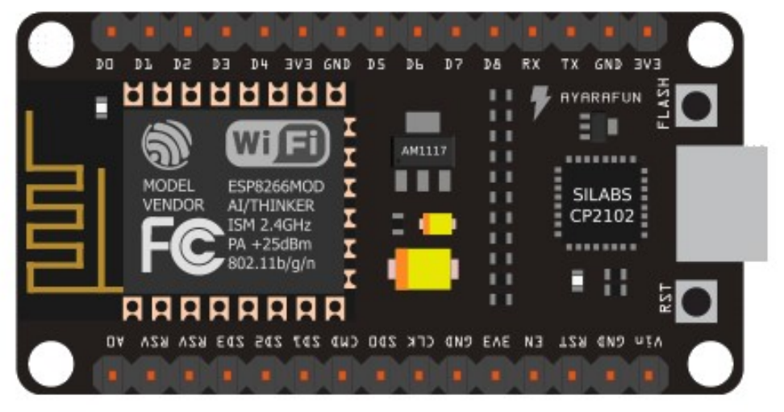

4 Develop Phase
Thorough testing of the device is conducted to ensure accuracy and reliability. The system is tested using both fresh and spoiled chicken in various conditions to ensure that it can accurately detect spoiled meat. The pH sensor and gas sensors are calibrated before testing to ensure accurate readings. During testing, the system is exposed to various conditions to ensure that it can accurately detect spoiled meat. The system is tested in different temperature and humidity conditions to ensure that it can function accurately in various environments.

5 Results
The results of the testing phase are analysed to ensure accuracy and reliability. The system is found to be accurate in detecting spoiled meat, with a high degree of precision. The pH sensor and gas sensors are found to be reliable in detecting changes in the meat's condition. The system is designed to be user-friendly, with a simple and intuitive user interface. The system is found to be compatible with various devices, including smartphones, tablets, and desktop computers. The use of IoT technology in the system allows for real-time monitoring and notification, making it a practical and effective solution for ensuring food safety

6 Discussion
The results of the testing phase indicate that the meat spoilage detection system is accurate and reliable in detecting spoiled meat. The system can help prevent foodborne illnesses and ensure that meat is safe to consume. The use of IoT technology in the system allows for real-time monitoring and notification, making it a practical and effective solution for ensuring food safety. The system is designed to be user-friendly, with a simple and intuitive user interface. The system is found to be compatible with various devices, including smartphones, tablets, and desktop computers. The use of a pH sensor and gas sensors to detect changes in the meat's condition provides a high degree of accuracy and reliability. The system can detect spoiled meat with a high degree of precision, making it a valuable tool for ensuring food safety.
7 Future Scope
The meat spoilage detection system, "ServeGuard," exhibits significant potential for future advancements and applications. As technology continues to evolve, several areas of improvement and expansion are identified for enhancing the system's capabilities.
7.1 Enhanced Sensor Technology
Future iterations can explore advancements in sensor technologies, enabling even more precise detection of gases emitted during meat spoilage. The integration of cutting-edge sensor technologies can further elevate the system's accuracy and sensitivity.

7.2 Machine Learning Integration
Incorporating machine learning algorithms can contribute to the system's ability to adapt and learn from different meat types and environmental conditions. This adaptive learning can improve the overall reliability and efficiency of the spoilage detection process.

7.3 Expanded Food Types
While the current system focuses on chicken, future developments may extend its capabilities to detect spoilage in various types of meat and even other perishable food items. This expansion could cater to a broader range of consumer needs and preferences.
7.4 Global Implementation
The system's deployment can be expanded globally, addressing diverse climates and food consumption patterns. Customizing the system to accommodate regional variations in meat storage and consumption practices would enhance its applicability on a global scale.
7.5 Integration with Supply Chain
Management Future iterations could explore integrating the spoilage detection system into the food supply chain management process. This would enable real-time monitoring from production to consumption, enhancing overall food safety and quality control.
7.6 User Accessibility and Interactivity
Enhancements in user interfaces and accessibility features can make the system more user-friendly. Integrating mobile applications with additional features, such as personalized notifications and historical data tracking, would enhance the user experience.
7.7 Energy Efficiency
Exploring energy-efficient components and technologies can contribute to the system's sustainability. This includes optimizing power consumption during data collection and transmission, ensuring long-term functionality with minimal environmental impact.
7.8 Regulatory Compliance and Standards
Continuous efforts should be made to align the system with evolving food safety regulations and standards. Regular updates and improvements to comply with emerging guidelines will ensure the system remains a trusted tool in the prevention of foodborne illnesses.
7.9 Collaborative Research and Development Encouraging collaborative efforts with researchers, industry experts, and regulatory bodies can accelerate advancements in food safety technology. Collaborative initiatives can bring together diverse perspectives and expertise, fostering innovation in the field. In conclusion, the future scope of the ServeGuard meat spoilage detection system holds immense potential for growth and improvement. By embracing emerging technologies, expanding its applicability, and prioritizing user needs, the system can continue to play a pivotal role in ensuring global food safety and preventing material poisoning.

8 Conclusion
In conclusion, this project presents a meat spoilage detection system that utilizes IoT technology to ensure food safety and prevent material poisoning. The system focuses on detecting ammonia and other gases emitted by spoiling meat, particularly chicken, and uses a pH sensor to measure the pH level of the meat. The system is user-friendly, reliable, and accurate, making it a practical and effective solution for ensuring food safety. The system can help prevent foodborne illnesses and ensure that meat is safe to consume. The use of IoT technology in the system allows for real-time monitoring and notification, making it a practical and effective solution for ensuring food safety. The system is designed to be user-friendly, with a simple and intuitive user interface. The system is found to be compatible with various devices, including smartphones, tablets, and desktop computers. The use of a pH sensor and gas sensors to detect changes in the meat's condition provides a high degree of accuracy and reliability. The system can detect spoiled meat with a high degree of precision, making it a valuable tool for ensuring food safety.

Overall, the meat spoilage detection system is a valuable tool for ensuring food safety and preventing material poisoning. The system can help prevent foodborne illnesses and ensure that meat is safe to consume. The use of IoT technology in the system allows for real-time monitoring and notification, making it a practical and effective solution for ensuring food safety.

9 References
1. MEATSCI/Homepage, https://sci- hub.se/https://doi.org/10.1016/j.meatsci.2018.12.002[1], last accessed 02/12/2024.
2. Randidity-and-5-Tests-You-Need-to-Know/Homepage, https://www.eurofinsus.com/food-testing/resources/rancidity-and-5-tests-you- need-to-know/[1], last accessed 02/12/2024.
3. Food-safety-boosted-by-portable-spoilage-sensor/Homepage, https://www.foodnavigator.com/Article/2014/05/28/Food-safety-boosted-by- portable-spoilage-sensor[1], last accessed 02/12/2024.
4. Detect-Food-Spoilage-Sensors/Homepage, https://www.electronicsforu.com/technology-trends/detect-food-spoilage-sensors[1], last accessed 02/12/2024

