

**Experiment 03 : Two Pass Assembler**

**Learning Objective**: Student should be able to Apply 2 pass Assembler for X86 machine.

**Tools:** Jdk1.8,Turbo C/C++, Python, Notepad++

**Theory:**

An assembler performs the following functions

1 Generate instructions

* 1. Evaluate the mnemonic in the operator field to produce its machine code.
  2. Evaluate subfields- find value of each symbol, process literals & assign address.

2 Process pseudo ops: we can group these tables into passed or sequential scans over input associated with each task are one or more assembler modules.

**Format of Databases:**

a) POT (Pseudo Op-code Table):-

POT is a fixed length table i.e. the contents of these table are altered during the assembly process.

|  |  |
| --- | --- |
| Pseudo Op-code (5 Bytes character) | Address of routine to process pseudo-op-code.  (3 bytes= 24 bit address) |
| “DROPb” | P1 DROP |
| “ENDbb” | P1 END |
| “EQUbb” | P1 EQU |
| “START” | P1 START |
| “USING” | P1 USING |

* The table will actually contain the physical addresses.
* POT is a predefined table.
* In PASS1 , POT is consulted to process some pseudo opcodes like-DS,DC,EQU
* In PASS2, POT is consulted to process some pseudo opcodes like DS,DC,USING,DROP

b) MOT (Mnemonic Op-code Table):-

MOT is a fixed length table i.e. the contents of these tables are altered during the assembly process.

|  |  |  |  |  |
| --- | --- | --- | --- | --- |
| Mnemonic Op-code  (4 Bytes character) | Binary Op-code  (1 Byte Hexadecimal) | Instruction Length  ( 2 Bits binary) | Instruction Format  (3 bits binary) | Not used in this design  (3 bits) |
| “Abbb” | 5A | 10 | 001 |  |
| “AHbb” | 4A | 10 | 001 |  |
| “ALbb” | 5E | 10 | 001 |  |
| “ALRb” | 1E | 01 | 000 |  |

b- Represents the char blanks.

Codes:-

Instruction Length Instruction Format

01= 1 Half word=2 Bytes 000 = RR

10= 2 Half word=4 Bytes 001 = RX

11= 3 Half word=6 Bytes 010 = RS

011= SI

100= SS

* MOT is a predefined table.
* In PASS1 , MOT is consulted to obtain the instruction length.(to Update LC)
* In PASS2, MOT is consulted to obtain:

1. Binary Op-code (to generate instruction)
2. Instruction length ( to update LC)
3. Instruction Format (to assemble the instruction).

C) Symbol table (ST):

|  |  |  |  |
| --- | --- | --- | --- |
| Symbol  (8 Bytes charaters) | Value  (4 Bytes Hexadecimal) | Length  ( 1 Byte Hexadecimal) | Relocation  (R/A)  (1 Byte character) |
| “PRG1bbb” | 0000 | 01 | R |
| “FOURbbbb” | 000C | 04 | R |

* ST is used to keep a track on the symbol defined in the program.
* In pass1- whenever the symbol is defined an entry is made in the ST.
* In pass2- Symbol table is used to generate the address of the symbol.

D) Literal Table (LT):

|  |  |  |  |
| --- | --- | --- | --- |
| Literal | Value | Length | Relocation (R/A) |
| = F ‘5’ | 28 | 04 | R |

* LT is used to keep a track on the Literals encountered in the program.
* In pass1- whenever the literals are encountered an entry is made in the LT.
* In pass2- Literal table is used to generate the address of the literal.

E) Base Table (BT):

|  |  |
| --- | --- |
| Register Availability  (1 Byte Character) | Contents of Base register  (3 bytes= 24 bit address hexadecimal) |
| 1 ‘N’ | - |
| 2 ‘N’ | - |
| .  . | - |
| 15 ‘N’ | 00 |

* Code availability-
* Y- Register specified in USING pseudo-opcode.
* N--Register never specified in USING pseudo-opcode.
* BT is used to keep a track on the Register availability.
* In pass1- BT is not used.
* In pass2- In pass2, BT is consulted to find which register can be used as base registers along with their contents.

F) Location Counter (LC):

- LC is used to assign addresses to each instruction & address to the symbol defined in the program.

- LC is updated only in two cases:-

a) If it is an instruction then it is updated by instruction length.

b) If it is a data representation (DS, DC) then it is updated by length of data field

**Data Structures:**

**Pass 1: Database**

1. Input source program
2. Location counter (LC) to keep the track of each instruction location
3. MOT (Machine OP table that gives mnemonic & length of instruction
4. POT (Pseudo op table) which indicate mnemonic and action to be taken for each pseudo-op
5. Literals table that is used to store each literals and its location
6. A copy of input to be used later by pass-2.

**Pass 2: Database**

1. Copy of source program from Pass1
2. Location counter
3. MOT which gives the length, mnemonic format op-code
4. POT which gives mnemonic & action to be taken
5. Symbol table from Pass1
6. Base table which indicates the register to be used or base register
7. A work space INST to hold the instruction & its parts
8. A work space PRINT LINE, to produce printed listing
9. A work space PUNCH CARD for converting instruction into format needed by loader
10. An output deck of assembled instructions needed by loader.

**Algorithm:**

**Pass 1**

1. Initialize LC to 0
2. Read instruction
3. Search for pseudo-op table and process it.
   1. If its a USING & DROP pseudo-op then pass it to pass2 assembler
   2. If its a DS & DC then Adjust LC and increment LC by L
   3. If its EQU then evaluate the operand field and add value of symbol in symbol table
   4. If its END then generates Literal Table and terminate pass1
4. Search for machine op table
5. Determine length of instruction from MOT
6. Process any literals and enter into literal table
7. Check for symbol in label field
   1. If yes assign current value of LC to Symbol in ST and increment LC by length
   2. If no increment LC by length
8. Write instruction to file for pass 2
9. Go to statement 2

**Pass 2**

1. Initialize LC to 0.
2. Read instruction
3. Search for pseudo-op table and process it.
   1. If it’s a USING then check for base register number and find the contents of the base register
   2. If it’s a DROP then base register is not available
   3. If it’s a DS then find length of data field and print it
   4. If DC then form constant and insert into machine code.
   5. If its EQU and START then print listing
   6. If its END then generates Literal Table and terminate pass1
   7. Generate literals for entries in literal table
   8. stop
4. Search for machine op table
5. Get op-code byte and format code
6. Set L = length
7. Check for type of instruction
   1. evaluate all operands and insert into second byte
   2. increment LC by length
   3. print listing
   4. Write instruction to file
8. Go to step 2

**Flowchart:Pass1**

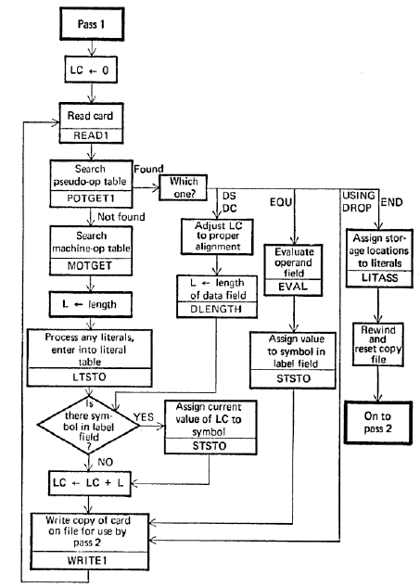

**Flowchart: Pass 2**

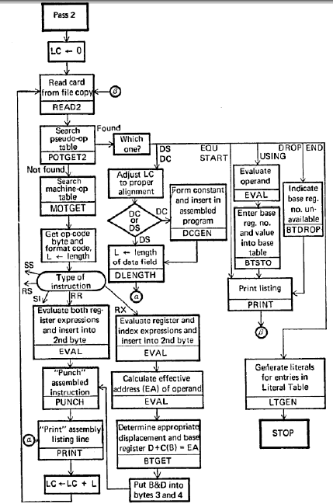

**Example:** JOHN START 0

USING *, 15

L 1, FIVE

A 1, FOUR

ST 1, TEMP

FOUR DC F ‘4’

FIVE DC F ‘5’

TEMP DS 1F

END

**Output:**Display as per above format.

**Application:** To design 2-pass assembler for X86 processor.

**Design:**

code = []

MOT_ref = {

    'L': ['L', '58', '4', 'RX'],

    'A': ['A', '5A', '4', 'RX'],

    'ST': ['ST', '50', '4', 'RX'],

    'BASR': ['BASR', '0D', '4', 'RX'],

    'BALR': ['BALR', '05', '2', 'RR'],

}

POT_ref = {

    'START': ['START', 'OPCODE FOR START'],

    'USING': ['USING', 'OPCODE FOR USING'],

    'END': ['END', 'OPCODE FOR END'],

    'DC': ['DC', 'OPCODE FOR DC'],

    'DS': ['DS', 'OPCODE FOR DS']

}

lc = 0

length = 0

MOT = []

POT = []

symbolTable = []

operands = []

# take input form file

with open('./textfile.txt') as f:

    code = f.readlines()

for i, line in enumerate(code):

    tokens = line.split(' ')

    print(f"LINE {i+1}:{tokens}")

    for token in tokens:

        if token in MOT_ref:

            length = int(MOT_ref[token][2])

            lc += length

            MOT.append(MOT_ref[token])

        elif token in POT_ref:

            if token == "DC" or token == 'DS':

                lc += 4

            POT.append(POT_ref[token])

        else:

            flag = True

            for char in token:

                if char == ',' or char in '0123456789':

                    flag = False

                    break

            if flag:

                symbolTable.append(tuple((token, lc, length, 'R')))

            else:

                operands.append(tuple((token[:-1].split(','), f"line: {i+1}")))

print('\n\nMOT:')

print("mnemonic\tbinary_op\tins_length\tins_format")

for x in MOT:

    print(f"{x[0]}\t\t{x[1]}\t\t{x[2]}\t\t{x[3]}")

print('\n\nPOT:')

print("mnemonic\topcode")

for x in POT:

    print(f"{x[0]}\t\t{x[1]}")

print('\n\nSymbols:')

print('symbol\tvalue\tlength\trelocation')

for x in symbolTable:

    print(f"{x[0]}\t{x[1]}\t{x[2]}\t{x[3]}")

print('\n\nOperands:', operands)

print('')

**Result and Discussion:**

LINE 1:['JOHN', 'START', '0\n']

LINE 2:['USING', '*,15\n']

LINE 3:['L', '1,FOUR\n']

LINE 4:['A', '1,FIVE\n']

LINE 5:['ST', '1,TEMP\n']

LINE 6:['FOUR', 'DC', "F'4\n"]

LINE 7:['FIVE', 'DC', "F'5\n"]

LINE 8:['TEMP', 'DS', '1F\n']

LINE 9:['END']

MOT:

mnemonic    binary_op   ins_length  ins_format

L       58      4       RX

A       5A      4       RX

ST      50      4       RX

POT:

mnemonic    opcode

START       OPCODE FOR START

USING       OPCODE FOR USING

DC      OPCODE FOR DC

DC      OPCODE FOR DC

DS      OPCODE FOR DS

END     OPCODE FOR END

Symbols:

symbol  value   length  relocation

JOHN    0   0   R

FOUR    12  4   R

FIVE    16  4   R

TEMP    20  4   R

Operands: [(['0'], 'line: 1'), (['*', '15'], 'line: 2'), (['1', 'FOUR'], 'line: 3'), (['1', 'FIVE'], 'line: 4'), (['1', 'TEMP'], 'line: 5'), (["F'4"], 'line: 6'), (["F'5"], 'line: 7'), (['1F'], 'line: 8')]

**Learning Outcomes:** The student should have the ability to

LO1: ***Describe*** the different database formats of 2-pass Assembler with the help of examples.

LO2: **Design** 2 pass Assembler for X86 machine.

LO3: ***Develop***2-pass Assembler for X86 machine.

LO4: Illustrate the working of 2-Pass Assembler.

**Course Outcomes**: Upon completion of the course students will be able to Describe the various data structures and passes of assembler design.

**Conclusion:** In these experiment we perform code is a script for parsing assembly code written in a specific syntax. It reads input from a file, identifies and categorizes different types of tokens (i.e., mnemonics, opcodes, symbols, and operands), and then outputs the results in a formatted manner.

For Faculty Use

|  |  |  |  |  |
| --- | --- | --- | --- | --- |
| **Correction Parameters** | **Formative Assessment [40%]** | **Timely completion of Practical [ 40%]** | **Attendance / Learning Attitude [20%]** |  |
| **Marks Obtained** |  |  |  |