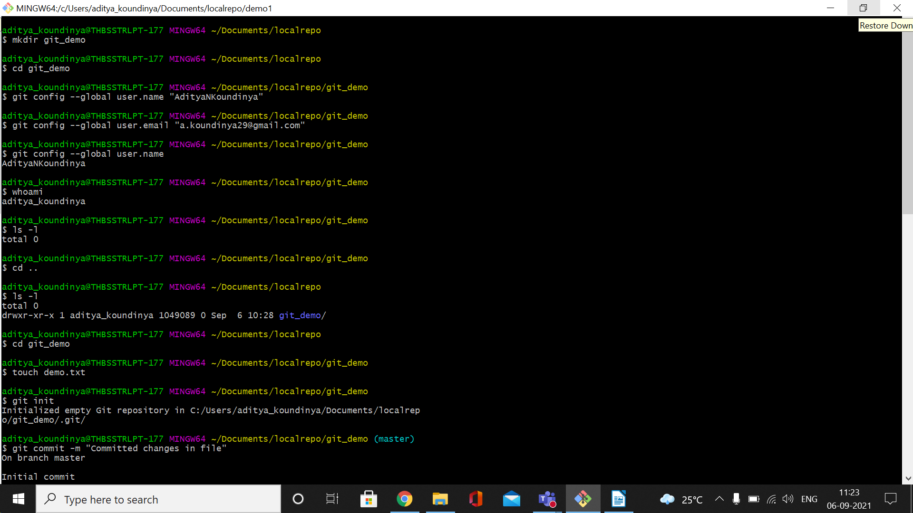
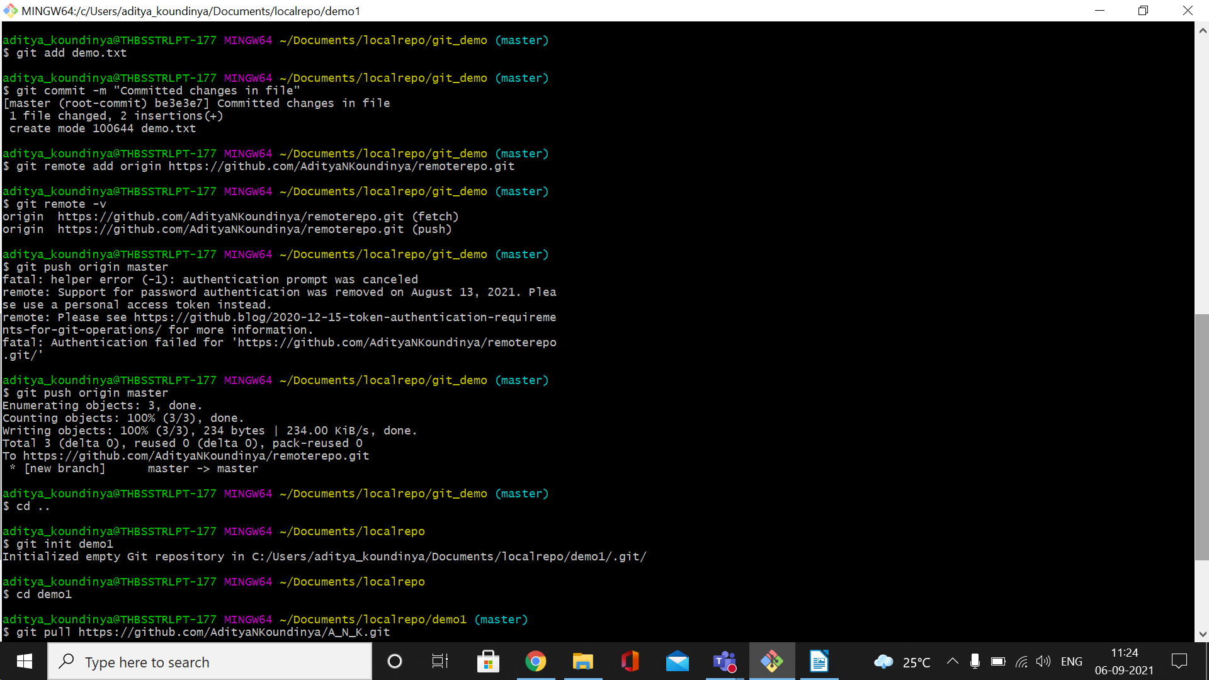
File push
go to localrepo director and open the gitBash
1. create directory
2. cd to the new created director
3. create a new file : touch demo.txt
4. git init :---> curr directory
5 git add demo.txt
6 git commit -m message
7. git remote add origin https://github.com/mythsubu1073busfund/neweclipserepo1.git
8. git removte -v
9. git push origin master

File pull from remote repository

1. git init demo_repo
2. git pull https://github.com/mythsubu1073busfund/neweclipserepo1.git

File push using clone
1. go to localrepo director and open the gitBash
2. git clone https://github.com/mythsubu1073busfund/neweclipserepo1
3. cd neweclipserepo1
4, Create a project in eclipse and give path : browse and give the path:local repository
5. ls
/scr /bin
6. git add .
7. git commit -m message
8. git push origin master

