**Amplify**

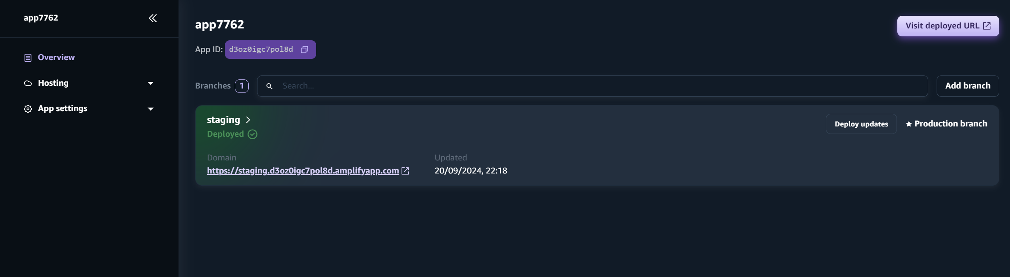

**Lambda**

Lambda tests

**Lambda IAM Role**

**API Gateway**

API Gateway Resources

API GET

Get integration request – lambda proxy integration on

Enable CORS

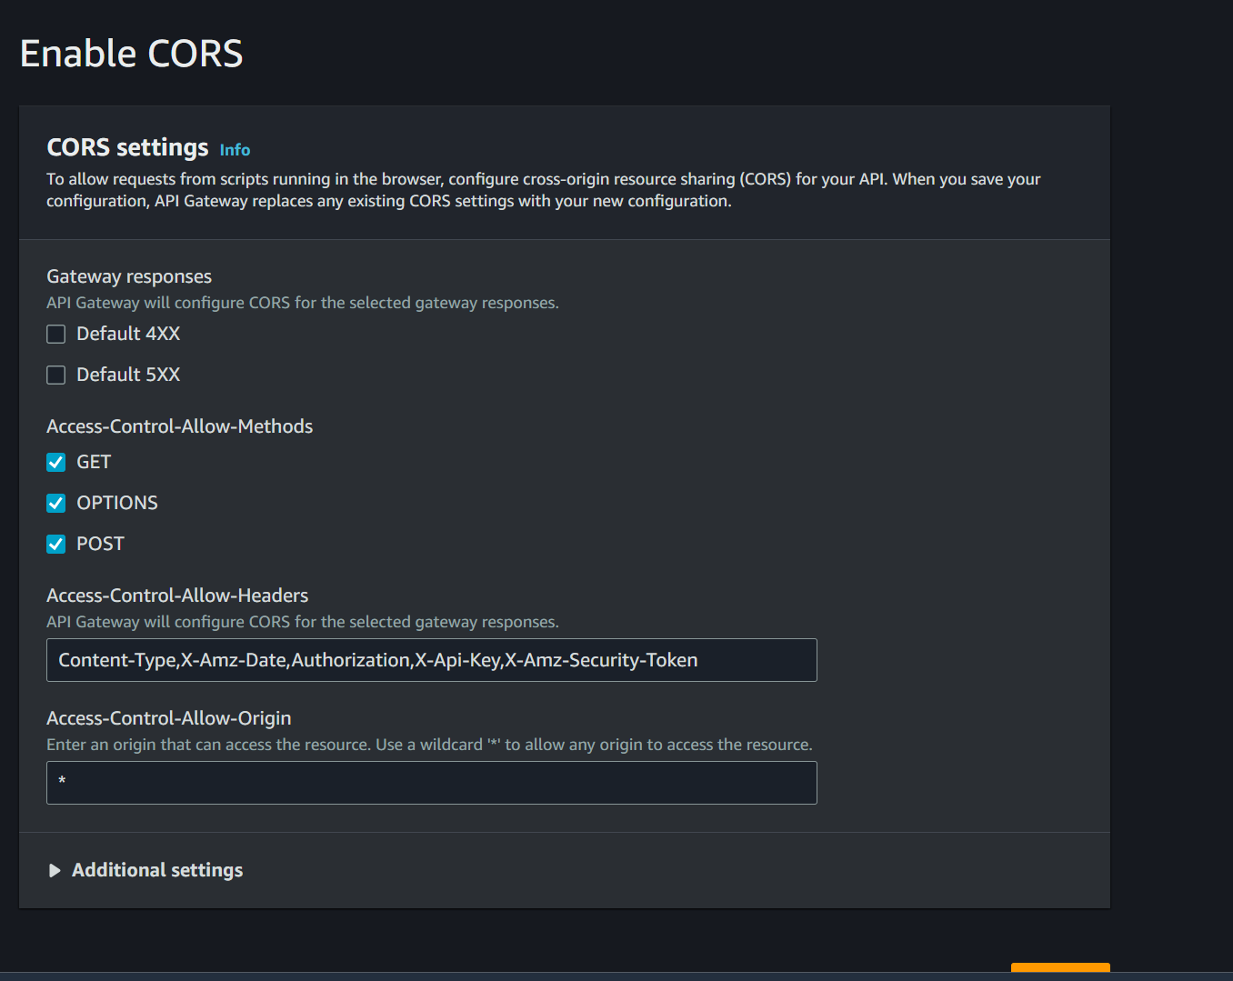

Deploy with stage - dev

**Dynamo DB**

