DEMO

**AWS AMPLIFY – deploy app**

No Git provider

Zip index.html

Give app name & branch name

Drag and drop zipped index.html

Deploy (filename inside zipped folder mustbe index.html)

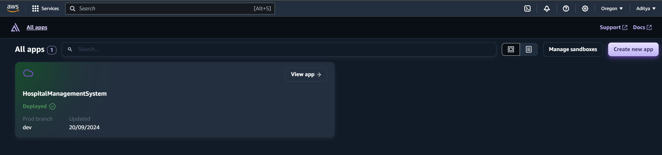

**AWS LAMBDA FUNCTION – add functionality**

Create the add patient & search patient function

Author from scratch

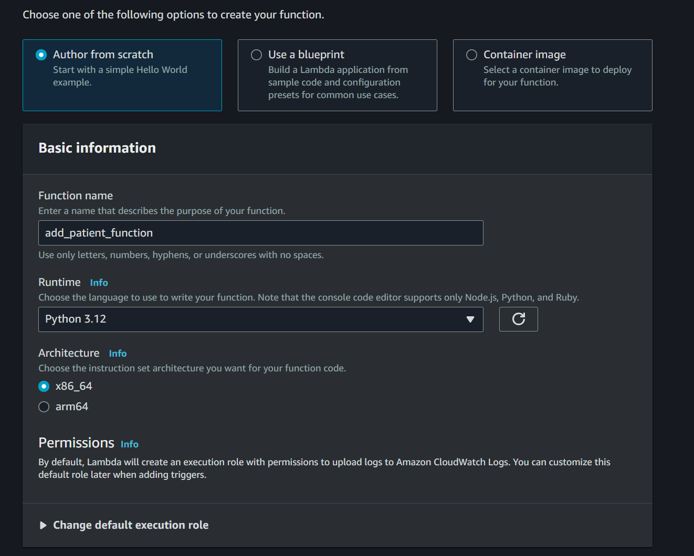

Write add patient function

Write search patient function

Deploy function

Test function

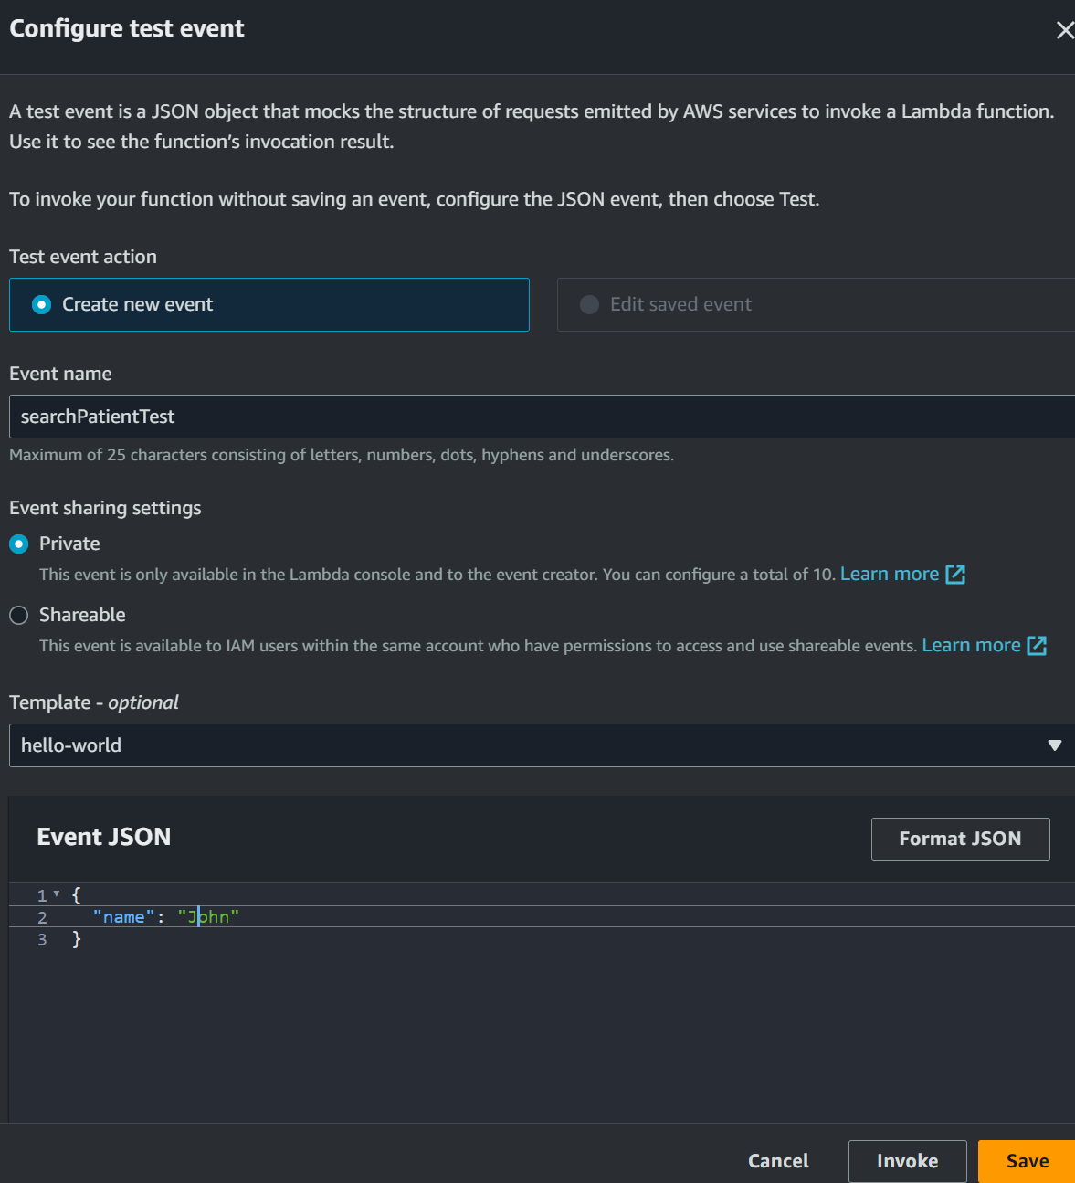

**API GATEWAY**

POST /add-patient – Calls the Lambda function to add a new patient.

GET /search-patients – Calls the Lambda function to search or filter patients.

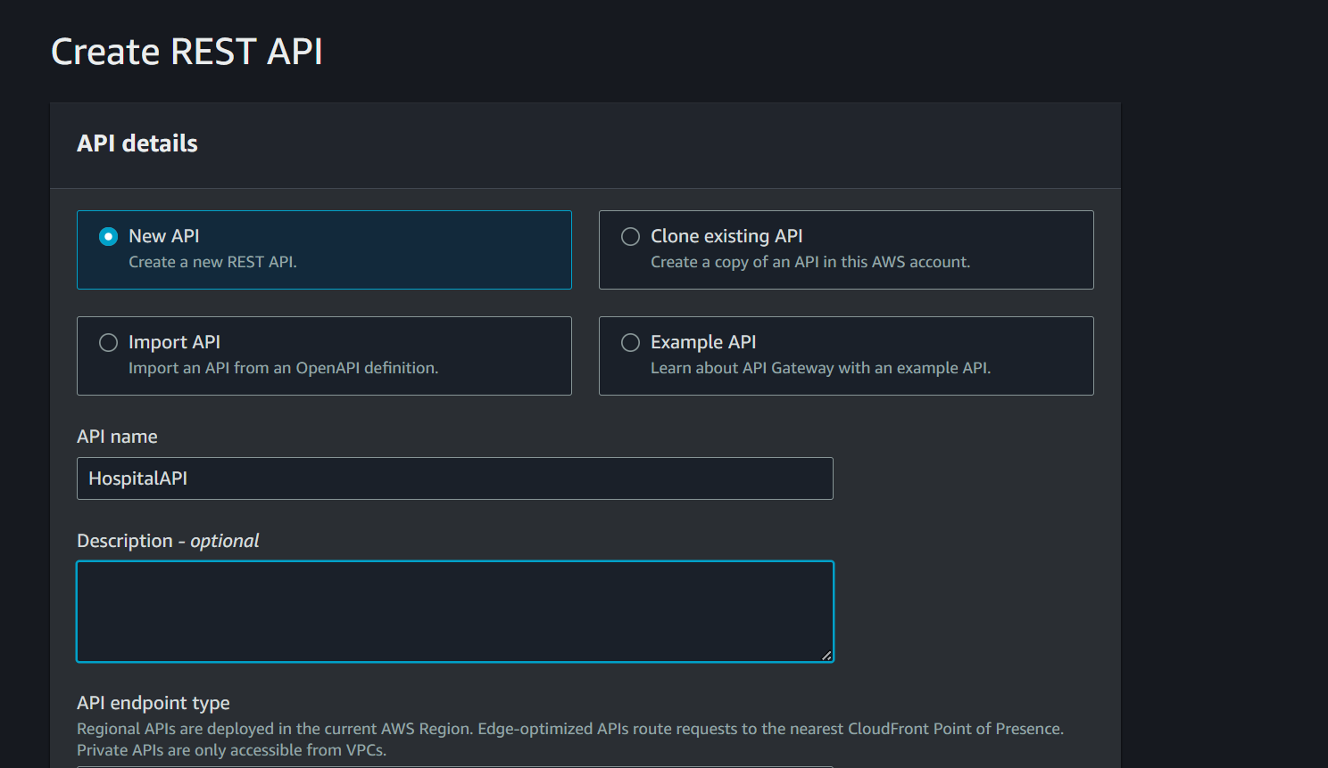

Create method

Post and Get methods

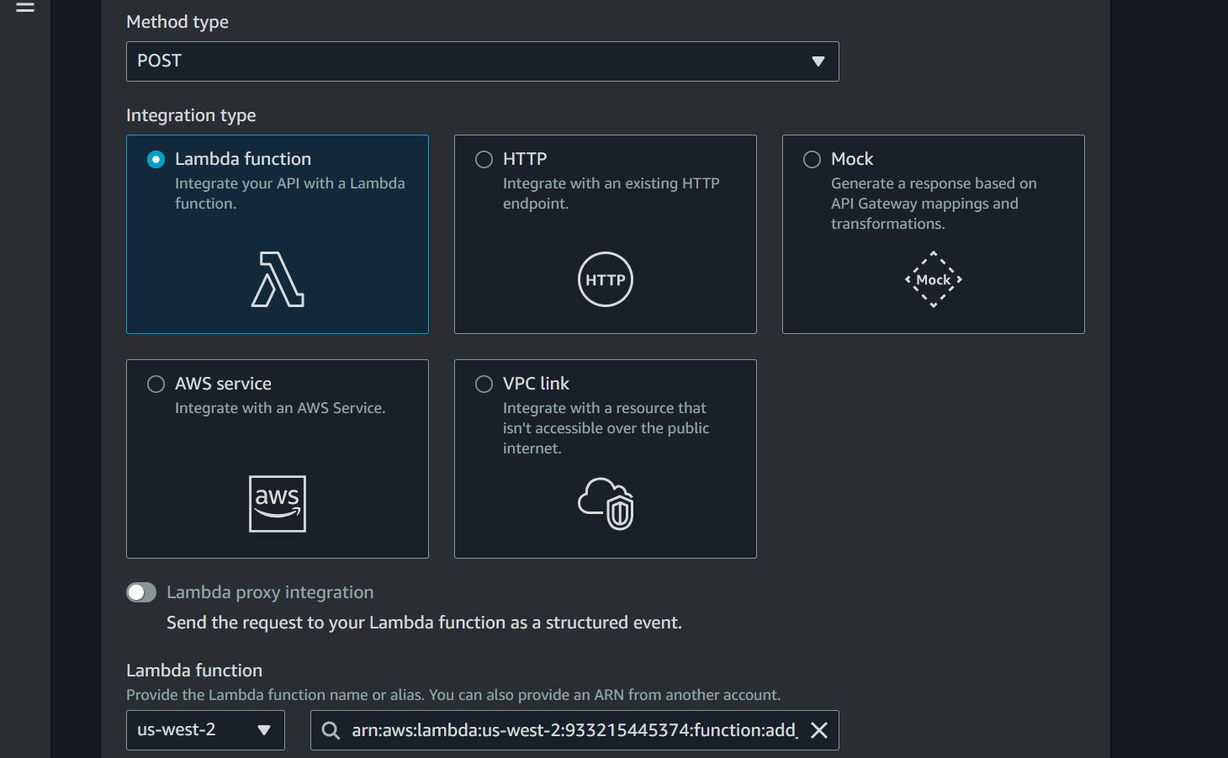

For Get method

Create URL query string parameters to accept (name and illness) in “Method Request section of API GET request”

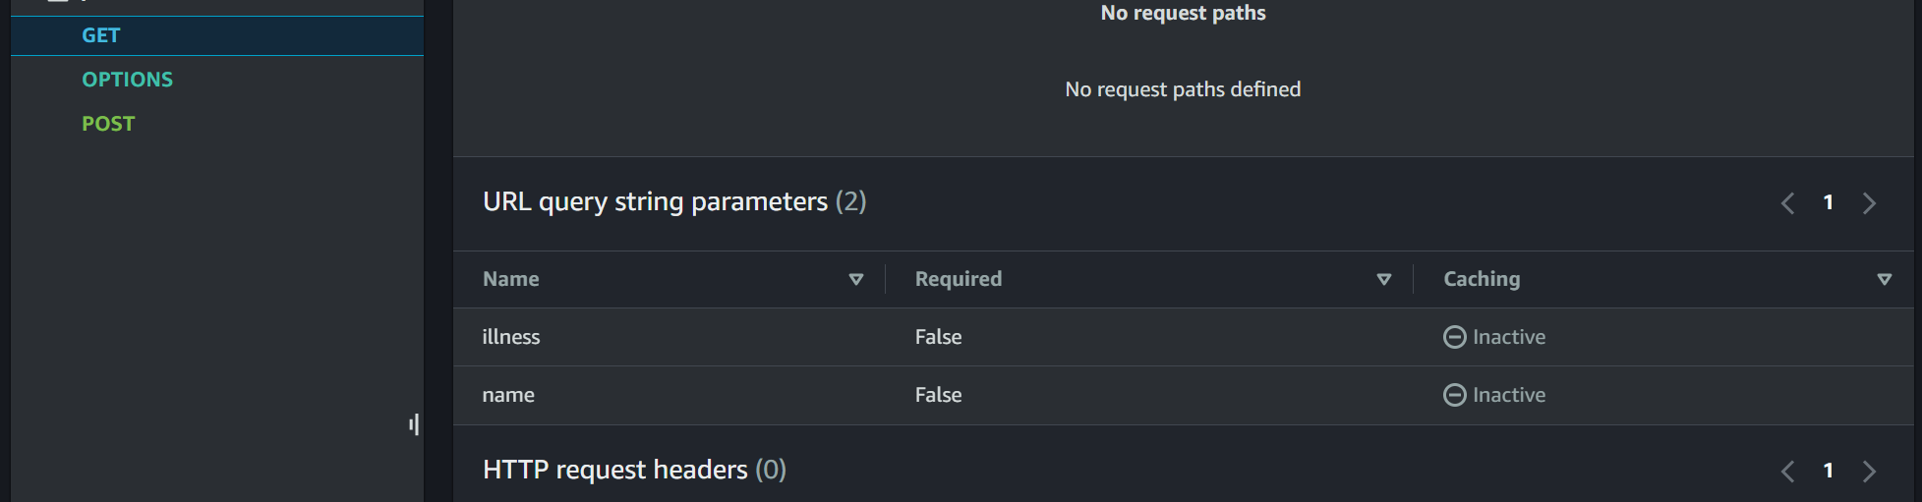

• **Integration Request**:

* In the method settings, look for the **Integration Request** option and click on it.

• **Check Query String Parameters**:

* Scroll down to find the **Query string parameters** section.
* Ensure that the parameters you want to pass (e.g., name, illness) are defined here. If they are not listed, add them by clicking **Add query string**.

**Enable Lambda proxy integration**

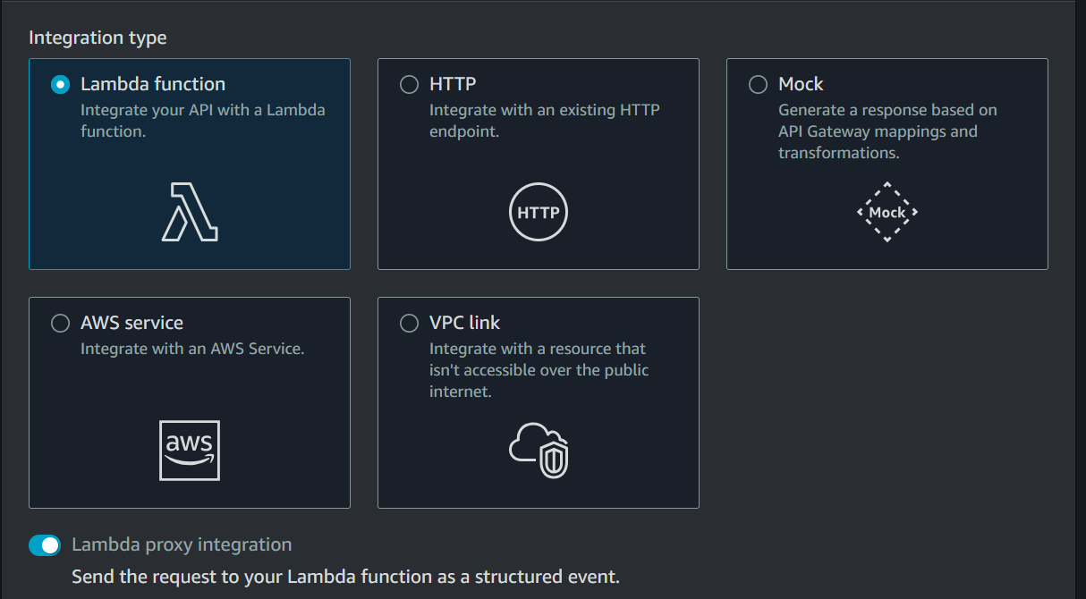

• **Mapping to Lambda Event**:

* Ensure that each query string parameter is mapped correctly to the Lambda function. The mapping should look something like this:
  + **Name**: name
  + **Mapped from**: method.request.querystring.name
  + Similarly for illness.

• **Save Changes**:

* If you made any changes, be sure to save them.

Enable CORS

to allow cross-origin requests from your Amplify frontend.

Make sure the following headers are included in your CORS configuration:

* Access-Control-Allow-Origin: *
* Access-Control-Allow-Methods: GET, POST
* Access-Control-Allow-Headers: Content-Type

Deploy API with new stage

Copy and keep invoke URL for later modification in index.html

**DYNAMODB**

Go to the **DynamoDB Console** and create a table:

Give table name

Give partition and sort key

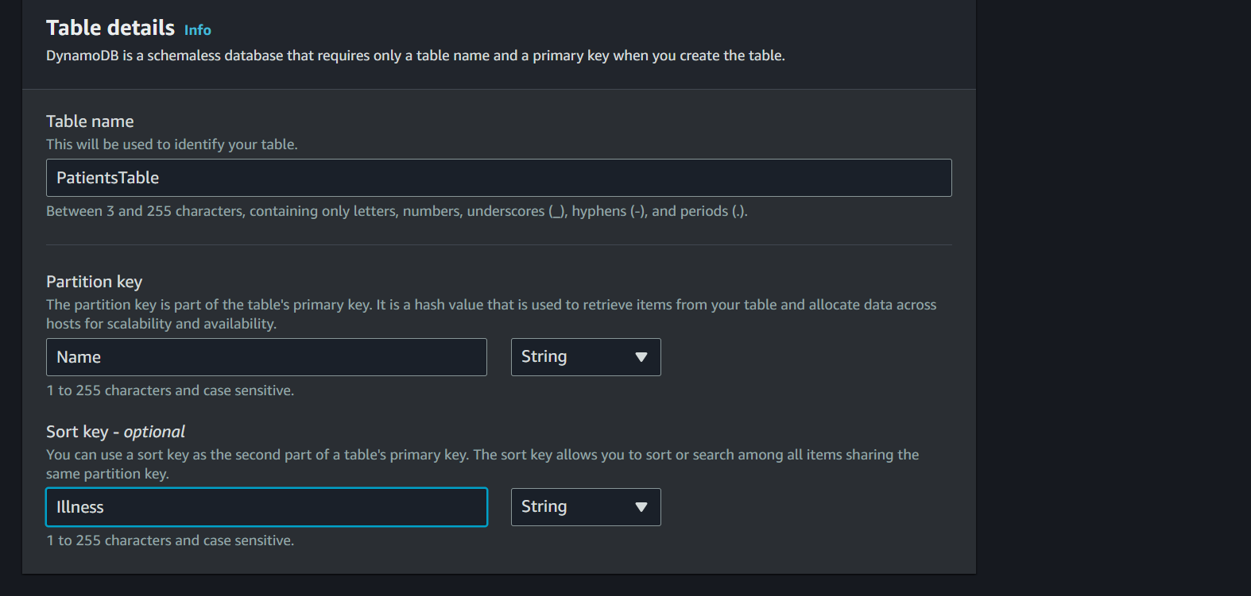

**IAM Role Policy for Lambda functions**

Go to configuration – permissions – role link

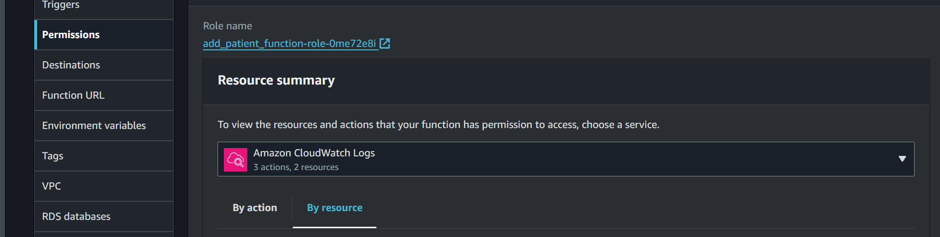

Add permissions – add inline policy

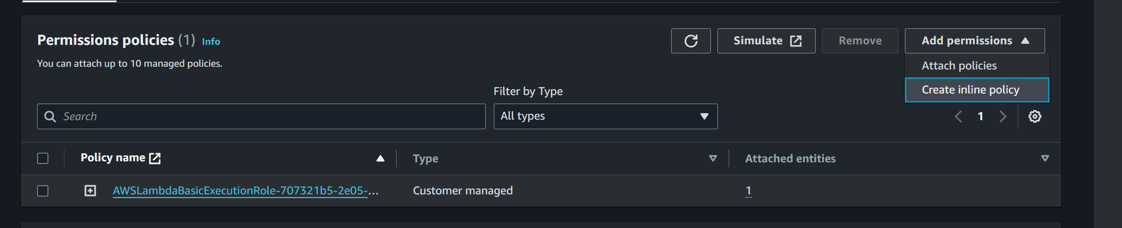

In the permissions give resource as table ARN

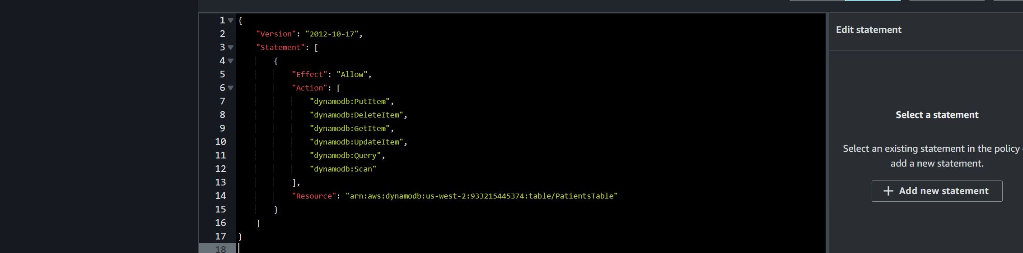

Test Lambda Function with test configuration

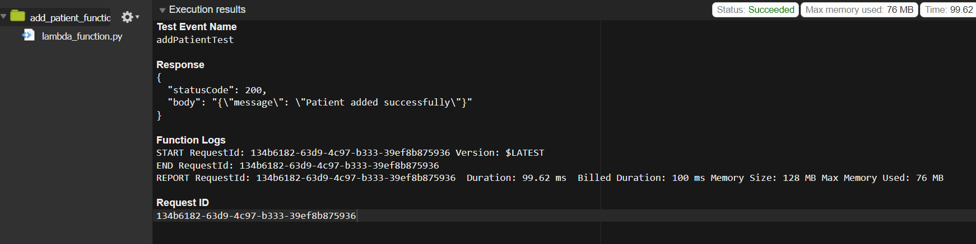

**Redeploy index.html with API URL**

Add API invoke URL to index.html for modifications

Deploy Updates in Amplify