**CELLULAR SIGNAL JAMMER**

**A**

**MINOR PROJECT SYNOPSIS**

**Submitted in partial fulfilment of the requirements for the award of the degree**

**Of**

**BACHELOR OF TECHNOLOGY**

**In**

**ELECTRONICS & COMMUNICATION ENGINEERING**

**By**

**Aakash Singh Aditya Nahata Rohan Singh**

**00196202817 00496202817 01796202817**

**ECE F-14 ECE F-14 ECE F-14**

**Guided by**

**Ms. Manan Jani, ECE Department, ADGITM**



**Department of Electronics and Communication Engineering**

**DR. AKHILESH DAS GUPTA INSTITUTE OF TECHNOLOGY & MANAGEMENT,**

**(AFFILIATED TO GURU GOBIND SINGH INDRAPRASTHA UNIVERSITY)**

**New Delhi - 110053**

**Aug-Dec, 2020**

**TABLE OF CONTENTS**

1. **Introduction**
2. **History**
3. **Objective**
4. **Techniques Used**
5. **Methodology and Tools Used**

**Hardware Used**

4.1. NE555 Timer

4.2. BF495 Transistor

4.3. Circuit Diagram

4.4 Layout

4.5 Top Silk Screen

**Software Used**

* 1. KiCad EDA

1. **Applications**

6.1 Signal Jamming

1. **References**

**Introduction**

**Cellular Signal Jammer**

**What is it?**

A mobile phone jammer or blocker is a device which deliberately transmits signals on the same radio frequencies as mobile phones, disrupting the communication between the phone and the cell-phone base station, effectively disabling mobile phones within the range of the jammer, preventing them from receiving signals and from transmitting them. Jammers can be used in practically any location, but are found primarily in places where a phone call would be particularly disruptive because silence is expected, such as entertainment venues.

Because they disrupt the operations of legitimate mobile phone services, the use of such blocking devices is illegal in many jurisdictions, especially without a licence. When operational, such devices also block access to emergency services.

Jamming devices overpower the cell phone by transmitting a signal on the same frequency as the cell phone and at a high enough power that the two signals collide and cancel each other out. Cell phones are designed to add power if they experience low-level interference, so the jammer must recognize and match the power increase from the phone. Cell phones are full-duplex devices, which mean they use two separate frequencies, one for talking and one for listening simultaneously. Some jammers block only one of the frequencies used by cell phones, which has the effect of blocking both. The phone is tricked into thinking there is no service because it can receive only one of the frequencies. Less complex devices block only one group of frequencies, while sophisticated jammers can block several types of networks at once to head off dual-mode or tri-mode phones that automatically switch among different network types to find an open signal. Some of the high-end devices block all frequencies at once and others can be tuned to specific frequencies

**History**

Radio jamming is the deliberate jamming, blocking or interference with authorized wireless communications. In the United States, radio jamming devices (known as "jammers") are illegal and their use can result in large fines.

In some cases jammers work by the transmission of radio signals that disrupt communications by decreasing the signal-to-noise ratio.The concept can be used in wireless data networks to disrupt information flow.It is a common form of censorship in totalitarian countries, in order to prevent foreign radio stations in border areas from reaching the country.

Jamming is usually distinguished from interference that can occur due to device malfunctions or other accidental circumstances. Devices that simply cause interference are regulated differently. Unintentional "jamming" occurs when an operator transmits on a busy frequency without first checking whether it is in use, or without being able to hear stations using the frequency. Another form of unintentional jamming occurs when equipment accidentally radiates a signal, such as a cable television plant that accidentally emits on an aircraft emergency frequency.

**Objective**

The purpose behind cellular jamming can be varied depending upon its applications. Signal Jammers in general have varied uses depending upon their need. From personal uses to the modern military conflicts, Signal Jammers are used everywhere. In sensitive areas like hospitals and prisons they can be deployed. They are also needed in modern Electro-Magnetic Spectrum Warfare for jamming enemy RADAR Signals and Communication Lines.

Dissimilar cellular-systems process signals differently, and yet, all cell-phone-networks use radio-signals that can be interrupted or, even, blocked, completely. This project highlights the design of a simple, low-cost mobile-phone- jammer and aims to present a solution for the problem of inappropriate-use of the cell-phones in restricted and prohibited-areas. The main concept of jamming is the releasing of signal (noise) of the same-frequency which is using by mobile-service-provider to overpower and destruct the user-signal. The fabrication of the jammer involved uncomplicated discrete components, resistors, capacitors, inductors and transistors to generate the required frequency (noise) and then amplifies the frequency generated to range of 800 MHZ to 1.4 GHZ in order to match the frequency of the mobile-phone being transmitted by the base-station. Relatively-satisfactory jamming of a mobile-signal was confirmed by the blocking of the signals of the mobile-phones in 2G and 3Gnetworks (UMTS / WCDMA) operated via Jio ,Airtel, and Vodafone, when the phone indicated “no network”, thereby allowing no call to go through, with no-interference to other communication-means observed. Overall recommendation is that further and more deeper-research is needed to produce more-sophisticated and better jamming devices, as not to affect the other base-station-transmission systems.

**Techniques Used**

Printed Circuit Board (PCB) fabrication is the assembly method for circuit boards used in electronic and computer devices. The layers of the board are put together along with the specific surface pattern so it can be used in electronics manufacturing. Often firms that fabricate PCBs also make related products for their customers. Manufacturers of electronic goods can either fabricate in-house or contract this operation out to third party specialists. So many companies operate in this grey area and Hi5 Electronics can assist with a broader range of services if required.

1. KiCad is a free software suite for electronic design automation (EDA). It facilitates the design of schematics for electronic circuits and their conversion to PCB designs. KiCad was originally developed by Jean-Pierre Charras. It features an integrated environment for schematic capture and PCB layout design. Tools exist within the package to create a bill of materials, artwork, Gerber files, and 3D views of the PCB and its components.
2. After having the layout we make the silk screen and fabricate the board. Then the devices are inserted on the board and power supply is provided. Device then can be turned on and checked for effects.

**Methodology and Tools Used**

**Hardware Used**

**NE555 Timer**

This IC NE555 is 8-pin timer IC. These devices are precision timing circuits capable of producing accurate time delays or oscillation. In the time-delay or mono-stable mode of operation, the timed interval is controlled by a single external resistor and capacitor network. This is small DIP 8 pin IC..

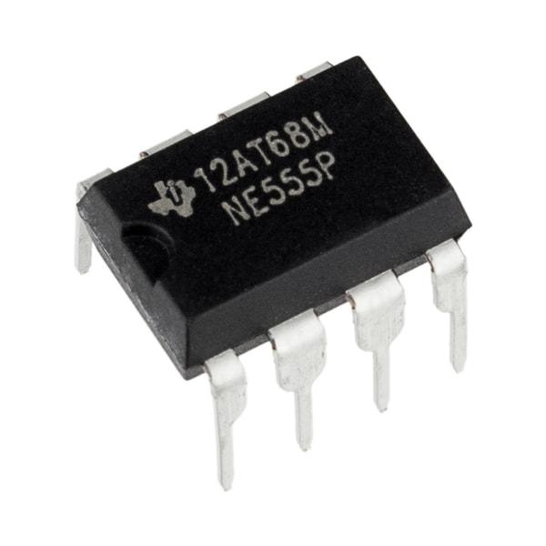

Figure1: NE555 Timer

**BF495 TRANSISTOR**

BF495 NPN Medium Frequency Transistor

BF495 are NPN silicon Planar Epitaxial Transistors for RF small signal applications upto 100 Mhz.

Features of BF495

Collector Base Voltage : 30 Volts

Collector Emitter Voltage : 20 Volts

Emitter Base Voltage : 5 Volts

Collector Current : 30ma

Power Dissipation : 300mw

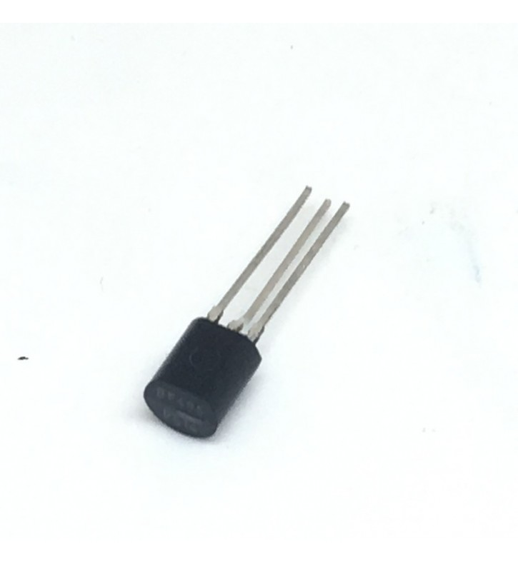

Figure2: BF495 Transistor

**CIRCUIT DIAGRAM :-**

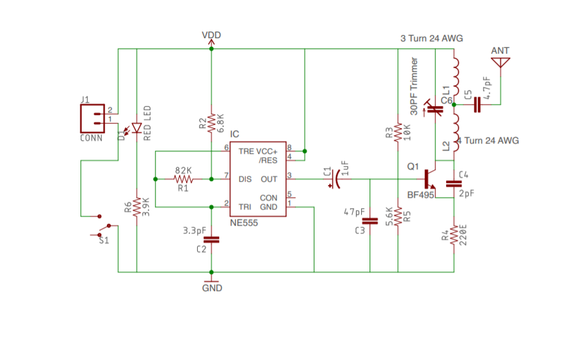

**LAYOUT :-**

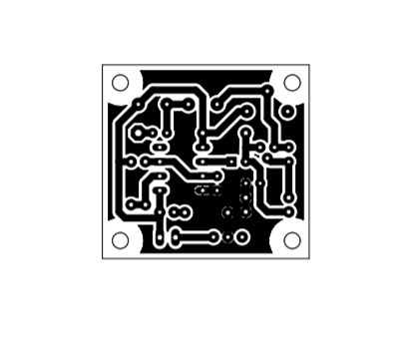

**Top Silk Screen:-**

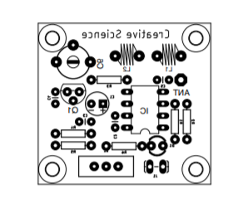

**Software Used**

**KiCad EDA**

KiCad is a free software suite for electronic design automation (EDA). It facilitates the design of schematics for electronic circuits and their conversion to PCB designs. KiCad was originally developed by Jean-Pierre Charras. It features an integrated environment for schematic capture and PCB layout design. Tools exist within the package to create a bill of materials, artwork, Gerber files, and 3D views of the PCB and its component

KiCad uses an integrated environment for all of the stages of the design process: Schematic capture, PCB layout, Gerber file generation/visualization, and library editing.

KiCad is a cross-platform program, written in C++ with wxWidgets to run on FreeBSD, Linux, Microsoft Windows and Mac OS X. Many component libraries are available, and users can add custom components. The custom components can be available on a per-project basis or installed for use in any project. There are also tools to help with importing components from other EDA applications, for instance EAGLE. There are also third party libraries available for KiCad, including SnapEDA, and the Digi-Key KiCad Library.Configuration files are in well documented plain text, which helps with interfacing version control systems, as well as with automated component generation scripts.

**Applications**

Signal Jamming is technique that is widely used in modern electronic environment varying from personal uses to corporate uses and military uses. Given below are some of the modern day applications of Signal Jamming

* Electronic Warfare in Modern Military Conflicts
* Radar and Communication Jamming
* Worship Places
* IED Jamming
* Public Places
* Personal uses
* Hospitals , Movie Theaters & Restaurants
* Counter Terror Operations

**References**

1. <https://apps.fcc.gov/edocs_public/attachmatch/DA-12-347A1.pdf> Enforcement Advisory No. 2012-02 FCC Enforcement Advisory Cell Jammers, GPS Jammers, and Other Jamming Devices Consumer Alert: Using or Importing Jammers is Illegal
2. ^ [Jump up to:***a***](https://en.wikipedia.org/wiki/Radio_jamming#cite_ref-Berg2008_2-0) [***b***](https://en.wikipedia.org/wiki/Radio_jamming#cite_ref-Berg2008_2-1) *Jerome S. Berg (2008).*[*Broadcasting on the Short Waves, 1945 to Today*](https://books.google.com/books?id=Ux9fZj6izuEC&pg=PA46)*. McFarland. pp. 46–.*[*ISBN*](https://en.wikipedia.org/wiki/ISBN_(identifier))[*978-0-7864-5198-2*](https://en.wikipedia.org/wiki/Special:BookSources/978-0-7864-5198-2)*. Retrieved 17 February 2013.*
3. [**^**](https://en.wikipedia.org/wiki/Radio_jamming#cite_ref-3) *(NIST), Author: Sheila Frankel; (BAH), Author: Bernard Eydt; (BAH), Author: Les Owens; (NIST), Author: Karen Scarfone.*[*"SP 800-97, Establishing Wireless Robust Security Networks: A Guide to IEEE 802.11i"*](http://csrc.nist.gov/publications/nistpubs/800-97/SP800-97.pdf)*(PDF). csrc.nist.gov.*
4. [**^**](https://en.wikipedia.org/wiki/Radio_jamming#cite_ref-4) [*"What jamming of a wireless security system is and how to resist it | Ajax Systems Blog"*](https://ajax.systems/blog/what-is-jamming/)*. Ajax Systems. Retrieved 2020-01-11.*
5. [**^**](https://en.wikipedia.org/wiki/Radio_jamming#cite_ref-5) [*"Kraut sieve"*](http://www.verzetsmuseum.org/museum/en/alwayspresent,topstukken/moffenzeef)*. Museum: Second World War. Dutch Resistance Museum. Retrieved 22 May 2012.*
6. [**^**](https://en.wikipedia.org/wiki/Radio_jamming#cite_ref-6) *Col. David Eshel.*[*"Hezbollah's Intelligence War"*](http://defense-update.com/analysis/lebanon_war_1.htm)*. Defense Update. Defense Update. Retrieved 23 May 2012.*
7. [**^**](https://en.wikipedia.org/wiki/Radio_jamming#cite_ref-7) [*"Radio Northsea International"*](http://www.bobleroi.co.uk/ScrapBook/RobinBanksPt2/RNIwithRobinBanks2.html)*. bobleroi.co.uk. Bob Le-Roi. Retrieved 23 May 2012.*
8. [**^**](https://en.wikipedia.org/wiki/Radio_jamming#cite_ref-8) [*"Cooperate?"*](http://www.verzetsmuseum.org/tweede-wereldoorlog/en/kingdomofthenetherlands/thenetherlands,may_1940_-_february_1941/cooperate-)*. Second World War: Kingdom of the Netherlands. Dutch Resistance Museum. Retrieved 22 May 2012.*
9. ^ [Jump up to:***a***](https://en.wikipedia.org/wiki/Radio_jamming#cite_ref-umich_9-0) [***b***](https://en.wikipedia.org/wiki/Radio_jamming#cite_ref-umich_9-1) [***c***](https://en.wikipedia.org/wiki/Radio_jamming#cite_ref-umich_9-2) [***d***](https://en.wikipedia.org/wiki/Radio_jamming#cite_ref-umich_9-3) *Price, Rochelle B. (1984).*[*"Jamming and the Law of International Communications"*](https://repository.law.umich.edu/cgi/viewcontent.cgi?article=1841&context=mjil)*. Michigan Journal of International Law.****5****(1).*
10. [**^**](https://en.wikipedia.org/wiki/Radio_jamming#cite_ref-10) *Office of Research, USIA (1983),*[*Jamming of Western Radio Broadcasts to the Soviet Union and Eastern Europe*](http://www.radiojamming.puslapiai.lt/doc_en.htm)*, United States Information Agency*
11. [*"ARCHIVE DOCUMENTS"*](http://www.radiojamming.puslapiai.lt/doc_en.htm). www.radiojamming.info. Radio Baltic Waves*. Retrieved 22 May 2012*.
12. [Pakistani army to jam Taliban radio in Swat Valley"](https://web.archive.org/web/20120217204909/http:/blogs.rnw.nl/medianetwork/pakistani-army-to-jam-taliban-radio-in-swat-valley). *Media Network*. Radio Netherlands Worldwide. Archived from [the original](http://blogs.rnw.nl/medianetwork/pakistani-army-to-jam-taliban-radio-in-swat-valley)on 17 February 2012. Retrieved 22 May 2012.