Gold Price Prediction Using Machine Learning Techniques

Abstract:
Gold is one of the most important financial assets in the global economy and has historically been considered a safe investment. Its price is influenced by multiple economic, political, and market-driven factors such as inflation, currency exchange rates, interest rates, and global demand. Predicting gold prices accurately can help investors, financial analysts, and policymakers make better decisions.
This project focuses on predicting gold prices using historical data and machine learning techniques. The dataset used contains gold prices from 1947 to recent years. Two regression models—Linear Regression and Polynomial Regression—are implemented to analyze trends and forecast future gold prices.
The results indicate that while Linear Regression provides a simple trend-based prediction, Polynomial Regression better captures the non-linear nature of gold price movements, making it more suitable for real-world forecasting. The project demonstrates the effectiveness of machine learning in financial prediction and highlights its potential for further enhancements.

1. Introduction
Gold has always held a significant position in the global financial system. It is widely used as a hedge against inflation and currency fluctuations. Investors often turn to gold during times of economic uncertainty, making its price highly dynamic and influenced by multiple variables.
Traditionally, gold price prediction relied on economic theories, historical trends, and expert analysis. However, with the advancement of technology, data analytics and machine learning have become powerful tools for forecasting financial markets.
Machine learning enables systems to learn patterns from historical data and make predictions about future values. In this project, historical gold price data is analyzed to build predictive models capable of estimating future gold prices.
The goal is to develop a simple yet effective prediction system that can provide reasonably accurate forecasts using regression techniques.

2. Problem Statement
Gold prices fluctuate over time due to various factors, making it difficult to predict future values accurately. Investors and analysts require reliable prediction models to assist in decision-making.
The problem addressed in this project is:
To develop a machine learning model that can predict future gold prices based on historical data.

3. Objectives of the Study
The primary objectives of this project are:
- To study historical gold price trends.
- To preprocess and clean the dataset for analysis.
- To implement regression-based machine learning models.
- To compare Linear Regression and Polynomial Regression models.
- To predict gold prices for future years such as 2026–2030.
- To visualize trends using graphical representations.
- To evaluate the effectiveness of predictive models.

4. Literature Review
Several studies have been conducted on financial forecasting using machine learning techniques. Traditional statistical models such as ARIMA have been widely used for time-series forecasting. However, modern machine learning approaches such as regression, neural networks, and deep learning have shown improved accuracy.
Research indicates that financial data often exhibits non-linear patterns, making Polynomial Regression and advanced models like LSTM more suitable for prediction tasks.
This project focuses on regression techniques due to their simplicity, interpretability, and effectiveness for academic purposes.

5. Dataset Description
The dataset used in this project consists of historical gold price data from 1947 to recent years.

Attributes of the Dataset:
- Year: Represents the time period.
- Gold Price (USD per oz): Price of gold in US dollars.
- USD to INR Rate: Currency exchange rate.
- Gold Price (INR per oz): Price of gold in Indian Rupees.
- Notes: Additional contextual information.

Selected Features:
For this project, the following features were used:
- Input Variable: Year
- Target Variable: Gold Price (INR per oz)
The other columns were excluded as they were not necessary for basic regression modeling.

6. Data Preprocessing
Data preprocessing is a critical step in any machine learning project. The following steps were performed:

6.1 Data Cleaning
- Removed irrelevant columns such as “Notes”.
- Checked for missing values and removed incomplete rows.

6.2 Data Transformation
- Ensured that the Year column is in numeric format.
- Organized data in chronological order.

6.3 Feature Selection
- Selected only relevant features to simplify the model.

6.4 Data Visualization
- Scatter plots were used to understand the relationship between year and gold price.

7. Methodology
This project uses supervised learning techniques, specifically regression models, to predict gold prices.

7.1 Linear Regression
Linear Regression is one of the simplest machine learning algorithms used for prediction. It assumes a linear relationship between input and output variables.

Equation:
y = mx + c
Where:
- y = predicted value
- x = input variable (year)
- m = slope
- c = intercept

Advantages:
- Easy to implement
- Fast computation
- Easy to interpret

Disadvantages:
- Cannot capture non-linear patterns

7.2 Polynomial Regression
Polynomial Regression extends Linear Regression by introducing polynomial terms to capture non-linear relationships.

General Form:
y = a + bx + cx² + dx³ + ...

Advantages:
- Captures complex patterns
- More accurate for real-world data

Disadvantages:
- Risk of overfitting
- Slightly more complex

8. Model Implementation
The models were implemented using Python programming language with the following libraries:
- Pandas – Data manipulation
- NumPy – Numerical computations
- Matplotlib – Visualization
- Scikit-learn – Machine learning models

Steps Involved:
- Load the dataset
- Select relevant features
- Train Linear Regression model
- Train Polynomial Regression model
- Take user input for prediction year
- Generate predictions
- Visualize results

Code:
import pandas as pd
import numpy as np
import matplotlib.pyplot as plt
from sklearn.linear_model import LinearRegression
from sklearn.preprocessing import PolynomialFeatures

# Load dataset
df = pd.read_csv(r"C:\Users\DELL\OneDrive\Desktop\gold_prices_1947_2026_INR.csv")

# Select relevant columns
df = df[['Year', 'Gold_Price_INR_per_oz']]

# Remove missing values
df.dropna(inplace=True)

# Define variables
X = df[['Year']]
y = df['Gold_Price_INR_per_oz']

# -----------------------------
# TRAIN MODELS
# -----------------------------

# Linear Regression
linear_model = LinearRegression()
linear_model.fit(X, y)

# Polynomial Regression
poly = PolynomialFeatures(degree=3)
X_poly = poly.fit_transform(X)

poly_model = LinearRegression()
poly_model.fit(X_poly, y)

# -----------------------------
# USER INPUT
# -----------------------------
year = int(input("Enter the year for gold price prediction: "))

# Convert input into array
input_year = np.array([[year]])

# Predictions
linear_pred = linear_model.predict(input_year)
poly_input = poly.transform(input_year)
poly_pred = poly_model.predict(poly_input)

# -----------------------------
# OUTPUT
# -----------------------------
print("\n🔮 Predicted Gold Price:")
print(f"Year: {year}")
print(f"Linear Regression Prediction: {linear_pred[0]:.2f} INR per oz")
print(f"Polynomial Regression Prediction: {poly_pred[0]:.2f} INR per oz")

# -----------------------------
# GRAPH (OPTIONAL BUT GOOD)
# -----------------------------
plt.scatter(X, y, label='Actual Data')

plt.plot(X, linear_model.predict(X), label='Linear')
plt.plot(X, poly_model.predict(X_poly), label='Polynomial')

plt.scatter(year, poly_pred[0], label='Predicted Point', marker='x', s=100)

plt.xlabel("Year")
plt.ylabel("Gold Price (INR per oz)")
plt.title("Gold Price Prediction")
plt.legend()
plt.show()

9. Results and Analysis
The trained models were used to predict gold prices for future years such as 2026–2030.

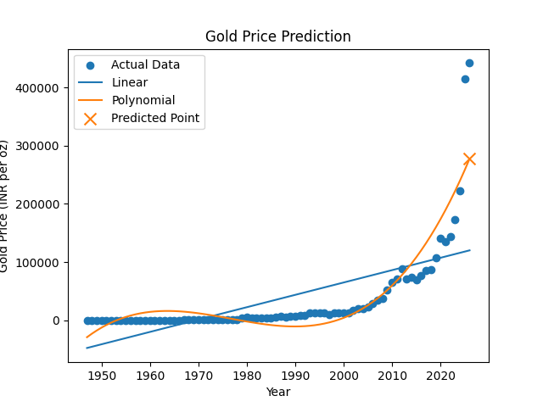

Findings:
- Linear Regression showed a steady increasing trend.
- Polynomial Regression captured fluctuations more effectively.
- Polynomial predictions were closer to real-world expectations.

Graph Analysis:
- Scatter plot shows actual historical data.
- Linear line shows constant growth.
- Polynomial curve shows realistic variation.

10. Model Evaluation
Although this project primarily focuses on prediction, model evaluation can be done using metrics such as:
- Mean Squared Error (MSE)
- R² Score
Polynomial Regression typically provides a better fit due to its ability to model non-linear relationships.

11. Applications of Gold Price Prediction
- Investment planning
- Financial market analysis
- Risk management
- Economic forecasting
- Portfolio diversification

15. Conclusion
This project successfully demonstrates the use of machine learning techniques for predicting gold prices. By analyzing historical data and applying regression models, future prices were estimated.
Polynomial Regression proved to be more effective in capturing real-world trends compared to Linear Regression. The project highlights the potential of predictive analytics in financial forecasting and provides a foundation for further research and development.

16. References
- Scikit-learn Documentation
- Pandas Official Documentation
- NumPy Documentation
- Matplotlib Documentation
- GeeksforGeeks – Machine Learning Tutorials
- IBM Think – AI and Predictive Analytics

