Game Design Document

Fill up the following document

1. Write the title of your project.

Ans = Police-Theif Game

1. What is the goal of the game?

Ans = To escape from the Maze

1. Write a brief story of your game.

Ans = There once lived a theif who wanted to collect coins but wasn’t

able to do that because the police kept the away from collecting the

coin so wanted a help from you and there are some hearts also for you collect coin.

1. Which are the playing characters of this game?

* Playing characters are the ones who respond to the user based on the input from the user.
* Cars, monkeys, dinos, wizards, etc., are the playing characters in the game.

|  |  |  |
| --- | --- | --- |
| Number | Character Name | What can this character do? |
| 1 | Theif | He Is controlled by you because he wanted collect the coin. |
| 2 | Police | They are there to catch the theif in simpler way you. |

1. Which are the Non-Playing Characters of this game?

* Non-Playing characters are the ones that don't have an action or behavior when the user interacts with the game.
* Hurdles, stones, bananas, coins, etc., are non-playing characters in the game.

|  |  |  |
| --- | --- | --- |
| Number | Character Name | What can this character do? |
| 1 | Walls | To capture the thief from going out |
| 2 | Maze | To capture the thief from going out |

Draw your imagination of this game. What does this game look like?

* Draw the game either on your computer or on paper.
* Add images of the game scenes to show each of the playing and non-playing characters at least once.

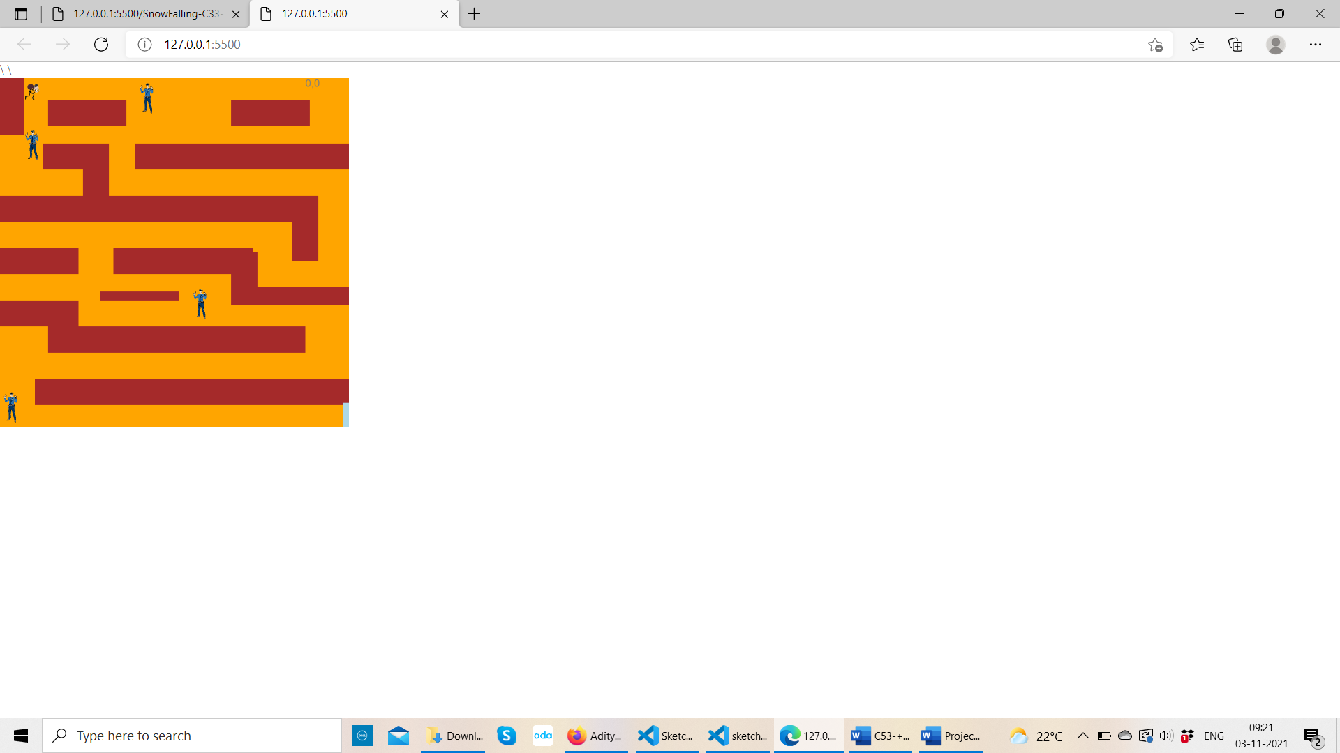

How do you plan to make your game engaging?

By You(thief) to escape from the maze so with this I make my game engaging.