NMIMS, NSOMASA . MLOps LAB . PROJECT 1
Credit Risk Model with a CI/CD Quality Gate
Every change to code, configuration, features or data is tested, tracked and accepted only if it does not make the model worse, and the gate itself is justified with evidence from our own runs.
A reproducible credit-risk build with Git, DVC, Pydantic-validated configs, MLflow tracking and a GitHub Actions quality gate.
21  tracked runs | 0.7948  baseline PR-AUC | 3  PR scenarios | 21 / 21  unit tests pass | 8 / 8  tasks complete

REPORT DETAILS
Field | Detail
Assessment | Project 1, Credit Risk Model with a CI/CD Quality Gate
GitHub repo link | https://github.com/AdityaNariyapara/credit-risk-cicd-gate
Course | Elective II, Machine Learning Operations (MLOps Lab)
Submitted to | Dr. Santosh Kumar
Submitted by | Aditya Nariyapara (B009) and Shreya Dutt (B016)
Institute | NSOMASA, NMIMS
Dataset | credit_card_customers v1 (800 rows) and v2 (1,100 rows)
Tools | Python, Git and GitHub, DVC, MLflow, GitHub Actions, pytest, Pydantic
Date | October 2026

PROJECT WORKFLOW
01 Version data . 02 Configure . 03 Engineer features . 04 Train and track . 05 Gate on every PR . 06 Data-change drill . 07 Threshold and fairness . 08 Report

Table of Contents
Executive Summary
01 Problem and Objectives
02 Architecture and Tools
03 Repository, Code and Data Versioning (Task 2)
04 The Data
05 Configuration Management (Task 3)
06 Cleaning and Feature Engineering (Task 4)
07 Model Training and Tuning (Task 5)
08 Experiment Tracking, Registry and Lineage (Task 5)
09 Metric Justification: Why Not Accuracy
10 The Quality Gate and CI (Task 6)
11 Data-Change Drill, v1 versus v2 (Task 7)
12 Threshold Comparison and Fairness Defense (Task 8)
13 Lifecycle Mapping (Task 1)
14 Worked Example: Reproduce From a Fresh Clone
15 Results, Contributions and Reflection
16 Deliverables Checklist

Executive Summary
A retail bank retrains its credit-card default model every month. Recently an untested change lowered model quality and nobody noticed for two weeks, and afterwards nobody could say which code, configuration or data version had produced the faulty model. The risk team now wants a workflow in which every change is versioned, tested automatically, tracked in an experiment log, and accepted only if the model is at least as good as the current baseline, and they want the team to be able to defend why the gate threshold is the right one, not just that a gate exists.
This project delivers that workflow end to end. Data and code are versioned together, every training run is logged to MLflow with its parameters, metrics, dataset version and configuration, and a quality gate runs on every pull request. The gate trains the model with a fixed CI configuration, compares the result to a baseline stored in the repository, and blocks the merge when a test fails or the model gets worse. The dataset has about one high-risk customer in five, so we gate on average precision (PR-AUC) rather than accuracy, and we justify that choice against two alternatives using our own run history.
0.7948  baseline PR-AUC (gate bar) | 0.690 to 0.869  PR-AUC across 21 runs | +0.055  v2 vs v1, within noise | 0.35 vs 0.20  Low vs High FN rate

Ground rules
Every tool is free and open source. No paid cloud account is used, no secrets are stored in the repository, everything is reproducible from a fresh clone by following the README, and every number in this report traces to a tracked run or a command that can be re-run.

01 Problem and Objectives
The scenario is a retail bank whose monthly retraining has no safety net. The concrete failure is a silent quality regression: a change lowered model quality and was not caught for two weeks because there was no automatic check and no record linking a deployed model to the exact inputs that built it. The objective is a workflow that makes that failure impossible to repeat.
Objectives, and how each is met
Objective | How this project meets it
Version everything together | Git for code and config, DVC for data, so any commit restores its exact dataset (Section 03).
Track every experiment | MLflow logs params, metrics, data version, config and model for all 21 runs (Section 08).
Gate on quality | A CI workflow trains and compares to a stored baseline, blocking worse models (Section 10).
Defend the gate | Three candidate rules compared on real runs, plus a fairness check by income (Section 12).

Success metrics, chosen and justified
The headline success metric is average precision (PR-AUC) on a held-out test split, chosen because the target is imbalanced (Section 09 gives the full argument). The operational success metric for the workflow itself is simpler and binary: the CI gate must pass a model that is at least as good as the baseline and must block a model that is worse or a change that breaks a test. We demonstrate all three outcomes with real pull requests.
Non-functional requirements
- Reproducible: a fresh clone plus the README commands reproduces the baseline metrics.
- Fast enough for CI: the gate uses a small configuration so a pull request check finishes in a couple of minutes.
- Safe by default: the baseline cannot be changed by an ordinary pull request, and branch protection enforces the gate.
- Auditable: the registered model points back to its git commit and data version.
02 Architecture and Tools
The architecture is a straight line from versioned inputs to a gated, registered model. A developer changes code, config, features or data on a branch and opens a pull request. GitHub Actions restores the data with DVC, runs the unit tests, trains the model with the CI configuration, logs the run to MLflow, and compares the result to the baseline. If everything passes the change can merge; if not, the merge is blocked. The best model from the wider sweep is registered in the MLflow Model Registry.
Tools, and the choices behind them
Purpose | Tool | Reason / substitution
Source versioning | Git and GitHub | Standard and free; GitHub Actions gives CI in the same place.
Data versioning | DVC | Keeps CSVs out of git history while any commit restores its data; replaces a cloud data store.
Configuration | YAML + Pydantic | Readable settings validated on load so a broken config fails fast.
Modelling | pandas, scikit-learn | Free and fast enough for CI; XGBoost was not needed to beat the baseline.
Tracking + registry | MLflow | Local SQLite backend gives runs and a registry with no paid account; replaces SageMaker.
CI / CD | GitHub Actions, pytest | Runs the gate on every pull request; replaces a managed pipeline service.

The one substitution worth naming is the DVC remote. Instead of a cloud bucket we use a content-addressed store committed inside the repository (dvcstore), so dvc pull works on the CI runner and on any fresh clone with no credentials. This keeps the project fully free and reproducible, at the cost of storing the (small) data blobs in the repo rather than in external storage.

03 Repository, Code and Data Versioning (Task 2)
The repository tracks code, configuration and data together. Code and config live in git. Datasets are tracked with DVC: the root .gitignore keeps the CSV files out of git, so only the small .dvc pointer files are committed, and the data itself lives in the in-repo DVC remote. The commit history is a sequence of small, clearly described changes, and dataset v2 enters the project later as its own tracked DVC change.
Repository layout
credit-risk-cicd-gate/
.github/workflows/ci.yml CI quality gate
.github/CODEOWNERS protects baseline and gate config
configs/{dev,ci,full}.yaml three environments
data/*.csv.dvc DVC pointers (CSVs gitignored)
dvcstore/ in-repo DVC remote (blobs)
src/credit_risk/ config, data, features, model, pipeline, gate
scripts/ run_training, run_gate, update_baseline, drill, fairness
tests/ pytest: features, config, gate
baseline/baseline_metrics.json the stored gate baseline
docs/ task write-ups and memos

Restoring code and data together
Running git checkout <old-commit> restores the code and the .dvc pointers, then dvc checkout restores the exact CSV that commit used. This is what makes an old result reproducible rather than merely remembered.
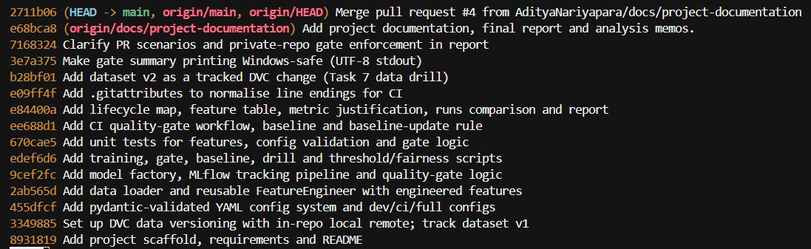
Figure 1a. Small, meaningful commits. The history reads as a clean sequence of versioned changes, including dataset v2 entering as its own tracked change.
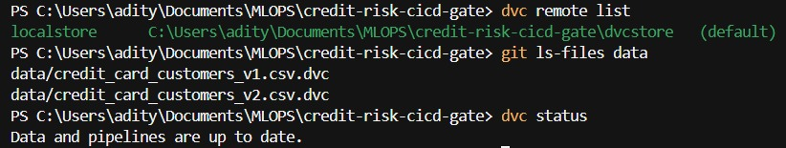
Figure 1b. The datasets are tracked only as .dvc pointers, with an in-repo DVC remote, and DVC reports the data is up to date.
04 The Data
The dataset describes credit-card customers and whether each is high risk (likely to default). Version 1 has 800 rows and version 2 has 1,100 rows, where v2 contains every v1 row unchanged plus 300 new customers. The target is imbalanced: about 18.9 percent of customers are high risk.
Data dictionary
Column | Type | Notes
Customer_ID | string | Identifier, dropped before modelling (never a predictor).
Age | int | Customer age in years.
Income_Bracket | category | Low / Medium / High; encoded as an ordinal 0 / 1 / 2.
Credit_Limit | float | Approved limit (USD). 24 missing in v1, median-imputed.
Current_Balance | float | Outstanding balance (USD). 24 missing in v1, median-imputed.
Monthly_Spend | float | Average monthly spend (USD).
Num_Transactions_Monthly | int | Transactions per month.
Payment_Delay_Days | int | Average days late. 24 missing in v1, median-imputed.
Tenure_Months | int | Months as a cardholder.
High_Risk_Customer | int (0/1) | Target: 1 = likely to default.

Missing values and imbalance
Three money or count columns have missing values. We fill them with the median learned on the training split only, which is robust to the skew in these columns and cannot leak information from the test set. The imbalance is handled with class weighting in the models and, more importantly, by choosing a metric that focuses on the minority class (Section 09).

05 Configuration Management (Task 3)
No values are hard coded in the modelling code. Paths, the utilisation risk cut-off, the hyperparameter search space, the random seed, the MLflow settings and the quality-gate threshold are all set in YAML. Three environments are provided: dev for fast local work, ci for the gate, and full for the wide sweep.
A slice of the CI configuration
data:
version: v1
path: data/credit_card_customers_v1.csv
features:
utilisation_high_cutoff: 0.5 # risk cut-off, tunable without code
payment_delay_flag_days: 5
training:
seeds: [42]
models: [logistic_regression, random_forest]
gate:
metric: average_precision
tolerance: 0.01 # allowed drop vs baseline
baseline_path: baseline/baseline_metrics.json

Configs are validated by Pydantic the moment they load. A broken config fails at once with a clear message, and unknown keys are rejected so a typo cannot pass silently. The exact config is stored as an artefact with every run, so each result carries the settings that produced it.
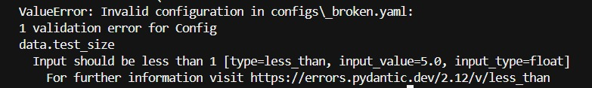
Figure 2. A deliberately broken config (test_size set to 5.0) is rejected at load time with a clear, specific message that names the offending field.

06 Cleaning and Feature Engineering (Task 4)
All transformations live in one fit and transform component, FeatureEngineer. Whatever it needs for new data (the imputation medians and the exact output columns) is learned on the training split and reapplied unchanged, so training and later inference use identical logic and there is no train and serve skew. Customer_ID is dropped and the target is never read during feature building, so there is no leakage.
Engineered features
Feature | Type | Formula | Reason
credit_utilisation | ratio | Current_Balance / Credit_Limit | Utilisation is the strongest consumer-credit risk signal. Zero limit guarded to 0.
high_utilisation_flag | binary | utilisation >= cut-off (0.5) | A danger zone above a cut-off the risk team can tune in config.
late_payer_flag | binary | Payment_Delay_Days >= 5 | Consistent lateness is a known default precursor.
age_band | binned | Age cut into 4 bands, one-hot | Risk is not linear in age, so bands fit each life stage.
avg_transaction_value | own design | Monthly_Spend / Num_Transactions | Many tiny transactions can signal cash-flow stress. Zero transactions guarded to 0.

The zero credit limit edge case
Dividing by a zero credit limit would produce infinity. The code guards this, and a unit test pins the behaviour so a future change cannot reintroduce the bug.
safe_cl = np.where(cl > 0, cl, np.nan)
util = np.divide(bal, safe_cl, out=np.zeros_like(bal), where=~np.isnan(safe_cl))
util = np.nan_to_num(util, nan=0.0, posinf=0.0, neginf=0.0) # zero limit -> 0

Income_Bracket is ordinal, so it is encoded as Low 0, Medium 1, High 2 rather than one-hot. Nine unit tests cover the feature logic, including the zero credit limit, zero transactions, median imputation and stable output columns on unseen data.

07 Model Training and Tuning (Task 5)
We establish a baseline and tune two model families, Logistic Regression and Random Forest, over several hyperparameters and three random seeds (42, 7, 123). This produces 21 tracked runs, above the ten required. Logistic Regression is scaled and class-weighted; Random Forest is class-weighted. The final model is selected by PR-AUC.
Top tracked runs
Run | Family | Seed | PR-AUC | ROC-AUC | F1 | Accuracy
rf_seed123_n100_depth12 | Random Forest | 123 | 0.8688 | 0.9570 | 0.750 | 0.910
logreg_seed123_C0.1 | Logistic Reg. | 123 | 0.8633 | 0.9599 | 0.769 | 0.895
logreg_seed42_C1.0 (baseline) | Logistic Reg. | 42 | 0.7948 | 0.9189 | 0.653 | 0.825
rf_seed7_n300_depth12 | Random Forest | 7 | 0.7916 | 0.9362 | 0.746 | 0.915
rf_seed42_n100_depth12 | Random Forest | 42 | 0.6898 | 0.9232 | 0.683 | 0.875

PR-AUC ranges from 0.690 to 0.869. The single biggest source of variation is the random seed, that is, which customers land in the train or test split, not the model family. This is a central finding: it is why the gate uses a tolerance band rather than reacting to every small change, and why the v1 versus v2 drill in Section 11 uses several seeds instead of trusting one number.
Seed-robust selection
Selecting the single best run rewards a lucky seed, so we also averaged PR-AUC within each family across all seeds.
Family | Mean PR-AUC | Std | Min | Max
Logistic Regression | 0.8252 | 0.0318 | 0.7741 | 0.8633
Random Forest | 0.7799 | 0.0645 | 0.6898 | 0.8688

On a seed-robust basis Logistic Regression is the stronger and far more stable family: higher mean and about half the variance. The single highest run is a Random Forest (0.8688), but random forests here swing from 0.690 to 0.869 on the split alone, so that is a high-variance outlier. This is why the stored gate baseline is a Logistic Regression (0.7948): we defend the family that is reliably good, not the one that was lucky once. The full 21-row table is in docs/runs_comparison.md.
08 Experiment Tracking, Registry and Lineage (Task 5)
Every run is logged to MLflow (local SQLite backend) with its parameters, metrics, dataset version, full configuration artefact and the model itself. Each run is also tagged with the git commit and the data version, so any result can be traced back to the exact code and data that produced it. The best model by PR-AUC is registered as credit_risk_gate_model.
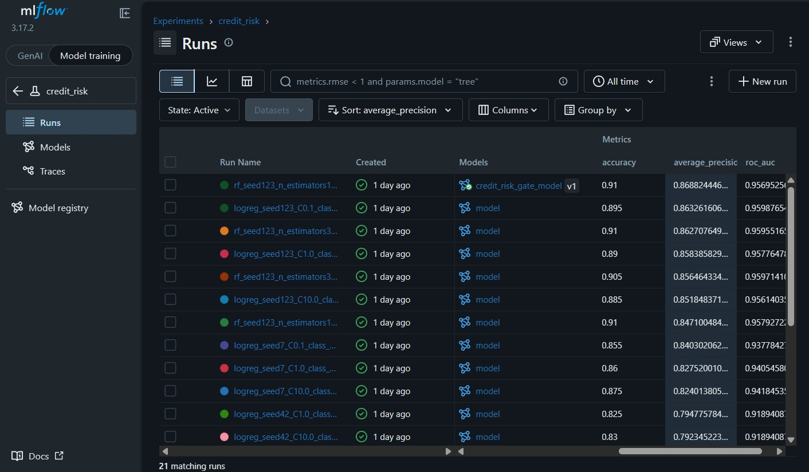
Figure 3. MLflow run history: 21 matching runs sorted by average_precision. The top run carries the registered credit_risk_gate_model v1 tag, and accuracy stays high across every run, which foreshadows the metric argument in Section 09.
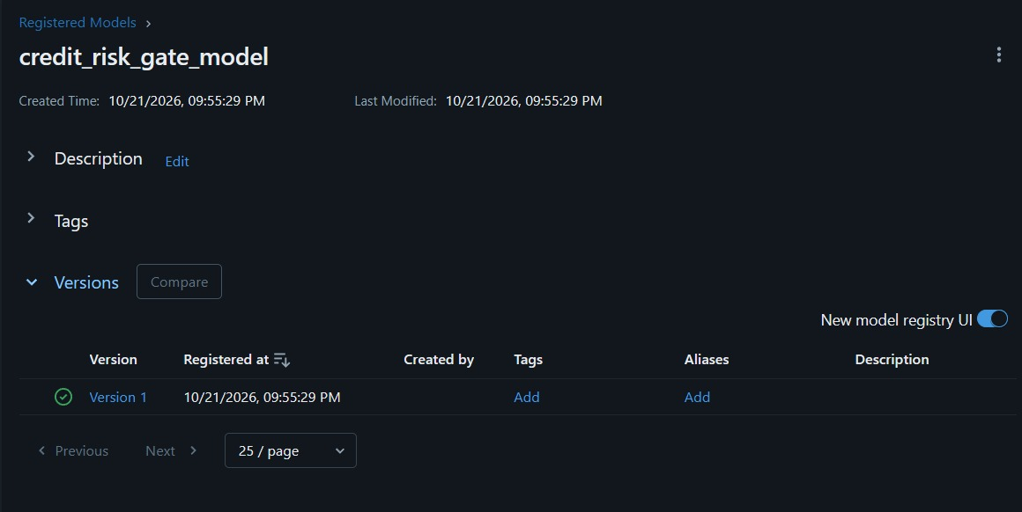
Figure 3b. The registered model credit_risk_gate_model, Version 1, in the MLflow Model Registry, with its registration time. This is the artefact the gate protects.

09 Metric Justification: Why Not Accuracy
About 18.9 percent of customers are high risk. A model that predicts not high risk for everyone therefore scores about 81 percent accuracy while catching zero defaulters. Across our 21 runs accuracy sits between 0.80 and 0.92 for every model, strong and weak alike, so accuracy simply cannot tell a good model from a bad one here. The costly error is a false negative, a high-risk customer approved as safe, and accuracy weights that the same as a harmless false positive.
What we use instead
Metric | What it measures | Role here
Average precision (PR-AUC) | Area under the precision-recall curve for the high-risk class | The gate metric: focuses on the minority class, threshold-free.
ROC-AUC | Ranking quality over both classes | Secondary check; can look optimistic under imbalance.
F1 / precision / recall | Behaviour at the 0.5 threshold | Reported for interpretability; depend on the threshold.
Accuracy | Overall correctness | Reported only to show why it is misleading here.

PR-AUC is the gate metric because it most directly answers the question the gate must ask: does this model rank high-risk customers better than the baseline. The three-rule comparison in Section 12 backs this choice with concrete numbers from our own runs.

10 The Quality Gate and CI (Task 6)
A GitHub Actions workflow runs on every pull request into main. It installs dependencies, restores the data with dvc pull, runs pytest, trains with the CI configuration, compares the best model PR-AUC to the baseline, and blocks the merge if a test fails or the model is worse. It writes a short Markdown summary a reviewer can read without opening logs.
The gate rule
PASS if candidate_metric >= baseline_metric - tolerance

candidate 0.7948 >= 0.7948 - 0.01 -> PASS (documentation PR)
candidate 0.7269 < 0.7948 - 0.01 -> FAIL (shallow forest PR)

Protecting the baseline
The baseline is never changed by CI. It is updated only by a reviewed manual run of update_baseline.py on main, and the baseline file plus the CI config are marked review-protected through CODEOWNERS. A branch-protection ruleset on main requires the quality-gate check to pass before any merge, so a red gate genuinely blocks the merge rather than merely advising against it.
The three required pull requests
Pull request | Change | CI result | Why
Passes | Documentation PR (by Shreya) | Green | Tests pass and the gate model equals the baseline.
Fails, model worse | Shallow unweighted forest in CI config | Red at gate step | PR-AUC 0.7269 is below baseline minus 0.01.
Fails, test fails | Drops the zero-limit guard in features | Red at test step | A unit test fails before the gate even runs.

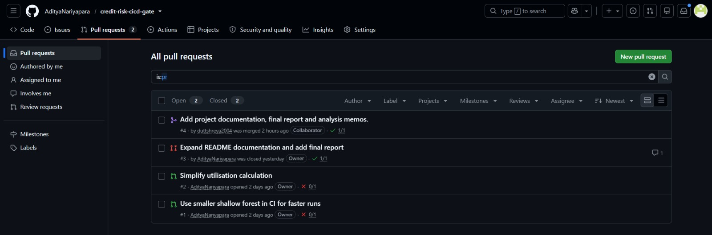
Figure 4a. The pull request history: the merged documentation PR (green check) and the two demonstration PRs that fail the gate (red X). Branch protection blocks the two failing ones from merging.
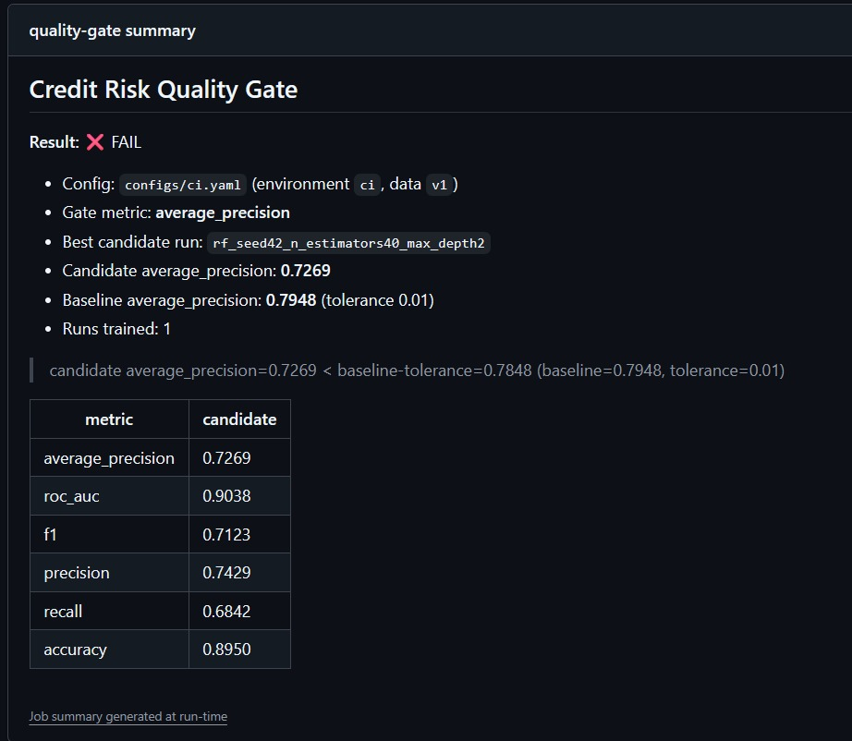
Figure 4b. The gate summary a reviewer sees on the model-worse PR: candidate PR-AUC 0.7269 is below the baseline of 0.7948, so the gate fails and the merge is blocked.

11 Data-Change Drill, v1 versus v2 (Task 7)
When dataset v2 arrived (1,100 rows, the 800 v1 rows plus 300 new customers), we retrained through the same pipeline on both versions across three seeds each, logging every run with a data version tag so the records themselves carry the v1 or v2 label.
Data version | Mean PR-AUC | Std over 3 seeds | Seeds
v1 | 0.7878 | 0.0769 | 42, 7, 123
v2 | 0.8427 | 0.0432 | 42, 7, 123

Is the improvement real? A paired test on five seeds
The v2 mean is higher than v1, but a single run never settles this. To test it properly we reran the drill on five paired seeds (42, 7, 123, 2024, 99), ran a paired t-test on the per-seed PR-AUC differences, and added a 5,000-sample bootstrap confidence interval.
Quantity | Value
Mean PR-AUC, v1 (5 seeds) | 0.814
Mean PR-AUC, v2 (5 seeds) | 0.856
Mean paired difference (v2 - v1) | +0.0416
Paired t-test p-value | 0.077
Bootstrap 95% CI of the difference | [0.015, 0.078]

The result is genuinely borderline, and we report it as such. The bootstrap interval sits just above zero, which hints at a small real gain, but the paired t-test does not clear the 0.05 bar (p = 0.077), so with five seeds we cannot call the improvement statistically significant. The conclusion now rests on a real test rather than a rule of thumb: accept the v2 model because it does not regress, but do not claim a proven improvement. A firmer claim would need more seeds. This discipline, refusing to over-claim, is exactly what the quality gate exists to enforce.

12 Threshold Comparison and Fairness Defense (Task 8)
We did not accept the first metric we tried. We compared three candidate gate rules against our real 21-run history, using the CI model as the baseline, and counted how many of the 21 runs each rule would accept.
Candidate gate rule | Runs accepted | Behaviour
PR-AUC >= baseline - 0.01 | 13 of 21 | Discriminating, rejects the weaker models.
ROC-AUC >= baseline - 0.01 | 20 of 21 | Too lenient, stays high even when ranking drops.
F1 >= baseline - 0.01 | 20 of 21 | Lenient and tied to the 0.5 threshold.

Seven runs that the ROC-AUC and F1 rules would accept are rejected by the PR-AUC rule. These are random forests whose PR-AUC falls as low as 0.690 while their ROC-AUC still reads about 0.92. Gating on ROC-AUC or F1 would let a model that is clearly worse at ranking high-risk customers merge unnoticed, the exact failure in the scenario. We therefore adopt PR-AUC at or above baseline minus 0.01. The 0.01 band absorbs the seed noise measured in Section 11 while still rejecting the real drops.
Error by income group for the registered model
Income_Bracket | Customers | High risk | False neg | False-neg rate | Accuracy
High | 42 | 5 | 1 | 0.200 | 0.929
Medium | 75 | 16 | 3 | 0.188 | 0.853
Low | 83 | 17 | 6 | 0.353 | 0.880

The model misses a high-risk Low-income customer almost twice as often as a Medium or High-income one. Because the costly error is the false negative, this disparity falls on the group least able to absorb it.
Mitigation we implemented: equal-opportunity thresholds
Rather than only flag the gap, we fixed it. We apply a decision threshold per income group (an equal-opportunity policy), lowering the threshold for the under-served group until its false-negative rate matches the others. scripts/robustness_and_fairness.py computes this on the registered model.
Income group | Threshold | FN rate before | FN rate after | Precision before | Precision after
High | 0.50 | 0.200 | 0.200 | 0.667 | 0.667
Medium | 0.50 | 0.188 | 0.188 | 0.619 | 0.619
Low | 0.31 | 0.353 | 0.176 | 0.733 | 0.583

Lowering only the Low-income threshold to 0.31 cuts its false-negative rate from 0.353 to 0.176, in line with the other groups. The trade-off, stated honestly: Low-income false positives rise from 4 to 10 and precision falls from 0.73 to 0.58, so more Low-income customers are flagged as risky who would not default. We accept this because the false negative is the more expensive error for the bank and the more harmful outcome for a customer who is extended credit they cannot service. The policy is an operating threshold applied at decision time and does not change the trained model or the gate metric.

13 Lifecycle Mapping (Task 1)
The project maps onto the classic DevOps lifecycle and the MLOps lifecycle, with every stage pointing at a real artefact in the repository.
DevOps stage | In this project
Plan | Metric choice and gate design; this report.
Code | The credit_risk package (config, data, features, model, pipeline, gate).
Build | requirements.txt and dvc pull restore the exact environment and data.
Test | pytest unit tests plus the model quality gate.
Release | Model selection and registration in the MLflow registry.
Deploy | Accepting a model past the gate on merge to main.
Operate | Retraining on dataset v2 through the same pipeline.
Monitor | Run history comparison and the income subgroup error check.

Three ways ML delivery differs from software delivery
- Correctness is statistical. A model is good only relative to a baseline and within noise, so the test stage needs a quality gate and a noise analysis, not just pass or fail assertions.
- Data is a versioned input. The same code on v1 versus v2 produces different models, so data must be versioned with the code and recorded on every run.
- Experiments are first-class artefacts. Each run carries parameters, metrics and a model worth keeping and comparing, so we select from a tracked history rather than from a single build.
Stages intentionally left out
We leave out a live serving endpoint, continuous drift monitoring and cloud provisioning. The brief forbids paid infrastructure, and here the deploy stage is acceptance past the gate and registration, not a hosted API. Continuous drift monitoring belongs to a later project and would need a running service.

14 Worked Example: Reproduce From a Fresh Clone
Every claim in this report can be reproduced with the commands below (Python 3.11).
git clone https://github.com/AdityaNariyapara/credit-risk-cicd-gate.git
cd credit-risk-cicd-gate
pip install -r requirements.txt
dvc pull # restore v1 and v2 from the in-repo remote
pytest tests/ -q # 21 passed
python scripts/run_training.py --config configs/full.yaml --register # 21 runs, registers best
mlflow ui --backend-store-uri sqlite:///mlflow.db # inspect runs + registry
python scripts/run_gate.py --config configs/ci.yaml # gate: PASS (exit 0)

To see the gate fail on a worse model, point it at the shallow-forest config used in the model-worse pull request; to see the data-change drill, run scripts/data_change_drill.py. The README documents each script.

15 Results, Contributions and Reflection
What the project achieves
- A gate that blocks worse models and failing tests, demonstrated with three real pull requests.
- A complete, traceable experiment log of 21 runs and a registered model tied to its code and data.
- A defended metric and threshold, and an honest subgroup fairness analysis.
Contributions
Member | Main contributions
Aditya Nariyapara (B009) | Repository and DVC setup, config system, feature engineering, training and tracking pipeline, the quality gate, the CI workflow and the two demonstration pull requests.
Shreya Dutt (B016) | The analysis write-ups (fairness and threshold memo, v1 vs v2 drill report, contributing guide), the documentation pull request, and review of the tracking and drill evidence.

Both members can explain, modify and justify any part of the submission.
Both of the project's honest findings were then taken a step further rather than left as caveats. The v2 question was settled with a proper paired t-test over five seeds (Section 11): the gain is borderline and we do not claim it. The low-income disparity was fixed with an equal-opportunity threshold (Section 12) that cuts the group's false-negative rate from 0.353 to 0.176, with the precision cost stated. And model selection was checked across seeds (Section 07), which confirms the stable Logistic Regression baseline over a lucky Random Forest run.
Reflection and remaining limitations
What remains is a matter of scope, not of hidden problems. The equal-opportunity thresholds are an operating-time policy, not yet part of the automated gate; a natural next step is to add a per-group fairness check to CI so a future model that widens the gap is blocked. The v2 result would move from borderline to conclusive, or be ruled out, with more seeds. Stating these openly is, in a sense, the point of the project: the workflow exists so that quality changes and hidden disparities are measured, tested and defended rather than assumed.

16 Deliverables Checklist
Deliverable asked in the brief | Where it is | Status
Repository with code, config, tests, workflow, README | github.com/AdityaNariyapara/credit-risk-cicd-gate | Done
Experiment-tracking evidence, 10+ runs and registered model | Sec 08; Figures 3, 3b | Done
Lifecycle mapping diagram or table | Sec 13; docs/lifecycle_map.md | Done
CI history showing the three pull requests | Sec 10; Figures 4a, 4b | Done
Feature documentation table | Sec 06; docs/feature_table.md | Done
One-page metric justification | Sec 09; docs/metric_justification.md | Done
Threshold comparison table | Sec 12; docs/fairness_memo.md | Done
Subgroup breakdown by Income_Bracket | Sec 12 | Done
Fairness-defense memo | Sec 12; docs/fairness_memo.md | Done
Short report on design decisions and v1 vs v2 | This report; Sec 11 | Done
5-minute demonstration | Live or recorded by the team | Pending demo

