**Course: Data Structures and Algorithms**

**Assignment no: 3**

**­**

**Outputs:**

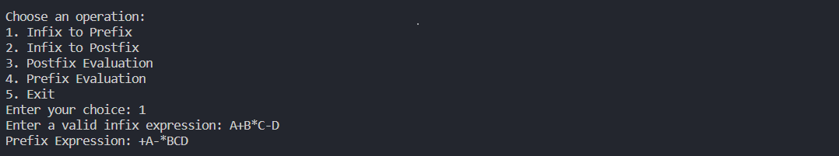Choice: Infix to Prefix

Choice: Infix to Postfix

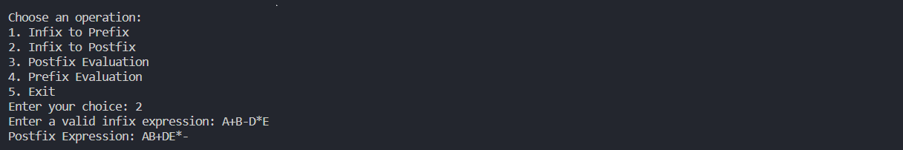

Choice: Postfix Evaluation

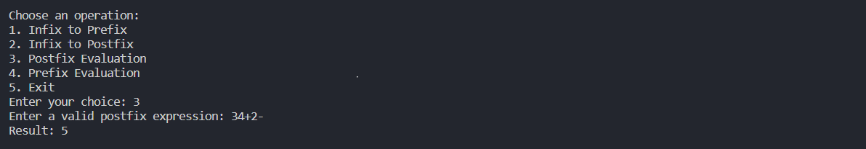

Choice: Prefix Evaluation

