GAME NAME: BBC (Bharat Beats Corona)

PLAYING CHARACTER: BHARAT(MAN)

NON-PAYING CHARACTER:

1. Corona Virus
2. Mask
3. Sanitizer
4. Hot water Glass
5. Honey Bottle
6. Medicine
7. Vitamin C Tablet
8. Oximeter
9. Temperature Gun

GOAL: Safely reach to his Home crossing various Corona virus challenges

STORY:

1. BHARAT/Man has to reach to its goal safely without dying.
2. Start from Airport
3. On the way first mob outside the airport so he chooses fly over
4. On the way increase or earn point/size/immunity by taking hot glass water on the way (earn 10 points)
5. On the way he has to catch the mask so that he will be safe this will increase his size or earn point/size/immunity (earn 30 points) with pop up message “Immunity Boost”.
6. On the way he has to sanitize his hands so that he will be safe this will increase his size or earn point/size/immunity by taking hot glass water on the way (earn 50 points) with pop up message “Immunity Boost”.
7. On fly over he found various virus on road jump over them to safe and if BHARAT touches the virus his size decrease and loose his immunity, with pop up message “Immunity Loose”.
8. On the way found group of people/ mob then use tunnel instead of touching with them and loose immunity / size decrease (lose 10 points)
9. On the way in tunnel increase or earn point/size/immunity by taking honey from bottle (earn 10 points)
10. After coming from tunnel, he found various virus on road jump over them to safe and if BHARAT touches the virus his size decrease and loose his immunity, with pop up message “Immunity Loose”.
11. On the way he has to increase his immunity/size by taking vitamin C tablet at somewhat at height or in trees by jump and touch them (earn 20 points) with pop up message “Immunity Boost”.
12. On the way he found “King of corona” when touches his immunity lose with pop up message “Immunity Loose” (lose 50 points).
13. On the way he has to catch the mask so that he will be safe this will increase his size or earn point/size/immunity (earn 30 points) with pop up message “Immunity Boost”.
14. On the way he has to sanitize his hands so that he will be safe this will increase his size or earn point/size/immunity by taking hot glass water on the way (earn 50 points) with pop up message “Immunity Boost”.
15. Finally he reached his home safely with pop up message “STAY HEALTHY-STAY SAFE”

**Mask**

AIRPORT

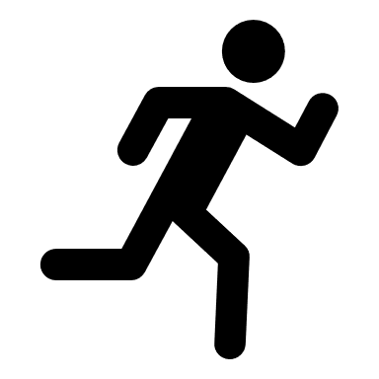

corona