INSTITUTE OF TECHNICAL EDUCATION AND RESEARCH (ITER), SOA UNIVERSITY
Capstone Project Report – Assignment 4 (LSP)
Subject: Linux System Programming
Project Title: Network File Sharing – Server & Client using C++ Sockets
Submitted by: Aditya Padhi
Regd No.: 2241016007
Branch: Computer Science and Engineering (CSE)
Semester: 7th
Under the Guidance of: Dr. Ayes Chinmay

Capstone Project Report

Assignment 4 (LSP): Network File Sharing – Server & Client

1. Title
Network File Sharing – Server & Client using C++ Sockets

2. Objective
The objective of this project is to develop a networked file-sharing system using C++ socket programming that allows users to share files between a server and multiple clients over a TCP/IP connection. The system supports uploading, downloading, and listing files remotely, demonstrating client–server architecture and inter-process communication under Linux.

3. Tools and Technologies
Component | Technology
Language | C++ 17
Platform | Linux (Ubuntu via WSL2)
IDE | Visual Studio Code
Protocol | TCP/IP
Libraries | <sys/socket.h>, <arpa/inet.h>, <netdb.h>, <thread>, <filesystem>

4. Problem Statement
Transferring files between systems often requires manual effort or third-party tools. This project provides a custom-built file-sharing application that can be run entirely on Linux systems, using only C++ sockets for secure and efficient file exchange.

5. Project Description
The project consists of two main modules:
- Server Module (server.cpp)
- Listens for incoming client connections on a specified IP and port.
- Handles client requests for file upload (put), file download (get), and listing (ls).
- Saves uploaded files to a shared directory (shared_root/uploads/).
- Logs client connections and file activity.
- Client Module (client.cpp)
- Connects to the server using TCP sockets.
- Sends commands (put, get, ls, quit) to interact with the server.
- Uploads and downloads files using reliable send/receive mechanisms.
- Displays file lists and transfer status in the terminal.

6. System Architecture
+-------------+ TCP/IP +-------------+
| Client | <------------------> | Server |
| (client.cpp)| | (server.cpp)|
| Upload/Download | | Store files |
+-------------+ +-------------+

7. Features Implemented
- Server–Client connection via TCP
- File Upload (Client → Server)
- File Download (Server → Client)
- File Listing (ls)
- Multi-directory support (uploads, hii, etc.)
- Real-time server logs for file activity
- Browser access through python3 -m http.server

8. Commands Used
Command | Description
put <local> <remote> | Uploads file to server
get <remote> | Downloads file from server
ls | Lists files/directories on server
quit | Disconnects client
python3 -m http.server 8080 | View shared files via browser

9. Output Screenshots
Include screenshots of server start, client connection, uploads, listings, logs, and browser view.
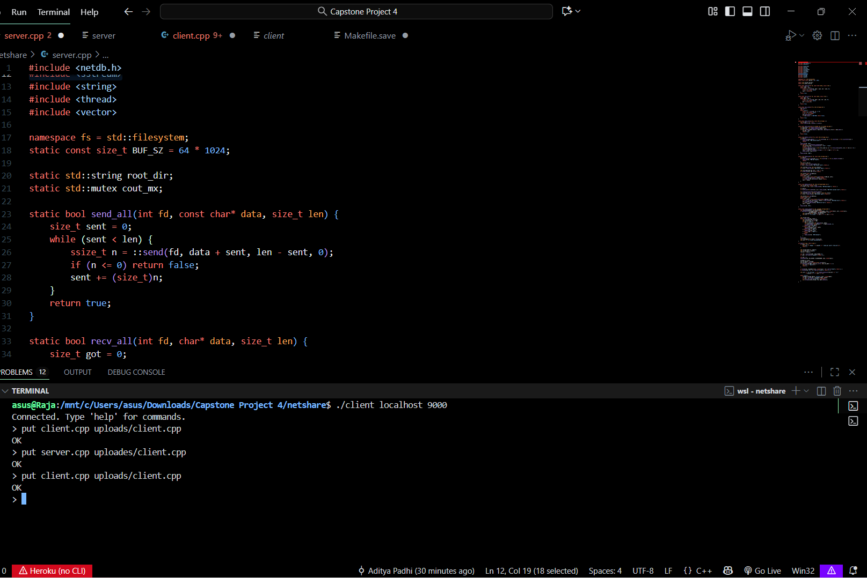
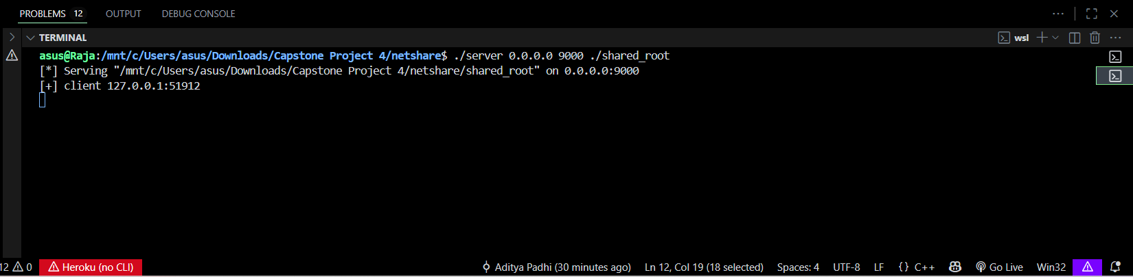
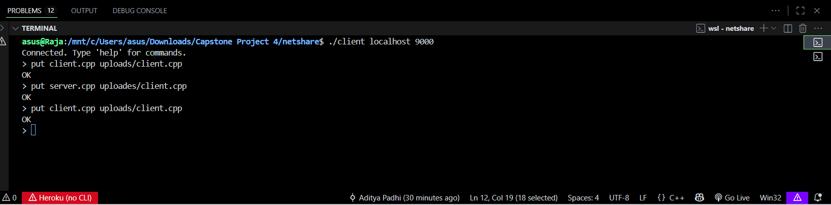
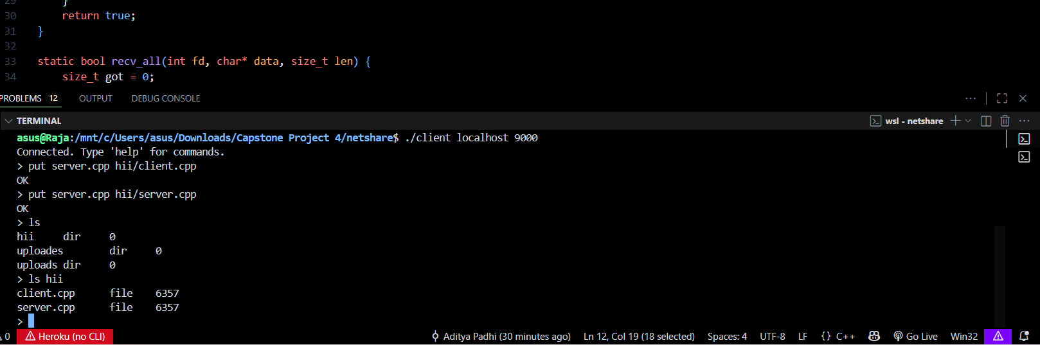

10. Results
Project successfully implements file-sharing using sockets with upload, download, and web access features.

11. Conclusion
A fully functional file-sharing application was developed using C++, demonstrating client-server communication and socket programming.

12. GitHub Repository
https://github.com/AdityaPadhi-lab/Network-File-Sharing-Server-Client

13. Future Scope
Add user authentication, encryption, and web dashboard features for better usability.

14. References
Beej’s Guide to Network Programming, cppreference.com, and Linux man pages for socket functions.

Place: Bhubaneswar
Date: 09/11/2025
(Signature)
Aditya Padhi
Regd. No.: 2241016007
B.Tech – 7th Semester, CSE
ITER, SOA University

