Masterplan: SolarCast MVP

1. App Overview & Objectives
Goal: Predict short-term (0–48h) solar output for a single 5 MW site at 15–30 min intervals using preloaded “replay” data. Visualize forecasts vs. actuals, surface weather-driven insights, and report accuracy against a naïve baseline.
Why it matters: Operators and grid managers need reliable, explainable day-ahead forecasts to plan dispatch, reduce curtailment, and improve bidding decisions.

2. Target Audience
Primary: Renewable energy companies, plant operators, grid managers.
Secondary: Faculty evaluators and peers reviewing ML methodology, visualization, and system design.

3. Core Features & Functionality
- Forecast Graphs (Predicted vs. Actual Power)
- Weather Insights (irradiance, temperature, humidity, cloud cover)

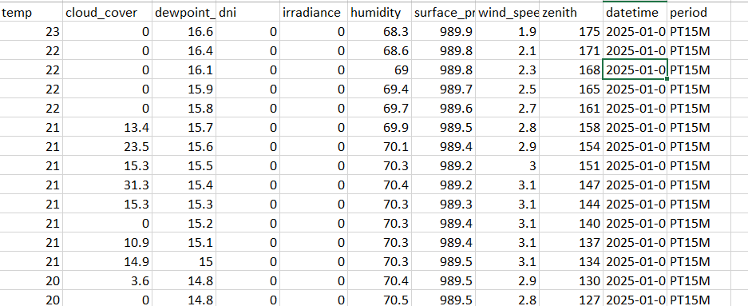
🌡️ 1️⃣ temp
- Meaning: Air temperature (in °C).
- Description: The ambient air temperature measured at the site.
- Use: Affects solar panel efficiency — as temperature increases, panel output generally decreases slightly.
- Example: 23°C means the surrounding air is warm but not extreme.

☁️ 2️⃣ cloud_cover
- Meaning: Fraction of the sky covered by clouds (in % or 0–100 scale).
- Description: Tells how cloudy the sky is at a given time.
- Use: A key factor affecting sunlight reaching the panels — higher cloud cover = lower irradiance (less sunlight).
- Example: 0 → clear sky; 100 → fully cloudy.

💧 3️⃣ dewpoint_dni
- Meaning: Dew point temperature (°C).
- Description: Temperature at which air becomes saturated with moisture and dew starts to form.
- Use: Indicates atmospheric moisture; can be correlated with humidity.
- Note: The name has “_dni,” but here it still refers to dew point temperature, not irradiance.

☀️ 4️⃣ irradiance
- Meaning: Global Horizontal Irradiance (GHI) in W/m².
- Description: Total solar radiation received per unit area on a horizontal surface.
- Use: This is the main input for calculating solar energy generation.
- Typical range:
  - Nighttime: 0 W/m²
  - Cloudy day: 100–400 W/m²
  - Sunny noon: 800–1000 W/m²

💦 5️⃣ humidity
- Meaning: Relative humidity (%) — moisture content in the air.
- Description: The percentage of water vapor in the air relative to the maximum it can hold at that temperature.
- Use: Affects air clarity and heat — very high humidity can slightly reduce solar radiation due to scattering.

🌬️ 6️⃣ surface_pr
- Meaning: Surface pressure (in hPa or millibar).
- Description: Atmospheric pressure near the ground level.
- Use: Helps identify weather conditions (e.g., low pressure → cloudy or rainy, high pressure → clear sky).

🌪️ 7️⃣ wind_spee
- Meaning: Wind speed (m/s).
- Description: Speed of wind measured near the surface.
- Use: Wind can cool solar panels (helping efficiency) but may also indicate turbulent or cloudy conditions.
- Example: 2.3 m/s = light breeze.

☀️ 8️⃣ zenith
- Meaning: Solar zenith angle (in degrees).
- Description: Angle between the sun and the vertical direction.
- Use:
  - When the sun is directly overhead → zenith ≈ 0° (maximum irradiance).
  - Larger zenith angles → sun lower in the sky (morning/evening), hence less irradiance.

🕒 9️⃣ datetime
- Meaning: Date and time stamp for each record.
- Description: Specifies the exact time (e.g., 2025-01-01 00:00).
- Use: Used for time-based analysis, feature engineering (like hour, month, lag features), and daily solar cycle tracking.

⏱️ 🔟 period
- Meaning: Data collection frequency.
- Example: PT15M = “Period of 15 Minutes”.
- Description: Indicates that each row corresponds to a 15-minute interval reading.
- Use: Important for resampling and calculating lag/rolling averages correctly (as used in your project constants).

- KPIs (MAPE ≤ 15%, RMSE ≤ 8%) and Baseline comparison
- Historical Comparison
- Simple Date Controls
- Light Explainability (Top features + narrative insight)
- Data Replay + Optional Live API call

4. Platform & UX
Platform: Desktop web (Streamlit)
UX: Clean, operator-friendly, high contrast visualization.

5. Technical Stack
Frontend/UI: Streamlit (Python)
Storage: Local CSV/JSON
ML: Python (pandas, scikit-learn/xgboost, SHAP for explainability)
Integration: Optional OpenWeatherMap API
Reason: Simple, demo-ready, and focused on ML outcomes.

6. Conceptual Data Model
Entities: Site, WeatherRecord, ActualGeneration, ForecastRecord, ModelMetadata, KPIRecord
Conversion Formula: predicted_kW = (predicted_%Capacity / 100) × Plant_Rated_kW

7. UI Design Principles
Top KPIs → Main Chart (Forecast vs Actual) → Weather Stack → Explainability Panel → Controls Sidebar.
Clean, minimalistic, color-blind-friendly.

8. Security & Access
Local demo only, no sensitive data, optional password, API key stored in .env file.

9. Development Phases
1. Data & Baseline
2. ML Model
3. Dashboard
4. Explainability & Polish
5. Packaging & Presentation

10. Challenges & Solutions
- Nighttime MAPE distortion → Filter daytime only
- Feature drift → Normalize & validate features
- Overfitting → Time-based validation & baseline comparison
- Demo reliability → Precompute outputs & optional API

11. Future Expansion
- Multi-site/tenant support
- Add wind/hybrid forecasting
- Real-time ingestion & auto-retraining
- Cloud hosting (Supabase/Firebase)
- Alerts & APIs for operators

12. Suggested Diagrams
System Data Flow: Replay Data → ML Engine → Forecast CSV → Streamlit Dashboard
Dashboard Layout: KPIs → Forecast Chart → Weather Trends → Explainability → Controls

13. Summary Recommendations
Scope: Solar, single site, 0–48h
Target: Predict % capacity, convert to kW/MW
KPIs: MAPE ≤15%, RMSE ≤8%, beat persistence ≥20%
Stack: Streamlit + CSV/JSON + scikit-learn
Explainability: Light insights + top drivers

- Steps to accomplish the project

🌞 Phase 1 – Data Preprocessing and Preparation

Objective
The purpose of this phase was to convert the raw weather data into a clean, consistent, and machine-learning-ready dataset.
SolarCast relies on accurate solar irradiance, temperature, humidity, and cloud-cover data to forecast the expected power output of a 5 MW solar plant.
Therefore, preparing high-quality input data was essential before any model training.

Steps Performed
- Data Loading and Organization
  - A structured project folder was created containing the directories data/, scripts/, and artifacts/.
  - The raw CSV file (wholedata.csv) was imported using Pandas.
  - Column names were standardized and the datetime field was parsed for proper time-based indexing.
- Handling Missing Values and Duplicates
  - Missing numeric values were filled using linear interpolation to maintain smooth continuity.
  - Duplicate timestamps were removed and data were chronologically sorted.
- Target Variable Creation
  - The main output variable, actual_power_kW, was computed using the formula:
Power (kW)=Irradiance (W/m²)×5000 kW (plant capacity)×0.20 (efficiency)/1000\text{Power (kW)} = \text{Irradiance (W/m²)} \times 5000 \text{ kW (plant capacity)} \times 0.20 \text{ (efficiency)} / 1000Power (kW)=Irradiance (W/m²)×5000 kW (plant capacity)×0.20 (efficiency)/1000
  - This represents the realistic power generation for a 5 MW site.
- Feature Engineering
  - New temporal features such as hour, minute, dayofyear, and cyclical sine/cosine encodings were created.
  - Lag features and rolling averages were added to capture short-term temporal patterns.
- Outlier Treatment
  - Outliers in irradiance, temperature, humidity, and cloud_cover were detected using the IQR (Inter-Quartile Range) method.
  - Extreme values were capped within calculated upper and lower bounds to prevent distortion in model training.
- Daytime Filtering and Clean Dataset Generation
  - Night-time records (irradiance < 30 W/m²) were removed to avoid MAPE distortion.
  - The cleaned dataset was saved as solar_data_clean.csv.
- Model Matrix Creation (Simplified)
  - A clean model-ready dataset (solar_data_model.csv) was created by keeping only relevant features and the target column.
  - The list of input features was stored in feature_cols.json for consistent use in later phases.
- Train/Test Split
  - The dataset was split into training (80 %) and testing (20 %) subsets using train_test_split() from scikit-learn.
  - Separate CSV files (x_train.csv, x_test.csv, y_train.csv, y_test.csv) were saved for Phase 2 model training and evaluation.

Outcome
By the end of Phase 1, a fully preprocessed and feature-engineered dataset was obtained.
The data are clean, standardized, and organized in a format ready for machine-learning models such as Random Forest or XGBoost.
This phase ensures reliable inputs and consistent performance evaluation in the subsequent modeling phase.

