Clemson University CPSC 8750

Smart Home Architecture Document

CONTENT OWNER: Aditya Patil and Amey Patil

|  |  |  |
| --- | --- | --- |
| DOCUMENT NUMBER: | RELEASE/REVISION: | RELEASE/REVISION DATE: |
| * 1.0 | * V1 | * 28th March 2016 |
| * 2.0 | * V2 | * 1st April 2016 |

Table of Contents

1.1 Stakeholder Representation 1

1.2 Viewpoint Definitions 2

1.2.1 Operational Viewpoint Definition 2

1.2.1.1 Abstract : 2

1.2.1.2 Stakeholders and Their Concerns Addressed: 2

1.2.1.3 Elements, Relations, Properties, and Constraints: 2

1.2.1.4 Language(s) to Model/Represent Conforming Views: 3

1.2.1.5 Applicable Evaluation/Analysis Techniques and Consistency/Completeness Criteria: 3

1.2.1.6 Viewpoint Source: 3

Home automation system present in household. 3

1.2.2 Context Viewpoint Definition 3

1.2.2.1 Abstract: 3

1.2.2.2 Stakeholders and Their Concerns Addressed: 4

1.2.2.3 Elements, Relations, Properties, and Constraints: 4

1.2.2.4 Language(s) to Model/Represent Conforming Views: 4

1.2.2.5 Applicable Evaluation/Analysis Techniques and Consistency/Completeness Criteria: 5

1.2.3 Development Viewpoint Definition 5

1.2.3.1 Abstract: 5

1.2.3.2 Stakeholders and Their Concerns Addressed: 5

Developer is the person who implements the system and their modules. 5

1.2.3.3 Elements, Relations, Properties, and Constraints: 5

1.2.3.4 Language(s) to Model/Represent Conforming Views: 6

1.2.3.5 Applicable Evaluation/Analysis Techniques and Consistency/Completeness Criteria 7

1.2.4 Specification Viewpoint Definition 7

1.2.4.1 Abstract: 7

1.2.4.2 Stakeholders and Their Concerns Addressed: 7

Executive is the person who takes all the decisions. 7

1.2.4.3 Elements, Relations, Properties, and Constraints: 7

1.2.4.4 Language(s) to Model/Represent Conforming Views: 8

1.2.4.5 Applicable Evaluation/Analysis Techniques and Consistency/Completeness Criteria 8

2 Architecture Background 9

2.1 Problem Background 9

2.1.1 System Overview 9

2.1.2 Goals and Context 9

2.1.3 Significant Driving Requirements 9

2.2 Solution Background 10

2.2.1 Architectural Approaches 10

2.2.2 Analysis Results 10

2.2.3 Requirements Coverage 10

2.2.4 Summary of Background Changes Reflected in Current Version 11

3 Views 12

3.1 Physical View 12

3.1.1 View Description: This view is from the Developer Stakeholder. 12

3.1.2 View Packet Overview 12

3.1.3 View Packets 13

3.1.3.1 View packet 13

3.1.3.1.1 Primary Presentation 13

3.1.3.1.2 Element Catalog 14

3.1.3.1.3 Context Diagram 16

3.2 System View 16

3.2.1 View Description: This view is from the Architect Stakeholder. 16

3.2.2 View Packet Overview 16

3.2.3 View Packets 16

3.2.3.1 View packet # j 17

3.2.3.1.1 Primary Presentation 17

3.2.3.1.2 Element Catalog 17

3.2.3.1.3 Context Diagram 18

3.2.3.1.4 Related View Packets 18

4 Relations Among Views 19

4.1 General Relations Among Views 19

4.2 View-to-View Relations 19

5 Referenced Materials 20

6 Figures 21

List of Figures

Figure 1: Sample Figure 1

List of Tables

Table 1: Stakeholders and Relevant Viewpoints 1

Table 2: Sample Table 1

## Stakeholder Representation

Primary Stakeholders-

* Users- namely Owner of system, Elderly people.
* System Architect
* Developer
* Executive

Secondary Stakeholders-

* Firefighting Department.
* Police Department.
* Hospital staff.

## Viewpoint Definitions

Table 1: Stakeholders and Relevant Viewpoints

| Stakeholder | Viewpoint(s) that apply to that class of stakeholder’s concerns |
| --- | --- |
| User | Operational Viewpoint |
| System Architect | Context Viewpoint |
| Developer | Development Viewpoint |
| Executive | Specification Viewpoint |

### Operational Viewpoint Definition

#### Abstract:

#### The Smart Home application smartly manages many functions in the house on its own without the aid of the owner. The owner has to just initially set the parameters for the various functionalities in the Smart Home system. Smart Home manages various function like Anti-theft, Energy saving and detection of fire, gas leak and also helps in communicating the emergency situation to the Hospitals, owner/Police.

#### Stakeholders and Their Concerns Addressed:

#### The 'User' represents the person staying in the house who wish that many of their functions of monitoring various activities in the house are done automatically by the Smart Home system. This is because many people rely on technology for almost all their daily activities. Technology can also handle these activities in an efficient manner.

#### Elements, Relations, Properties, and Constraints:

|  |  |  |  |
| --- | --- | --- | --- |
| Elements | Relations | Properties | Constraints |
| User | Uses the smart home system | User is able to use the system without considerable guidance | Needs his smart phone to be connected to system at every point of time. |
| GUI | Gives user an interface to interact with the smart home system | It is used by user and is user friendly and easy to use. | Customization of GUI is not provided so user has to rely on GUI provided by manufacturer |

#### Language(s) to Model/Represent Conforming Views:

Used AADL to model the operational view point. Figure 1 in section 6 represent the AADL model imv view of the Smart Home Architecture.

#### Applicable Evaluation/Analysis Techniques and Consistency/Completeness Criteria:

#### a) No module has a parent element (b) Major functionality is handled by Controller. (c) The union of all modules like Camera, Owner, Communication media like phone, different sensors for various functionalities and the energy saving system form the whole system covers the requirements for the system. (d) The module are required to interact between them and come up with the entire system functionality as a whole.

#### Viewpoint Source:

#### Home automation system present in household.

### Context Viewpoint Definition

#### Abstract:

#### The Smart Home application smartly manages many functions in the house on its own without the aid of the owner. The owner has to just initially set the parameters for the various functionalities in the Smart Home system. Smart Home manages various function like Anti-theft, Energy saving and detection of fire, gas leak and also helps in communicating the emergency situation to the Hospitals, owner/Police.

#### Stakeholders and Their Concerns Addressed:

#### System Architect represents the person who designs the entire system and models the different modules in the system and their interactions between them

#### Elements, Relations, Properties, and Constraints:

|  |  |  |  |
| --- | --- | --- | --- |
| Elements | Relations | Properties | Constraints |
| Architect | Creates a initial overview of the system comprising of components | Gives a component view and interactions among them. | Any issues within components or interdependency may not be considered. |
| Executive | Takes all the decisions in project management | Is program and project manager and is mainly responsible for any decisions within the system. | Has very less time to take decisions so need to think fast and accurate which might not be correct every time. |

#### Language(s) to Model/Represent Conforming Views:

Used AADL model.

#### Applicable Evaluation/Analysis Techniques and Consistency/Completeness Criteria:

#### a) No module has a parent element (b) Major functionality is handled by Controller. (c) The union of all modules like Camera, Owner, Communication media like phone, different sensors for various functionalities and the energy saving system form the whole system covers the requirements for the system. (d) The module are required to interact between them and come up with the entire system functionality as a whole.

### Development Viewpoint Definition

#### Abstract:

#### The Smart Home application smartly manages many functions in the house on its own without the aid of the owner. The owner has to just initially set the parameters for the various functionalities in the Smart Home system. Smart Home manages various function like Anti-theft, Energy saving and detection of fire, gas leak and also helps in communicating the emergency situation to the Hospitals, owner/Police.

#### Stakeholders and Their Concerns Addressed:

#### Developer is the person who implements the system and their modules.

#### Elements, Relations, Properties, and Constraints:

|  |  |  |  |
| --- | --- | --- | --- |
| Elements | Relations | Properties | Constraints |
| Developer | Creates the system from requirements | Has clear system requirements and correctly implements them. | Any requirement which is not specified will not be implemented by developer |
| Architect | Creates a initial overview of the system comprising of components | Gives a component view and interactions among them. | Any issues within components or interdependency may not be considered. |
| Executive | Takes all the decisions in project management | Is program and project manager and is mainly responsible for any decisions within the system. | Has very less time to take decisions so need to think fast and accurate which might not be correct every time. |
| User | Uses the system | User is able to use the system without considerable guidance | Needs his smart phone to be connected to system at every point of time. |

#### Language(s) to Model/Represent Conforming Views:

Used AADL model to represent this view.

#### Applicable Evaluation/Analysis Techniques and Consistency/Completeness Criteria

#### a) No module has a parent element (b) Major functionality is handled by Controller. (c) The union of all modules like Camera, Owner, Communication media like phone, different sensors for various functionalities and the energy saving system form the whole system covers the requirements for the system. (d) The module are required to interact between them and come up with the entire system functionality as a whole.

### Specification Viewpoint Definition

#### Abstract:

#### The Smart Home application smartly manages many functions in the house on its own without the aid of the owner. The owner has to just initially set the parameters for the various functionalities in the Smart Home system. Smart Home manages various function like Anti-theft, Energy saving and detection of fire, gas leak and also helps in communicating the emergency situation to the Hospitals, owner/Police.

#### Stakeholders and Their Concerns Addressed:

#### Executive is the person who takes all the decisions.

#### Elements, Relations, Properties, and Constraints:

|  |  |  |  |
| --- | --- | --- | --- |
| Elements | Relations | Properties | Constraints |
| Developer | Creates the system from requirements | Has clear system requirements and correctly implements them. | Any requirement which is not specified will not be implemented by developer |
| Architect | Creates a initial overview of the system comprising of components | Gives a component view and interactions among them. | Any issues within components or interdependency may not be considered. |
| Executive | Takes all the decisions in project management | Is program and project manager and is mainly responsible for any decisions within the system. | Has very less time to take decisions so need to think fast and accurate which might not be correct every time. |
| User | Uses the system | User is able to use the system without considerable guidance | Needs his smart phone to be connected to system at every point of time. |

#### Language(s) to Model/Represent Conforming Views:

Used AADL model to represent this view.

#### Applicable Evaluation/Analysis Techniques and Consistency/Completeness Criteria

#### a) No module has a parent element (b) Major functionality is handled by Controller. (c) The union of all modules like Camera, Owner, Communication media like phone, different sensors for various functionalities and the energy saving system form the whole system covers the requirements for the system. (d) The modules are required to interact between them and come up with the entire system functionality as a whole.

# Architecture Background

## Problem Background

Existing smart home solutions haven’t evolved with time and fail to address the problems faced by user which can be solved using additional functionality to existing system. We came up with a system which would address issues like fire/gas leak hazard, notification to owner, firefighting department, police and nearby hospital. All these functionality were quintessential with the evolution of internet of things but aren’t present in current home system. We identified this problem and came up with a smart home architecture which addresses the need of the hour and caters to the requirement of day to day human.

### System Overview

The Smart home system is decomposed into Control Unit, Sensors, actuators and phone subsystems. Sensors collect the data and send to control unit for processing. The control unit then communicates with actuators and phone subsystems. The functional of sensors, control units, actuators and phone subsystems differ from each other and have a specific time and conditions during which they are called/executed hence we created them as subsystems and not considered as a single system.

### Goals and Context

Smart Home provides intelligently designed functionalities that simplify human life by providing Reliability, Safety and reducing Communication Latency. Customer requirements for highly reliable Smart Home systems has ushered so incorporating various functionalities like providing immediate tele-assistance in case of emergencies, thus preventing major fatal accidents, notifying owner and firefighting department in case of fire/gas hazard, notifying police and owner in case of security breach are provided to ensure safety of the Customer and its belongings.

### Significant Driving Requirements

The significant driving requirements are as follows-

* Owner should be notified in case of fire/gas break.
* Elderly person requires help in case of medical emergency.
* Owner should be notified when there is intrusion at his/her home.
* Appliances like fan, tv, lights get switched off automatically in absence of people.

## Solution Background

### Architectural Approaches

Architecture of the System (Smart Home) - We are implementing Pipeline architecture. The components communicate with each other in a pipeline manner because the output of one component is an input to another component. The Smart Home system is decomposed according to various functional and non-functional requirements of the system. For example, the various sensors get the input from the actual home conditions and when they cross the threshold there needs to be a way to mitigate them, so when the threshold is crossed the signal of crossing threshold is send to control unit which then triggers other components like phone based on the actions which are defined in the control unit to mitigate a specific action. Thus outputs from sensors are given as inputs to control unit which then computes and sends the output to phone which takes it as an input does the necessary actions as defined by the phone component. Thus we are controlling every action at each stage based on the component and the way to handle an action is defined in the component. Thus every component acts together in a sequential manner to give desired result

### Analysis Results

Performed ATAM for Smart home and attached the document “SoftArch_ATAM_SmartHome.docx”

### Requirements Coverage

|  |  |
| --- | --- |
| Requirement | Component in architecture addressing the requirement |
| Owner should be notified in case of fire/gas break | Smoke detectors, sprinklers, gas detectors, mobile phones covers this requirement |
| Elderly person requires help in case of medical emergency. | Cameras, mobile phones, sensors cover this requirement. |
| Owner should be notified when there is intrusion at his/her home. | Cameras, motion detections, human sensors, mobile phones cover this requirement. |
| Appliances like fan, tv, lights get switched off automatically in absence of people. | Sensors, switches cover this requirement. |

### Summary of Background Changes Reflected in Current Version

Similar functionalities in the current architecture can be grouped to form a layer and thus can be converted into a unidirectional layered architecture.

1) Adding an auxiliary sensor to the camera to increase the efficiency.

2) The controller component can be divided into subcomponents so that the processing can be divided and well organized. This will also facilitate the debugging process in case any error occurs. I.e. converting into client server architectural style.

# Views

The views presented in this SAD are the following:

|  |  |  |  |  |  |  |
| --- | --- | --- | --- | --- | --- | --- |
| **Name of view** | **Viewtype that defines this view** | **Types of elements and relations shown** | | **Is this a module view?** | **Is this a component-and-connector view?** | **Is this an allocation view?** |
| Physical View | Module |  |  | Yes | Yes | No |
| System View | Module |  |  | Yes | Yes | No |

## Physical View

### View Description: This view is from the Developer Stakeholder.

### View Packet Overview

This view has been divided into the following view packets for convenience of presentation:

Refer figure 2, 3 in section 6 and figure in view packet section.

### View Packets

#### View packet

##### Primary Presentation

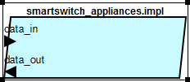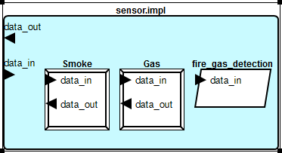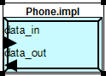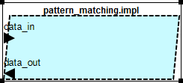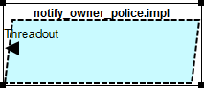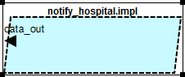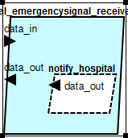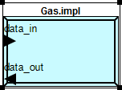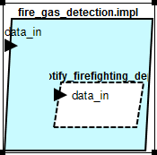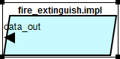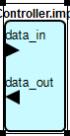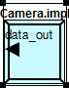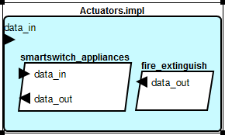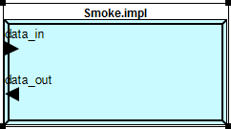

##### Element Catalog

* Actuators
* Camera
* Controller
* Fire extinguisher
* Gas
* Medical emergency signal
* Notification to owner, hospital
* Phone
* Sensor
* Smart switch
* Smoke

###### Elements

* Camera- Used to capture the realtime scene in the home and provide the result to controller for further processing
* Controller- Heart of the system which does all the processing from the outputs given by other components
* Actuators- Acts as an interface between physical systems with logical system.
* Phone- Provides a way of communication to the outer world from the system.
* Sensors- Used for detection.
* Fire extinguisher- Used to handle fire hazard.
* Gas- used to handle gas hazard.
* Medical emergency signal- Used to send emergency tele-assitance to hospitals by elderly.
* Notification to owner, hospital- Used to notify
* Smart switch- Devices which control appliances.
* Smoke- Used to handle smoke hazard.

###### Relations

The various items are components of the system as shown in the diagram2, 3 sections 6. Also the diagrams in the primary presentation of this viewpacket

###### Interfaces

The connection between the two components is as shown in the fig diagram2, 3 sections 6. Also the diagrams in the primary presentation of this viewpacket.

###### Constraints

Connection between all the components need to be active at any point of time.

##### Context Diagram

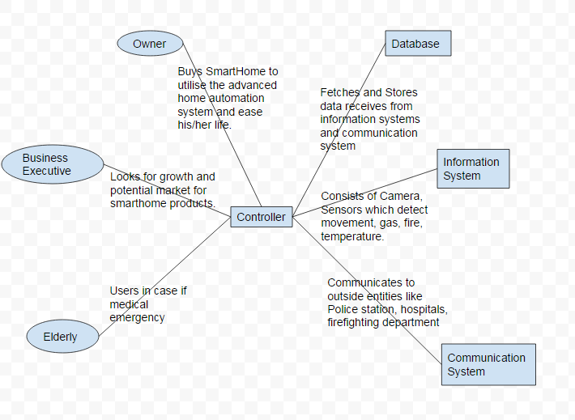

## System View

### View Description: This view is from the Architect Stakeholder.

### View Packet Overview

This view has been divided into the following view packets for convenience of presentation:

Refer figure 1 in section 6. View packet will be the subset of the system view represented in the figure 1 of section 6.

### View Packets

#### View packet # j

##### Primary Presentation

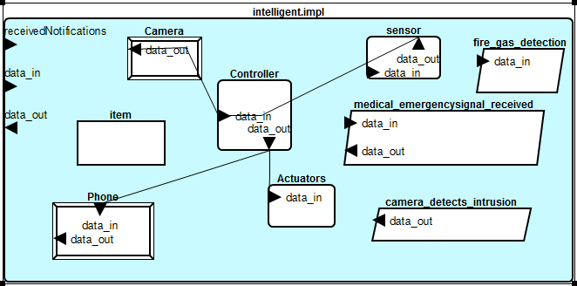

##### Element Catalog

* Camera
* Controller
* Actuators
* Phone
* Item
* Sensors

###### Elements

* Camera- Used to capture the realtime scene in the home and provide the result to controller for further processing
* Controller- Heart of the system which does all the processing from the outputs given by other components
* Actuators- Acts as an interface between physical systems with logical system.
* Phone- Provides a way of communication to the outer world from the system.
* Item- Data object.
* Sensors- Used for detection.

###### Relations

The various items are components of the system as shown in the diagram1 section 6.

###### Interfaces

The connection between the two components is as shown in the fig1 section 6.

###### Constraints

Connection between all the components need to be active at any point of time.

##### Context Diagram



##### Related View Packets

Physical view

# Relations Among Views

## General Relations Among Views

* System view encompasses physical view.
* Physical view gives a way to understand system view.

## View-to-View Relations

The physical view represents the inner working of components shown in system view. All the physical view items are implemented by developer. All the implemented items then form a system in whole.

# Referenced Materials

|  |  |
| --- | --- |
| Home automation online store. | https://www.smarthome.com/ |
| Connected home products | http://www.cnet.com/topics/smart-home/best-smart-home-devices/ |
| Springer Berlin Heidelberg 2006 | Davidoff, S., Lee, M. K., Yiu, C., Zimmerman, J., & Dey, A. K. (2006). Principles of smart home control. In *UbiComp 2006: Ubiquitous Computing*(pp. 19-34). Springer Berlin Heidelberg. |
| Mercolesia, A. E. 2013. | Garcia, M. R., Chan, H. R., Comendador, B. E., Cornell, G. B., Celestial, C. D., & Mercolesia, A. E. (2013). Smart Home Electricity Management System Using Cloud Computing (SHEMS). *Journal of Advances in Computer Networks*, *1*(1), 44-48. |

# Figures



Fig1. System overview

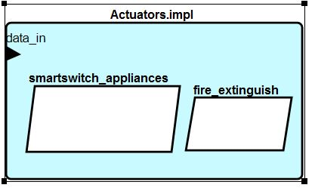

Fig2. Actuator overview

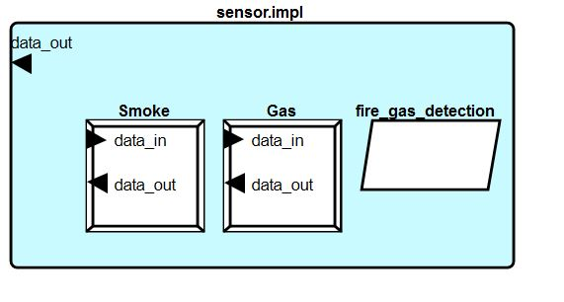

Fig3. Sensor overview