Himanshu Arora

himanshu.arora10@wipro.com

1. **Maven installation on Amazon EC2 Linux server:**

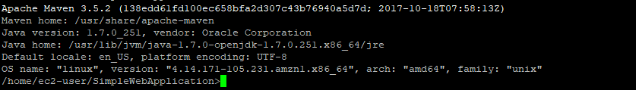

1. **Jenkins installed and running on Amazon EC2 Linux server:**



1. **Jenkins configuration of the pipeline project :**

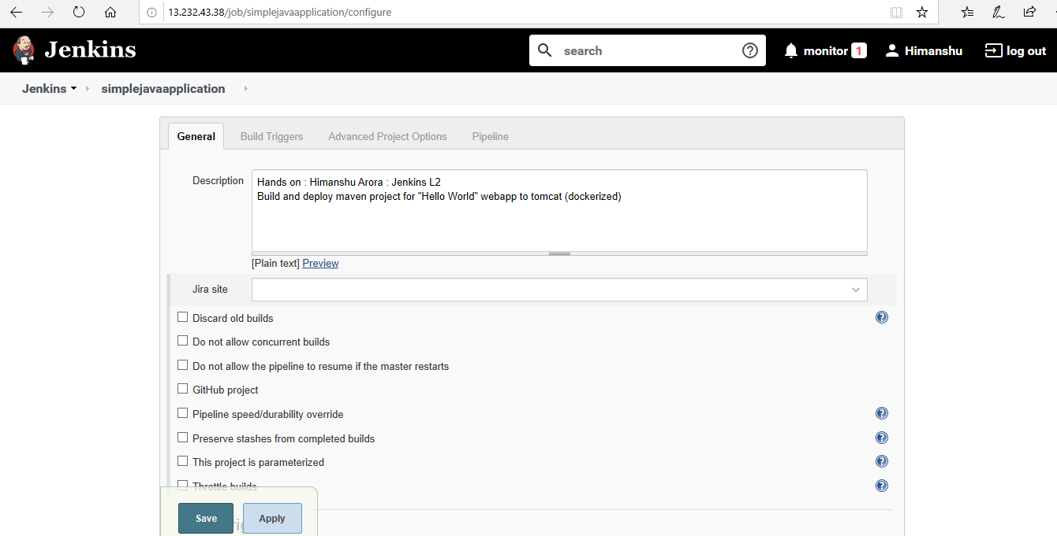

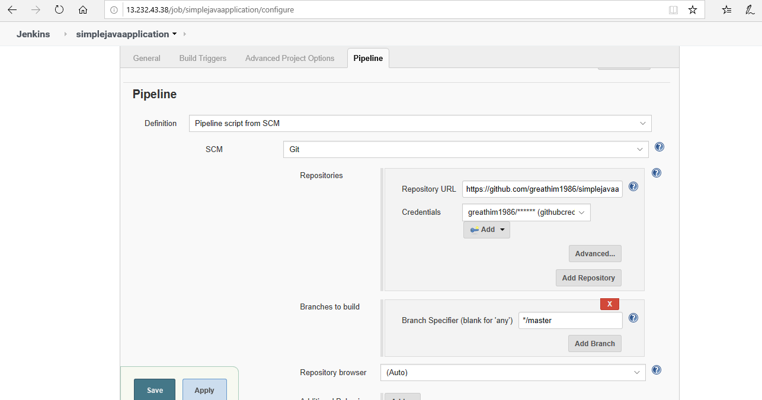

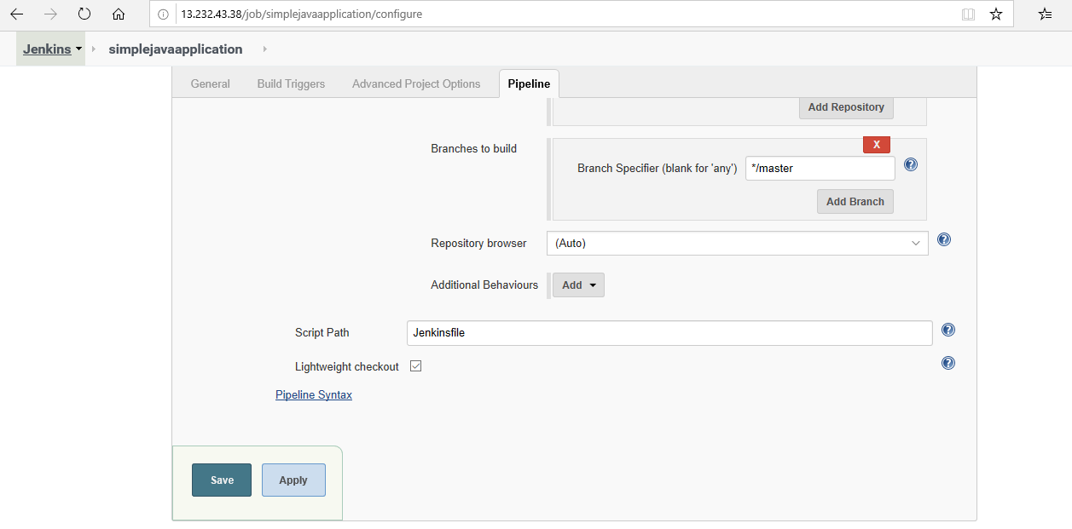

1. Tree structure of the Simple java web application created using mvn :

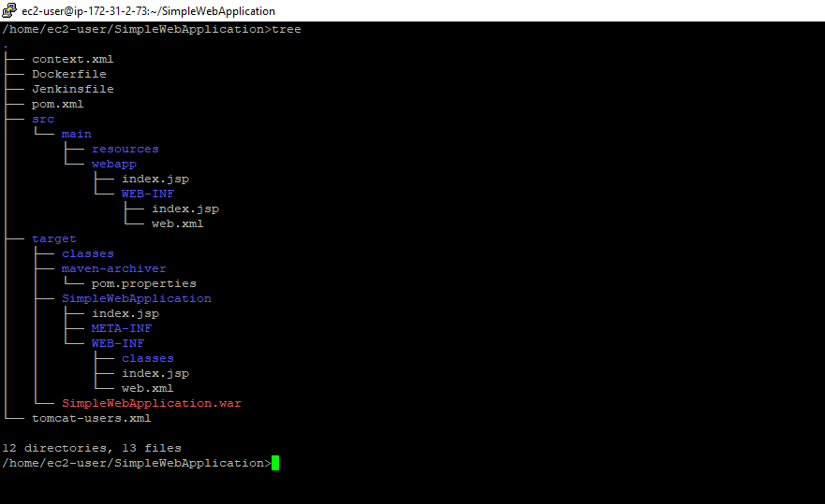

1. **Dockerfile content :**

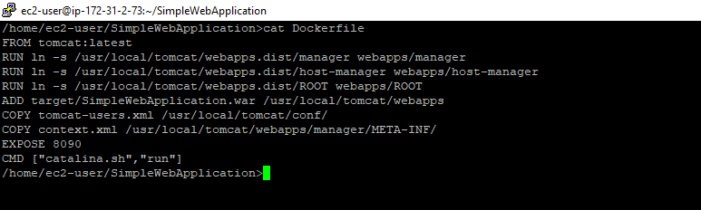

1. **Jenkinsfile content:**

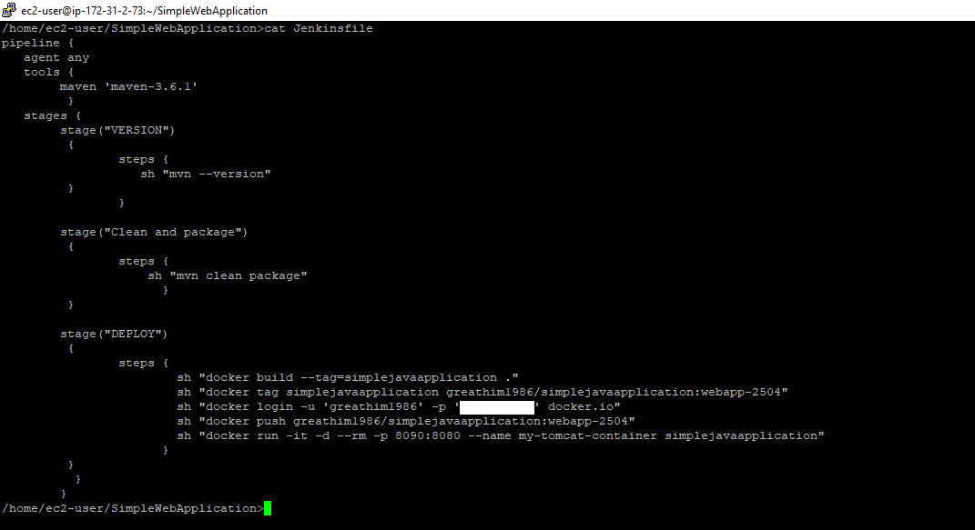

1. **Github repository content:**

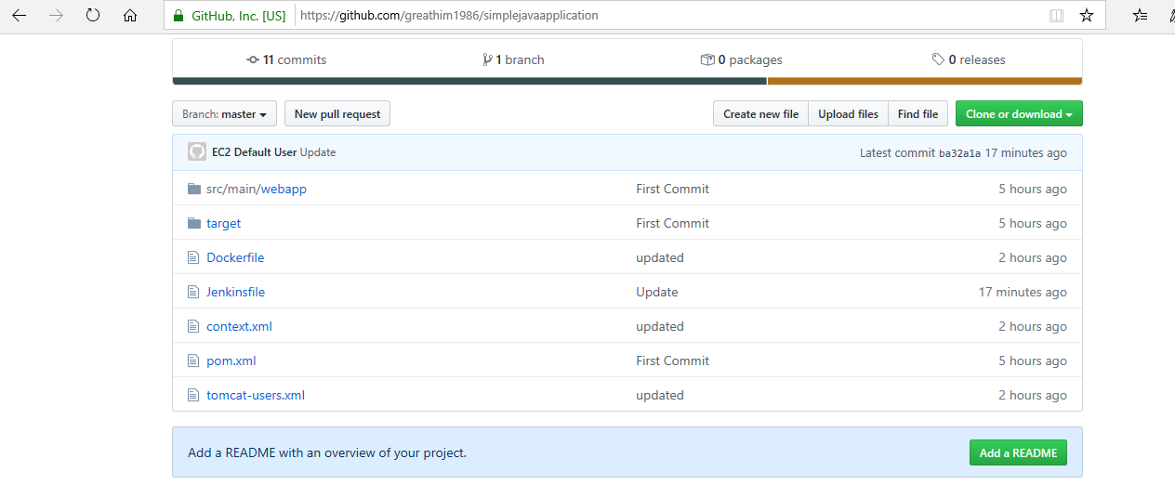

1. **hub.docker.com content:**

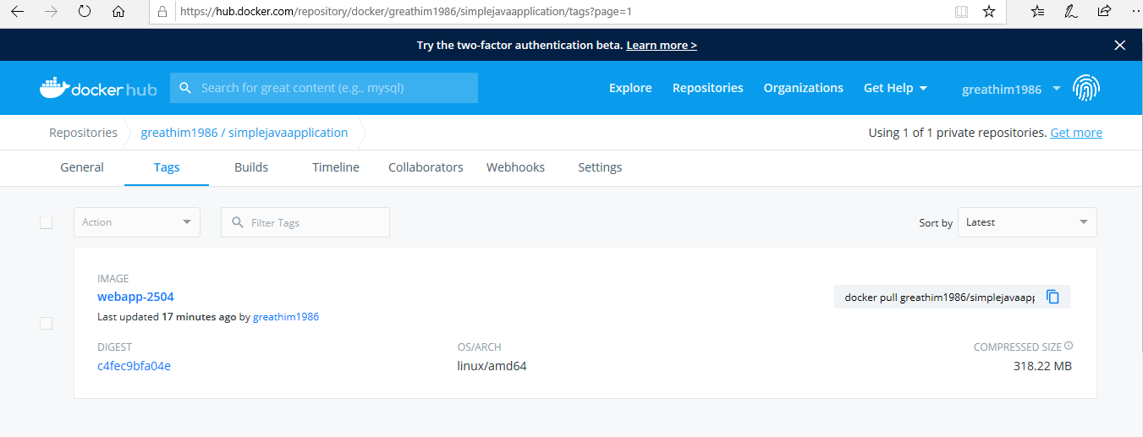

1. **Jenkins build details:**

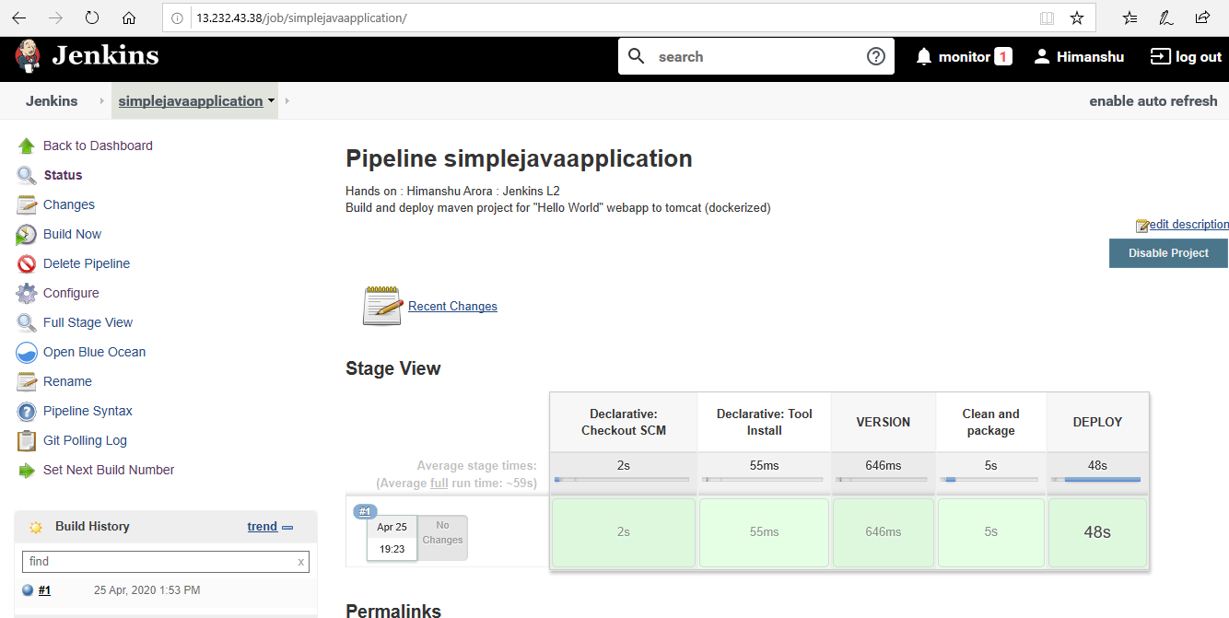

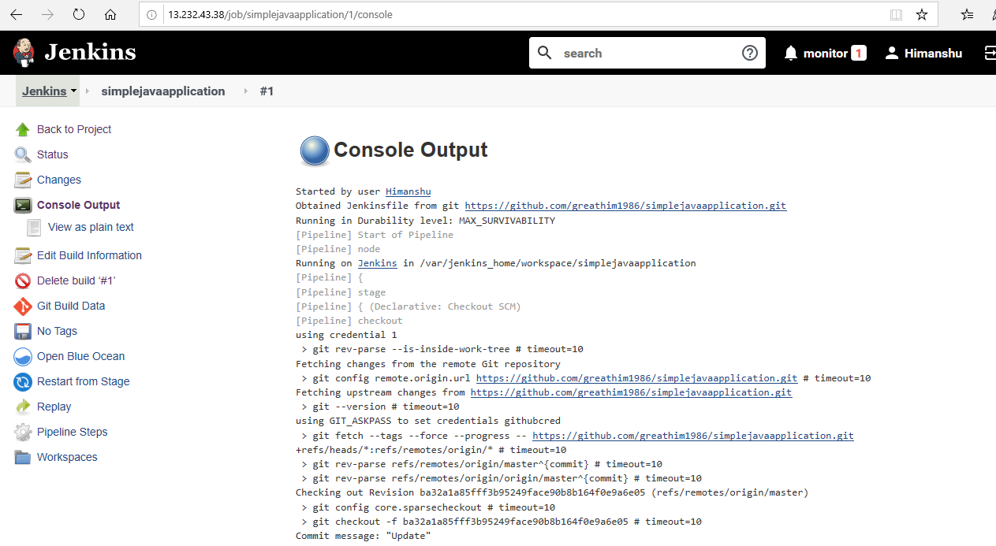

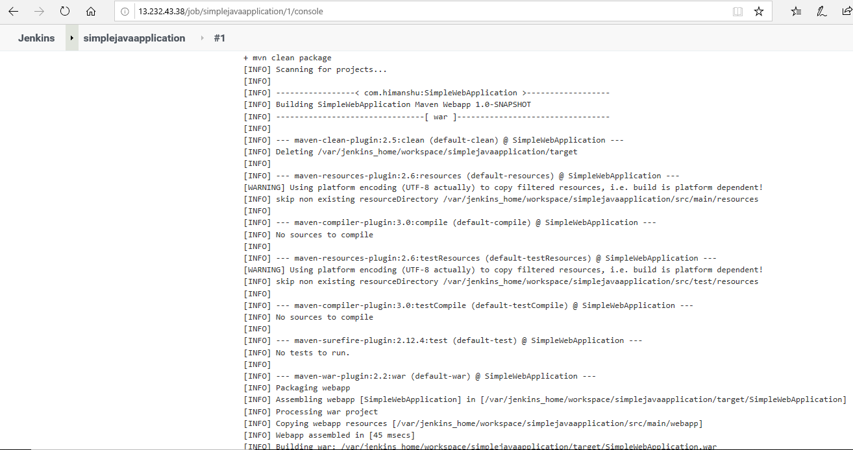

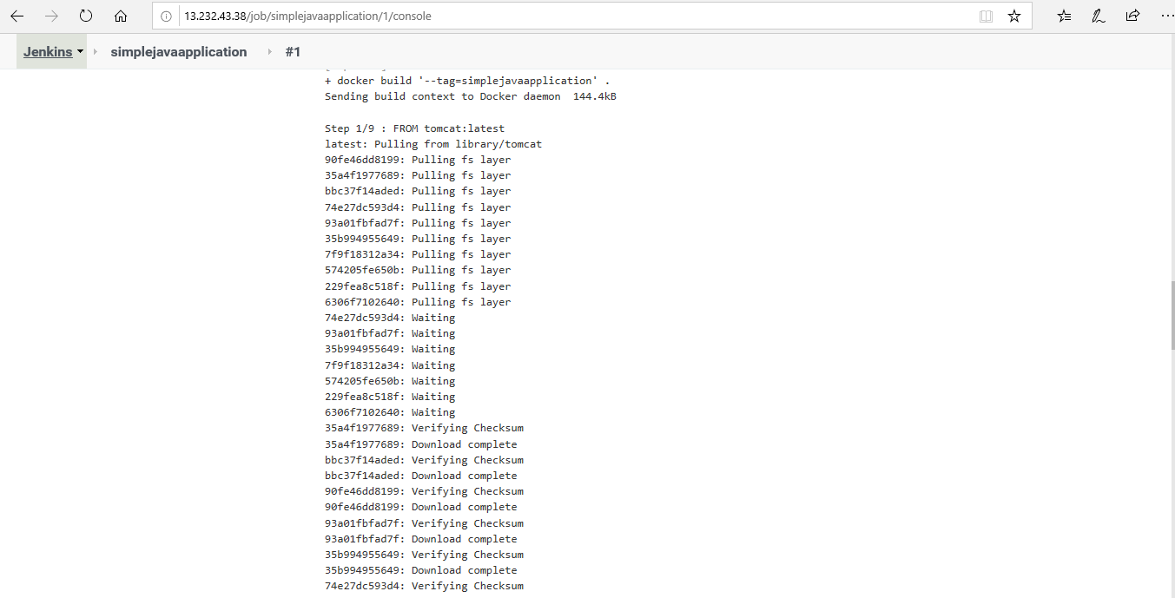

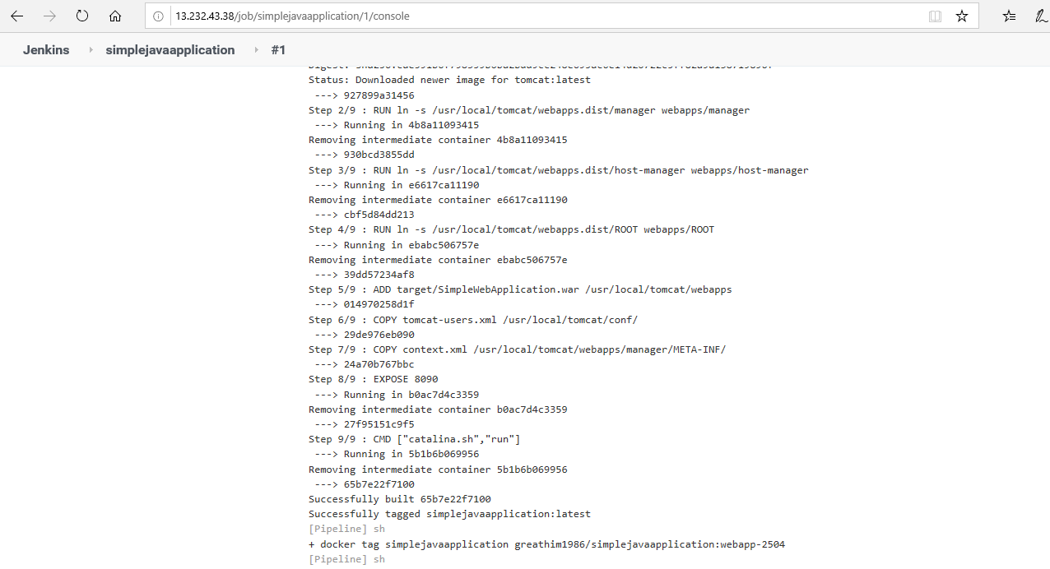

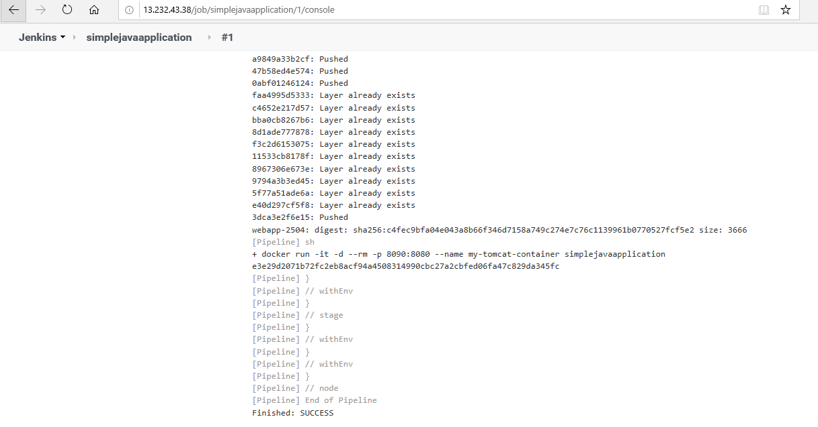

1. **Created image and running container details:**

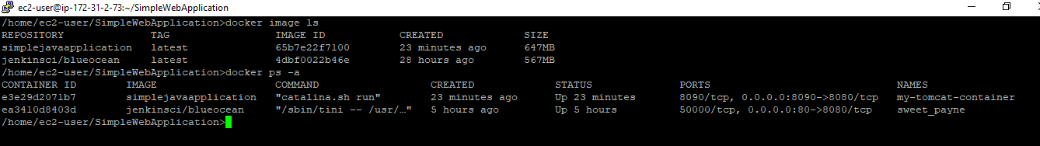

1. **Deployed application (SimpleWebApplication) on Tomcat under container :**

