VIDYALANKAR INSTITUTE OF TECHNOLOGY
Information Technology
TE INFT-B

MedyLink Project Report
Patient Records and Administrative Health Analytics
Web Application Project
Submitted by
Student name | Roll number
Aditya Patra | 24101B0072
Aditya Bhogavkar | 24101B0073
Krishna Tiwari | 24101B0077

Under the guidance of
Prof. Shruti Agrawal
October 2026
MedyLink brings patient identification, medical records and prescription dispensing into one application. Its separate analytics environment uses fictional patient histories from Mumbai station areas to demonstrate geographic clustering and disease-model evaluation.

1 Project Overview

Abstract
A patient may visit more than one doctor and collect medicines from different pharmacies. If each visit is recorded separately, the next professional has to reconstruct the patient history from papers, messages or memory. MedyLink addresses this coordination problem through a shared patient identity and role-based web application. Patients can view their health card, reports and prescriptions. Approved doctors can read earlier records and add consultations, while pharmacies can record how much of a prescription has been dispensed.
The project also provides a separate administrator demonstration built around 4,000 fictional patients associated with 34 Mumbai station areas. It combines DBSCAN geographic clustering with a comparison of four disease classifiers. The working release covers authentication, provider approval, private file access, persistent clinical data and reproducible synthetic imports. The machine-learning results describe the simulated dataset and are not evidence of clinical accuracy.
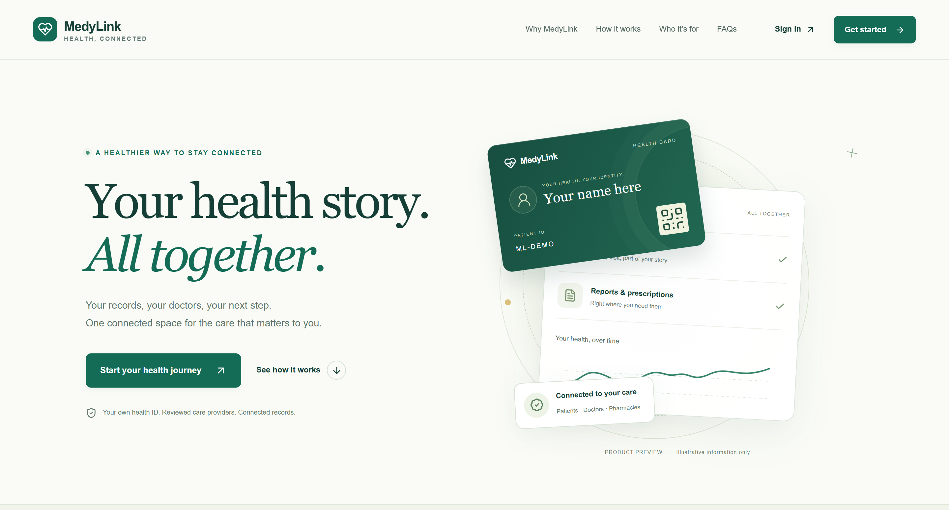
Figure 1 MedyLink public interface with entry points for the different user roles.

Problem and objectives
The main objective is continuity of records across a care workflow. A complete patient ID or health-card QR identifies the patient; authorization still decides what the signed-in user can access. The pharmacy view deliberately contains less information than the doctor view. This keeps the dispensing task focused on the prescription and relevant allergy context.
A second objective is to give administrators useful aggregate views without placing individual clinical records in their workspace. Date, condition and station filters make the demonstration easy to inspect. The report first explains the system design and care workflows, then examines the dataset, clustering, model evaluation and verification results.

2 System Design and Data Model
MedyLink separates the browser interface, application rules and stored data. Next.js, React and TypeScript provide the screens. Django REST Framework checks requests and applies the access rules before reading or changing PostgreSQL records. Neon supplies the hosted PostgreSQL database. Uploaded documents and trained model bundles are held in private storage rather than served as public website files [1].
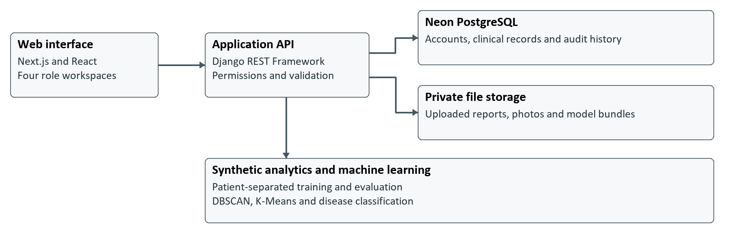
Figure 2 Application structure and the separate synthetic analytics workflow.

Main data relationships
Entity or group | Relationship and purpose
User and role profile | A user has a role; the patient or provider profile holds the corresponding details.
Patient and medical record | One patient can have many consultations. Each record keeps its author and clinical context.
Prescription and dispensing | Prescription items belong to a prescription; dispensing entries track quantities supplied by pharmacies.
Reports and laboratory results | Private reports and structured observations are linked to the patient and, where applicable, a visit.
Station and synthetic mapping | Station references and import mappings connect fictional records to the analytics cohort.
ML run and security event | Training metadata records model runs; audit events record relevant account and application actions.

This structure makes it possible to add a new consultation without replacing the earlier history. Corrections retain a connection to the original record. Database constraints and transactions protect operations such as partial dispensing, where two requests must not consume the same remaining quantity. The demonstration uses a separate database configuration so that synthetic imports do not populate the regular application.

3 Authentication and Access Control
Users register for the patient, doctor or pharmacist role and verify their email before signing in. Doctors and pharmacists must also submit professional credentials for administrator review. Approval is a continuing access condition: a signed-in account does not automatically have permission to use every clinical endpoint. Administrators are created through an explicit management command rather than public self-registration.
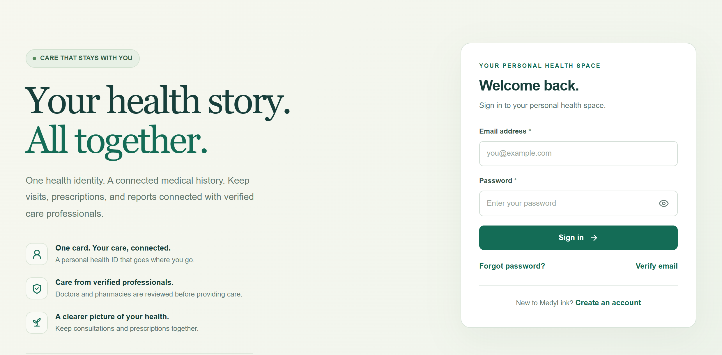
Figure 3 Sign-in screen used by the application roles.
Role | Permitted access
Patient | Own profile, health card, records, reports and prescriptions.
Approved doctor | Patient lookup, shared clinical history and new consultations or prescriptions.
Approved pharmacist | Prescription lookup, allergy context and dispensing; no full clinical history.
Administrator | Provider approvals, audit and aggregate analytics; no general clinical-record access.

Security in the implementation
Passwords are stored using Django password hashing. Authentication uses cookies and server-side session controls, with CSRF protection for state-changing browser requests. Email verification codes have expiry and attempt limits; password-reset links are single-use and expire. The backend checks permissions independently of whether a button is visible in the interface. Private reports are downloaded through authenticated endpoints.
The health-card QR is an identification aid, not a public medical-record link. A doctor still needs an approved account to use it. The current workflow allows approved doctors to access a patient by a complete ID or card; it does not require a separate permission request for each visit. Production operation also requires HTTPS, appropriate cookie settings, working email delivery and protected backups.

4 Patient Health Card and Records
The patient workspace brings the information from several visits into one place. A patient can open the health card, check earlier consultations, review prescriptions and see dispensing history. The digital card can be flipped to view its QR and downloaded as an authenticated PDF. Profile changes and a private photograph help the patient maintain the identity shown in the application.
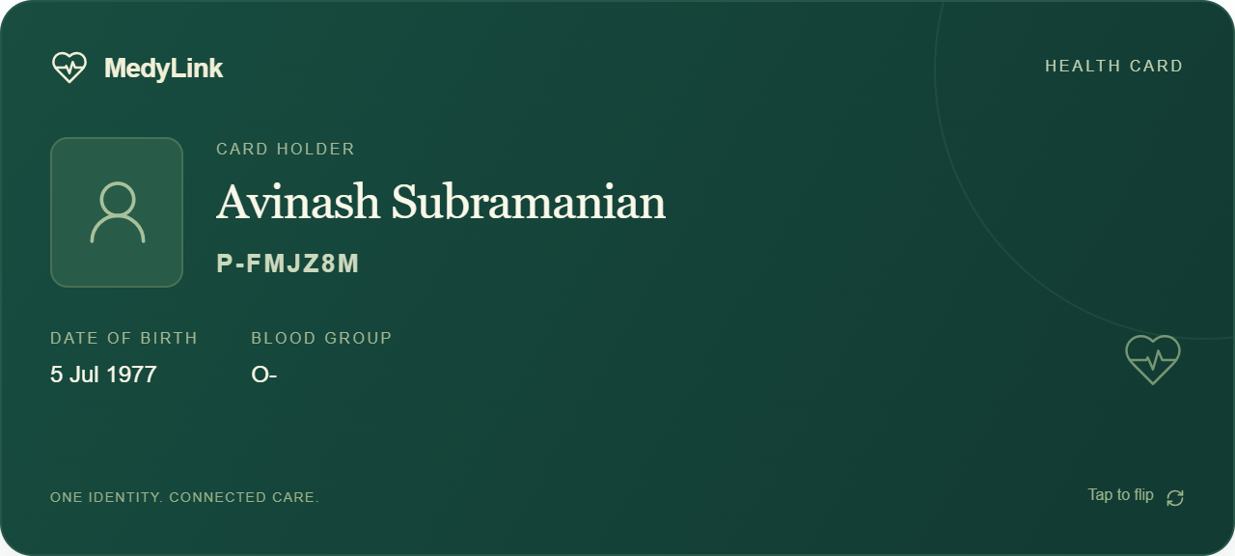
Figure 4 Patient health card showing the account identity, birth date and blood group.

A typical patient journey
After verification and sign-in, the patient presents the card or shares the complete patient ID at a consultation. The doctor opens the history and adds the new visit. The patient can then see that visit and its linked prescription in the same timeline. If a pharmacy supplies only part of the medicine quantity, the dispensing history records that event and the remaining balance stays available for the next visit to a pharmacy.
Blood-pressure and glucose charts use stored measurements. Dose logs support adherence calculations, while report links let the patient inspect the original document. Missing readings are shown as unavailable instead of being filled with a guessed value. The synthetic environment includes a demonstration score policy and supported structured monthly-report extraction; these should not be confused with a validated clinical score or general-purpose medical OCR.
The timeline is useful because it retains the sequence of care. A new report adds evidence to that history rather than silently changing an earlier consultation. Only the patient and authorized professionals can use the relevant record endpoints; the existence of a health-card identifier alone does not grant access.

5 Doctor and Pharmacy Workflows
An approved doctor can scan the health-card QR or enter the complete patient ID. The history includes earlier consultations and private reports, allowing the doctor to read the context before adding a visit. Saving a patient adds that person to the requesting doctor's own list; merely looking up a patient does not create a saved-list entry.
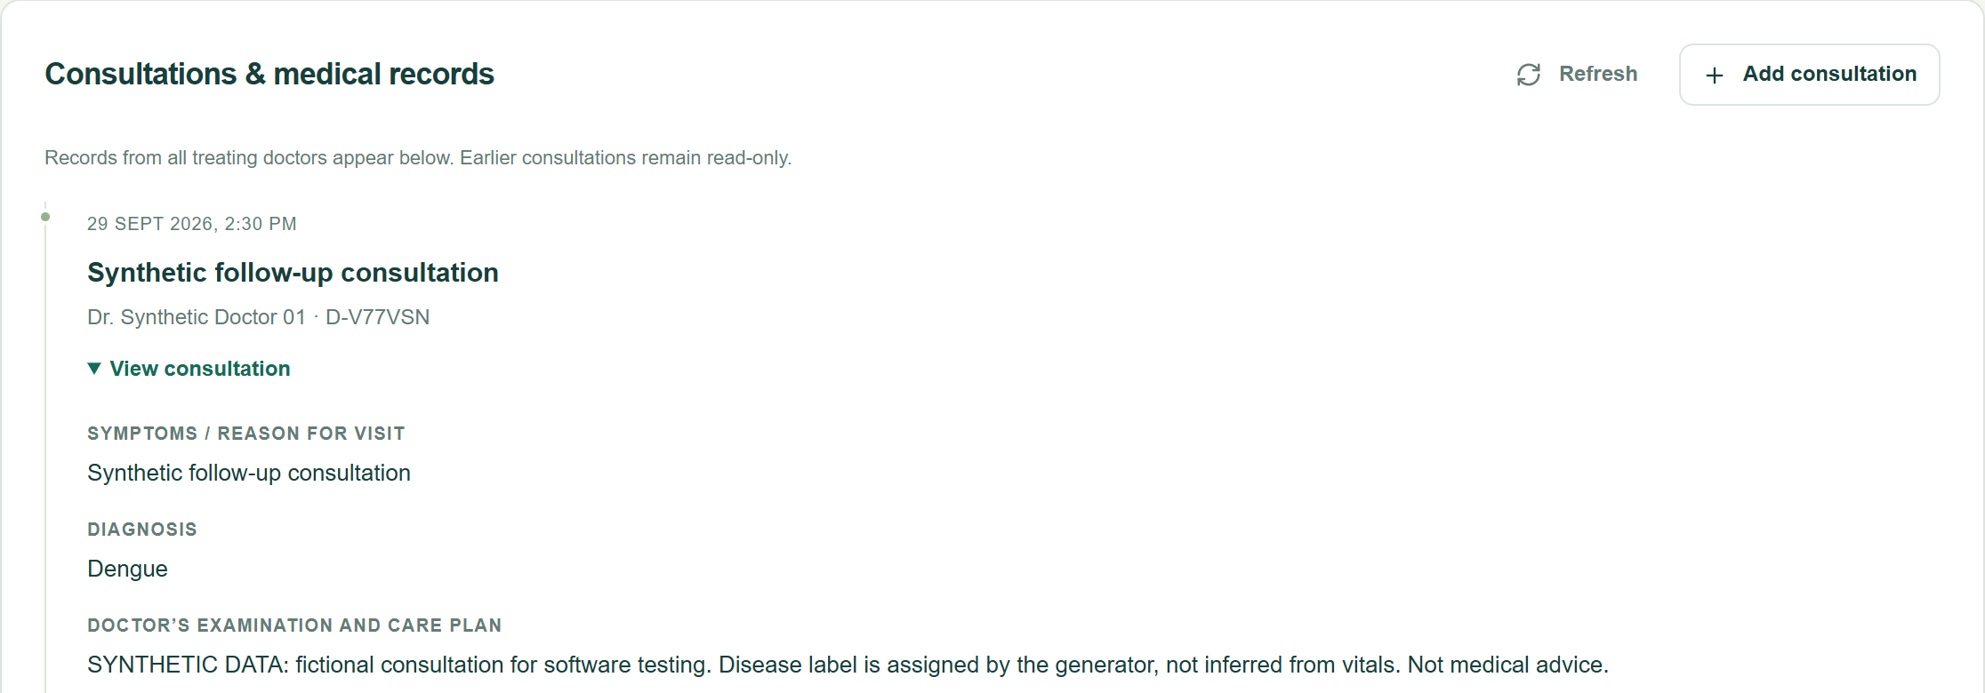
Figure 5 Doctor workspace showing a patient consultation history.
A consultation records the current findings and can have a linked prescription or report. The author remains attached to the record. Another doctor may read shared history but cannot silently rewrite the first doctor's entry. This distinction supports continuity while retaining responsibility for what was recorded.
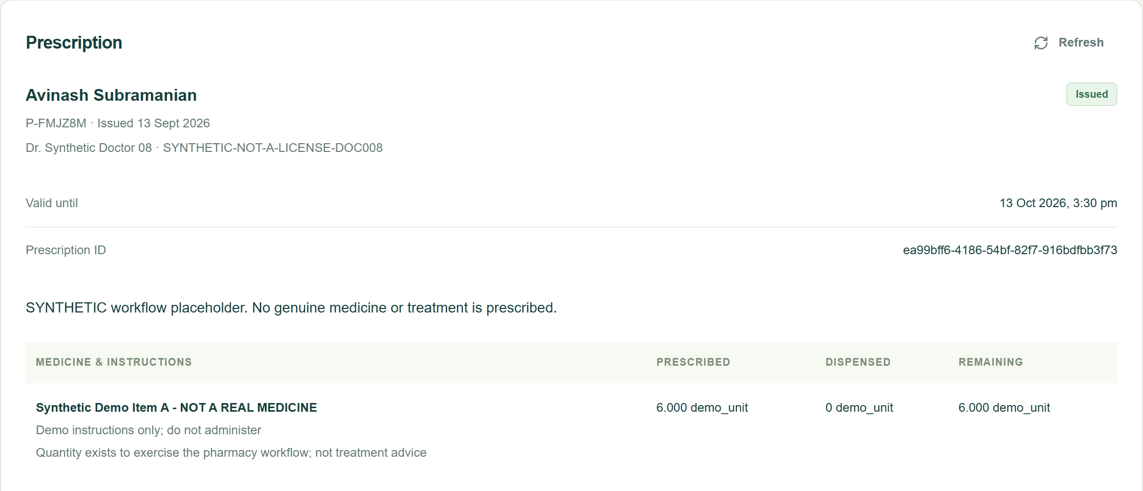
Figure 6 Pharmacy workspace for prescription review and quantity tracking.
The pharmacist looks up the patient and reviews prescriptions and relevant allergies. When ten units are prescribed and four are supplied, six remain. The application calculates this shared balance from dispensing records so that the next pharmacy sees the updated quantity. A database transaction protects the balance when requests arrive together. The pharmacy role does not receive the patient's complete clinical notes or report library.

6 Synthetic Dataset and Preparation
The repository contains two reproducible fixtures: the original 1,000-patient care dataset and an additional 3,000-patient disease-training dataset. They cover 34 selected station areas on the Central, Western and Harbour corridors. The station references are real public geographic anchors; names, histories and nearby patient coordinates are simulated [2]. Interchange stations can belong to more than one corridor, so corridor totals must not be added as though every patient belongs to only one line.
Record type | Fresh baseline count
Patients | 4,000
Consultations | 11,195
Laboratory results | 26,917
Disease observations | 12,719
Station areas | 34
Original login accounts | 1,013 across the four roles
Additional ML-only patient accounts | 3,000 inactive accounts

How the records are generated
The expansion uses a fixed random seed of 42. It varies age, station, primary disease, symptoms, measurements and visit dates, including noise and missing fields. Its ten labels are dengue, influenza, hypertension, type 2 diabetes, asthma, anemia, gastroenteritis, hypothyroidism, osteoarthritis and malaria. Seasonal and measurement patterns make the dataset useful for a repeatable experiment, but those patterns remain assumptions of the generator.
The public files contain no usable login passwords. The original patient, doctor, pharmacist and administrator credentials are created locally. The extra 3,000 accounts are inactive and have unusable passwords because their purpose is model training. The fixture manifest records file sizes and SHA-256 hashes; the importer also checks identifiers, station references and the original-data mapping before writing records.

Import and reproducibility
A fresh installation applies migrations, imports the original clinical data and analytics, then applies the expansion. The expansion runs in a transaction and can be repeated without creating duplicate records. Training is performed after the import, and the model files remain private. A Git pull transfers the published fixtures; it does not copy the database, uploaded reports, local passwords or saved model bundles. Later edits in an existing demonstration database therefore need a separate private transfer or backup.

7 Geographic Analysis with DBSCAN
The administrator can filter the selected cohort by date, recorded condition, railway line and station. The geographic view then groups nearby simulated patients using DBSCAN, a density-based clustering method. It can identify connected dense groups and leave isolated points as noise without requiring the administrator to choose the number of groups in advance [3].
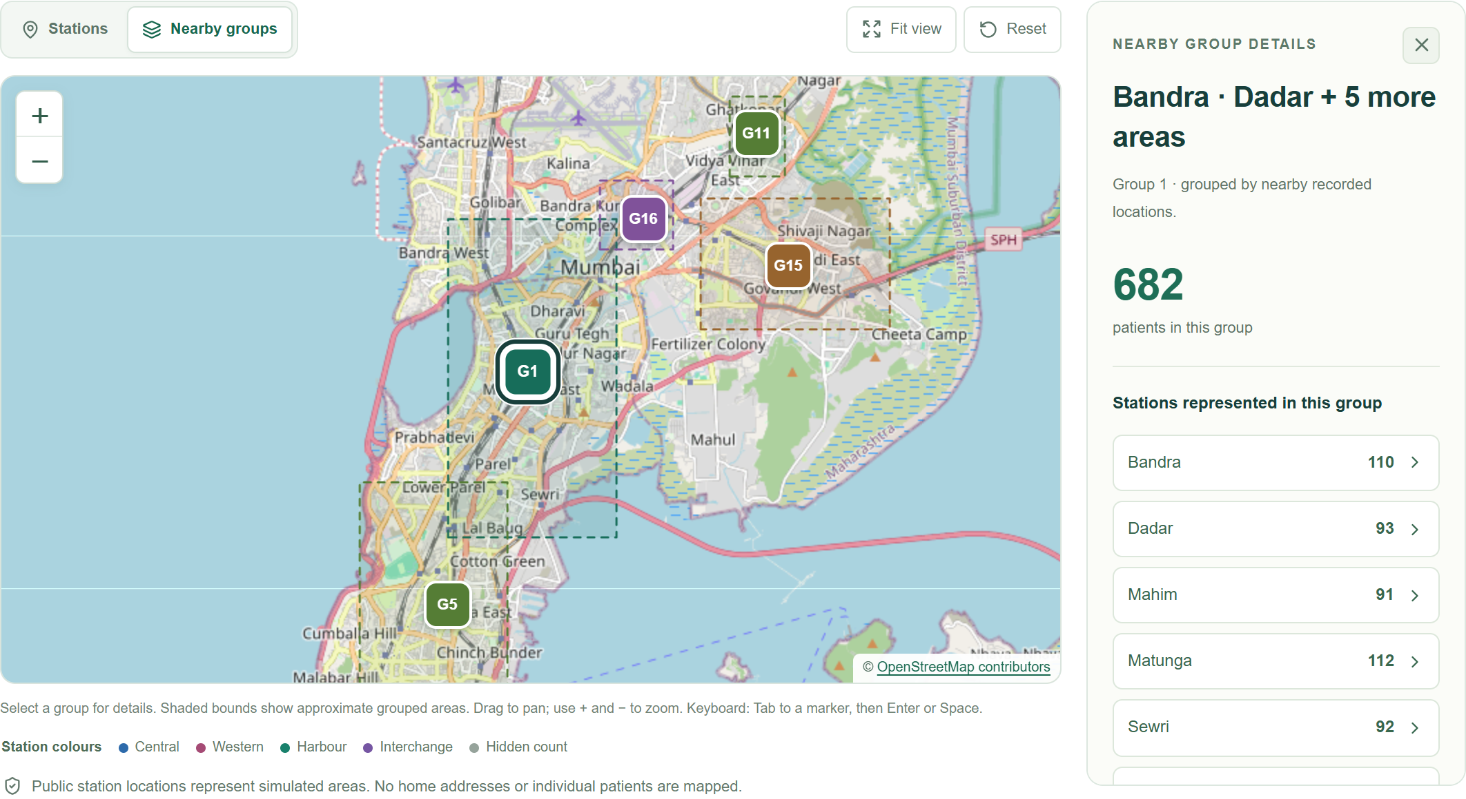
Figure 7 Synthetic DBSCAN groups in Mumbai. Map data © OpenStreetMap contributors.
Setting in the ML workspace | Value or behavior
Neighbourhood distance | 0.5 km, converted to an angular distance
Minimum samples | 5 patients
Distance calculation | Haversine distance on latitude and longitude in radians
Input and disclosure | Latest selected row per patient; aggregate locations rounded

A radius of 0.5 km describes the reach of a neighbourhood, not the maximum width of an entire cluster. Connected chains can join points across a larger area. Missing coordinates are excluded. Counts from one to four are hidden, and the response contains rounded aggregate locations rather than individual patient coordinates.
The map uses Leaflet and OpenStreetMap tiles, with station and group lists available below it. Selecting a condition allows the administrator to inspect that condition's local concentration. This is an exploratory view of recorded synthetic cases. It does not establish infection transmission, population incidence or a real outbreak, and its small-count rules are not a guarantee of anonymity across overlapping filters.

8 Disease Models and Evaluation
Disease classification compares Logistic Regression, Decision Tree, Random Forest and KNN. Inputs are information available at the visit, including age, measurements, symptoms, station and month. The primary disease is the target. Diagnosis text, prescriptions, names and clinician identity are excluded from the feature matrix to avoid giving the model the answer or relying on personal identifiers.
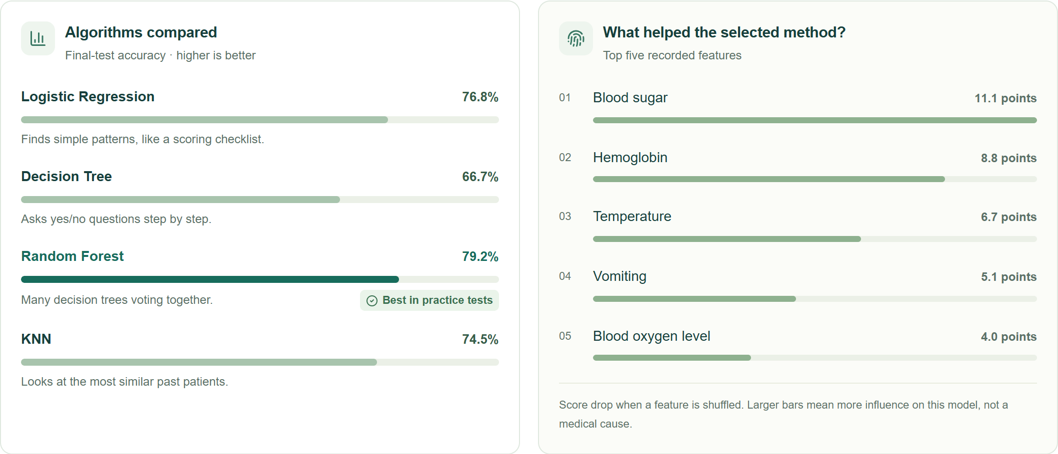
Figure 8 Admin comparison of disease classifiers and model feature importance.
Model | CV macro F1 | Test accuracy | Test macro F1
Logistic Regression | 74.6% | 76.8% | 74.8%
Decision Tree | 66.7% | 66.7% | 67.8%
Random Forest | 77.9% | 79.2% | 77.7%
KNN | 72.8% | 74.5% | 72.9%

The saved evaluation dated 4 October 2026 contains 3,892 eligible patients and 10,997 visits. Patients are split into 3,113 development and 779 final-test patients, with no patient overlap. Five shared cross-validation folds compare the algorithms within development data. Preprocessing is fitted within each fold, and each patient receives equal total evaluation weight. Keeping all visits from a patient together avoids repeated-patient leakage [4].
Random Forest won on mean cross-validation macro F1. Its held-out accuracy was 79.2% and macro F1 was 77.7%, above the fixed demonstration thresholds of 75% and 70%. This result belongs to the saved database run; a fresh baseline import can produce different coverage and scores. Recall, confusion matrices and permutation importance help explain errors. K-Means and PCA provide a separate view of similar measurement groups. None of these outputs is a clinical diagnosis.

9 Verification and Conclusion
The release was checked at the database, service and browser levels [2]. The most useful integration check started from an empty isolated PostgreSQL database, imported all 4,000 patients, repeated the expansion without duplicates, trained the models and received a successful admin insights response. Original account and clinical rows were preserved.
Verification area | Recorded result
PostgreSQL backend suite | 242 passed with zero skips
Standalone ML and credential helper | 31 ML tests and 7 credential tests passed
Frontend server proxy | 12 tests passed
Desktop and mobile admin regressions | 102 passed with mocked API and tile responses
Frontend quality checks | TypeScript, ESLint and production build passed
Fresh data and training rehearsal | 4,000 patients; repeat import and admin API verified

Limitations and further work
The dataset is fictional, and the models may learn the generator's rules rather than real clinical relationships. Deployment with real records would require governed data access, external validation and evaluation of calibration and bias. The local training worker is not a durable production job queue. General medical OCR, hospital-system integration and outbreak forecasting are outside the implemented scope. An external HTTPS deployment and a live backup-restore drill remain to be verified.

Conclusion
MedyLink demonstrates a complete shared-record workflow with different access levels for patients, doctors and pharmacies. Its strongest practical feature is that a consultation, prescription and dispensing event stay connected to the same patient history. The separate synthetic environment makes geographic clustering and model comparison reproducible. The current results support the project as a tested software demonstration, with clinical validation and operational deployment still requiring further work.

References
[1] MedyLink source code and README, release 8198a4f, 4 October 2026. github.com/AdityaPatra1947/MedyLink/tree/8198a4f
[2] Project evidence: docs/VALIDATION.md, docs/ML_INSIGHTS.md, ml/reports/disease_evaluation.json and data/reference/STATION_SOURCES.md in the same repository. Station anchors are attributed there to OpenCity and BMC.
[3] scikit-learn documentation, Clustering, DBSCAN. scikit-learn.org/stable/modules/clustering.html#dbscan
[4] scikit-learn documentation, Cross validation with grouped data. scikit-learn.org/stable/modules/cross_validation.html#cross-validation-iterators-for-grouped-data

