Name: Aditya Poddar

ID: 77229150

Aim:

This Project is based on Laravel Framework , some of the basic requirement are-

1 CRUD

2 AUTHENTICATION/AUTHORIZATION

3 form validation/sanitization

4 Session/Cookies

5 CSRF / Mass Assignments

6 Starter Kits

7 Blade Templates + Css framework

8 Factories/Seeders

9 Route management

Some of Extra Feature are-

1 Pagination

2 Newsletter Subscription

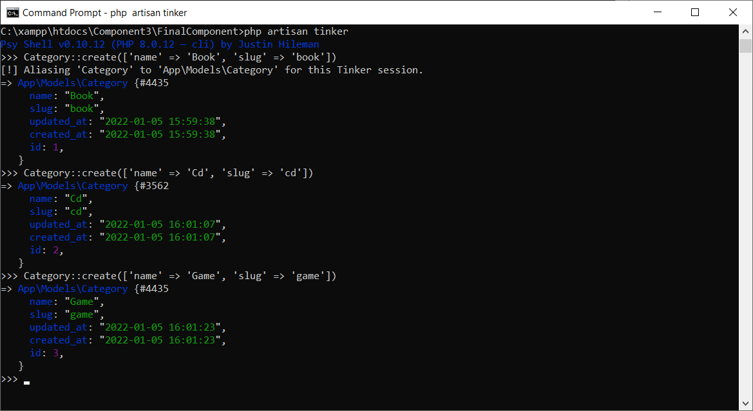

---Some Backend Screenshot

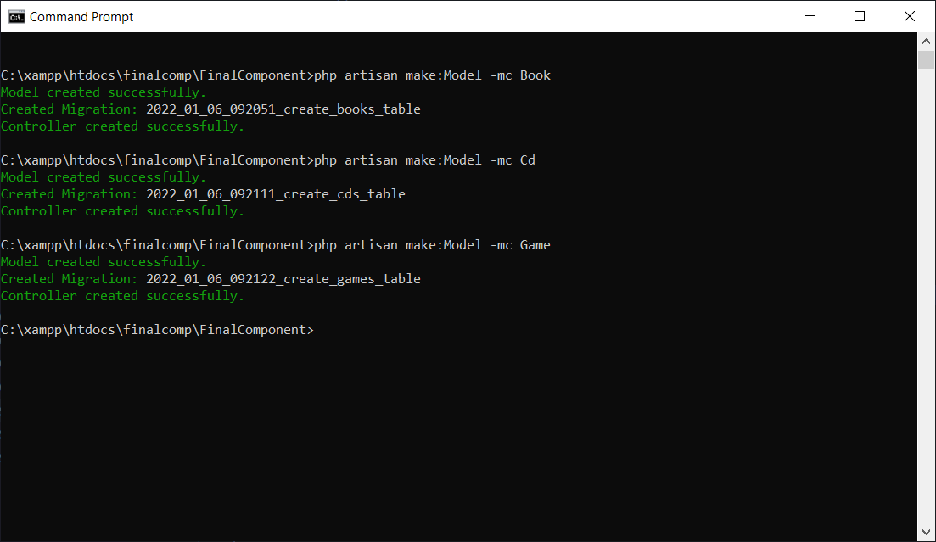

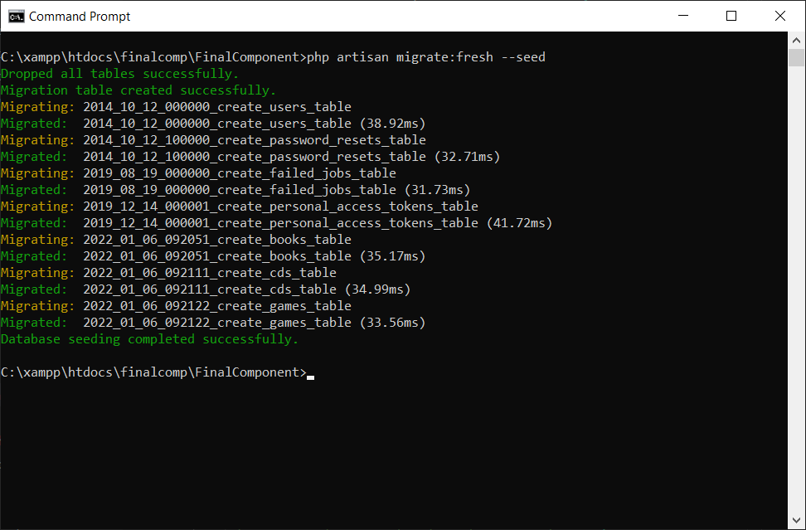

---Frontend Screenshot

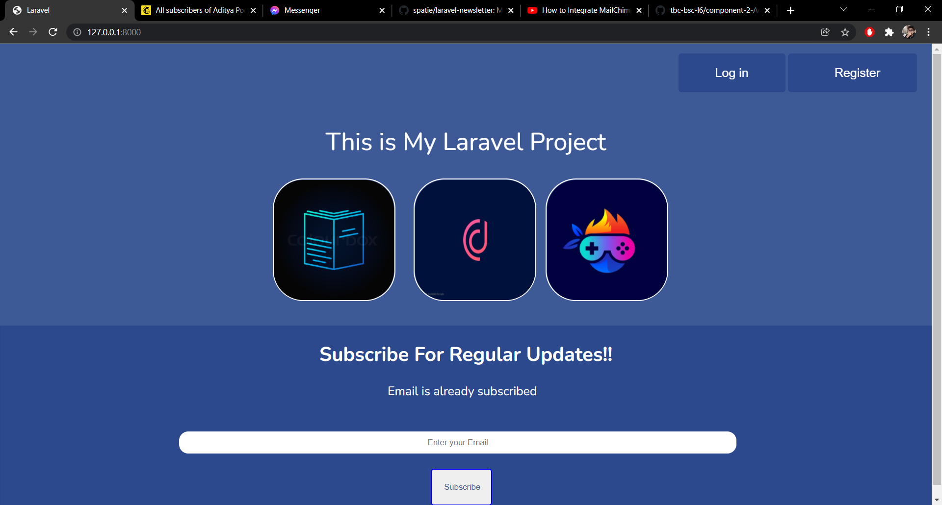

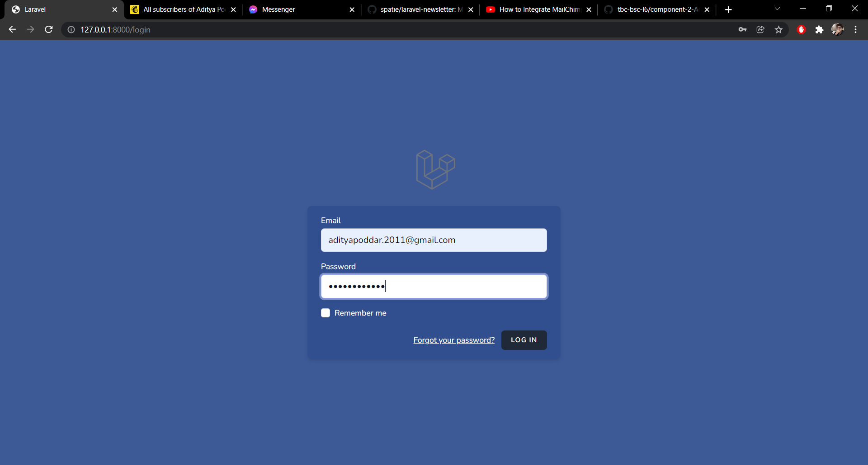

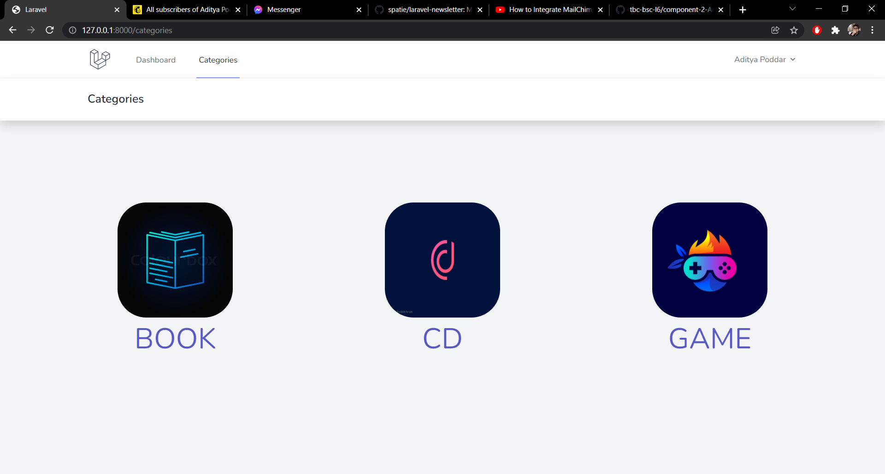

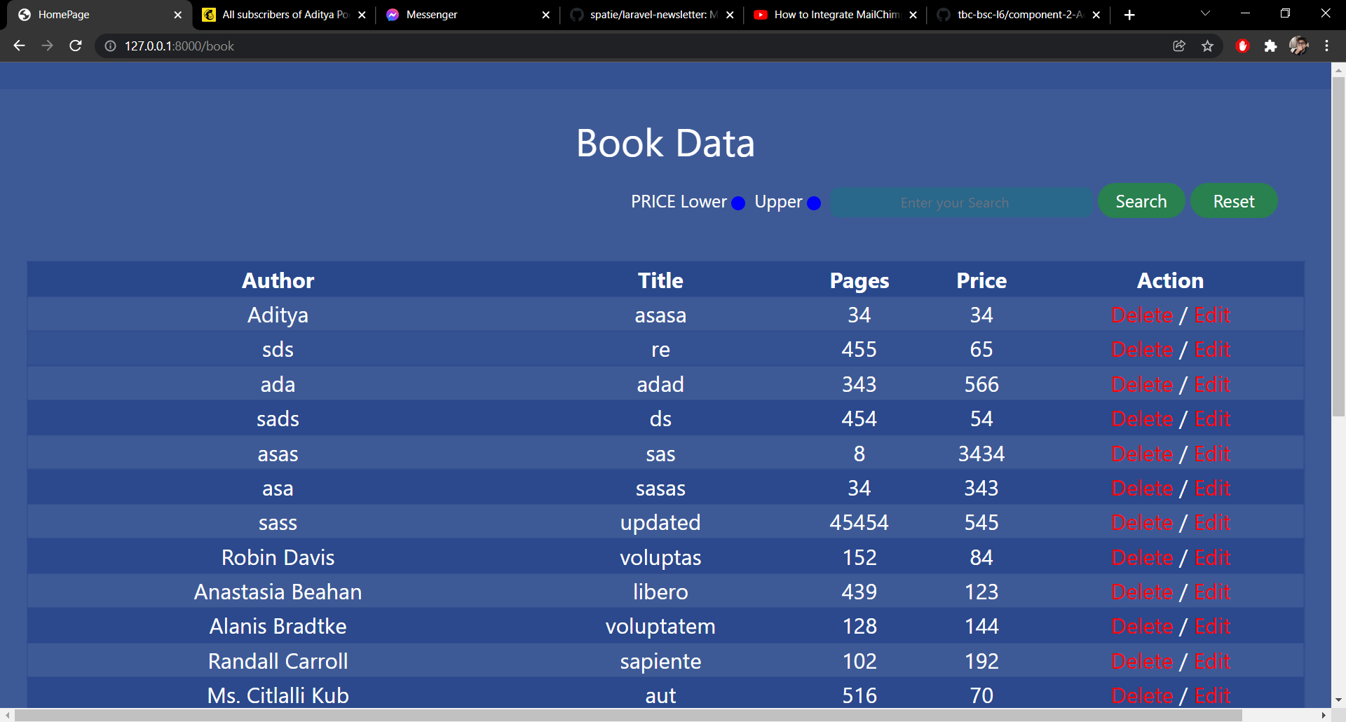

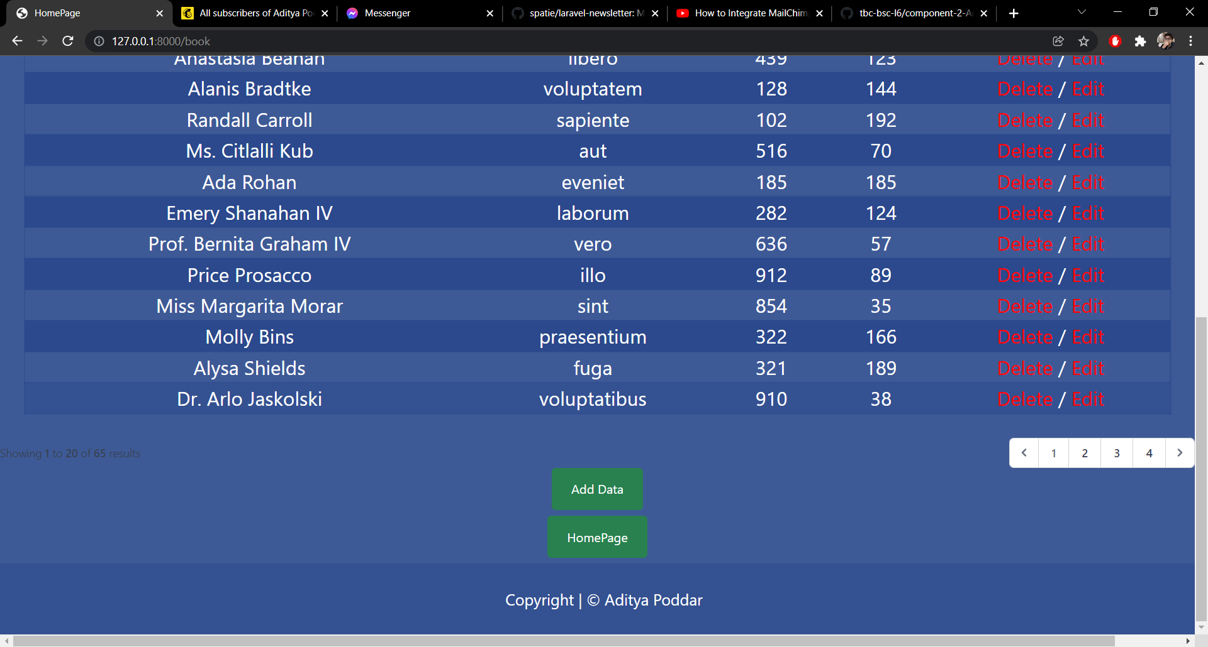

--Source Code

