***Major Project Synopsys on***

**“CitizenSphere: Bridging Politics and People”**

*Submitted by*

Aditya Pradhan, 202222017, MCA 4th Sem, Dept. of CA, aditya1pradhan21@gmail.com

*Under the Supervision of*

Mr. Gaurav Pradhan, Asst. Professor, Dept. of CA, SMIT

Mr. Logesh R, Tech Co-Founder, NE Developers

Name & Signature of Members Signature of Guide

***Abstract:*** This application will function as a central repository, that provides a platform for dishing out information about the party’s organizational structure, leaders, policies, and initiatives. Built using ReactJS this application will have a dynamic structure, which is complemented by Firebase that provides a real-time update for dynamic structure. The backend is built using Firebase along with NodeJS, which will be hosted on Firebase Hosting. Security measures such as CAPTCHA and SSL will be used to prevent DOS attacks, and securing user data.

***Keywords:*** Political party, ReactJS, Firebase, NodeJS

**1. Introduction**

In the ever-changing landscape of modern politics, efficient communication and, getting in touch with the public are integral components of a successful political party. Communication is a two-way process, where the information is transferred from the sender or a group of senders to a receiver or a group of receivers. Therefore, in order for a party to reveal its principles to the public, communication becomes essential. While it is easy for a political party to divulge its ideals to the public through various forms of media, the same cannot be said for a general civilian.

So, we are developing a website that addresses the responsiveness, accessibility, and transparency, of a political party. In the centre of this web application is a user-friendly homepage with interactive modules that will facilitate seamless interaction between the party and the public.

In this application the homepage will act as a gateway that offers vital functionalities such as a feedback system, grievance resolution mechanism, enabling citizens to voice their opinion to the party. To support the party's cause financially, through volunteering, or by becoming a member, users can explore options including "Make a Donation," "Be a volunteer," and "Join Party."

In the "Make a Donation" pages, individuals can check the various donation options, payment methods. Similarly, "Join Party" page will guide the users on the detailed membership benefits, requirements, and the process of becoming an official member.

This website will also include detailed information about the party’s organizational structure, leaders, policies, and initiatives. From the ground-level workers to the top, this site will serve as a medium of engagement; encouraging participation and feedback. This website will also be include a grievance resolution mechanism, that will streamline the process of receiving, categorizing, and addressing public grievances and feedback.

**2. Aim and Objective**

This project bridges the gap between the general public and a political party, whilst also improving intra-party communication.

**3. Feasibility Study**

**3.1 Technical Feasibility**

* This application will be using the react.js framework as it has a component-based architecture, which will help make dynamic content.
* Firebase will be used in the back-end, which will provide a real-time update for dynamic content.
* Scalability of the application will also be ensured using Firebase as it comes equipped with the ability to handle potential increases in user traffic and data volume.
* React.js and Firebase will serve as the front-end and back-end respectively as they are can be seamlessly integrated, and if a custom server logic beyond the capability of Firebase is required, Node.js will be used along with Express.js to frame the functionality.
* Firebase will be used to host the React.js application.

**3.2 Operational Feasibility**

* The user interface will be interactive so that the end-users can efficiently and easily complete their task.
* The existing data will be transferred to Firebase.
* React.js and Firebase have good community support which will be of great help while troubleshooting.

**3.3 Economical Feasibility**

* This application is being built by a team of college students for their Major Project, so there will be no cost for hiring developers.
* The Meta-owned React.js no longer requires licensing, aside from some specific packages, which won’t be used while building this application.
* Firebase also doesn’t require licensing but some Terms of Services must be complied with.
* Firebase has a Spark Plan that will give authentication, cloud storage, hosting, real-time database, and test lab at no cost, provided the number of users is under a certain limit. So, there will be no cost overhead for using Firebase in the development life cycle.

**3.4 Schedule Feasibility**

This application is being built as a part of the college curriculum, where the time allotted is 16 weeks.

* Requirement Gathering and Analysis: 2 weeks.
* Design: 2 weeks.
* Implementation: 7 weeks.
* Testing: 3 weeks.
* Deployment: 2 weeks.

**4. Problem Definition**

* Lack of transparency of political party.
* Utter absence of communication between the general public and political parties.
* Even when there is a means of communication established, there are many cases where the interaction deteriorates due to the presence of some unsavory characters, who employ the use of inferior language, thereby making the whole communication platform hostile.
* Feedback Management: The feedback must go to the relevant personnel.
* Troll or spam submission: a website can be vulnerable to trolling or spamming, i.e. users submitting false or malicious feedback.
* User anonymity: Some users may prefer to provide feedback or file grievances anonymously.
* Data security and compliance: this web application will have some pages that will handle financial transactions, like a “make a donation” page, so it is a must to ensure that the donor information is securely collected, stored, and transmitted.

**5. Proposed Solution Strategy**

* This application will have a repository that will contain the policies, and initiatives implemented by the party, which can be easily updated.
* A grievance resolution mechanism will be built which will act as the bridge between the public and the party.
* A filtering system will be used that will filter out the use of vulgar words, e.g. when a user types an unsavoury word, and presses the send button the message/query won’t be processed unless the word is not removed.
* A dropdown box will be provided to users, who can then select where the feedback/grievance must go.
* A CAPTCHA will be used to prevent automated submissions, deterring spammers.
* Users will be provided an option for submitting feedback or grievance anonymously, but it will be made clear to those users that, they will face some limitations regarding how their query is handled.
* Encryption protocols such as SSL/TLS will be used to secure data transmission between the user’s browser and the server/

**6. Literature Study**

|  |  |  |  |
| --- | --- | --- | --- |
| **Paper Title & Year** | **Findings** | **Research Gap** | **Relevant to our work** |
| Rui Yao et. al.  “A Sensitive Words Filtering Model Based on Web Text Features”[1]  2018  ACM | The K-means clustering algorithm and the vote by majority strategy has the best accuracy and error rate. | The method mentioned in this paper is very strict and may miss some false propaganda text strategy. | DFA algorithm. |
| Suryanto Nugroho et. al.  “Comparative Analysis of Software Development Methods between Parallel, V-shaped and Iterative”[2]  2017  IJCA | Success of software development depends on the overall management of software projects. | Extensive study is required for choosing appropriate model. | V-shaped model. |
| Fei Wu et. al.  “A Chinese Message Sensitive Words Filtering System based on DFA and Word2vec”[3]  2018  ELSEVIER | It is seen that the experimental results after segmentation and correction, the use of DFA recognition is more efficient than using a simple DFA algorithm. | Only used Chinese word. | DFA algorithm. |
| Shengyi Jiang et. al.  “An Improved K-nearest-neighbor algorithm for text categorization”[4]  2012  ELSEVIER | The INNTC has a significant boost in performance when compared with KNN, NB, SVM and other classifiers in dealing with large-scale, high dimensional and imbalance text data. | INNTC is only compared with traditional text categorization techniques. | KNN. |
| Konrad Bielak et. al.  “Web application performance analysis using Angular, React, and Vue frameworks”[5]  2021  JCSI | Vue was faster in rendering, and refreshing, whereas React was faster in rendering and deleting large amounts of data. | Only provides performance analysis for simple application using CRUD Operation. |  |

Table 6.1 Literature Study

**7. Project Plan**

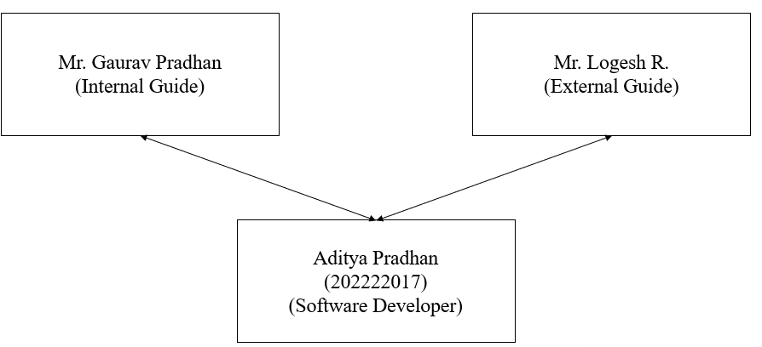 **A. Team Structure**

Fig 7.1 Team Structure

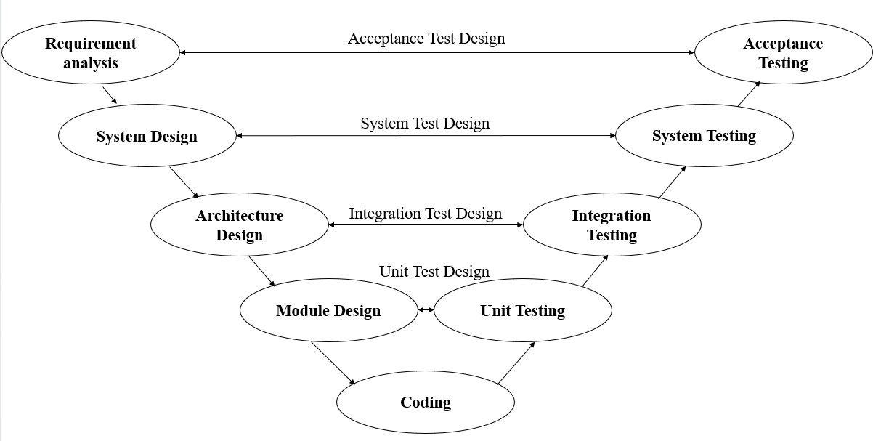 **B. SDLC**

Fig 7.2 V-Shaped Model

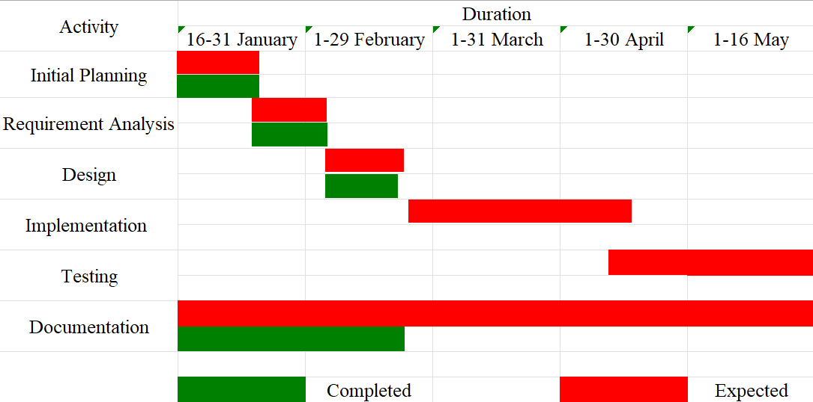 **C. Gantt Chart**

Fig 7.3 Gantt Chart

**D. Hardware and Software Requirements**

* Hardware:
  + Server: Firebase will be used to handle server-side operations, so there is no need for dedicated server hardware.
  + Development device:
    - CPU: Dual-core or higher
    - RAM: 2GB or higher
    - Storage: SSD storage for better performance.
* Software:

All the software used in this development process will be the latest version available.

* + Operating System: Windows, Linux, or Mac.
  + IDE: Virtual Studio Code version 1.86.2, for coding HTML, CSS, JS and react.js components.
  + npm version 10.4.0 to manage project dependencies and packages.
  + Node.js v20.11.1 is required for running development servers.
  + React.js for building reusable components, and dynamic user interfaces.
  + Mozilla 123.0 Firefox for testing and debugging.
  + SSL certificate to keep user data secure.
  + Git 2.44.0.windows.1 for version control.

**8. Conclusion**

In summary, the goal of this project is to facilitate contact between the public and political parties. It focuses on several important modules, including volunteer, donation, feedback, and membership portals.

With the use of bleeding-edge technologies such as React.js and Firebase, including robust security measures including CAPTCHA and SSL encryption, this application ensures seamless and secure interaction between users and the political party. The feedback system encourages citizens to express their opinions and concerns directly to the party, achieving a transparent and responsive environment. The donation, volunteer, and membership portals offer avenues for citizens to actively contribute to the party's mission. The development process will follow the V-shaped model, with it's rigorous testing it ensures that there is minimal flaw within the application.

**References**

[1] R. Yao, Y. Cao, Z. Ding, and L. Guo, “A sensitive words filtering model based on web text features,” *ACM Int. Conf. Proceeding Ser.*, pp. 516–520, 2018, doi: 10.1145/3297156.3297232.

[2] S. Nugroho, S. Hadi, and L. Hakim, “Comparative Analysis of Software Development Methods between Parallel, V-Shaped and Iterative,” *Int. J. Comput. Appl.*, vol. 169, no. 11, pp. 7–11, 2017, doi: 10.5120/ijca2017914605.

[3] F. Wu and Y. Cai, “A Chinese Message Sensitive Words Filtering System based on DFA and Word2vec,” *Procedia Comput. Sci.*, vol. 139, pp. 293–298, 2018, doi: 10.1016/j.procs.2018.10.271.

[4] S. Jiang, G. Pang, M. Wu, and L. Kuang, “An improved K-nearest-neighbor algorithm for text categorization,” *Expert Syst. Appl.*, vol. 39, no. 1, pp. 1503–1509, 2012, doi: 10.1016/j.eswa.2011.08.040.

[5] K. Bielak, B. Borek, and M. Plechawska-Wójcik, “Web application performance analysis using Angular, React and Vue.js frameworks,” *J. Comput. Sci. Inst.*, vol. 23, no. December 2021, pp. 77–83, 2022, doi: 10.35784/jcsi.2827.