Q1. Write a TCP client which sends a string to a server program. Server displays the string along with client IP and ephemeral port number. Server then responds to the client by echoing back the string in uppercase. The process continues until one of them types “QUIT”.

Code

Server Code
#include <stdio.h>
#include <stdlib.h>
#include <unistd.h>
#include <sys/socket.h>
#include <sys/types.h>
#include <netinet/in.h>
#include <arpa/inet.h>
#include <string.h>
#include <ctype.h>
#define PORT 7000
#define sa struct sockaddr

int main()
{
int sockid = socket(AF_INET, SOCK_STREAM, 0);
int m = 0, n = 0, data_len, sockid_new;
char buff[100];
unsigned int len;
struct sockaddr_in serv_addr, cli_addr;
bzero(&serv_addr, sizeof(serv_addr));
serv_addr.sin_family = AF_INET;
serv_addr.sin_port = htons(PORT);
serv_addr.sin_addr.s_addr = htonl(INADDR_ANY);
if (bind(sockid, (sa *)&serv_addr, sizeof(serv_addr)) < 0)
{
printf("Could not bind socket");
exit(0);
}
listen(sockid, 5);
len = sizeof(cli_addr);
sockid_new = accept(sockid, (sa *)&cli_addr, &len);
printf("\nClient with IP %s and port %d ", inet_ntoa(cli_addr.sin_addr), ntohs(cli_addr.sin_port));
for (;;)
{
bzero(buff, sizeof(buff));
read(sockid_new, buff, sizeof(buff));
printf("\nClient says : %s", buff);
for (int i = 0; i < strlen(buff); i++)
buff[i] = toupper(buff[i]);
// write(sockid_new, buff, sizeof(buff));
printf("\nUppercase of it is-> %s", buff);
if (strncmp(buff, "QUIT", 4) == 0)
break;
}
printf("\nServer Shutting Down\n");
close(sockid);
return 0;
}

Client Code
#include <stdio.h>
#include <stdlib.h>
#include <unistd.h>
#include <netinet/in.h>
#include <arpa/inet.h>
#include <sys/socket.h>
#include <sys/types.h>
#include <string.h>
#define PORT 7000
#define sa struct sockaddr

int main()
{
int sockid = socket(AF_INET, SOCK_STREAM, 0);
int data_len;
unsigned int len;
struct sockaddr_in serv_addr, temp;
bzero(&serv_addr, sizeof(serv_addr));
serv_addr.sin_family = AF_INET;
serv_addr.sin_port = htons(PORT);
serv_addr.sin_addr.s_addr = htonl(INADDR_ANY);
connect(sockid, (sa *)&serv_addr, sizeof(serv_addr));
char buff[100], line[100];
for (;;)
{
printf("\nEnter your message or QUIT\n");
bzero(line, sizeof(line));
bzero(buff, sizeof(buff));
scanf("%s", line);
write(sockid, line, strlen(line));
// read(sockid, buff, sizeof(buff));
// printf("\nServer says: %s\n", buff);
if (strncmp(buff, "QUIT", 4) == 0)
break;
}
printf("\nThank You!");
close(sockid);
return 0;
}
Output

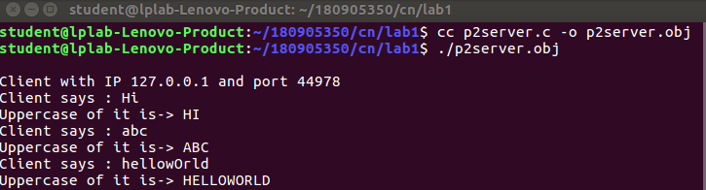
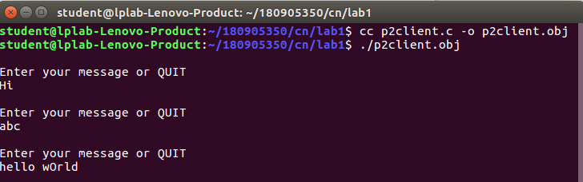
Q2) DayTime Server: Where client sends request to time server to send current time. Server responds by sending the current time . [Hint: read man pages of asctime() and localtime()] . Display server process id at client side along with time.

Code
Server
#include <arpa/inet.h>
#include <netdb.h>
#include <netinet/in.h>
#include <stdio.h>
#include <stdlib.h>
#include <string.h>
#include <sys/socket.h>
#include <sys/types.h>
#include <time.h>

#define MAX 80
#define PORT 5005
#define SA struct sockaddr

void servfunc(int sockfd, struct sockaddr_in *cli)
{
char buff[MAX];
int n;
for (;;)
{
bzero(buff, sizeof(buff));
n = recv(sockfd, buff, sizeof(buff), 0);

buff[n] = '\0';

if (strcmp(buff, "QUIT") == 0)
{
printf("Server Exit...\n");
break;
}
else if (strcmp(buff, "time") == 0)
{
time_t rawtime;
struct tm *info;
time(&rawtime);
info = localtime(&rawtime);

char *str = asctime(info);

ssize_t size_str = strlen(str);
n = send(sockfd, str, size_str, 0);
if (n == -1)
{
printf("Error in sending message. Try Again!\n");
continue;
}
}
else
{
char str[] = "ERROR";
if (send(sockfd, str, sizeof(str), 0) == -1)
{
printf("Error in sending message. Try Again!\n");
continue;
}
}
}
}
int main()
{
int sockfd, connfd, len;
struct sockaddr_in servaddr, cli;

sockfd = socket(AF_INET, SOCK_STREAM, 0);
if (sockfd == -1)
{
printf("socket creation failed...\n");
exit(0);
}
else
{
printf("Socket successfully created..\n");
}
bzero(&servaddr, sizeof(servaddr));

servaddr.sin_family = AF_INET;
servaddr.sin_addr.s_addr = htonl(INADDR_ANY);
servaddr.sin_port = htons(PORT);

if ((bind(sockfd, (SA *)&servaddr, sizeof(servaddr))) != 0)
{
printf("socket bind failed...\n");
exit(0);
}
else
{
printf("Socket successfully binded..\n");
}

if ((listen(sockfd, 5)) != 0)
{
printf("Listen failed...\n");
exit(0);
}
else
{
printf("Server listening..\n");
}

len = sizeof(cli);
connfd = accept(sockfd, (SA *)&cli, &len);
if (connfd < 0)
{
printf("server acccept failed...\n");
exit(0);
}
else
printf("server acccept the client...\n");

servfunc(connfd, (struct sockaddr_in *)&cli);
close(sockfd);
}

Client
#include <arpa/inet.h>
#include <netdb.h>
#include <netinet/in.h>
#include <stdio.h>
#include <stdlib.h>
#include <string.h>
#include <sys/socket.h>

#define MAX 80
#define PORT 5005
#define SA struct sockaddr

void clifunc(int sockfd, struct sockaddr_in *cli)
{
char buff[MAX];
int n;

char *client_ip = inet_ntoa(cli->sin_addr);
int client_port = (int)ntohs(cli->sin_port);
for (;;)
{
bzero(buff, sizeof(buff));
printf("Enter the string : ");
n = 0;
scanf("%[^\n]%*c", buff);
if (send(sockfd, buff, sizeof(buff), 0) == -1)
{
printf("Error in sending message. Try Again!\n");
continue;
}
if (strcmp(buff, "QUIT") == 0)
{
printf("Server Closed, client exiting!");
break;
}
bzero(buff, sizeof(buff));

n = recv(sockfd, buff, sizeof(buff), 0);
buff[n] = '\0';

if (strcmp(buff, "ERROR") == 0)
{
printf("Wrong time command. Enter `time`");
continue;
}
else
{

printf("Recieved time from Server IP:%s and Port:%d is %s\n", client_ip,
client_port, buff);
}
}
}

int main()
{
int sockfd, connfd;
struct sockaddr_in servaddr, cli;

sockfd = socket(AF_INET, SOCK_STREAM, 0);
if (sockfd == -1)
{
printf("socket creation failed...\n");
exit(0);
}
else
printf("Socket successfully created..\n");
bzero(&servaddr, sizeof(servaddr));

servaddr.sin_family = AF_INET;
servaddr.sin_addr.s_addr = htonl(INADDR_ANY);
servaddr.sin_port = htons(PORT);

if (connect(sockfd, (SA *)&servaddr, sizeof(servaddr)) != 0)
{
printf("connection with the server failed...\n");
exit(0);
}
else
printf("connected to the server..\n");

clifunc(sockfd, &servaddr);
close(sockfd);
}

Output

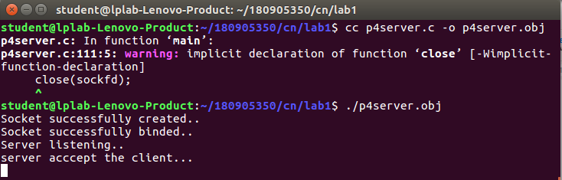
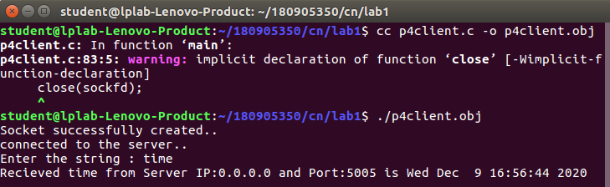
Q3)
Implement concurrent Remote Math Server To perform arithmetic operations in the server and display the result at the client. The client accepts two integers and an operator from the user and sends it to the server. The server will performs the operation on integers and sends result back to the client which is displayed in the client.

Code

server
#include <stdio.h>
#include <stdlib.h>
#include <sys/types.h>
#include <sys/socket.h>
#include <arpa/inet.h>
#include <netinet/in.h>
#include <unistd.h>
#define PORT 5000
int calc(int a, int b, char op)
{
switch (op)
{
case '+':
return a + b;
break;
case '-':
return a - b;
break;
case '/':
return a / b;
break;
case '*':
return a * b;
break;
default:
return 0;
break;
}
}
void servfunc(int sockfd, struct sockaddr_in server_address)
{
struct sockaddr_in client_address;
int clientfd, a, b, res, size = sizeof(client_address);
char op;
while (1)
{
clientfd = accept(sockfd, (struct sockaddr *)&client_address, &size);
if (fork() == 0)
{
//in child process
printf("Child process created with clientfd %d\n", clientfd);
close(sockfd);
read(clientfd, (int *)&a, sizeof(int));
read(clientfd, (int *)&b, sizeof(int));
read(clientfd, (char *)&op, sizeof(char));
res = calc(a, b, op);
write(clientfd, (int *)&res, sizeof(int));
close(clientfd);
printf("Child process terminated with clientfd %d\n", clientfd);
exit(0);
}
else
{
//parent process
close(clientfd);
}
}
printf("server closing\n");
}
int main()
{
int sockfd;
struct sockaddr_in server_address;
bzero(&server_address, sizeof(server_address));
server_address.sin_family = AF_INET;
server_address.sin_port = htons(PORT);
server_address.sin_addr.s_addr = htonl(INADDR_ANY);
sockfd = socket(AF_INET, SOCK_STREAM, 0);
int res = bind(sockfd, (struct sockaddr *)&server_address, sizeof(server_address));
if (res < 0)
{
printf("Server unable to bind\n");
exit(0);
}
else
printf("Server bound successfully\n");
res = listen(sockfd, 2);
if (res < 0)
{
printf("Server unable to listne\n");
exit(0);
}
else
printf("Server listening successfully\n");
servfunc(sockfd, server_address);
close(sockfd);
}

client
#include <sys/types.h>
#include <sys/socket.h>
#include <stdio.h>
#include <netinet/in.h>
#include <arpa/inet.h>
#include <unistd.h>
#include <stdlib.h>
#define PORT 5000

void clifunc(int sockfd)
{
printf("Enter an expression\n");
int a, b;
char c;
scanf("%d%c%d", &a, &c, &b);
write(sockfd, (int *)&a, sizeof(int));
write(sockfd, (int *)&b, sizeof(int));
write(sockfd, (char *)&c, sizeof(char));
int ans;
read(sockfd, (int *)&ans, sizeof(int));
printf("Answer is %d\n", ans);
printf("client closing");
}
int main(int argc, char const *argv[])
{
int sockfd;
int len;
struct sockaddr_in server_address;
int result;
char ch;
sockfd = socket(AF_INET, SOCK_STREAM, 0);
bzero(&server_address, sizeof(server_address));
server_address.sin_family = AF_INET;
server_address.sin_port = htons(PORT);
server_address.sin_addr.s_addr = htonl(INADDR_ANY);
len = sizeof(server_address);
result = connect(sockfd, (struct sockaddr *)&server_address, len);
if (result == -1)
{
printf("connection error\n");
exit(0);
}
clifunc(sockfd);
close(sockfd);
}
Output

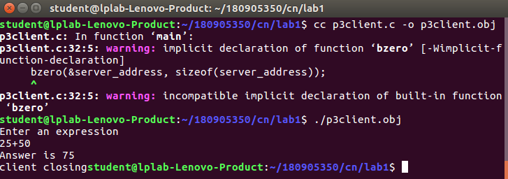
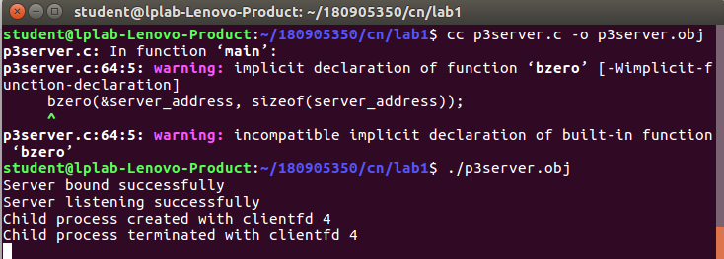
Q4) Write a UDP client-server program where client sends rows of a matrix to the server combines them together as a two dimensional matrix and display the same.

Code

Server
// server program for udp connection
#include <stdio.h>
#include <strings.h>
#include <sys/types.h>
#include <arpa/inet.h>
#include <sys/socket.h>
#include <netinet/in.h>
#define PORT 5000
#define MAXLINE 1000

// Server code
int main()
{
char buffer[100];
int servsockfd, len, n;
struct sockaddr_in servaddr, cliaddr;
bzero(&servaddr, sizeof(servaddr));

// Create a UDP Socket
servsockfd = socket(AF_INET, SOCK_DGRAM, 0);
servaddr.sin_addr.s_addr = htonl(INADDR_ANY);
servaddr.sin_port = htons(PORT);
servaddr.sin_family = AF_INET;

// bind server address to socket descriptor
bind(servsockfd, (struct sockaddr *)&servaddr, sizeof(servaddr));

//receive the datagram
while (1)
{
bzero(buffer, sizeof(buffer));
len = sizeof(cliaddr);
n = recvfrom(servsockfd, buffer, sizeof(buffer), 0, (struct sockaddr *)&cliaddr, &len);

// buffer[n] = '\0';

//Echoing back to the client
if ((strncmp(buffer, "exit", 4)) == 0)
{
printf("Client Exit BYE...\n");

break;
}
for (int i = 0; i < n; i++)
{
printf("%c", buffer[i]);
}
// sendto(servsockfd, buffer, n, 0, (struct sockaddr *)&cliaddr, sizeof(cliaddr));
// getchar();
}

// close the descriptor
close(servsockfd);
}

client

#include <stdio.h>
#include <strings.h>
#include <sys/types.h>
#include <arpa/inet.h>
#include <sys/socket.h>
#include <netinet/in.h>
#include <unistd.h>
#include <stdlib.h>

#define PORT 5000
#define MAXLINE 1000

// Driver code
int main()
{
char buffer[100];
//char *message = "";
int sockfd, n, len;
struct sockaddr_in servaddr, cliaddr;

// clear servaddr
bzero(&servaddr, sizeof(servaddr));
servaddr.sin_addr.s_addr = htonl(INADDR_ANY);
servaddr.sin_port = htons(PORT);
servaddr.sin_family = AF_INET;

// create datagram socket
sockfd = socket(AF_INET, SOCK_DGRAM, 0);
char buff[100];
for (;;)
{
bzero(buff, sizeof(buff));
printf("Enter matrix row : ");
n = 0;
while ((buff[n++] = getchar()) != '\n')
;
buff[n] = '\0';
sendto(sockfd, &buff, MAXLINE, 0, (struct sockaddr *)&servaddr, sizeof(servaddr));
if (strncmp(buff, "exit", 4) == 0)
{
printf("Closing..");
break;
}
bzero(buff, sizeof(buff));
len = sizeof(cliaddr);
}

// close the descriptor
close(sockfd);
}

Output

