Q1)
code
#include <sys/types.h>
#include <sys/stat.h>
#include <unistd.h>
#include <stdio.h>
int main (int argc, char *argv[])
{
struct stat sb;
int ret;
if (argc < 2) {
fprintf (stderr, "usage: %s <file>\n", argv[0]);
return 1;
}
ret = stat (argv[1], &sb);
if (ret) {
perror ("stat");
return 1;
}

printf ("Inode number for %s is: %ld ", argv[1], sb.st_ino);
return 0;
}
Output

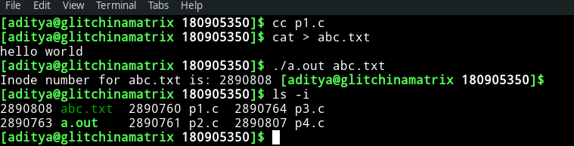
Q2)
Code
#include <sys/types.h>
#include <sys/stat.h>
#include <unistd.h>
#include <stdio.h>
#include <time.h>
#include <stdlib.h>
#include<dirent.h>
#include<string.h>
char* formatdate(char* str, time_t val)
{
strftime(str, 36, "%d.%m.%Y %H:%M:%S", localtime(&val));
return str;
}
int main(int argc, char *argv[]) {
struct stat sb;
if(argc < 2) {
printf("Insufficient arguments!\n");
return 1;
}
int ret;
char date[36];
ret = stat(argv[1], &sb);
if(ret) {
perror("stat");
return 1;
}
printf("ID of device - %d\n", sb.st_dev);
printf("INO Number is - %llu\n", sb.st_ino);
printf("File mode - %hu\n", sb.st_mode);
printf("Number of hard links - %d\n", sb.st_nlink);
printf("User ID - %d\n", sb.st_uid);
printf("Group owner - %d\n", sb.st_gid);
printf("File size - %lld\n", sb.st_size);
printf("Blocksize - %d\n", sb.st_blksize);
printf("Number of Blocks - %lld\n", sb.st_blocks);
printf("Last access time - %s\n", formatdate(date,sb.st_atime));
printf("Last modification time - %s\n", formatdate(date,sb.st_mtime));
printf("Last change time - %s\n", formatdate(date,sb.st_ctime));
DIR * dp;
struct dirent * entry;
struct stat statbuf;
if((dp = opendir(".")) == NULL) {
printf("Cannot open directory \n");
return 0;
}
chdir(".");
while((entry = readdir(dp)) != NULL){
lstat(entry->d_name,&statbuf);
if(!S_ISDIR(statbuf.st_mode)){
if(strcmp(entry->d_name,argv[1])==0){
printf("Permissions\t");
printf( (S_ISDIR(statbuf.st_mode)) ? "d" : "-");
printf( (statbuf.st_mode & S_IRUSR) ? "r" : "-");
printf( (statbuf.st_mode & S_IWUSR) ? "w" : "-");
printf( (statbuf.st_mode & S_IXUSR) ? "x" : "-");
printf( (statbuf.st_mode & S_IRGRP) ? "r" : "-");
printf( (statbuf.st_mode & S_IWGRP) ? "w" : "-");
printf( (statbuf.st_mode & S_IXGRP) ? "x" : "-");
printf( (statbuf.st_mode & S_IROTH) ? "r" : "-");
printf( (statbuf.st_mode & S_IWOTH) ? "w" : "-");
printf( (statbuf.st_mode & S_IXOTH) ? "x" : "-");
printf("\n\n");
}
}
}
}

Output

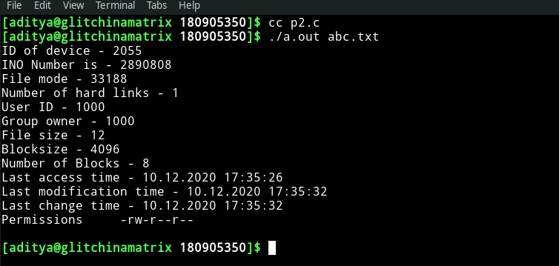
Q3)
Code
#include<sys/types.h>
#include<sys/stat.h>
#include<unistd.h>
#include<stdio.h>
#include <inttypes.h>
#include<stdlib.h>
void main(int argc, char* argv[])
{
if(argc<2)
{
printf("Insufficient arguments\n");
return;
}
char new_path[100]="random.txt";
struct stat start;
int ret1 = stat(argv[1],&start);
printf("Number of hard links:%ld\n", start.st_nlink);
system("ls");
printf("Linking..\n");
int ret2 = link(argv[1],new_path);
struct stat intermediate;
int ret3 = stat(argv[1],&intermediate);
printf("Number of hard links:%ld\n", intermediate.st_nlink);
printf("New path:%s\n",new_path);
system("ls");
int ret4 = unlink(argv[1]);
struct stat ending;
int ret5 = stat(new_path,&ending);
printf("Unlinking...\n");
printf("Number of hard links after unlinking:%ld\n", ending.st_nlink);
system("ls");
}

Output

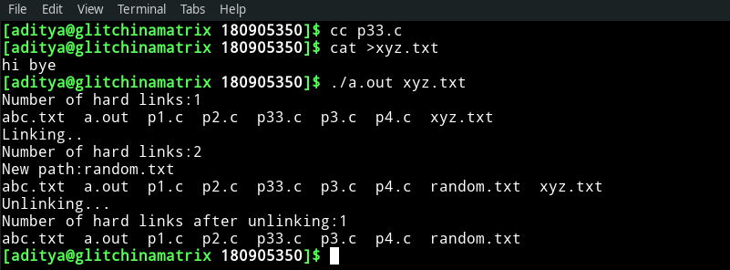
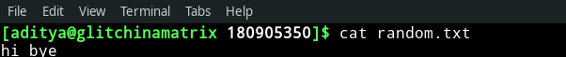
Q4)

#include<sys/types.h>
#include<sys/stat.h>
#include<unistd.h>
#include<stdio.h>
#include <inttypes.h>
#include<stdlib.h>
void main(int argc, char* argv[])
{
if(argc<2)
{
printf("Insufficient arguments\n");
return;
}
char new_path[100]="random2.txt";
struct stat start;
int ret1 = stat(argv[1],&start);
system("ls");
printf("Linking..\n");
int ret2 = symlink(argv[1],new_path);
struct stat intermediate;
int ret3 = stat(argv[1],&intermediate);
printf("New path:%s\n",new_path);
system("ls");
int ret4 = unlink(argv[1]);
struct stat ending;
int ret5 = stat(new_path,&ending);
printf("Unlinking...\n");
system("ls");
}
Output

