Q1)
code

/*
S->a | > | ( T )
T->T, S|S

after removing lr
S->a | > | ( T )
T -> ST'
T' -> ,ST' | empty

ex1- (a,>)$ //success
ex2- ,a)$ //failure
*/

#include <stdio.h>
#include <stdlib.h>
#include <string.h>
int curr = 0;
char str[100];

void S();
void T();
void Tprime();

void invalid()
{
printf("-----------------ERROR!----------------\n");
exit(0);
}
void valid()
{
printf("----------------SUCCESS!---------------\n");
exit(0);
}

void S(){
if(str[curr]=='a' || str[curr]=='>'){
curr++;
return;

}
else if(str[curr]=='('){
curr++;
T();
if(str[curr]==')'){
curr++;
return;
}
else{
invalid();
}
}
else{
invalid();
}
}
void T(){
S();
Tprime();
}
void Tprime(){
if(str[curr]==','){
curr++;
S();
Tprime();
}
}

void main(){
printf("Enter String\n");
scanf("%s",str);
S();
if(str[curr]=='$')
valid();
else{
// printf("c\n",str[curr]);
invalid();
}
}

Output
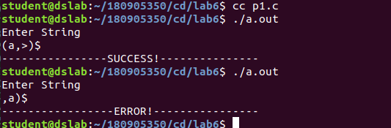
Q2)
Code
/*
S->UVW
U -> (S) | aSb | d
V ->aV | empty
W->cW | empty

ex1-daac$
ex2- addca$
*/

#include <stdio.h>
#include <stdlib.h>
#include <string.h>
int curr = 0;
char str[100];

void S();
void U();
void V();
void W();

void invalid()
{
printf("-----------------ERROR!----------------\n");
exit(0);
}
void valid()
{
printf("----------------SUCCESS!---------------\n");
exit(0);
}

void S(){
U();
V();
W();
}

void U(){
if(str[curr]=='('){
curr++;
S();
if(str[curr]==')'){
curr++;
return;
}
else {
invalid();
}

}
else if(str[curr]=='a'){
curr++;
S();
if(str[curr]=='b'){
curr++;
return;
}
else{
invalid();
}
}
else if(str[curr]=='d'){
curr++;
return;
}
else{
invalid();
}
}

void V(){
if (str[curr]=='a'){
curr++;
V();
}
}
void W(){
if(str[curr]=='c'){
curr++;
W();
}
}

void main(){
printf("Enter String\n");
scanf("%s",str);
S();
if(str[curr]=='$')
valid();
else{
// printf("c\n",str[curr]);
invalid();
}
}
Output
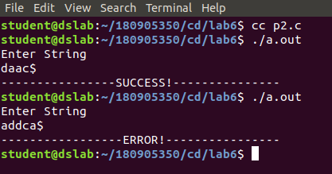
Q3)
Code
/*
S->aAcBe
A->Ab|b
B->d

after removing lr
S->aAcBe
A->bA'
A'->bA'|empty
B->d

ex1- abbbbcde$
ex2 -abbce$
*/

#include <stdio.h>
#include <stdlib.h>
#include <string.h>
int curr = 0;
char str[100];

void S();
void A();
void Aprime();
void B();

void invalid()
{
printf("-----------------ERROR!----------------\n");
exit(0);
}
void valid()
{
printf("----------------SUCCESS!---------------\n");
exit(0);
}

void S(){
if(str[curr]=='a'){
curr++;
A();
if(str[curr]=='c'){
curr++;
B();
if(str[curr]=='e'){
curr++;
return;
}
else{
invalid();
}
}
else{
invalid();
}
}
else{
invalid();
}
}

void A(){
if(str[curr]=='b'){
curr++;
Aprime();
}
else{
invalid();
}
}
void Aprime(){
if(str[curr]=='b'){
curr++;
Aprime();
}
}
void B(){
if(str[curr]=='d'){
curr++;
return;
}
else{
invalid();
}
}

void main(){
printf("Enter String\n");
scanf("%s",str);
S();
if(str[curr]=='$')
valid();
else{
// printf("c\n",str[curr]);
invalid();
}
}

Ouput

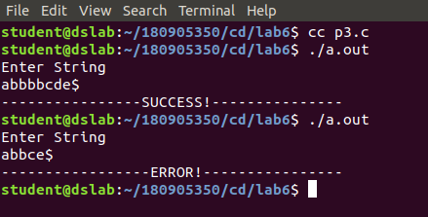

Q4)
Code
/*
S ->(L) | a
L ->L,S | S

after removing lr
S ->(L) | a
L ->SL'
L'->,SL'|empty

ex1-((a,(a),a))$
ex2- (aa,a)$

*/

#include <stdio.h>
#include <stdlib.h>
#include <string.h>
int curr = 0;
char str[100];

void S();
void L();
void Lprime();

void invalid()
{
printf("-----------------ERROR!----------------\n");
exit(0);
}
void valid()
{
printf("----------------SUCCESS!---------------\n");
exit(0);
}

void S(){
if(str[curr]=='a' ){
curr++;
return;

}
else if(str[curr]=='('){
curr++;
L();
if(str[curr]==')'){
curr++;
return;
}
else{
invalid();
}
}
else{
invalid();
}
}
void L(){
S();
Lprime();
}
void Lprime(){
if(str[curr]==','){
curr++;
S();
Lprime();
}
}

void main(){
printf("Enter String\n");
scanf("%s",str);
S();
if(str[curr]=='$')
valid();
else{
// printf("c\n",str[curr]);
invalid();
}
}

Output

