Q1)
Code
Producer
#include<stdio.h>
#include<stdlib.h>
#include<unistd.h>
#include<sys/types.h>
#include<limits.h>
#include<fcntl.h>
#include<sys/msg.h>
#include<sys/stat.h>
#include<string.h>
#define FIFO_NAME "my_fifo"
#define BUFFER_SIZE 1000

int main(int argc, char *argv[]){
int pipe_fd;
int res;
int open_mode=O_RDONLY;
int n=0;
char buffer[BUFFER_SIZE+1];
memset(buffer,'\0',sizeof(buffer));

printf("Process %d opening FIFO O_RDONLY\n",getpid());
pipe_fd=open(FIFO_NAME,open_mode);
printf("Process %d result %d\n",getpid(),pipe_fd);
if (pipe_fd!=-1){
do{
res=read(pipe_fd,buffer,BUFFER_SIZE);
printf("%s\n",buffer );
n++;
}while(n<4);
(void)close(pipe_fd);
}
else
exit(EXIT_FAILURE);
printf("Process %d Finished, %d bytes read\n",getpid(),n );
exit(EXIT_SUCCESS);

}
Consumer

#include<stdio.h>
#include<stdlib.h>
#include<unistd.h>
#include<sys/types.h>
#include<limits.h>
#include<fcntl.h>
#include<sys/msg.h>
#include<sys/stat.h>
#include<string.h>
#define FIFO_NAME "my_fifo"
#define BUFFER_SIZE 1000

int main(int argc, char *argv[]){
int pipe_fd;
int res;
int open_mode=O_RDONLY;
int n=0;
char buffer[BUFFER_SIZE+1];
memset(buffer,'\0',sizeof(buffer));

printf("Process %d opening FIFO O_RDONLY\n",getpid());
pipe_fd=open(FIFO_NAME,open_mode);
printf("Process %d result %d\n",getpid(),pipe_fd);
if (pipe_fd!=-1){
do{
res=read(pipe_fd,buffer,BUFFER_SIZE);
printf("%s\n",buffer );
n++;
}while(n<4);
(void)close(pipe_fd);
}
else
exit(EXIT_FAILURE);
printf("Process %d Finished, %d bytes read\n",getpid(),n );
exit(EXIT_SUCCESS);

}
Output

Producer window
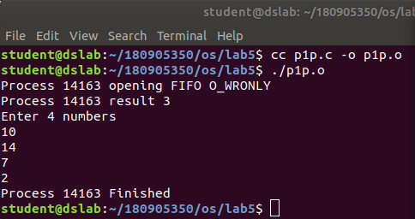

Consumer Window
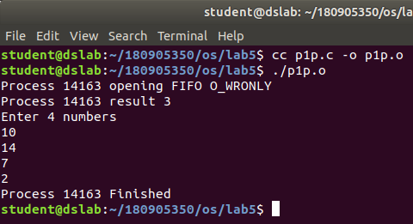

Q2)

Code
#include<stdio.h>
#include<stdlib.h>
#include<unistd.h>
#include<sys/types.h>
#include<sys/ipc.h>
#include<sys/msg.h>
#include<string.h>

int main(int argc, char *argv[]){
int n;
int fd[2];
char buf[1025];
char *data="hello this is sample data";
pipe(fd);
write(fd[1],data,strlen(data));
if(n=read(fd[0],buf,1024)>=0){
buf[n]=0;
printf("Read %d bytes from pipe\"%s\"\n",n,buf);

}
else
perror("read");
exit(0);
}

Output

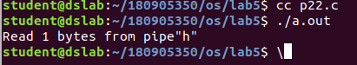

Q3)

Code
user1

#include<stdio.h>
#include<stdlib.h>
#include<unistd.h>
#include<sys/types.h>
#include<limits.h>
#include<fcntl.h>
#include<sys/msg.h>
#include<sys/stat.h>
#include<string.h>
#define FIFO_NAME "my_fifo33"
#define BUFFER_SIZE 10000

int main(int argc, char *argv[]){
int pipe_fd;
int res;
int open_mode1=O_WRONLY;
int open_mode2=O_RDONLY;
int n=0;
char buffer[BUFFER_SIZE+1];
if(access(FIFO_NAME,F_OK)==-1){
res=mkfifo(FIFO_NAME,0777);
if(res!=0){
fprintf(stderr, "Could not create file%s\n",FIFO_NAME );
exit(EXIT_FAILURE);
}
}
printf("You can start chatting with user2 now\n");
while(1){
pipe_fd=open(FIFO_NAME,open_mode1);
printf("\nEnter Text to send User2: ");
fgets(buffer,BUFFER_SIZE,stdin);
res=write(pipe_fd,buffer,BUFFER_SIZE);

close(pipe_fd);
printf("Wait for user 2 reply\n");
pipe_fd=open(FIFO_NAME,open_mode2);
printf("\nText from User2: ");
res=read(pipe_fd,buffer,BUFFER_SIZE);
printf("%s\n",buffer );
close(pipe_fd);

}
(void)close(pipe_fd);

printf("Process %d Finished\n",getpid() );
exit(EXIT_SUCCESS);
}

User2

#include<stdio.h>
#include<stdlib.h>
#include<unistd.h>
#include<sys/types.h>
#include<limits.h>
#include<fcntl.h>
#include<sys/msg.h>
#include<sys/stat.h>
#include<string.h>
#define FIFO_NAME "my_fifo33"
#define BUFFER_SIZE 10000

int main(int argc, char *argv[]){
int pipe_fd;
int res;
int open_mode1=O_WRONLY;
int open_mode2=O_RDONLY;
int n=0;
char buffer[BUFFER_SIZE+1];
if(access(FIFO_NAME,F_OK)==-1){
res=mkfifo(FIFO_NAME,0777);
if(res!=0){
fprintf(stderr, "Could not create file%s\n",FIFO_NAME );
exit(EXIT_FAILURE);
}
}
printf("You can start chatting with user2 now\n");
while(1){
pipe_fd=open(FIFO_NAME,open_mode2);
printf("\nText from User1: ");
res=read(pipe_fd,buffer,BUFFER_SIZE);
printf("%s\n",buffer );
close(pipe_fd);
printf("Wait for user 1 reply\n");
pipe_fd=open(FIFO_NAME,open_mode1);
printf("\nEnter Text to send User1: ");
fgets(buffer,BUFFER_SIZE,stdin);
res=write(pipe_fd,buffer,BUFFER_SIZE);

close(pipe_fd);

}
(void)close(pipe_fd);

printf("Process %d Finished\n",getpid() );
exit(EXIT_SUCCESS);
}

Output

User1
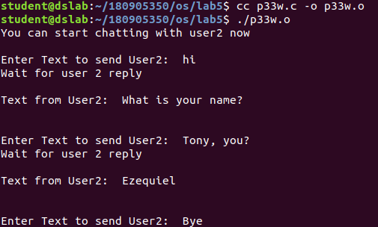

User2
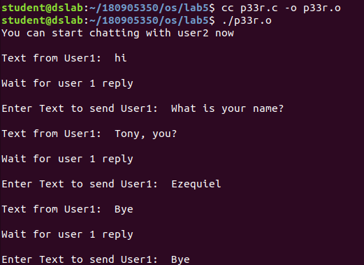
Q4)
Code
#include <stdio.h>
int main()
{
char ch;

FILE *fpbr, *fpbw;

fpbr = fopen("bin1.exe", "rb");

if (fpbr == NULL)
{
puts("Input Binary file is having issues while opening");
}

fpbw= fopen("bin2.exe", "wb");

if (fpbw == NULL)
{
puts("Output binary file is having issues while opening");
}

while(1)
{
ch = fgetc(fpbr);
if (ch==EOF)
break;
else
fputc(ch, fpbw);
}

fclose(fpbr);
fclose(fpbw);

return 0;
}
Output
