Q1)
code
Sender
#include<stdio.h>
#include<stdlib.h>
#include<unistd.h>
#include<sys/types.h>
#include<limits.h>
#include<fcntl.h>
#include<sys/msg.h>
#include<sys/stat.h>
#include<string.h>
#include<sys/msg.h>
#include<sys/ipc.h>
#include<errno.h>
#define MAX_TEXT 512

struct my_msg_st
{
long int my_msg_type;
int msg;
};
int main(int argc, char const *argv[])
{
int running=1;
struct my_msg_st some_data;
int msgid;
int num;
msgid=msgget((key_t)1234,0666|IPC_CREAT);
if(msgid==-1){
fprintf(stderr, "msgget failed with error%d\n",errno );
exit(EXIT_FAILURE);
}
printf("Enter -1 to quit\n");
while(running){
printf("Enter number\n");
scanf("%d",&num);
some_data.my_msg_type=1;
some_data.msg=num;
if (msgsnd(msgid,(void*)&some_data,MAX_TEXT,0)==-1){
fprintf(stderr, "msgsnd failed\n" );
exit(EXIT_FAILURE);
}
if(num==-1)
running=0;
}
exit(EXIT_SUCCESS);
}
Reciever
#include<stdio.h>
#include<stdlib.h>
#include<unistd.h>
#include<sys/types.h>
#include<limits.h>
#include<fcntl.h>
#include<sys/msg.h>
#include<sys/stat.h>
#include<string.h>
#include<sys/msg.h>
#include<sys/ipc.h>
#include<errno.h>
#define MAX_TEXT 512

struct my_msg_st
{
long int my_msg_type;
int msg;
};
int reverse(int x) {
int y = 0;
while(x > 0) {
y *= 10;
y += x % 10;
x /= 10;
}
return y;
}
int main(int argc, char const *argv[])
{
int running=1;
struct my_msg_st some_data;
long int msg_to_receive=0;
int msgid;
int num;
msgid=msgget((key_t)1234,0666|IPC_CREAT);
if(msgid==-1){
fprintf(stderr, "msgget failed with error%d\n",errno );
exit(EXIT_FAILURE);
}
while(running){
if (msgrcv(msgid,(void*)&some_data,BUFSIZ,msg_to_receive,0)==-1){
fprintf(stderr, "msgrc failedwith error %d\n",errno );
exit(EXIT_FAILURE);
}
printf("You wrote %d\n",some_data.msg);
if(some_data.msg == reverse(some_data.msg))
printf("Number received is a palindrome\n");
else
printf("Number received is not a palindrome\n");
if(some_data.msg==-1)
running=0;
}
if(msgctl(msgid,IPC_RMID,0)==-1){
fprintf(stderr, "msgctl(IPC_RMID) failed\n");
exit(EXIT_FAILURE);
}
exit(EXIT_SUCCESS);
}

Output
sender
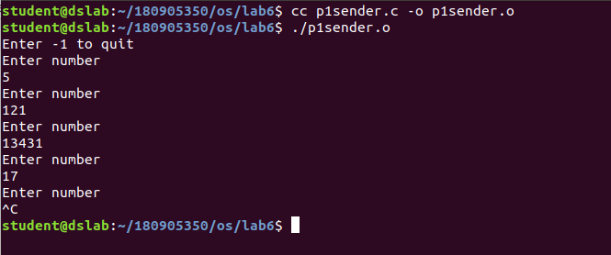
Receiver
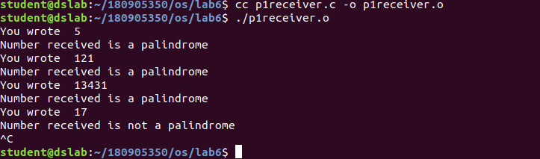
Q2)
code

#include<stdio.h>
#include<stdlib.h>
#include<unistd.h>
#include<sys/types.h>
#include<sys/ipc.h>
#include<sys/shm.h>

struct shared_str{
int status;
char alphabet;
};

int main(int argc, char const *argv[])
{
int shmid = shmget((key_t)1234,sizeof(struct shared_str),0666|IPC_CREAT);
pid_t pid = fork();

if(pid < 0) {
printf("Error in fork()\n");
exit(-1);
}

else if(pid == 0) { //child process
struct shared_str* shared_mem = shmat(shmid,(void*)0,0);
if(shared_mem == (void*)-1) {
printf("shmat() failed\n");
exit(-1);
}
printf("Memory attached at %p for child process\n",shared_mem);
while(1) {
if(shared_mem->status < 0) {
// printf("Exit code received %d\n",shared_mem->status);
if(shmdt(shared_mem) == -1) {
printf("shmdt failed\n");
exit(-1);
}
break;
}
if(shared_mem->status == 1) {
char c = shared_mem->alphabet;
printf("\n");
if((int)c >= 65 && (int)c <= 90) { //uppercase
c = ((c - 'A' + 1)%26) + 'A';
}
else if((int)c >= 97 && (int)c <= 122) { //lowecase
c = ((c - 'a' + 1)%26) + 'a';
}
else {
printf("Non-alphabetic character received\n");
//do nothing
}
shared_mem->alphabet = c; //write to shared memory
shared_mem->status = 2;
}
}
}

else { //parent process
sleep(1);
struct shared_str* shared_mem = shmat(shmid,(void*)0,0);
if(shared_mem == (void*)-1) {
printf("shmat() failed\n");
exit(-1);
}
printf("Memory attached at %p for parent process\n",shared_mem);
shared_mem->status = 0;
while(1) {
if(shared_mem->status == 1) {
// printf("Waiting for child process\n");
continue;
}
if(shared_mem->status == 2) {
printf("%c\n",shared_mem->alphabet);
}
shared_mem->status = 0;
char c,nl;
printf("Enter an alphabet (0 to exit) : \n");
scanf("%c",&c);
scanf("%c",&nl);
if(c == '0') {
shared_mem->status = -1;
printf("Exiting...\n");
if(shmdt(shared_mem) == -1) {
printf("shmdt failed\n");
exit(-1);
}
if(shmctl(shmid,IPC_RMID,0) == -1) {
printf("shmctl failed\n");
exit(-1);
}
break;
}
shared_mem->alphabet = c;
shared_mem->status = 1;
}
}
return 0;
}

Output

