Andromeda Robotics Assessment Task:

Automatic Dog Feeder

# Research:

Dog breeds within the weight limit of 3kg generally fall under the “Toy Dogs” breed[1]. These dog breeds generally grow upto 33cms in height[2]. The most common examples of toy breed dogs are the Chihuahua, the Pomeranian and the Poodle.

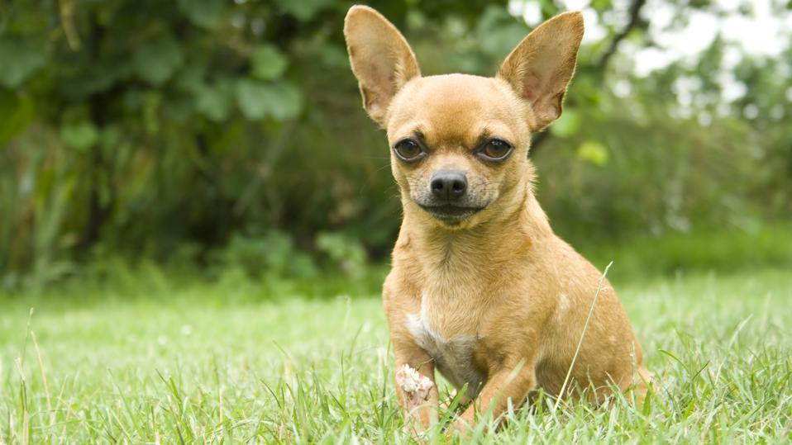 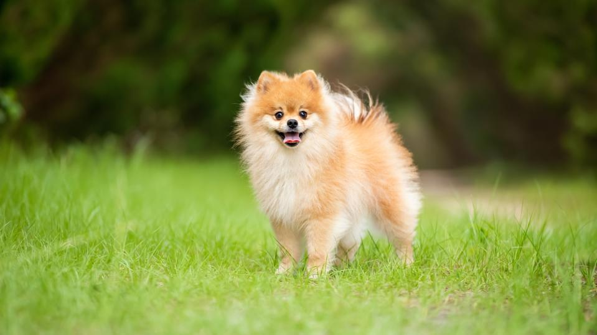

*Fig.1. Toy dog breeds(from left to right) – Chihuahua, Pomeranian, Poodle*

The commercial Automatic Dog Feeders these days come with advanced features[3] such as

* 1. Monitoring cameras
  2. Voice interaction
  3. Timed food dispenser
  4. Robust power supply

These feeders are meant only to handle dry dog food. For hydration needs, there are automated water bowl feeders that provide continuous supply of fresh drinking water. This is in line with the fact that dogs require food at timed intervals, for which they are trained, but continuous supply of drinking water[4]. Commercial feeders come in 2 form factors

1. Tower style feeder – This style of feeder has a tower structure as the central storage for food and the control electronics. The food bowl(s) is placed under the outlet.
2. Bowl style feeder – This style of feeder has an actuated internal slotted feeding bowl that rotates to feed small portions of dry food by rotating the internal bowl and giving access to just the portion of food at the time.

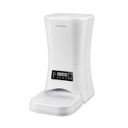 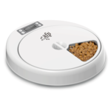

Fig.2 (From left to right) Tower style feeder, Bowl style feeder

# Goal:

The task requires to design an Automatic dog feeder(ADF) for a 3kg dog that provides not just food, but also water as per requirement. This will need to be durable and have various sensors to monitor the dog’s interaction with the feed.

# Constraints:

The provided constraints for the 3 different work areas are as follows

* 1. Software:
     + The ADF should record the dog feeding
     + The recorded video should be stored locally
     + The software should be made in ROS2
     + The software be run in container
     + The software should detect the dog and begin dispensing food and water
  2. Electrical:
     + The ADF should have a rechargeable and removable power supply
     + The camera should be connected to a Raspberry Pi(RPi)
     + Upto 5 sensors/actuators/outputs should be in the system
       - 1 sensor with analog amplifier
       - 1 output signal should be buffered
     + The components should be connected with locking connectors
     + The PCB should be designed in a HAT form factor
  3. Mechanical:
     + The ADF should be durable to against physical impacts from a 3kg dog
     + The ADF should hold 600ml of water and 300g of dry dog food
     + The camera should be properly mounted
     + The sensors(RFID/Ultrasonic/Proximity) should be able to detect the dog
     + The ADF should dispense 10% at a time
     + The ADF should hold all the electronics and electromechanical parts

# Concept System Design:

The following possible system designs was conceptualized for the task

Dog’s recording

Camera

ADF System

Raspberry Pi:

Runs ROS2 nodes, controls the overall system and records video of dog

Dog’s Weight

Sensors:

HX711+Load cell sensor, Ultrasonic sensor

Dispensed food and water

Arduino Nano:

Interfaces with low-level harware

Actuator:

Servo motors

# Conclusion:

The presence of an effective dog feeder can help to maintain the health and well-being of a pet dog and well-designed ADF can be commercial success as well, considering the increasing number of pet-owners around the globe. The goal for this task is to design a capable and versatile ADF within the constraints to achieve its key goal – great health the man’s best friend!

# References:

1. <https://www.akc.org/dog-breeds/toy/>
2. <https://www.forbes.com/advisor/pet-insurance/pet-care/popular-toy-dog-breeds/>
3. <https://petpawz.com.au/collections/automatic-pet-feeder>
4. <https://www.petangel.com.au/dos-and-donts-of-feeding-you-dog/>
5. <https://www.petcircle.com.au/dog/feeding/automated>