Quiz 3: Thermodynamic property calculation for oxygen [Due for submission at 5 pm September 30, 2022]
Name: Aditya Narayan Prasad
Role number: 210020007

The Peng-Robinson equation of state is
$$P=\frac{RT}{\underline{V}-b}-\frac{a\left(T\right)}{\underline{V}\left(\underline{V}+b\right)+b\left(\underline{V}-b\right)}$$ | where
$$a\left(T\right)=0.45724\frac{R^{2}T_{c}^{2}}{P_{c}}{\left[1+κ\left(1-\sqrt{\frac{T}{T_{c}}} \right)\right]}^{2}$$ | $$b=0.0778\frac{RT_{c}}{P_{c}}$$
For oxygen
$$κ=0.4069$$ | $$T_{c}=154.6 K$$ | $$P_{c}=5.046 MPa$$
This EOS can be written in a cubic polynomial form as
$$Z^{3}+αZ^{2}+βZ+γ=0$$
where
$$α=B-1$$ | $$β=A-3B^{2}-2B$$ | $$γ=B^{3}+B^{2}-AB$$
$$A=aP/{\left(RT\right)}^{2}$$ | $$B=bP/RT$$ | $$Z=P\underline{V}/RT.$$

(a) Find the vapor pressure $P_{vap}(T)$ at temperatures $T=-125, -150$ and $-175 ℃$.
Hint: To find the vapor pressure you require $T$ and a guess value of $P$. Figure 6.4-3 can be used to obtain a guess value. Solve for $Z^{L}$ and $Z^{V}$ using the cubic equation $Z^{3}+αZ^{2}+βZ+γ=0$. We shall employ fugacity. For vapor, calculate the vapor fugacity $f^{V}$ with the help of
$$\ln{\frac{f^{V}}{P}}=\left(Z^{V}-1\right)-\ln\left(Z^{V}-B\right)-\frac{A}{2\sqrt{2}B}\ln\left[\frac{Z^{V}+\left(1+\sqrt{2}\right)B}{Z^{V}+\left(1-\sqrt{2}\right)B}\right].$$
For liquid, calculate the liquid fugacity $f^{L}$ with the help of
$$\ln{\frac{f^{L}}{P}}=\left(Z^{L}-1\right)-\ln\left(Z^{L}-B\right)-\frac{A}{2\sqrt{2}B}\ln\left[\frac{Z^{L}+\left(1+\sqrt{2}\right)B}{Z^{L}+\left(1-\sqrt{2}\right)B}\right].$$
Recall that $A$ and $B$ depend on $T$ and $P$. Therefore, they have to be calculated each time for a new value of $T$ and $P$.
For vapor-liquid coexistence we require $f^{V}(T,P)=f^{L}\left(T,P\right)$. Therefore, check whether $\left|\frac{f^{L}}{f^{V}}-1\right|<0.0001$. If so, then you can stop – you have a solution for $P_{vap}$ at the selected temperature. Otherwise, set $P=P\frac{f^{L}}{f^{V}}$. The flowchart below will help:

P_{vap}(-125 C) = 3.9422 * 10⁶ Pa
P_{vap}(-150 C) = 1.2258 * 10⁶ Pa
P_{vap}(-175 C) = 2.1931 * 10⁵ Pa
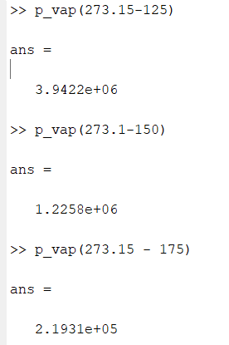

Code for Vapour Pressure as a Function Of Temperature
function y = p_vap(T)
Pc = 5.046e6;
Pvap = Pc; %Pa -- initial guess
nroots=1;
while nroots~=3 %check whether this initial guess provides 3 roots
z=PR(T,Pvap);
nroots=size(z,1);
if nroots==1
Pvap=Pvap-10e5; %New guess
end
end
fl = 1;
fv = 0.1;
while abs((fl/fv)-1) > 0.0001
[A, B] = pt_consts(T, Pvap);
alpha= -1.+B;
beta=A-3*B*B-2*B;
gamma= -A*B + B*B*(B+1.);

PReq=[1.0 alpha beta gamma];
zr=real(roots(PReq));
check_zr=abs(polyval(PReq,zr))<1.e-8 & zr>1.e-5;

zl = zr(3);
zv = zr(1);

fl = f(zl, T, Pvap);
fv = f(zv, T, Pvap);
Pvap = Pvap*fl/fv;
end
y = Pvap;
end
Function for Fugacity
function y = f(Z, T, P)

[A B] = pt_consts(T, P);

term1 = Z-1;
term2 = log(Z-B);
term3 = (Z + (1+sqrt(2))*B)/(Z + (1-sqrt(2))*B);
term3 = (A/(sqrt(8)*B))*log(term3);

y = exp(term1 - term2 - term3).*P;
end

b) Plot the isotherm $P-\underline{V}$ curve at temperatures $T=-125, -150$ and $-175 ℃$ as shown in Figure 6.4-3 (page 1).
P-V Plot for T = -125, -150 and -175 C
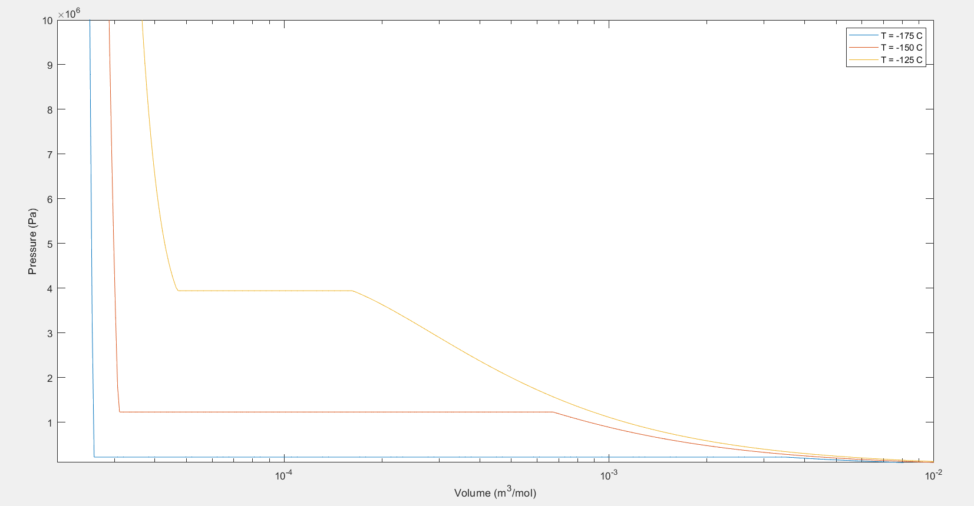

Code
- PV plot
R = 8.314;
v = logspace(-2, 1, 500)*1e-3;
p = zeros(1, size(v, 2));
t = [-175 -150 -125]+273.15;

for j =1:size(t, 2)
vapour_p = p_vap(t(1, j));
[A, B] = pt_consts(t(1, j), vapour_p);
alpha= -1.+B;
beta=A-3*B*B-2*B;
gamma= -A*B + B*B*(B+1.);

PReq=[1.0 alpha beta gamma];
zr=real(roots(PReq));
check_zr=abs(polyval(PReq,zr))<1.e-8 & zr>1.e-5;

zl = zr(3);
zv = zr(1);

vl = zl*R*t(1, j)/vapour_p;
vu = zv*R*t(1, j)/vapour_p;

for i = 1:size(v, 2)
if v(1, i) <vl
p(1, i) = pv(v(1, i), t(1, j));
elseif v(1, i) > vu
p(1, i) = pv(v(1, i), t(1, j));
else
p(1, i) = vapour_p;
end
end

semilogx(v, p);
xlim([2e-5 0.01]);
ylim([1e5 100e5]);
hold on;
end

xlabel('Volume (m^3/mol)');
ylabel('Pressure (Pa)');
legend('T = -175 C', 'T = -150 C', 'T = -125 C');

- PV
function y = pv(V, T)
Pc = 5.046e6;
Tc = 154.6;
R = 8.314;
b = 0.0778*(R*Tc)/Pc;
a = 0.45724*((R*Tc)^2)/Pc;

kappa = 0.4069;
alpha=1+kappa*(1-sqrt(T/Tc));
alpha=alpha*alpha;
a=a*alpha;
term1 = (R*T)/(V-b);
term2 = a/(V^2 + 2*V*b - b^2);
y = term1 - term2;
end

(c) Make a plot for $P_{vap}$ versus $T$ for the vapor-liquid coexistence. Choose temperatures $T=-125, -130, -140, -150, -160, -170, -175, -180$ and $-183 ℃$.

$P_{vap}$ versus $T$
- For $T=-125, -130, -140, -150, -160, -170, -175, -180$ and $-183 ℃$, $P_{vap}$ in Circles
- Best fit curve in red line gotten through lagrange interpolation
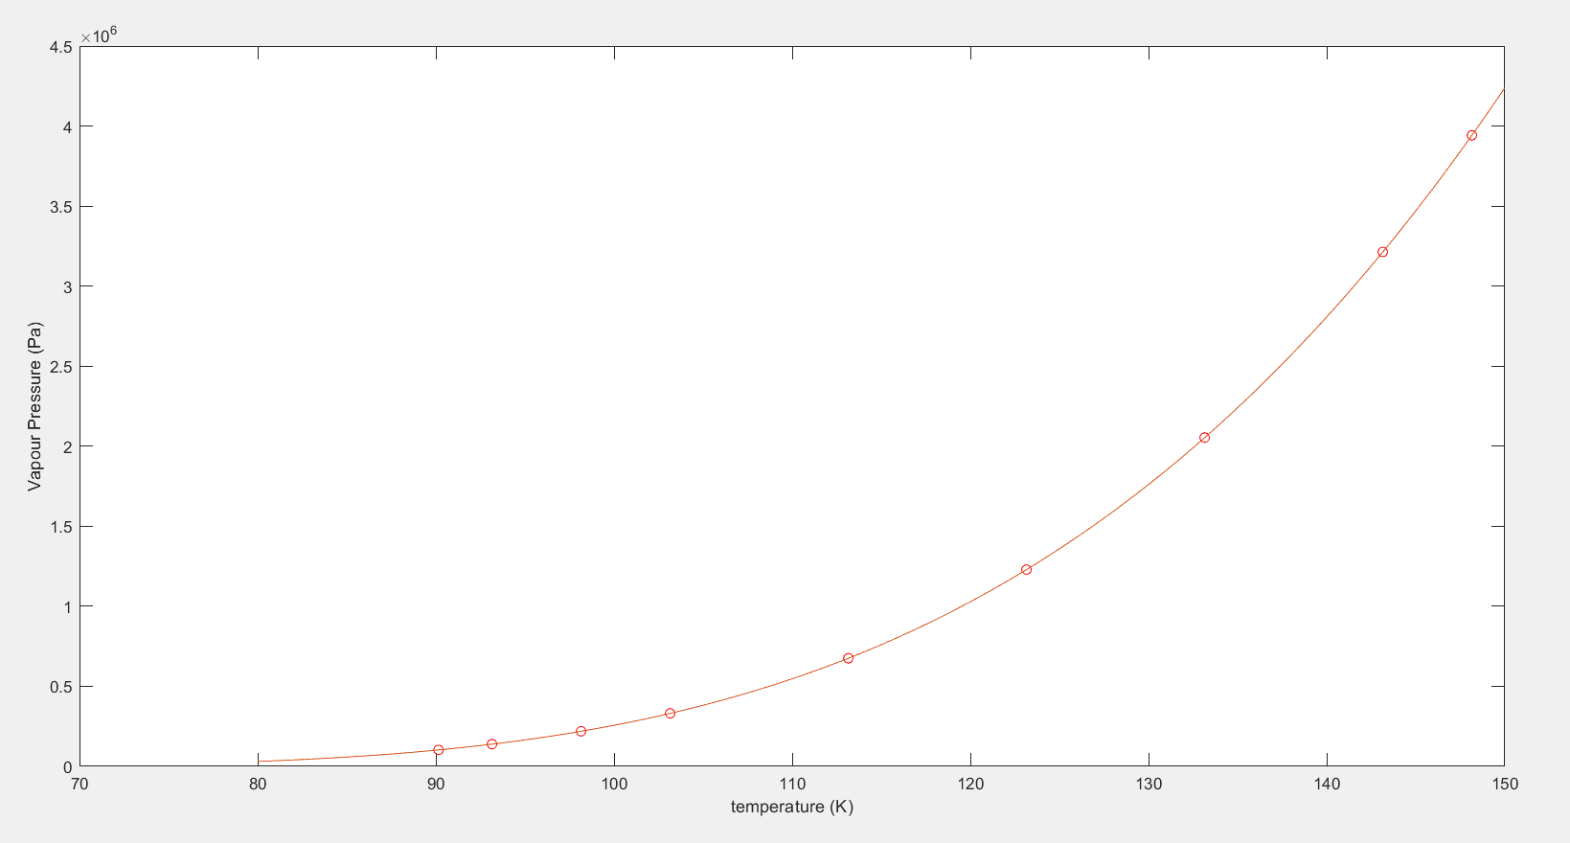

Code
P_{vap} for T = -180 to -125 C & Curve Fitting
T = [-183 -180 -175 -170 -160 -150 -140 -130 -125] + 273.15;
Pvap = zeros(1, size(T, 2));

for i = 1:size(T, 2)
Pvap(1, i) = p_vap(T(1, i));
end

plot(T, Pvap, 'ro');
hold on;

t = logspace(log(80)/log(10), log(150)/log(10), 300);
p = zeros(1, size(t, 2));
for k = 1:size(t, 2)
sum = 0;
for i = 1:size(T, 2)
product = 1;
for j = 1:size(T, 2)
if j ~= i
product = product*((t(1, k)-T(1, j))/(T(1, i) - T(1, j)));
end
end
sum = sum + product*Pvap(1, i);
end
p(1, k) = sum;
end

plot(t, p);
xlabel('temperature (K)')
ylabel('Vapour Pressure (Pa)')

(d) Fit a polynomial curve to $P_{vap}$ versus $T$. Make sure that the polynomial curve fits your data well. Recall that according to the Clapeyron equation
$$\frac{dP_{vap}}{dT}=\frac{Δ\underline{S}}{Δ\underline{V}}=\frac{Δ\underline{H}}{TΔ\underline{V}}.$$
Calculate $Δ\underline{H}={\underline{H}}^{V}-{\underline{H}}^{L}$, $Δ\underline{S}={\underline{S}}^{V}-{\underline{S}}^{L}$ and $Δ\underline{V}={\underline{V}}^{V}-{\underline{V}}^{L}$ from the information you have collected so far. For this you can also fit a curve through $Δ\underline{V}(T)$.
Compare your value of $Δ\underline{H}$ to the value given in the figure below:
Note that in general the pressure where the transition happens from one phase to another is also called saturation pressure $P^{sat}\left(T\right)$. For vapor-liquid equilibrium (VLE) $P^{sat}\left(T\right)≡P^{vap}(T)$.

(e) Plot $Δ\underline{H}$ and $Δ\underline{S}$ as a function of temperature.

Plot Of $Δ\underline{H}$ and $Δ\underline{S}$ Vs T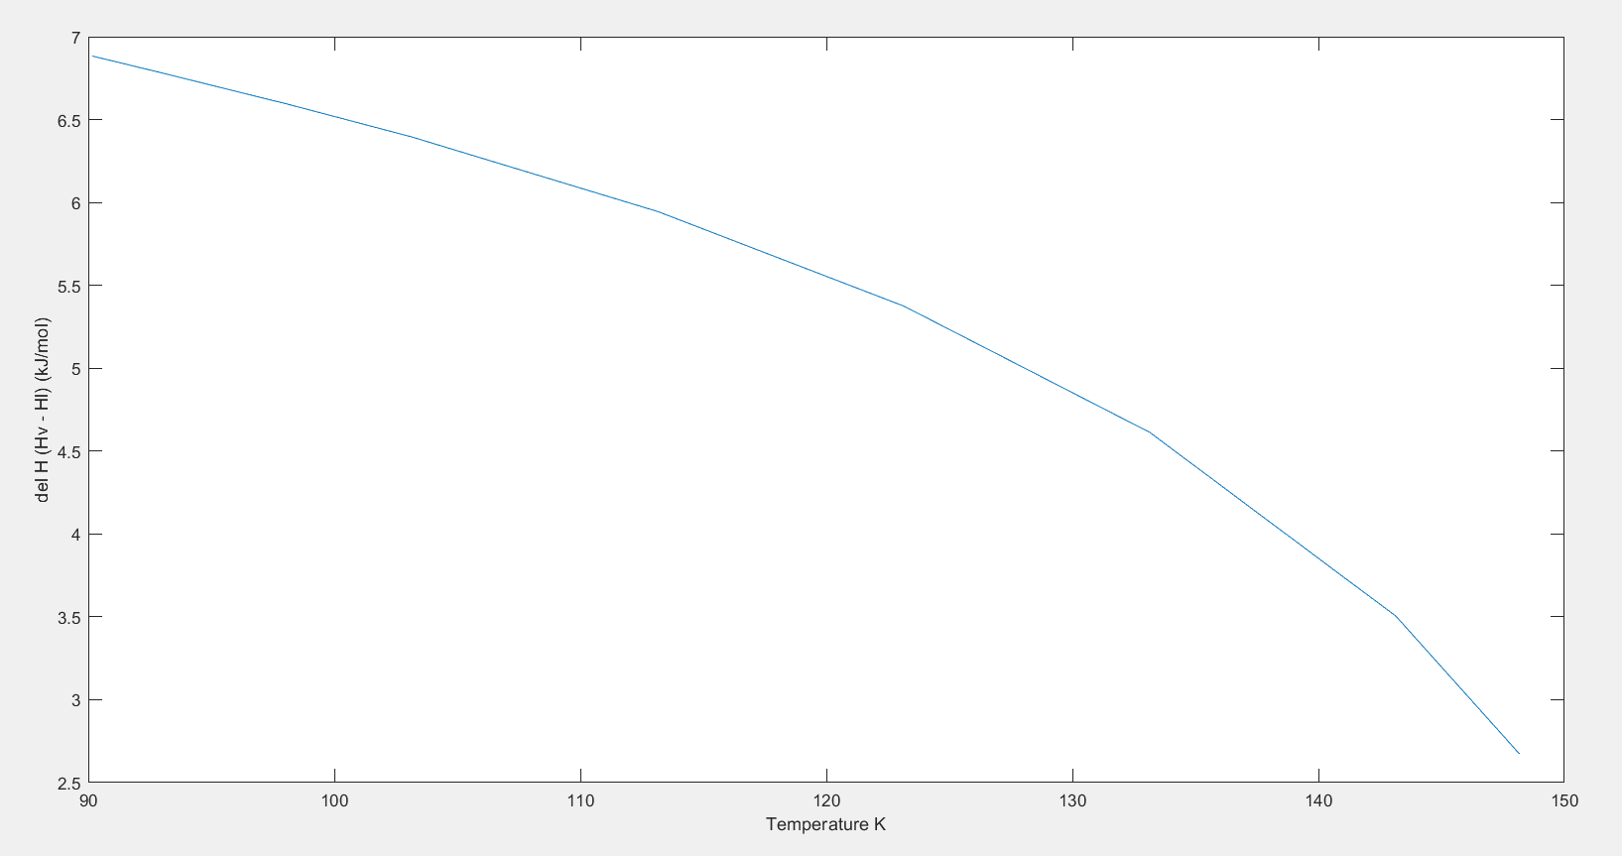 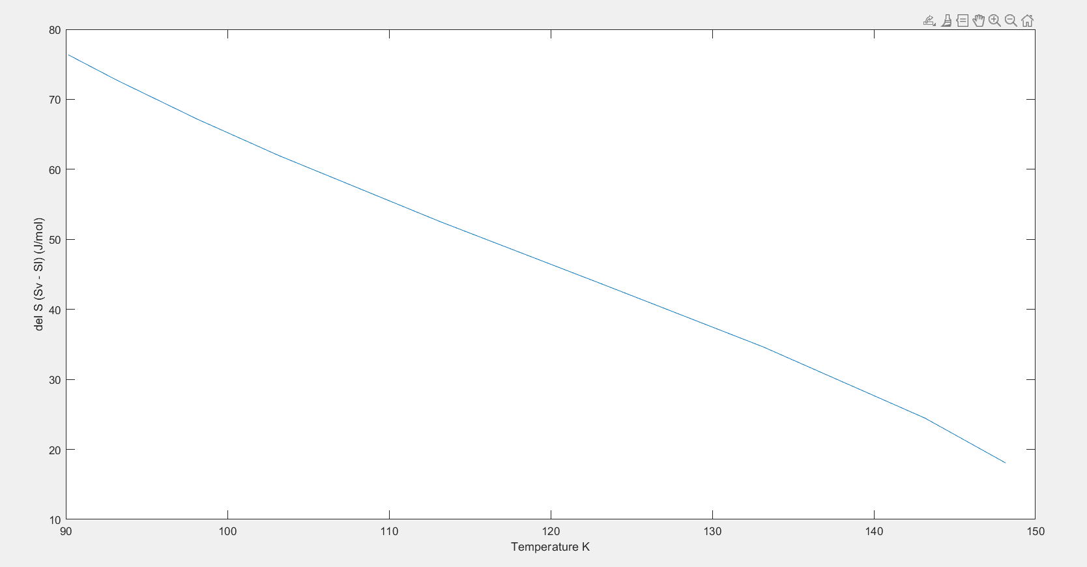

Code
Plot Enthalpy ($Δ\underline{H}$ = H^{V}-H^{L}) and Entropy ($Δ\underline{S}$ = S^{V} – S^{L}) as a function of Temperature
T = [-125 -130 -140 -150 -160 -170 -175 -180 -183]+273.15;
delH = zeros(1, size(T, 2));
delS = zeros(1, size(T, 2));
for i = 1:size(T, 2)
delH(1, i) = delHS(T(1, i), 2);
delS(1, i) = delHS(T(1, i), 1);
end
plot(T, delS);
xlabel('Temperature K');
ylabel('del S (Sv - Sl) (J/mol)');
figure;
plot(T, delH/1e3);
xlabel('Temperature K');
ylabel('del H (Hv - Hl) (kJ/mol)')

function y = delS(T, h_or_s)
R = 8.314;
vap = p_vap(T);

[A, B] = pt_consts(T, vap);
alpha= -1.+B;
beta=A-3*B*B-2*B;
gamma= -A*B + B*B*(B+1.);

PReq=[1.0 alpha beta gamma];
zr=real(roots(PReq));
check_zr=abs(polyval(PReq,zr))<1.e-8 & zr>1.e-5;

zl = zr(3);
zv = zr(1);

vl = zl*R*T/vap;
vv = zv*R*T/vap;
delT = 5;
if h_or_s == 1
y = (vv-vl)*(p_vap(T + delT) - p_vap(T-delT))/(2*delT); %entropy
else
y = (vv-vl)*T*(p_vap(T + delT) - p_vap(T-delT))/(2*delT); %enthalpy
end
end

(f) Enthalpy calculations:
Choose ${\underline{H}}^{IG}\left(T=25℃,P=1 bar\right)=0$. $IG$ implies ideal gas. This sets our reference state. Now calculate enthalpy as
$$\underline{H}\left(T,P\right)-{\underline{H}}^{IG}\left(T=25℃,P=1 bar\right) =\left\{ \underline{H}\left(T,P\right)-{\underline{H}}^{IG}\left(T,P\right)\right\}+\left\{{\underline{H}}^{IG}\left(T,P\right)-{\underline{H}}^{IG}\left(T=25℃,P=1 bar\right)\right\}$$
Here ${\underline{H}}^{IG}\left(T=25℃,P=1 bar\right)$ has a value zero therefore it has been struck through.

For Peng-Robinson equation, the departure function for enthalpy or residual enthalpy
$$\underline{H}\left(T,P\right)-{\underline{H}}^{IG}\left(T,P\right)=RT\left(Z-1\right)+\frac{T\left(\frac{da}{dT}\right)-a}{2\sqrt{2}b}\ln\left[\frac{Z+\left(1+\sqrt{2}\right)B}{Z+\left(1-\sqrt{2}\right)B}\right].$$
Also
$${\underline{H}}^{IG}\left(T,P\right)-{\underline{H}}^{IG}\left(T=25℃,P=1 bar\right)=\int_{T=298.15 K}^{T}{C_{P}^{*}dT}$$
where
$$C_{P}^{*}=25.46+1.519×{10}^{-2}T-0.7151×{10}^{-5}T^{2}+1.311×{10}^{-9}T^{3} \left(\frac{J}{mol.K}\right)$$
for oxygen and $T$ is in K.
Obtain the pressure-enthalpy along the isotherm as shown in Figure 6.4-4 in page 3.

Hint:
For saturated liquid, we write
$${\underline{H}}^{L}(T,P_{vap}\left(T\right))={\underline{H}}^{V}(T,P_{vap}\left(T\right))- Δ\underline{H}(T).$$
For liquid,
$$\underline{H}\left(T,P\right)-{\underline{H}}^{IG}\left(T=25℃,P=1 bar\right) =\left\{ \underline{H}\left(T,P\right)-{\underline{H}}^{L}(T,P_{vap}\left(T\right))\right\}+{\underline{H}}^{L}(T,P_{vap}\left(T\right))$$
where
$$\underline{H}\left(T,P\right)-{\underline{H}}^{L}\left(T,P_{vap}\left(T\right)\right)={\left\{RT\left(Z-1\right)+\frac{T\left(\frac{da}{dT}\right)-a}{2\sqrt{2}b}\ln\left[\frac{Z+\left(1+\sqrt{2}\right)B}{Z+\left(1-\sqrt{2}\right)B}\right]\right\}}_{T,P}-{\left\{RT\left(Z-1\right)+\frac{T\left(\frac{da}{dT}\right)-a}{2\sqrt{2}b}\ln\left[\frac{Z+\left(1+\sqrt{2}\right)B}{Z+\left(1-\sqrt{2}\right)B}\right]\right\}}_{T,P_{vap}\left(T\right)}$$

(g) Entropy calculations:
Choose ${\underline{S}}^{IG}\left(T=25℃,P=1 bar\right)=0$. $IG$ implies ideal gas. This sets our reference state. Now calculate entropy as
$$\underline{S}\left(T,P\right)-{\underline{S}}^{IG}\left(T=25℃,P=1 bar\right) =\left\{\underline{S}\left(T,P\right)-{\underline{S}}^{IG}\left(T,P\right)\right\}+\left\{{\underline{S}}^{IG}\left(T,P\right)-{\underline{S}}^{IG}\left(T=25℃,P=1 bar\right)\right\}$$
Here ${\underline{S}}^{IG}\left(T=25℃,P=1 bar\right)$ has a value zero therefore it has been struck through.

For Peng-Robinson equation, the departure function for entropy or the residual entropy
$$\underline{S}\left(T,P\right)-{\underline{S}}^{IG}\left(T,P\right)=R\ln\left(Z-B\right)+\frac{\frac{da}{dT}}{2\sqrt{2}b}\ln\left[\frac{Z+\left(1+\sqrt{2}\right)B}{Z+\left(1-\sqrt{2}\right)B}\right].$$
Also
$${\underline{S}}^{IG}\left(T,P\right)-{\underline{S}}^{IG}\left(T=25℃,P=1 bar\right)=\int_{T=298.15 K}^{T}{\frac{C_{P}^{*}}{T}dT}-R\ln\left(\frac{P}{1 bar}\right).$$
Obtain the pressure-entropy along the isotherm.

Enthalpy Vs Pressure Isotherms
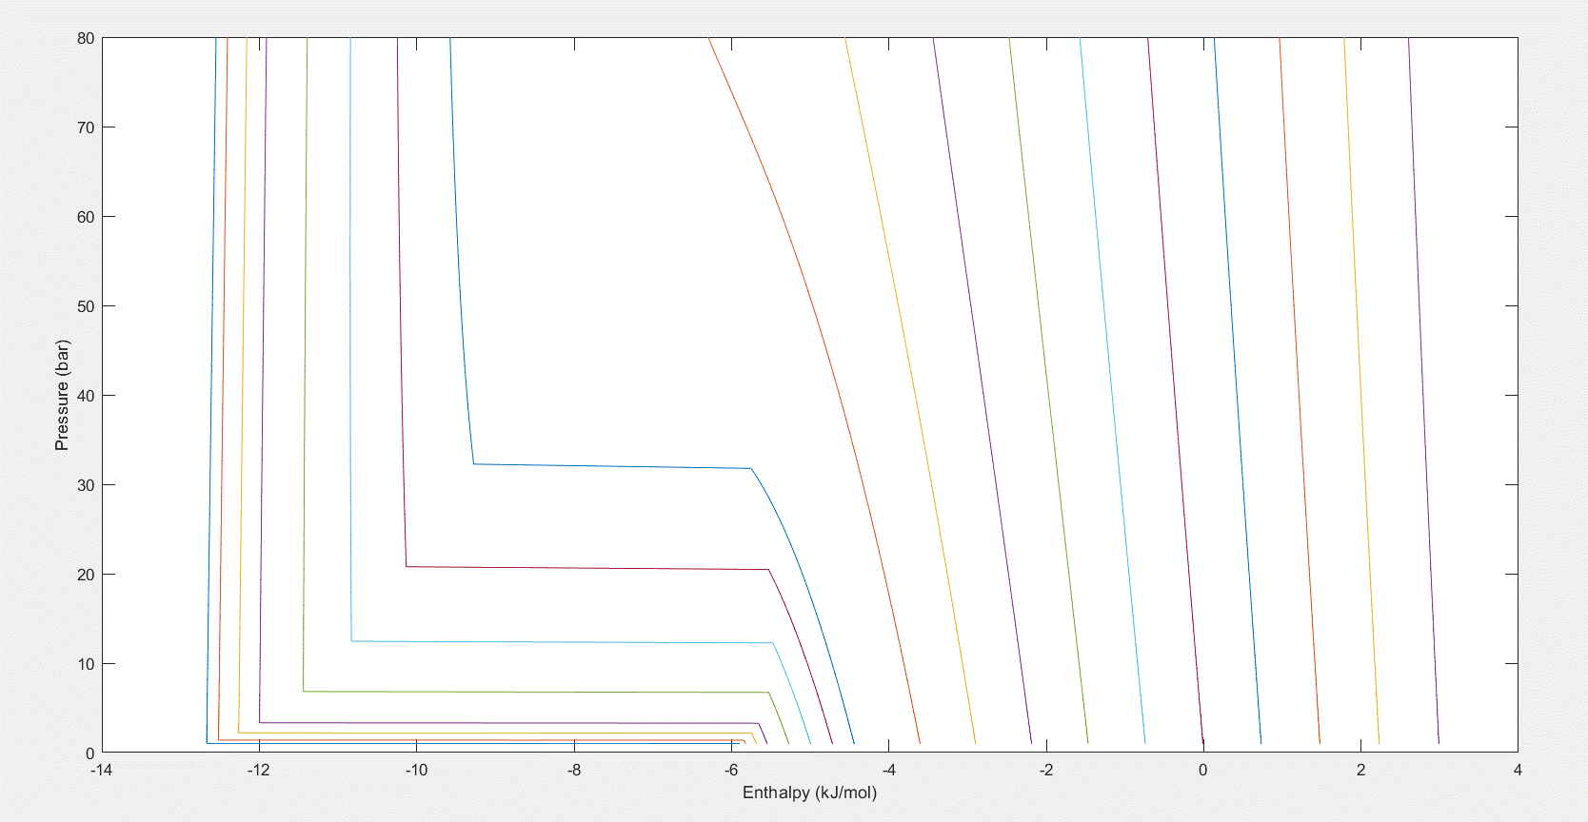

Entropy Vs Pressure Isotherms
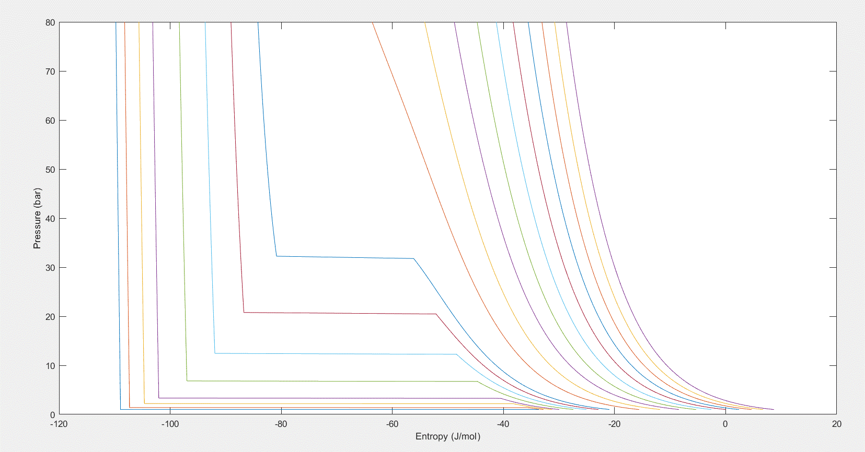

(H) Entropy Vs Temperature Isobars
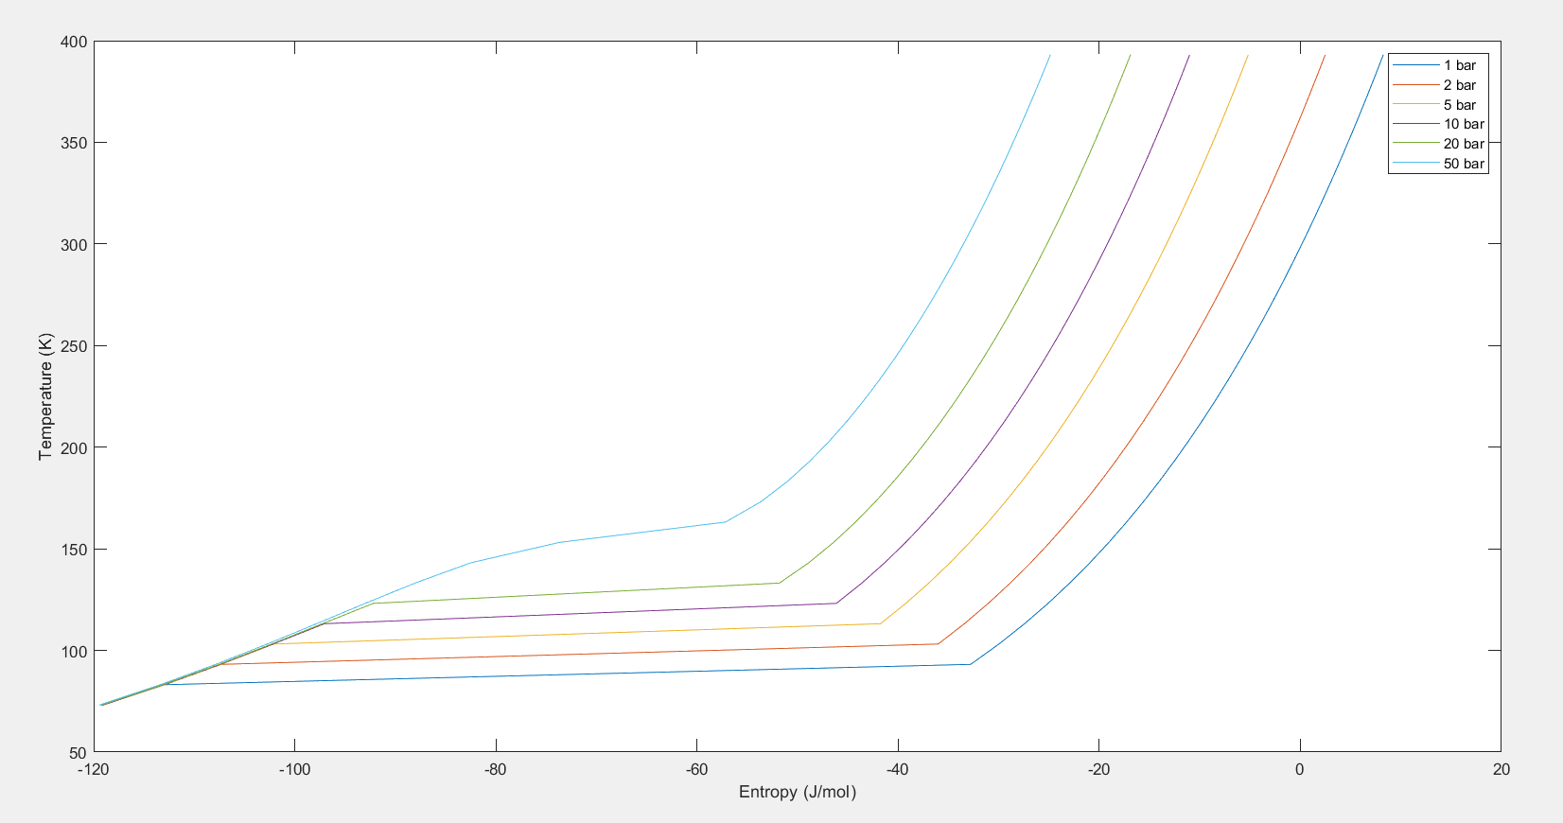

Code
Main
Enthalpy Vs Pressure Isotherms
R = 8.314;
Tc=154.6; %K
Pc=5.046e6; %Pa
Vc=0.0732e-3; %m^3/mol
a=0.45724*(R*Tc)^2/Pc; %at T=Tc
b=0.0778*R*Tc/Pc;
omega=0.021;

T = [-183 -180 -175 -170 -160 -150 -140 -130 -100 -75 -50 -25 0 25 50 75 100 125] + 273.15;
P=logspace(0, log(80)/log(10),300)*1e5; %Pa

nT = size(T, 2);
nP = size(P, 2);

enth = zeros(1, nP);
for t = 1:nT
for p = 1:nP
enth(1, p) = 0.001*enthalpy(T(1, t), P(1, p));
end
plot(enth, P/1e5);
hold on;
end
xlabel('Enthalpy (kJ/mol)');
ylabel('Pressure (bar)');
figure;
Entropy Vs Temperature Isobars
T = 73.15:10:400.15;
P = [1 2 5 10 20 50]*1e5;
nT = size(T, 2);
nP = size(P, 2);
ent = zeros(1, nT);
for p1 = 1:nP
for t1 = 1:nT
ent(1, t1) = entropy(T(1, t1), P(1, p1));
end
plot(ent, T);
hold on;
end
xlabel('Entropy (J/mol)');
ylabel('Temperature (K)');
legend('1 bar', '2 bar', '5 bar', '10 bar', '20 bar', '50 bar');
figure
Entropy Vs Pressure Isotherms
T = [-183 -180 -175 -170 -160 -150 -140 -130 -100 -75 -50 -25 0 25 50 75 100 125] + 273.15;
P=logspace(0,log(80)/log(10),300)*1e5; %Pa
nT = size(T, 2);
nP = size(P, 2);
ent = zeros(1, nP);
for t1 = 1:nT
for p1 = 1:nP
ent(1, p1) = entropy(T(1, t1), P(1, p1));
end
plot(ent, P/1e5);
hold on;
end
xlabel('Entropy (J/mol)');
ylabel('Pressure (bar)');
Enthalpy
function y = enthalpy(T, P)
[A, B] = pt_consts(T, P);
alpha= -1.+B;
beta=A-3*B*B-2*B;
gamma= -A*B + B*B*(B+1.);

PReq=[1.0 alpha beta gamma];
zr=real(roots(PReq));

if T < 173.15
if P< p_vap(T)
Z = max(zr);
elseif P> p_vap(T)
Z = min(zr);
else
return
end
else
Z = PR(T,P);
end
Constants
Pc = 5.046e6;
Tc = 154.6;
R = 8.314;
b = 0.0778*(R*Tc)/Pc;
a = 0.45724*((R*Tc)^2)/Pc;
kappa = 0.4069;

alpha=1.+kappa*(1.-sqrt(T/Tc));
da_dt = (-1)*a*alpha*(kappa/sqrt(T*Tc));
alpha = alpha*alpha;
a=a*alpha;
H(T, P) – H^{IG}(T, P) -
c1 = (T*da_dt - a)/(sqrt(8)*b);
B = (b*P)/(R*T);
c2 = (Z + (1+sqrt(2))*B)/(Z + (1-sqrt(2))*B);
c2 = log(c2);
h1 = R*T*(Z-1) + c1*c2;
H^{IG}(T, P) – H^{IG}(25 C, 1 atm) -
c3 = 25.46*(T-298.15);
c4 = (0.01519/2)*(T^2 - 298.15^2);
c5 = ((0.7151e-5)/3)*(T^3 - 298.15^3);
c6 = ((1.311e-9)/4)*(T^4-298.15^4);
h2 = c3 + c4 - c5 + c6;
Total Enthalpy
y = h1 + h2;
end

Entropy

function y = entropy(T, P)
[A, B] = pt_consts(T, P);
alpha= -1.+B;
beta=A-3*B*B-2*B;
gamma= -A*B + B*B*(B+1.);
PReq=[1.0 alpha beta gamma];
zr=real(roots(PReq));
if T < 173.15
if P< p_vap(T)
Z = max(zr);
elseif P>p_vap(T)
Z = min(zr);
else
return
end
else
Z = PR(T, P);
end
Constants
Pc = 5.046e6;
Tc = 154.6;
R = 8.314;
b = 0.0778*(R*Tc)/Pc;
a = 0.45724*((R*Tc)^2)/Pc;
kappa = 0.4069;
alpha=1.+kappa*(1.-sqrt(T/Tc));
da_dt = (-1)*a*alpha*(kappa/sqrt(T*Tc));
S(T, P ) - S^{IG}(T,P) -
c1 = (da_dt)/(sqrt(8)*b);
B = (b*P)/(R*T);
c2 = (Z + (1+sqrt(2))*B)/(Z + (1-sqrt(2))*B);
c2 = log(c2);
s1 = R*log(Z-B) + c1*c2;
S^{IG}(T, P) - S^{IG}(25 C, 1 atm) -
c3 = 25.46*log(T/298.15);
c4 = (0.01519)*(T - 298.15);
c5 = ((0.7151e-5)/2)*(T^2 - 298.15^2);
c6 = ((1.311e-9)/3)*(T^3-298.15^3);
s2 = c3 + c4 - c5 + c6 - R*log(P/1e5);
Total Entropy -
y = s1 + s2;
end
(I)
Compressibility Factor (Z) Vs Reduced Pressure (Pr)
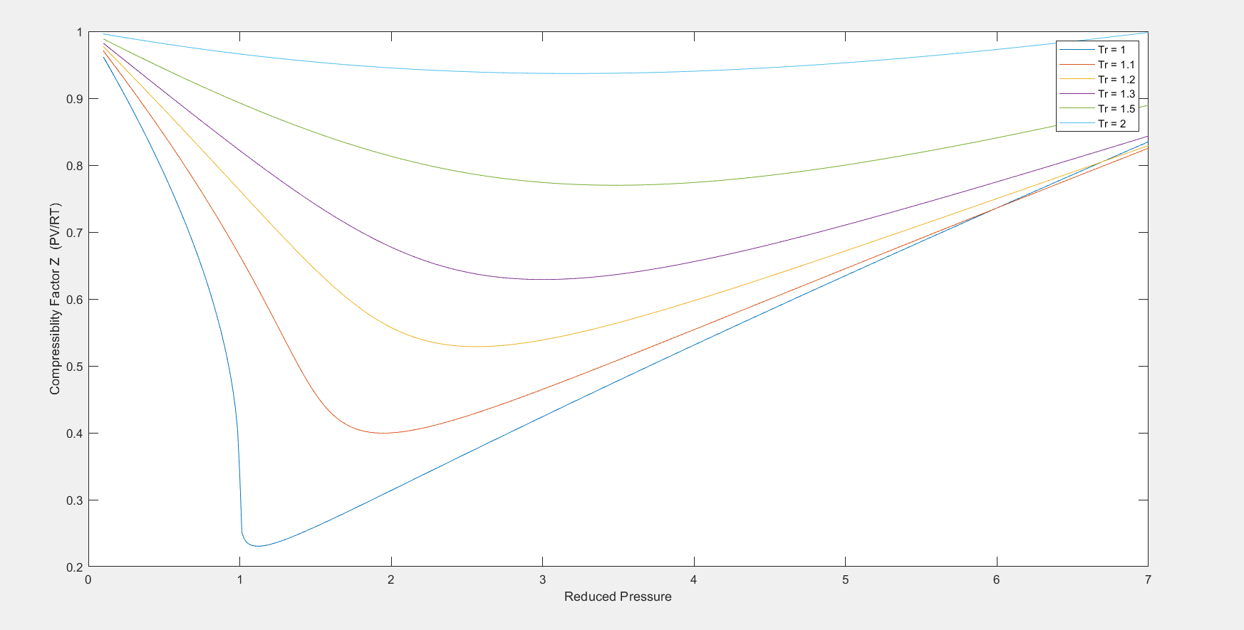
Code
Pc = 5.046e6;
Tc = 154.6;
R = 8.314;
b = 0.0778*(R*Tc)/Pc;
a = 0.45724*((R*Tc)^2)/Pc;

Pr = logspace(log(0.1)/log(10), log(7)/log(10), 300);
P = Pr*Pc;

Tr = [1 1.1 1.2 1.3 1.5 2];
T = Tr*Tc;

z = zeros(1, size(P, 2));

for i = 1:size(T, 2)
for j = 1:size(P, 2)
[A, B] = pt_consts(T(1, i), P(1, j));
alpha= -1.+B;
beta=A-3*B*B-2*B;
gamma= -A*B + B*B*(B+1.);

PReq=[1.0 alpha beta gamma];
zr=real(roots(PReq));

%get only relevant values of z
check_zr=abs(polyval(PReq,zr))<1.e-8;
pos=find(check_zr==1);
z(1, j) = zr(pos);
end
plot(Pr, z);
xlabel('Reduced Pressure');
ylabel('Compressiblity Factor Z (PV/RT)');
legend('Tr = 1', 'Tr = 1.1', 'Tr = 1.2', 'Tr = 1.3', 'Tr = 1.5', 'Tr = 2');
hold on
end

Code that support all the above codes
Function For Calculating Z for Given P and T
function z=PR(T,P)

[A, B] = pt_consts(T, P);
alpha= -1.+B;
beta=A-3*B*B-2*B;
gamma= -A*B + B*B*(B+1.);

PReq=[1.0 alpha beta gamma];
zr=real(roots(PReq));

%get only relevant values of z
check_zr=abs(polyval(PReq,zr))<1.e-8;
pos=find(check_zr==1);
z=zr(pos);
end

