**Overview**

In this tutorial, we will cover the following steps:

1. Download Anaconda
2. Install Anaconda
3. Start and Update Anaconda
4. Update scikit-learn Library
5. Install Deep Learning Libraries

**1. Download Anaconda**

In this step, we will download the Anaconda Python package for your platform.

Anaconda is a free and easy-to-use environment for scientific Python.

1. Visit the [Anaconda homepage](https://www.continuum.io/).

2. Click “Anaconda” from the menu and click “Download” to go to the [download page](https://www.continuum.io/downloads).

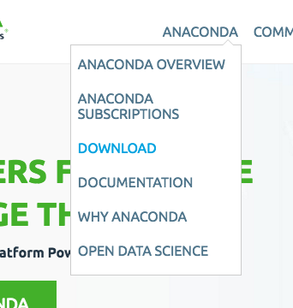

3. Choose the download suitable for your platform (Windows, OSX, or Linux):

* Choose Python 3.5
* Choose the Graphical Installer

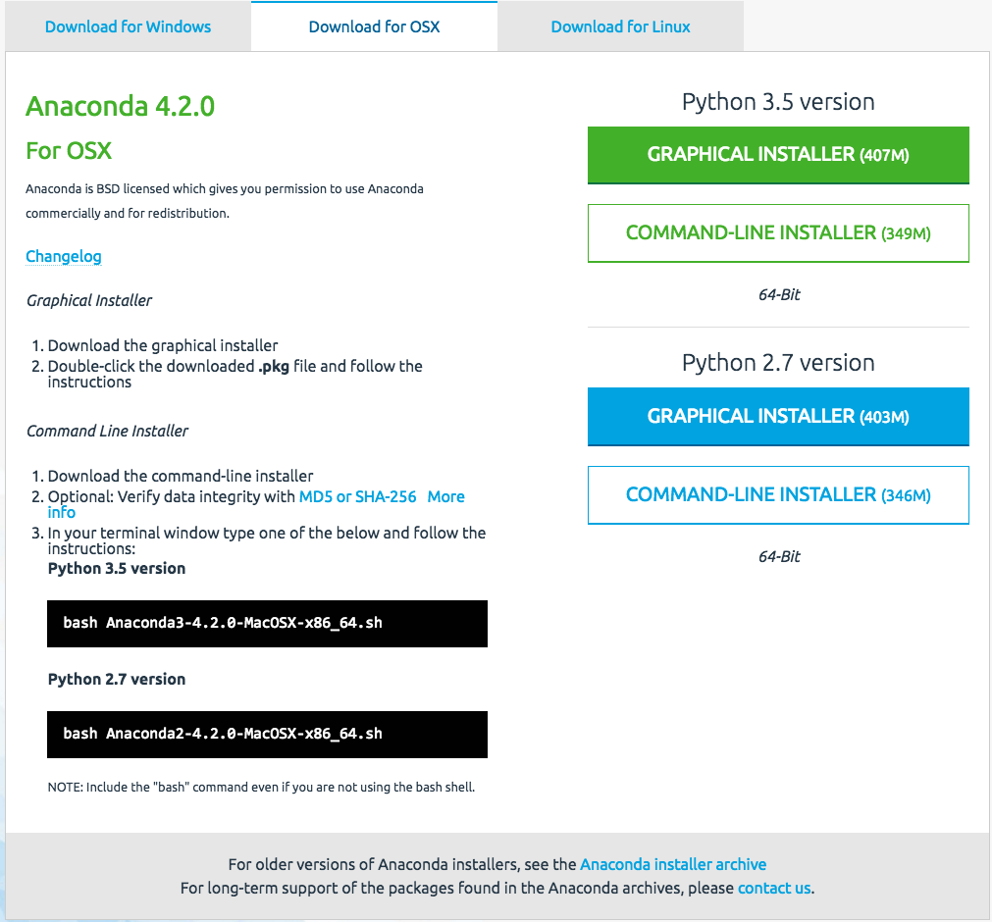

This will download the Anaconda Python package to your workstation.

I’m on OS X, so I chose the OS X version. The file is about 426 MB.

You should have a file with a name like:

Anaconda3-4.2.0-MacOSX-x86_64.pkg

**2. Install Anaconda**

In this step, we will install the Anaconda Python software on your system.

This step assumes you have sufficient administrative privileges to install software on your system.

* 1. Double click the downloaded file.
* 2. Follow the installation wizard.

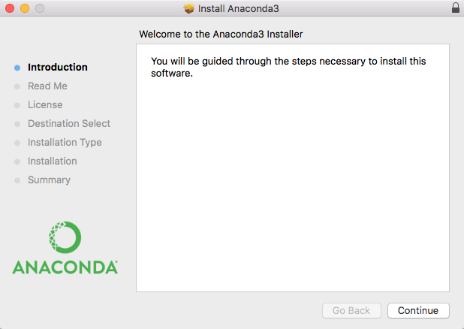

installation is quick and painless.

There should be no tricky questions or sticking points.

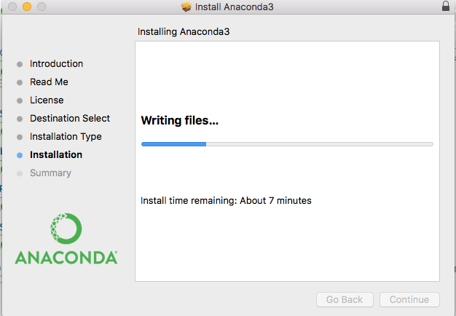

The installation should take less than 10 minutes and take up a little more than 1 GB of space on your hard drive.

## 3. Start and Update Anaconda

In this step, we will confirm that your Anaconda Python environment is up to date.

Anaconda comes with a suite of graphical tools called Anaconda Navigator. You can start Anaconda Navigator by opening it from your application launcher.

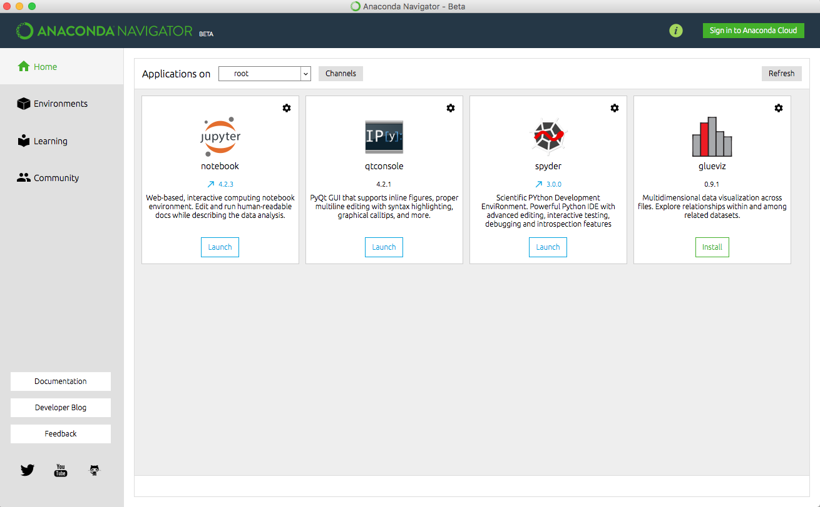

You can learn all about the [Anaconda Navigator here](https://docs.continuum.io/anaconda/navigator.html).

You can use the Anaconda Navigator and graphical development environments later; for now, I recommend starting with the Anaconda command line environment called [conda](http://conda.pydata.org/docs/index.html).

Conda is fast, simple, it’s hard for error messages to hide, and you can quickly confirm your environment is installed and working correctly.

* 1. Open a terminal (command line window).
* 2. Confirm conda is installed correctly, by typing:

|  |  |
| --- | --- |
|  | conda -V |

You should see the following (or something similar):

conda 4.2.9

* 3. Confirm Python is installed correctly by typing:

python –V

* 4. Confirm your conda environment is up-to-date, type:

|  |  |
| --- | --- |
|  | conda update conda  conda update anaconda |

You may need to install some packages and confirm the updates.

* 5. Confirm your SciPy environment.

The script below will print the version number of the key SciPy libraries you require for machine learning development, specifically: SciPy, NumPy, Matplotlib, Pandas, Statsmodels, and Scikit-learn.

You can type “python” and type the commands in directly. Alternatively, I recommend opening a text editor and copy-pasting the script into your editor.

|  |  |
| --- | --- |
|  | # scipy  import scipy  print('scipy: %s' % scipy.__version__)  # numpy  import numpy  print('numpy: %s' % numpy.__version__)  # matplotlib  import matplotlib  print('matplotlib: %s' % matplotlib.__version__)  # pandas  import pandas  print('pandas: %s' % pandas.__version__)  # statsmodels  import statsmodels  print('statsmodels: %s' % statsmodels.__version__)  # scikit-learn  import sklearn  print('sklearn: %s' % sklearn.__version__) |

**4. Update scikit-learn Library**

In this step, we will update the main library used for machine learning in Python called scikit-learn.

* 1. Update scikit-learn to the latest version.

At the time of writing, the version of scikit-learn shipped with Anaconda is out of date (0.17.1 instead of 0.18.1). You can update a specific library using the conda command; below is an example of updating scikit-learn to the latest version.

At the terminal, type:

|  |  |
| --- | --- |
|  | conda update scikit-learn |

## 5. Install Deep Learning Libraries

In this step, we will install Python libraries used for deep learning, specifically: Theano, TensorFlow, and Keras.

**NOTE**: I decided to use Keras for this class and Keras only requires TensorFlow to be installed.

* Install the TensorFlow deep learning library (all except Windows) by typing:

|  |  |
| --- | --- |
|  | conda install -c conda-forge tensorflow |

Alternatively, you may choose to install using pip and a specific version of tensorflow for your platform.

See the [installation instructions for tensorflow](https://www.tensorflow.org/get_started/os_setup#anaconda_installation).

* Install Keras by typing:

|  |  |
| --- | --- |
|  | pip install keras |

Create a script that prints the version numbers of each library, as we did before for the SciPy environment.

|  |  |
| --- | --- |
|  | # tensorflow  import tensorflow  print('tensorflow: %s' % tensorflow.__version__)  # keras  import keras  print('keras: %s' % keras.__version__) |

Congratulations, you now have a working Python development environment for machine learning and deep learning!