**College of Engineering Studies**

cid:1511675710.3638.14.camel@ddn.upes.ac.in****

**Branch: B.Tech-BEE**

**Assignment 1_BEE**

**---------------------------------------------------------------**

**Q.1.** What do you mean by fermi level? Draw the fermi level in the case of Extrinsic and intrinsic semiconductor. **(CO1)**

**Q.2.** If 48 eV of energy is required to move a charge through a potential difference of 12 V, determine the charge involved. **(CO1)**

**Q.3**. Explain the dependence of conductivity of semiconductors on temperature. **(CO2).**

**Q.4.** State the Mass Action Law. Write Diode Equation and hence explain the I-V characteristics of a diode.  **(CO1)**

**Q.5.** Differentiate between Avalanche and Zener Breakdown. **(CO2)**

**Q.6.** Determine output voltage V0 and the diode current ID for the below given network. **(CO 3)**

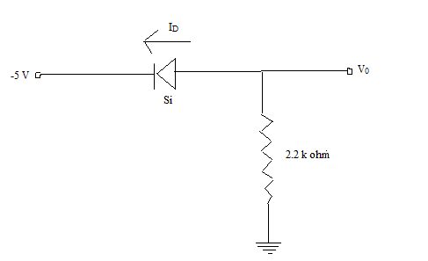

**Q 7:** The diode current is 0.5 mA at V =340 mV and 15 mA at V= 440 mV. Determine the value of η. Assume that kT/q= 25 mV. **(CO3)**

**Q 8:** Determine current density and current following through a copper wire of 2 mm diameter with conductivity of 5.8 x 107 is subjected to an electric field of 20 mV/m. **(CO3)**

**Q 9:** Determine the currents I1, I2 and ID for the network below **(CO3)**

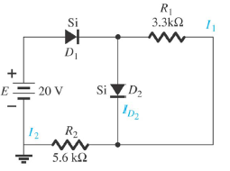

**Q 10:** A Ge p-n junction at 300 K has the following parameters ND =5 X 1018 / cm3,NA =6 X 1016 / cm3, ni =1.5 X 10 10 / cm3. Calculate the minority electron density in the P – region. **(CO3)**

**Q 11 :** Explain the effect of biasing on the width of depletion region in a p-n junction diode. **(CO2)**

**Q12:**  An a.c. Voltage is applied across a network with an ideal diode and load resistance 500 Ω as shown in figure. Find

1. The peak current through the diode
2. The peak output voltage **(CO4)**

