cid:1511675710.3638.14.camel@ddn.upes.ac.in**College of Engineering Studies**



**Branch: B.Tech-BEE**

**Assignment 2_BEE**

**---------------------------------------------------------------**

**Q.1.** Explain the functioning of a Zener diode as voltage regulator for both variable input as well as variable load arrangements. (**CO1**)

**Q.2**. Describe the functioning of diode as a rectifier? Explain the functioning of Half-Wave Rectifier. **(CO1)**

**Q 3:** Find the output voltage for the regulator circuit given below.

Data: Unstable voltage 40V, R= 1KΩ,VZ = 30V and RL =1KΩ. (**CO3**)

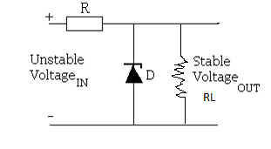

**Q.4.** Determine the output waveform for the network shown below and calculate the output dc level and the required PIV of each diode. (**CO 3**)



**Q.5.** Calculate the value of PIV for each diode of a bridge rectifier with secondary voltage of 20 V (rms). **(CO3)**

**Q.6.** Compare Half Wave and Full Wave Rectifier. **(CO2)**

**Q.7.** In a full wave rectifier peak value of ac voltage acting on each diode is 202 V. The resistance of each diode is 202 Ω and load resistance is 2kΩ. Calculate the peak, dc and rms value of current. **(CO3)**

**Q.8.** What is a filter circuit? Discuss the two types of LC filter circuits. **(CO1)**

**Q 9:** Determine the range of values of Vi that will maintain the Zener diode of figure given below in the “On” state **(CO3)**

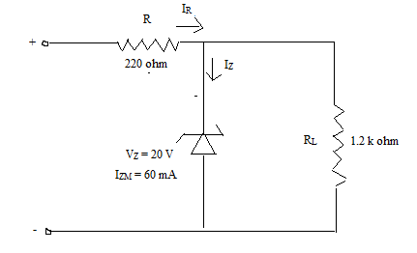

**Q 10:** For the Zener Diode network as shown in below figure, determine output voltage across the load **(CO3)**



**Q 11:**  Determine output (V0) for the given network. **(CO4)**

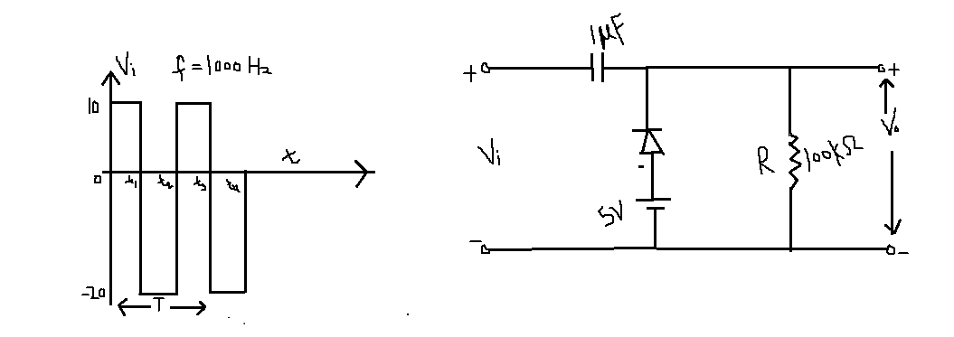

**Q 12:** Find V0 for the network shown below: **(CO4)**

