**Question 1 :** Suppose you are given the following requirements for a simple database for the National Hockey League (NHL):

* the NHL has many teams,
* each team has a name, a city, a coach, a captain, and a set of players,
* each player belongs to only one team,
* each player has a name, a position (such as left wing or goalie), a skill level, and a set of injury records,
* a team captain is also a player,
* a game is played between two teams (referred to as host_team and guest_team) and has a date (such as May 11th, 1999) and a score (such as 4 to 2).

Construct a clean and concise ER diagram for the NHL database.

**Answer :**

**[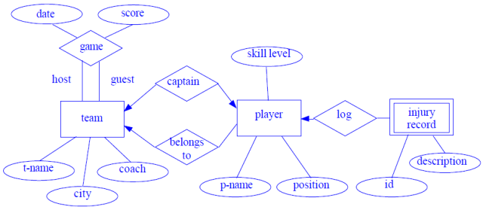](https://i1.wp.com/www.edugrabs.com/wp-content/uploads/2015/07/ERD-Q1A-er-diagram-questions-with-solutions.png)**

**Question 2:** A university registrars office maintains data about the following entities:

1. courses, including number, title, credits, syllabus, and prerequisites;
2. course offerings, including course number, year, semester, section number, instructor(s), timings, and classroom;
3. students, including student-id, name, and program;
4. instructors, including identi‑cation number, name, department, and title.

Further, the enrollment of students in courses and grades awarded to students in each course they are enrolled for must be appropriately modeled. Construct an E-R diagram for the registrars of‑ce.Document all assumptions that you make about the mapping constraints.

**Answer :**

**[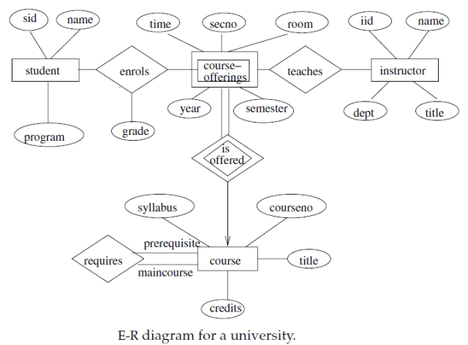](https://i1.wp.com/www.edugrabs.com/wp-content/uploads/2015/07/ERD-Q2A-er-diagram-questions-with-solutions.png)**

**Question 3:**  
**(a)** Construct an E-R diagram for a car-insurance company whose customers own one or more cars each. Each car has associated with it zero to any number of recorded accidents.

**Answer :**

**[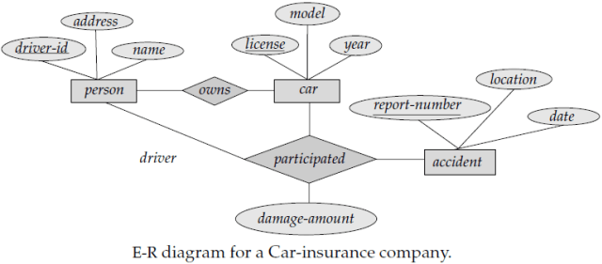](https://i2.wp.com/www.edugrabs.com/wp-content/uploads/2015/07/ERD-Q3A-er-diagram-questions-with-solutions.png)**

**(b)** Construct appropriate tables for the above ER Diagram ?

**Car insurance tables:**

**person (driver-id, name, address)**

**car (license, year,model)**

**accident (report-number, date, location)**

**participated(driver-id, license, report-number, damage-amount)**

**Question 4:**  
**(a)** Construct an E-R diagram for a hospital with a set of patients and a set of medical doctors. Associate with each patient a log of the various tests and examinations conducted.

**Answer :**

**[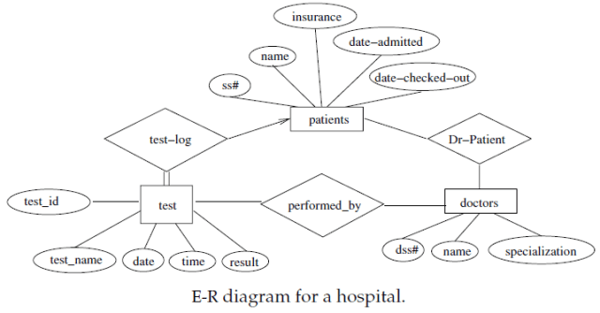](https://i0.wp.com/www.edugrabs.com/wp-content/uploads/2015/07/ERD-Q4A-er-diagram-questions-with-solutions.png)**  
**(b)** Construct appropriate tables for the above ER Diagram :

**Patient(SS#, name, insurance)**

**Physician ( name, specialization)**

**Test-log( SS#, test-name, date, time)**

**Doctor-patient (physician-name, SS#)**

**Patient-history(SS#, test-name, date)**

**Question 5:** Consider a database used to record the marks that students get in different exams of different course offerings.  
**a)** Construct an E-R diagram that models exams as entities, and uses a ternary relationship, for the above database.

**Answer a :**

**[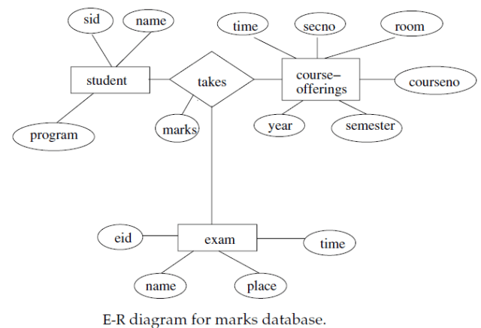](https://i0.wp.com/www.edugrabs.com/wp-content/uploads/2015/07/ERD-Q5aA-er-diagram-questions-with-solutions.png)**  
**b)** Construct an alternative E-R diagram that uses only a binary relationship between students and course-offerings. Make sure that only one relationship exists between a particular student and course-offering pair, yet you can represent the marks that a student gets in different exams of a course offering.

**Answer b:**

**[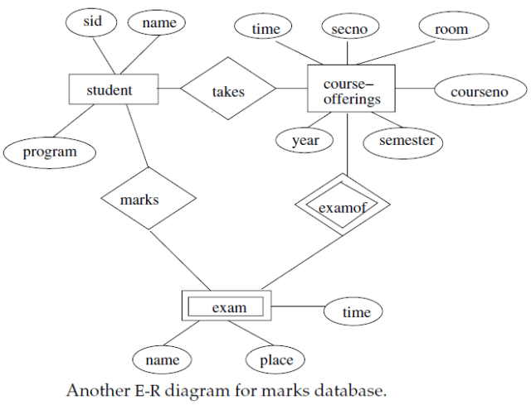](https://i1.wp.com/www.edugrabs.com/wp-content/uploads/2015/07/ERD-Q5bA-er-diagram-questions-with-solutions.png)**

**Question 6:** Design an E-R diagram for keeping track of the exploits of your favorite sports team. You should store the matches played, the scores in each match, the players in each match and individual player statistics for each match. Summary statistics should be modeled as derived attributes.

**Answer :**

**[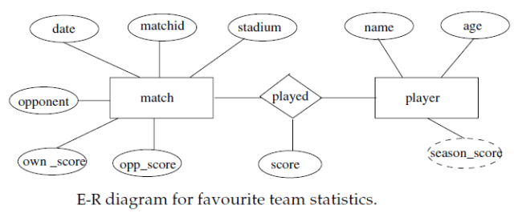](https://i2.wp.com/www.edugrabs.com/wp-content/uploads/2015/07/ERD-Q6A-er-diagram-questions-with-solutions.png)**

**Question 7 :**Extend the E-R diagram of the previous question to track the same information for all teams in a league.

**Answer :**

**[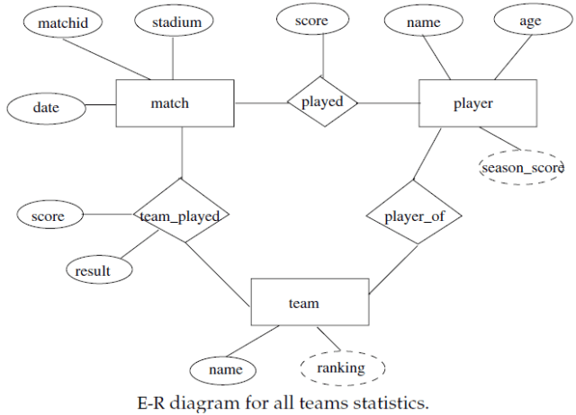](https://i1.wp.com/www.edugrabs.com/wp-content/uploads/2015/07/ERD-Q7A-er-diagram-questions-with-solutions.png)**

**Question 8 :** Draw the E-R diagram which models an online bookstore.  
**Answer :**

**[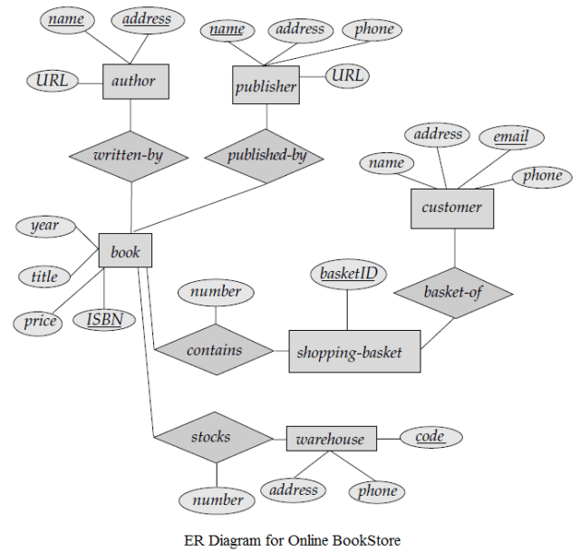](https://i1.wp.com/www.edugrabs.com/wp-content/uploads/2015/07/ERD-Q8A-er-diagram-questions-with-solutions.png)**

**Question 9 :** Consider a university database for the scheduling of classrooms for ‑final exams. This database could be modeled as the single entity set exam, with attributes course-name, section-number, room-number, and time. Alternatively, one or more additional entity sets could be defined, along with relationship sets to replace some of the attributes of the exam entity set, as

* course with attributes name, department, and c-number
* section with attributes s-number and enrollment, and dependent as a weak entity set on course
* room with attributes r-number, capacity, and building

Show an E-R diagram illustrating the use of all three additional entity sets listed.

**Answer :**

**[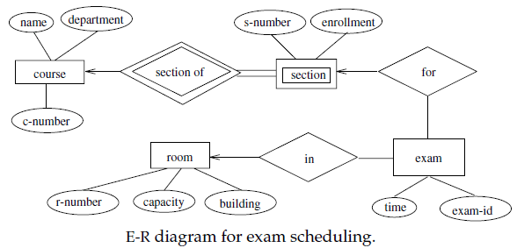](https://i2.wp.com/www.edugrabs.com/wp-content/uploads/2015/07/ERD-Q9A-er-diagram-questions-with-solutions.png)**

Question 10 : Construct an ER Diagram for Company having following details :

* Company organized into DEPARTMENT. Each department has unique name and a particular employee who  manages the department. Start date for the manager is recorded. Department may have several locations.
* A department controls a number of PROJECT. Projects have a unique name, number and a single location.
* Company’s EMPLOYEE name, ssno, address, salary, sex and birth date are recorded. An employee is assigned to one department, but may work for several projects (not necessarily controlled by her dept). Number of  
  hours/week an employee works on each project is recorded; The immediate supervisor for the employee.
* Employee’s DEPENDENT are tracked for health insurance purposes (dependent name, birthdate, relationship to employee).

Answer :

