**Module 5 Assignment: Creating Your Prototype Worksheet**

1. **Title or name for your prototype:**

**Rhythm: A Helping Hand**

1. **Description of your target audience (users) that your prototype is intended to serve:** (15–30 words)

**Roadside handicapped people and children who are unable to meet their basic food and educational needs.**

1. **A “Problem Statement” that explains the problem/challenge your prototype is intended to solve:** (50–100 words)

**The roadside children are unable to get their basic education and are not having proper meal even a single time a day; the same situation is with roadside handicapped people as they cannot work and they also lack in getting proper food to eat even a single time in a day.**

1. **Your prototype concept: what it is, how it works, and why it is a good idea:** (50–100 words).

**The basic version of our design thinking solution provides educational aid to roadside children and occasional food donations to roadside handicapped people. The primary source of fund of the organization is by the contribution of the members, all the resources collected are utilized for providing educational aid, food, source of income, basic healthcare to roadside children and handicapped people; And divine satisfactory happiness to our members for their contribution to the noble cause.**

**The prototype will be an event for providing educational aid to roadside children.**

1. **A list of the materials that you used to create your prototype:**

**Members, funds, books, notebooks, pen/pencil.**

1. **A representation of your prototype:**

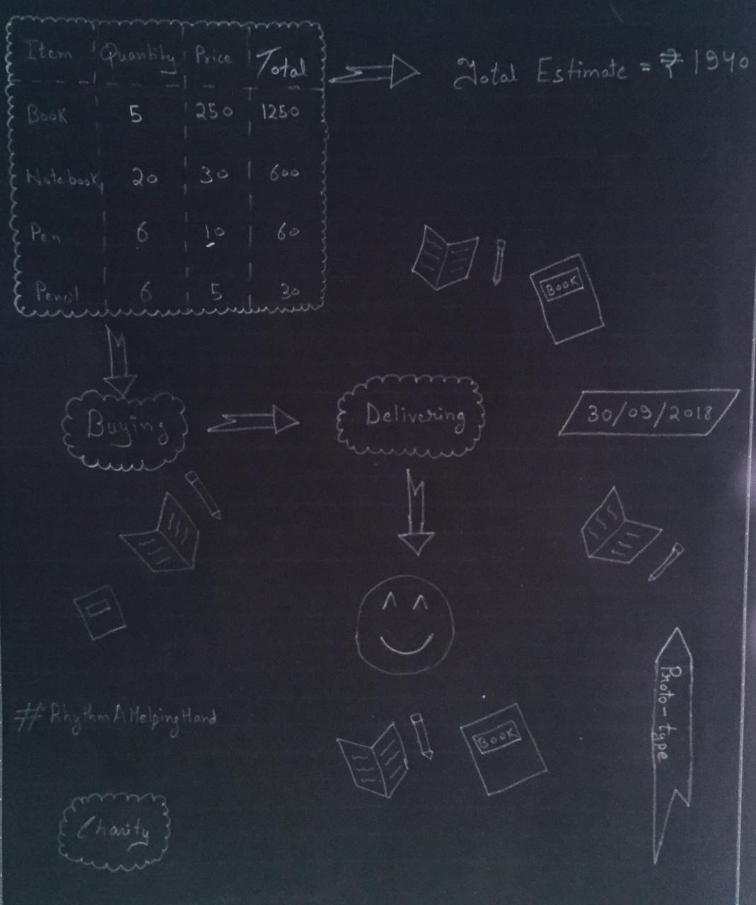

* **OPTIONAL: If you wish to share a video or additional images of your prototype, please insert them here or upload them as a separate attachment to this assignment. If not, simply write “Not Applicable” in this space.**

**NOT APPLICABLE**

* **OPTIONAL: If you have already received feedback on your prototype and wish to share the feedback and any ideas about your next steps, you may include that here. If not, simply write “Not Applicable” in this space.**

**Our next step would be providing educational assistance and aid to deserving children on monthly basis and extend our aid for providing school fees also.**