**Module 5: Brainstorming Solutions and Creating Your Prototype**

**Assignment: Prototype Worksheet Template**

*Use the Completed Prototype Worksheet as your guide.*

**Your name: Shashank Agrawal**

**1. Your current “How Might We?” question:**

How might we ensure free and prosper education for all.

**2. Title or name for your prototype:**

**“Veducate”**

**3. Description of your target audience (users) that your prototype is intended to serve:**

The purpose behind the Veducate is to provide to free education to all the people. Firstly, I will test the application in nearby area and after a successful testing it will available to all the students worldwide.

**4. A “Problem Statement” that explains the problem/challenge your prototype is intended to solve:**

Illiteracy is a curse for any nation or country .During my research, I found that people lacks basic education. When I prepared a report and insights I commence that the main reason for illiteracy is poverty. Today, we have to pay a lots of money to get a basic education. Illiteracy effects the lifestyle of the people. They were not able to gain knowledge and they doesn’t know there rights and role in the society.

**5. Your prototype concept: what it is, how it works, and why it is a good idea:**

Veducate is an Ed-Tech venture established to help people pursuing basic education in comprehending approach. Today despite having all of the major technology, lack of a proper platform to incorporate all the requirements can be considered one of the reasons for the unsustainability. All together we have videos, notes and fun quizzes to make you ready to face the exams very comfortably. At Veducate, we know how it feels to be deprived of motivation in life.

**6. A list of the materials that you used to create your prototype:**

We need to develop an mobile application or a website.

**7. If your potential solution is a product, include a photo of your completed prototype. Insert the photo in the document here.**

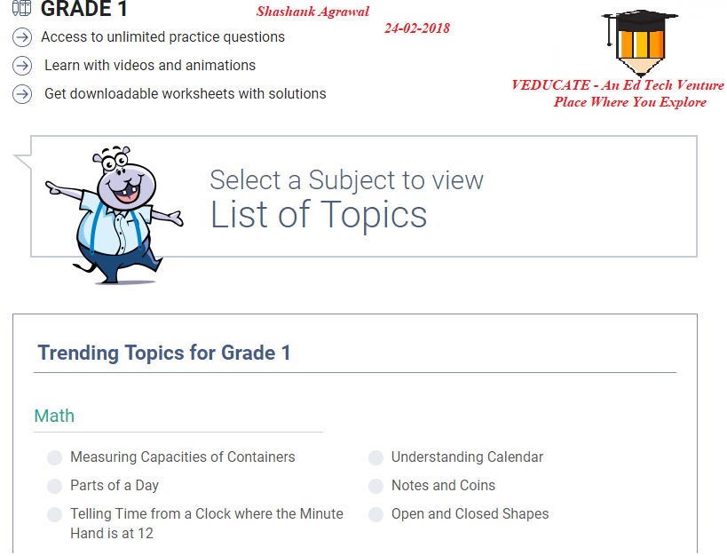

**8. OPTIONAL: If you wish to share a video or additional images of your prototype, please insert them here or upload them as a separate attachment to this assignment. If not, simply write “Not Applicable” in this space.**

Not Applicable.

**9. OPTIONAL: If you have already received feedback on your prototype and wish to share the feedback and any ideas about your next steps, you may include that here. If not, simply write “Not Applicable” in this space.**

Not Applicable.