**My Updated Prototype**

* **Your name:** Shashank Agrawal
* **Your design challenge:** Education Sector(Ensuring free education for all)
* **Your current “How Might We?” question:** How might we ensure free and prosper education for all.
* **Your product/service/process:** Veducate
* **Feedback and Insights:** As asked by the Instructor, Vedeucate focus on all the basic education from basic lesson, test preparation, virtual experiments and q&a section.Currently I’m working for class 1 to class 10.Later on, i will upgrade the course for the higher classes.The student can enhance all their basic skills including practical knowledge.Course is also industrial oriented to meet up the latest technology changes.

Illiteracy is a curse for any nation or country.During my research, I found that people lacks basic education. When I prepared a report and insights I commence that the main reason for illiteracy is poverty. Today, we have to pay a lots of money to get a basic education.Illiteracy affects the lifestyle of the people. They were not able to gain knowledge and they doesn’t know their rights and role in the society.Thus by providing free education it will cause great social change.

* **Your revised prototype:** Veducate is an Ed-Tech venture established to help people pursuing basic education in comprehending approach.Today despite having all of the major technology, lack of a proper platform to incorporate all the requirements can be considered one of the reasons for the unsustainability.All together we have videos, notes and fun quizzes to make you ready to face the exams very comfortably.At Veducate, we know how it feels to be deprived of motivation in life.As far the uniqueness is considered other website usually are paid and generally deals with the theory but Veducate deals in both the aspect theory as well as practical.

As an suggestion suggested by one of my colleague is to add the feature of report card, which itself is an unique way to analyse the weakness and strength at every subject.I’m currently working to deploy the context in the world wide network.

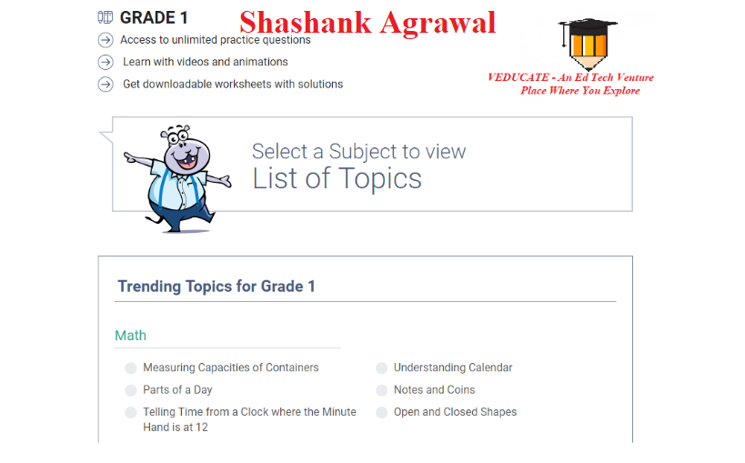

AN OVERVIEW OF THE WEBSITE